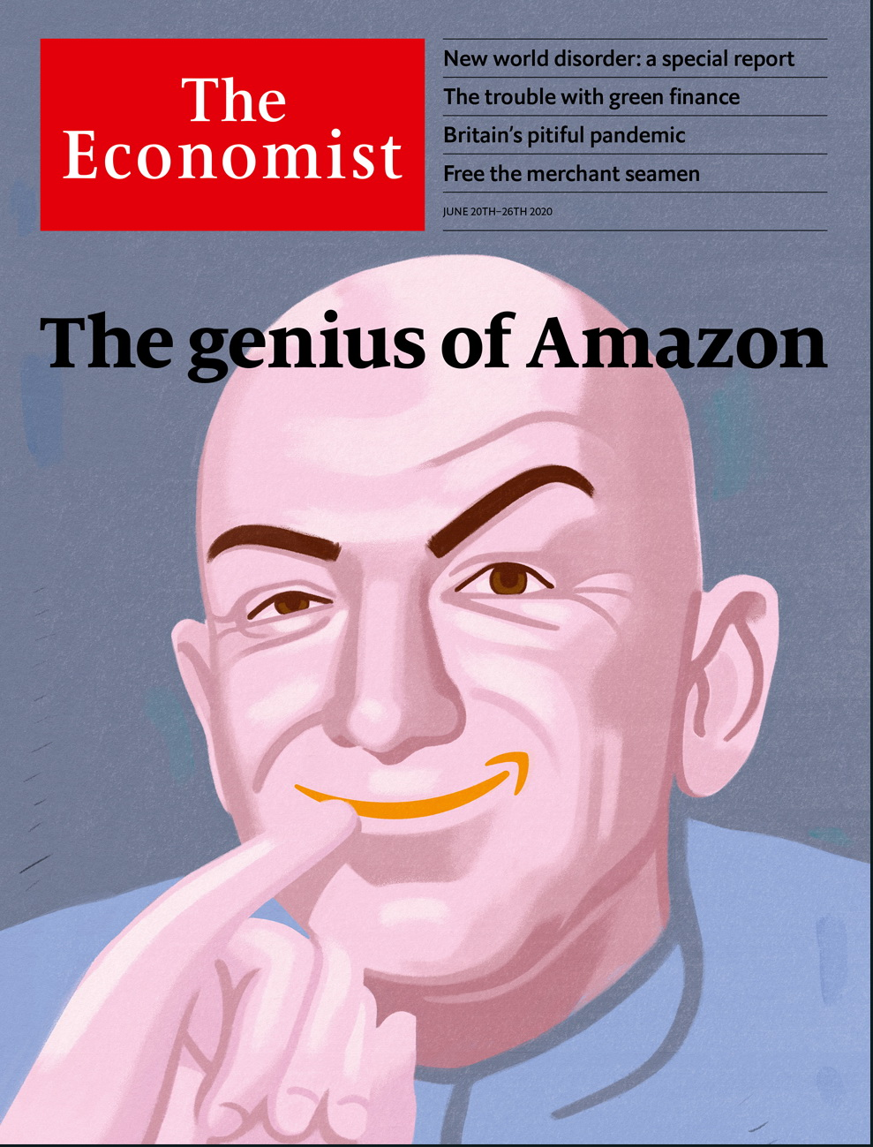

# Table of Contents

The world this week

Politics this week

Business this week

KAL’s cartoon

Leaders

The pandemic: Not Britain’s finest hour

Geopolitics: The new world disorder

India and China: Elephant v dragon

Climate change and investing: The trouble with green finance

Global trade: Invisible hands

Jeff Bezos: The genius of Amazon

Letters

Letters to the editor: On prosecutors, the media, mercenaries, Greek, carbon pricing, the Bible, Andrew Johnson

Briefing

Amazon: And on the second day…

Green investing: Hotting up

Asia

The Sino-Indian border: Death valley

South Asian civil servants: Manners maketh district commissioners

Migrant workers in Singapore: Breathing room

Inter-Korean relations: In the dust

Banyan: A bad rap?

United States

State finances: The calamity ahead

LGBT rights: A wider umbrella

Midwives: Ripe for rebirth

John Bolton’s revelations: National security chastiser

Bill de Blasio: How’s he doin’?

Maine politics: The race of the long driveways

Lexington: A shovel-ready project

China

The South China Sea: Identify yourself

Fighting the pandemic: It’s back

Chaguan: Why China bullies

The Americas

Covid-19: Leaving lockdowns

Uruguay: Standing apart

Bello: Breaking a gentlemen’s agreement

Middle East & Africa

Covid-19 in Africa: Testing times

Malawi: President v people

Football and war: More than a game

African cities: A tax on all your houses

Syria: From bad to worse

Europe

Poland’s election: Playing the family card

Belarus: The slipper revolt

The covid economy: Spending big to save jobs

France: The call of the wild

Charlemagne: How a dining club took over the EU

Britain

Covid-19: Trust me, I’m a prime minister

Drug discovery: Small ticket, big difference

Anti-racism protest: What next?

Diplomacy and foreign aid: Will charity begin at home?

Bookshops: Just browsing

Bagehot: Losing his grip

International

Pandemics and war: Horsemen of the apocalypse

Special report

The new world disorder: Missing in action

Power plays: Who’s in charge?

Global firefighting: Missions impossible

New START’s end?: Avoidable Armageddon

Reform: Grand redesigns

Reflections at 75: The wisdom of youth

Three future scenarios: Bedlam, bumbling or boldness?

Business

Luxury in the pandemic: Fashion victims

Race in Silicon Valley: Beyond the pale

Bartleby: Waging war on recessions

Samsung: No end in sight

Business in China: Chopped and screwed

JAB Holding: The Reimann hypothesis

Schumpeter: Zoom and gloom

Finance & economics

The Federal Reserve (1): From yields to maturity

The Federal Reserve (2): Swapping panic for calm

Poverty in China: Clarifying the battle lines

The euro area: Better tailored

The economics of reparations: Forty acres and a mule

Buttonwood: The detail on retail

Global trade: Ninety percent of everything

Free exchange: Changing room

Science & technology

Arctic exploration: Pole position

Books & arts

The fate of nations: Too many setbacks

Goths v Romans: Loser’s justice

Alfredo Jaar: Opening the black box

Rewatching “The Prisoner”: He was not a number

Illness in literature: Climb every mountain

Economic & financial indicators

Economic data, commodities and markets

Graphic detail

The Sahel: The next Afghanistan?

Obituary

Lily Lian: The lark of metro Barbès



### Friday, June 19, 2020

|  |  |
| --- | --- |
| The world this week | 3 |
| Leaders | 6 |
| Letters | 1 |
| Briefing | 2 |
| Asia | 5 |
| United States | 7 |
| China | 3 |
| The Americas | 3 |
| Middle East & Africa | 5 |
| Europe | 5 |
| Britain | 6 |
| International | 1 |
| Special report | 7 |
| Business | 7 |
| Finance & economics | 8 |
| Science & technology | 1 |
| Books & arts | 5 |
| Economic & financial indicators | 1 |
| Graphic detail | 1 |
| Obituary | 1 |

|  |  |  |
| --- | --- | --- |
|  | Sections | Leaders |

The world this week

Politics this week

.

Business this week

.

KAL’s cartoon

.

|  |  |  |
| --- | --- | --- |
|  | Sections | Leaders |

|  |  |  |  |
| --- | --- | --- | --- |
|  | Articles | Sections | Next |

# Politics this week

Jun 20th 2020 |

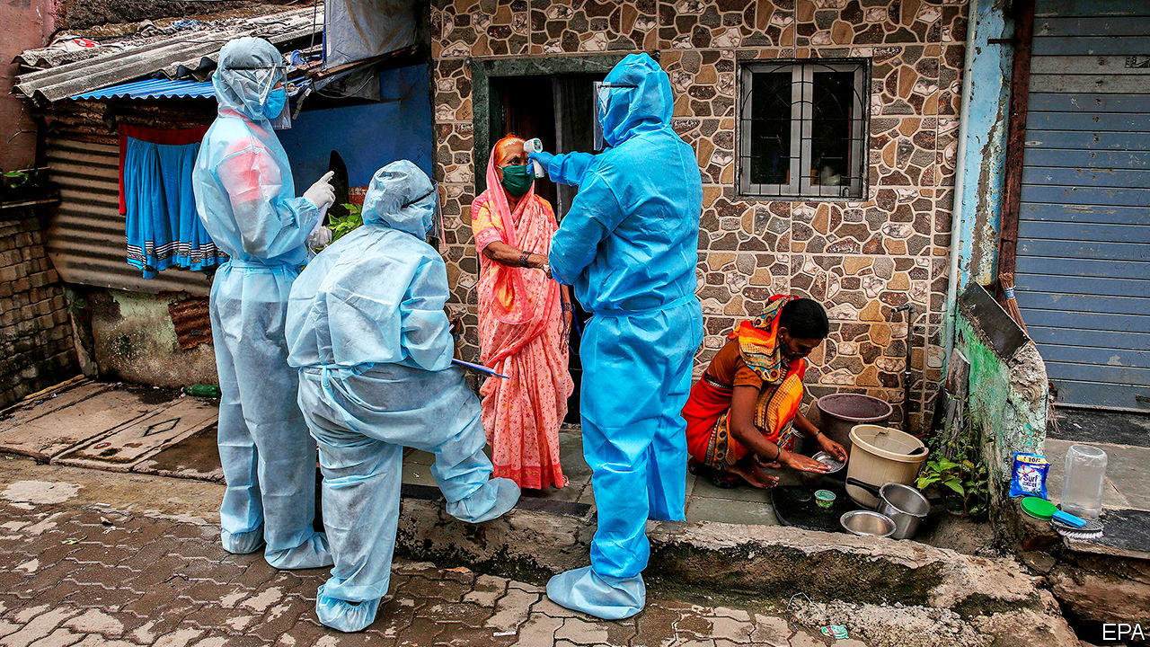

Brazil reported a record 35,000 new cases of covid-19 in a day. Even that grim figure is widely regarded as an undercount. India is now recording tens of thousands of new infections each week. In America, Florida, Texas and Arizona set daily records for new cases. Although many places are easing lockdowns, Anthony Fauci, the leading adviser to the White House on infectious diseases, warned that the pandemic is far from over: “The numbers speak for themselves.” See [article](https://www.economist.com/node/21788194).

Beijing went into “wartime mode” to battle an outbreak of covid-19, the first in the Chinese capital after eight weeks with no cases reported of local transmission. Many of the cases are linked to a wholesale food market. See [article](https://www.economist.com/node/21788206).

A court in China sentenced the country’s former insurance regulator, Xiang Junbo, to 11 years in prison for accepting 18m yuan ($2.5m) in bribes. Mr Xiang had also served as deputy governor of the central bank.

At least 20 Indian troops were killed in a fight with Chinese soldiers in the Galwan valley, the first combat deaths on the disputed Sino-Indian border in 45 years. China did not say how many of its soldiers died. The brawl involved nail-studded clubs and stones rather than guns. Tensions have increased since April, when the Chinese army encroached on Indian-claimed territory. See article.

North Korea blew up the building used for meetings between its officials and those from South Korea. It said the explosion was retaliation for unflattering leaflets about its supreme leader, sent over the border via balloons by defectors, whom North Korea called “rubbish-like mongrel dogs”. See article.

A court in the Philippines found Maria Ressa guilty of libel for alleging links between a businessman and a judge. Ms Ressa is the boss of Rappler, a news website that is critical of the country’s strongman president, Rodrigo Duterte. Her lawyer said the message to other journalists was “Keep quiet, or you’ll be next.”

Steven Mnuchin, America’s treasury secretary, said his government will nominate Mauricio Claver-Carone, a staff member of Donald Trump’s National Security Council, to lead the Inter-American Development Bank. All the bank’s four presidents since its founding in 1959 have been from Latin America. The US has 30% of the bank’s shares, the largest stake of any country. See article.

Venezuela’s Supreme Court removed the leaders of two opposition parties, Justice First and Democratic Action. It replaced them with men whom the parties had previously expelled for being stooges of Nicolás Maduro, the country’s dictator.

America’s Supreme Court ruled that the 1964 Civil Rights Act makes it illegal to fire workers for being gay or transgender. More than half the states allowed such discrimination. The 6-3 majority decision was written by Neil Gorsuch, a Trump appointee. See [article](https://www.economist.com/united-states/2020/06/18/americas-supreme-court-protects-americas-supreme-court-protects-lgbt-workers-against-discrimination-workers-against-discrimination).

The White House tried to stop publication of a book by John Bolton, a former national security adviser, claiming that it contained classified information. The book says that Donald Trump tried to persuade Xi Jinping, China’s president, to buy American farm goods to help his re-election campaign. It also alleges that in a meeting with Mr Xi, Mr Trump said he approved of China’s policy of putting Uighur Muslims in internment camps. On June 17th Mr Trump signed a bill that imposes sanctions on Chinese officials who were responsible for the Uighurs’ internment. See article.

A white policeman in Atlanta who shot dead a black man when he took the officer’s Taser weapon was charged with murder. Republicans in the Senate unveiled their own set of police reforms. These are less radical than those put forward by Democrats but support the creation of a database to track police officers with a record of misconduct.

Boris Johnson, Britain’s prime minister, announced that Britain’s Department for International Development would be folded back into the Foreign Office. British aid will now focus less on ending poverty and more on advancing British foreign-policy goals. See article.

Yousef al-Otaiba, a diplomat from the United Arab Emirates, wrote in an Israeli newspaper that any unilateral annexation of West Bank territory would harm Israel’s relations with Arab countries. It is thought to be the first-ever opinion piece written by an official from the Gulf for an Israeli newspaper.

America imposed new sanctions on Syria that target any person, company or institution—Syrian or foreign—that does business with or provides support to the regime of President Bashar al-Assad. See article.

There were more demonstrations in Lebanon. The government began injecting more American dollars into the market in an effort to support the local currency. Early talks with the IMF over a bail-out package have been shaken by concerns that the government is not serious about reform.

A judge overseeing a corruption trial in the Democratic Republic of Congo was murdered. Police initially said that the judge had had a heart attack, but an autopsy showed he had died from brain injuries after being stabbed in the head.

## Coronavirus briefs

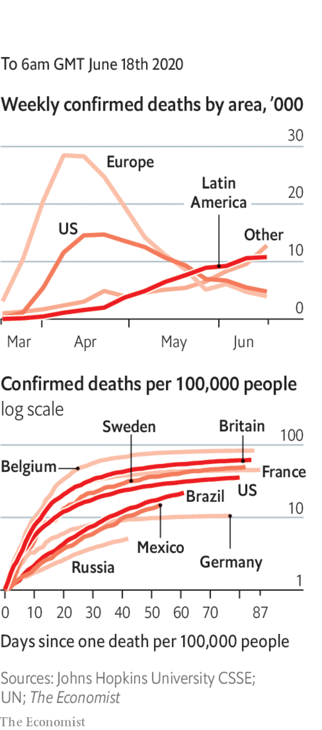

A randomised trial conducted by scientists at Oxford found that dexamethasone, a cheap steroid drug found in many countries, reduced the death rates for patients on ventilators by 35% and by 20% for those needing oxygen. See article.

The president of Honduras, Juan Orlando Hernández, said he and his wife have covid-19.

The remaining lockdown restrictions were lifted in France, enabling bars and restaurants to reopen fully. In England all shops were allowed to open their doors to customers again.

Next year’s Oscars ceremony was postponed by two months until April 25th. It is not yet clear whether the event will be held in a theatre or virtually.

The English Premier League resumed its season, three months after it was suspended. The football matches are being played behind closed doors.

This article was downloaded by calibre from <https://www.economist.com/the-world-this-week/2020/06/20/politics-this-week>

|  |  |  |  |
| --- | --- | --- | --- |
|  | Articles | Sections | Next |

|  |  |  |  |
| --- | --- | --- | --- |
| Previous | Articles | Sections | Next |

# Business this week

Jun 20th 2020 |

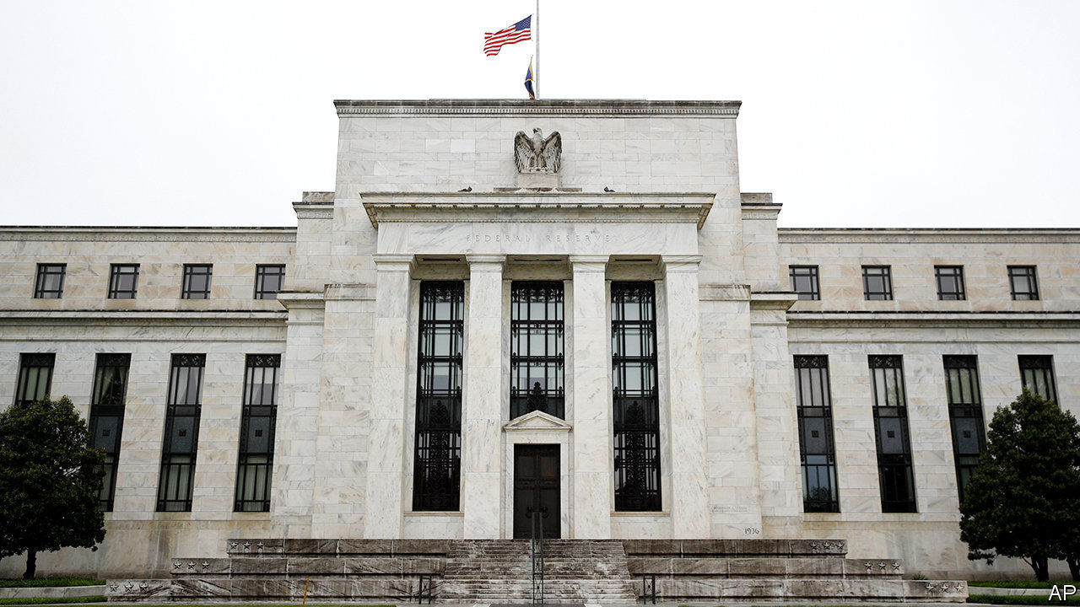

The Federal Reserve clarified its new bond-buying strategy, announcing that it would acquire individual corporate bonds on the secondary market. This comes on top of its purchases in exchange-traded funds, which include some junk-rated funds that track debt. But the central bank’s latest move comes almost three months after it first announced emergency measures to shore up markets. Questions have been raised about the length of time it has taken to roll out some of its programmes. See [article](https://www.economist.com/node/21788207).

Stockmarkets rallied in response to the news from the Fed, making up for some of the heavy losses they racked up in the week ending June 12th, which was the worst for the S&P 500 and Dow Jones Industrial Average since mid-March.

The Trump administration said it would let American tech firms work with Huawei on creating international standards for 5G. The decision represents a long-expected easing of the sanctions placed on the Chinese provider of telecoms networks and equipment over national-security concerns. America did not have much choice. Huawei’s size and expertise makes it one of the companies integral to setting the rules on international networks.

America’s Justice Department put forward proposals that roll back the immunity of social-media firms for content posted on their platforms. Donald Trump signed an executive order recently rescinding the protections after he got into a spat with Twitter, but it is unlikely to be upheld once it is challenged in court.

Robert Lighthizer, the US trade representative, confirmed that America had pulled out of talks with the EU that had sought to find common ground on taxing tech companies. America argues that such levies will disproportionately hit its global giants, such as Apple and Google, and has threatened to retaliate with sanctions if European countries impose their own digital tax.

Facebook launched a payment service on its WhatsApp platform in Brazil. Brazilians can link their credit or debit cards to WhatsApp Pay to send money to each other or buy goods from small firms. Facebook had hoped India would be the first country to use the facility nationwide, but became bogged down in regulatory objections there.

## Shop till you drop

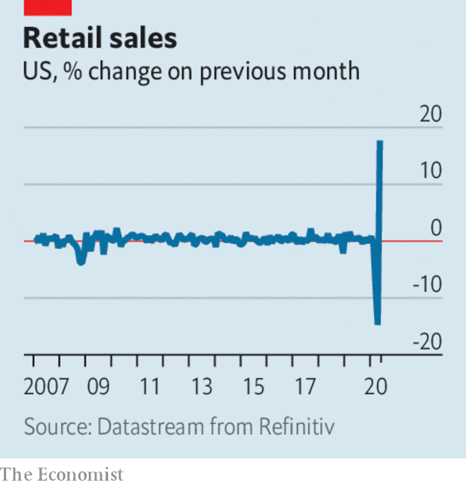

Retail sales in America surged last month by 17.7% over April, more than double the amount that had been expected. That followed a 14.7% decline in April. Sales were still down by 6.1% compared with May last year. It is thought that the government’s stimulus measures to households helped fuel the shopping spree, and that consumers might not spend so much when the money runs out.

In America’s biggest IPO so far this year, Royalty Pharma raised $2.2bn when it listed on the Nasdaq exchange. The company invests in the rights to royalties on future drug sales across the life sciences, combining scientific expertise with capital investment for the industry. Royalty’s share price leapt by more than half on the first day of trading.

Acknowledging that demand for energy will remain weak in the aftermath of covid-19 and that governments “will accelerate the pace of transition to a lower carbon economy”, BP said it would write down the value of its oil and gas assets in the second quarter by between $13bn and $17.5bn. To buttress its balance-sheet the energy giant reportedly raised $12bn through a sale of hybrid bonds.

In its first forecast for 2021, the International Energy Agency said that demand for oil would increase by 5.7m barrels a day next year to 97.4m. That is still below the average for 2019, mostly because the aviation industry will still struggle in 2021. However, China’s “strong exit from lockdown” saw its demand for oil in April rebound back almost to the level it was at a year ago.

In a rare admission of corporate wrongdoing on homicide-related charges, PG&E pleaded guilty to 84 counts of involuntary manslaughter in relation to the Camp Fire disaster in California two years ago. The electric utility’s faulty equipment sparked the inferno. Its chief executive (who was not in charge at the time of the fire) pled guilty to each one of the deaths of the 84 victims of the fire as their names were read out alphabetically. The company is soon to exit bankruptcy protection.

## Everybody Hertz

Hertz postponed a sale of new shares after the Securities and Exchange Commission raised objections. A judge had earlier allowed the sale to proceed, an unprecedented ruling for a company that has filed for bankruptcy protection. The car-hire company had warned potential buyers of the stock that they stand to lose their shirts unless there is a significant and “currently unanticipated improvement” in its business, which has been hammered by the pandemic.

This article was downloaded by calibre from <https://www.economist.com/the-world-this-week/2020/06/20/business-this-week>

|  |  |  |  |
| --- | --- | --- | --- |
| Previous | Articles | Sections | Next |

|  |  |  |  |
| --- | --- | --- | --- |
| Previous | Articles | Sections | Next |

# KAL’s cartoon

Jun 20th 2020 |

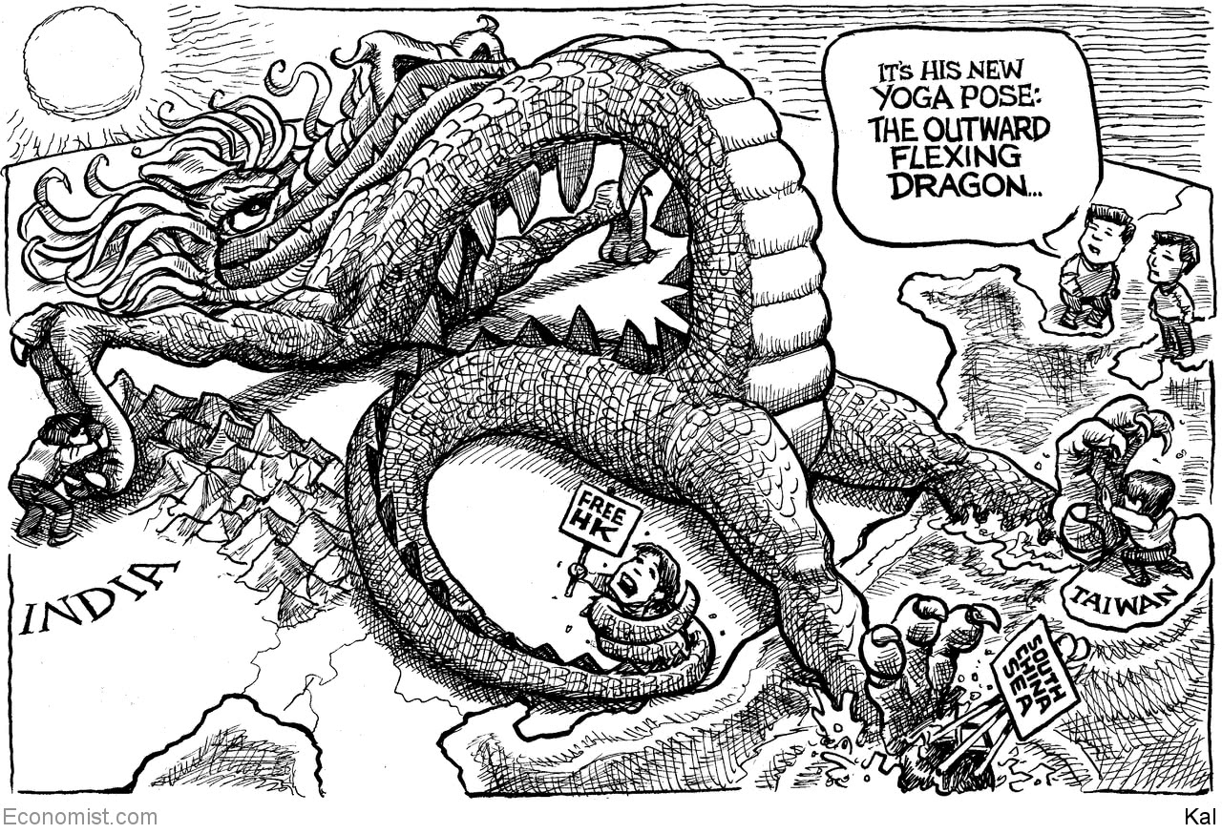

This article was downloaded by calibre from <https://www.economist.com/the-world-this-week/2020/06/20/kals-cartoon>

|  |  |  |  |
| --- | --- | --- | --- |
| Previous | Articles | Sections | Next |

|  |  |  |
| --- | --- | --- |
| The world this week | Sections | Letters |

Leaders

The pandemic: Not Britain’s finest hour

.

Geopolitics: The new world disorder

.

India and China: Elephant v dragon

.

Climate change and investing: The trouble with green finance

.

Global trade: Invisible hands

.

Jeff Bezos: The genius of Amazon

.

|  |  |  |
| --- | --- | --- |
| The world this week | Sections | Letters |

|  |  |  |  |
| --- | --- | --- | --- |
|  | Articles | Sections | Next |

#### Politics and the pandemic

# Britain has the wrong government for the covid crisis

It has played a bad hand badly

Jun 18th 2020 |

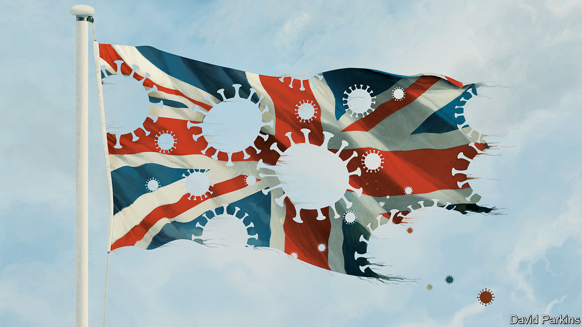

THERE WAS a lot going on in Britain in early March. London staged an England-Wales rugby match on March 7th, which the prime minister attended along with a crowd of 81,000; on March 11th Liverpool played Atletico Madrid, in front of a crowd of 52,000 fans, including 3,000 from Spain; 252,000 punters went to the Cheltenham Festival, one of the country’s poshest steeplechase meetings, which ended on March 13th.

As Britons were getting together to amuse themselves and infect each other, Europe was shutting down. Borders were closing, public gatherings being banned. Italy went into full lockdown on March 9th, Denmark on March 11th, Spain on March 14th and France on March 17th. Britain followed only on March 23rd.

Putting in place sweeping restrictions on everyday life was a difficult decision, fraught with uncertainty. Yet the delay is just one example of the government’s tardiness. Britain has been slow to increase testing, identify a contact-tracing app, stop visits to care homes, ban big public events, provide its health workers with personal protective equipment (PPE), and require people to wear face coverings on public transport. As this wave of the disease ebbs, Britons are wondering how they came to have the highest overall death rate of any country in the rich world, and why leaving lockdown is proving so difficult.

The evidence so far suggests that the British government played a bad hand badly. The country was always going to struggle. The virus took off in London, an international hub. Britain has a high proportion of ethnic-minority people, who are especially vulnerable to the disease. And Britons are somewhat overweight, which exacerbates the impact of the infection.

Britain has got some things right. Its researchers have been in the forefront of the race to find drugs and create vaccines against the disease. On June 16th a trial by Oxford University, the first to identify a life-saving medicine, showed that a cheap steroid can reduce mortality among the sickest patients by a third. A swift reorganisation of the National Health Service put paid to fears that it would be overwhelmed. But the government has wasted the most precious commodity in a crisis: time. In a federal system, like America’s, the central government’s failings can be mitigated by state and local authorities. In a centralised system, they cannot.

Hindsight is a fine thing, and offers a clarity that is absent in the blizzard of events. Yet it is now plain that Britain’s scientists initially argued for the wrong approach: accepting that the disease would spread through the population, while protecting the vulnerable and the health service. Neil Ferguson, an epidemiologist at Imperial College London, estimates that had Britain locked down a week earlier, at least half of the 50,000-or-so lives that have been lost would have been saved. This is more Britons than have died in any event since the second world war.

In retrospect, the government should have probed the scientists’ advice more deeply. Some of it was questionable. The received wisdom that people would tire of social distancing, and that shutting down early would mean loosening early too, was just a hunch. Even after the evidence changed, and it became clear the country was heading for catastrophe, the government was slow to impose the sort of lockdown seen across Europe.

Yet you do not need hindsight to identify other mistakes. Delays in fixing PPE supply chains, promoting face coverings and increasing testing capacity were clearly errors at the time. Despite the urging of the country’s scientists and the World Health Organisation, by the middle of April Britain was still carrying out just 12,000 tests a day, compared with 44,000 in Italy and 51,000 in Germany. Because most testing was reserved for hospitals, care homes struggled to find out which of their residents and staff were infected. Competition for PPE was fierce, so they also struggled to get the kit they needed to protect their workers.

The government is not solely to blame. The pandemic made new demands on the system. Some crucial bits of machinery did not work. The publicly owned company which supplies the health service with PPE failed. Public Health England, which was responsible for testing and tracing, failed. But there was a failure of leadership, too. When systems break it is the government’s job to mend them; when the evidence argues for drastic measures ministers need to take them.

Britain is still living with the consequences. The spread of the virus and the devastation it has wrought have made leaving lockdown difficult, as shown by the halting return of pupils to school. Only five year-groups have gone back, many parents are choosing to keep their children at home, and the government has abandoned an earlier ambition to get more in. The “world-beating” contact-tracing system still lacks its app, which is not due to arrive until winter. Slow progress at suppressing the virus will have grave economic consequences, too.

These shortcomings have claimed many victims. Among them is public trust. Britain went into this crisis with a powerful sense of unity and goodwill towards the government. Now Britons think worse of their government’s performance during the crisis than do the citizens of any of 22 countries polled by YouGov, aside from Mexico. That reflects the government’s mistakes and its hypocrisy, after the prime minister’s main adviser broke its own rules about when to travel—and kept his job. While the world waits for a vaccine this lack of trust will make managing the disease a lot harder.

The painful conclusion is that Britain has the wrong sort of government for a pandemic—and, in Boris Johnson, the wrong sort of prime minister. Elected in December with the slogan of “Get Brexit Done”, he did not pay covid-19 enough attention. Ministers were chosen on ideological grounds; talented candidates with the wrong views were left out in the cold. Mr Johnson got the top job because he is a brilliant campaigner and a charismatic entertainer with whom the Conservative Party fell in love. Beating the coronavirus calls for attention to detail, consistency and implementation, but they are not his forte.

The pandemic has many lessons for the government, which the inevitable public inquiry will surely clarify. Here is one for voters: when choosing a person or party to vote for, do not underestimate the importance of ordinary, decent competence. ■

This article was downloaded by calibre from <https://www.economist.com/leaders/2020/06/18/britain-has-the-wrong-government-for-the-covid-crisis>

|  |  |  |  |
| --- | --- | --- | --- |
|  | Articles | Sections | Next |

|  |  |  |  |
| --- | --- | --- | --- |
| Previous | Articles | Sections | Next |

#### Geopolitics

# The new world disorder

If America pulls back from global institutions, other powers must step forward

Jun 18th 2020 |

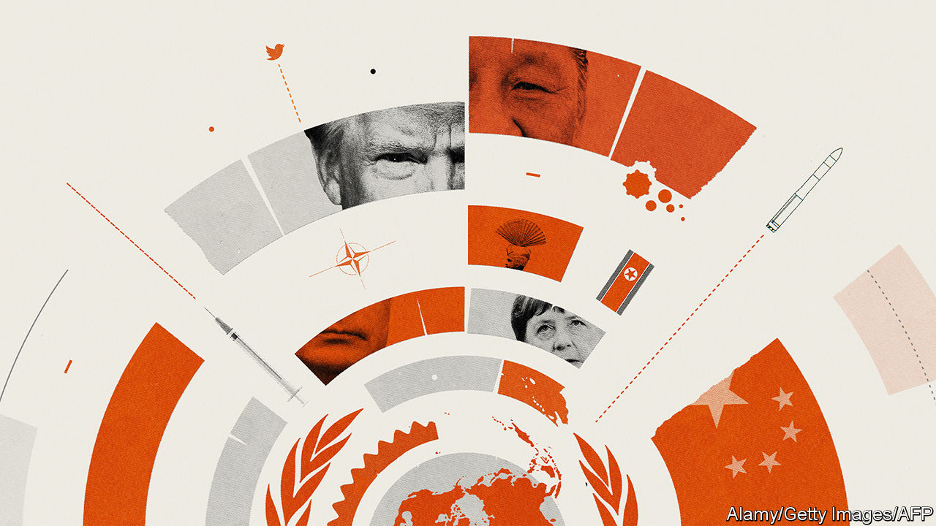

SEVENTY-FIVE years ago in San Francisco 50 countries signed the charter that created the United Nations—they left a blank space for Poland, which became the 51st founding member a few months later. In some ways the UN has exceeded expectations. Unlike the League of Nations, set up after the first world war, it has survived. Thanks largely to decolonisation, its membership has grown to 193. There has been no third world war.

And yet the UN is struggling, as are many of the structures, like the World Trade Organisation (WTO) and the Nuclear Non-Proliferation Treaty (NPT), designed to help create order out of chaos. This system, with the UN at its apex, is beset by internal problems, by the global struggle to cope with the rise of China, and most of all by the neglect—antipathy even—of the country that was its chief architect and sponsor, the United States.

The threat to the global order weighs on everyone, including America. But if the United States pulls back, then everyone must step forward, and none more so than the middling powers like Japan and Germany, and the rising ones like India and Indonesia, which have all become accustomed to America doing the heavy lifting. If they hesitate, they will risk a great unravelling—much like the nightmare in the 1920s and 1930s that first impelled the allies to create the UN and its siblings.

The UN is bureaucratic and infuriating. Its agencies fall prey to showboating and hypocrisy, as when despots on its Human Rights Council censure Israel yet again. The Security Council gives vetoes to Britain and France, much diminished powers since 1945, but no permanent membership to Japan, India, Brazil, Germany or any African country. Alas, it looks virtually unreformable.

Nonetheless, the global order is worth saving. As Dag Hammarskjold, a celebrated secretary-general, said, the UN “was not created to take mankind to heaven, but to save humanity from hell.” Our special report this week explains how the UN does that essential job, as do many other multilateral institutions. Its peacekeepers protect 125m people on a budget only a bit bigger than New York City Police Department’s. It says it is helping provide life-saving assistance to 103m. For all the Security Council’s flaws, it would be missed.

That is because, left to themselves, countries drift into antagonism. Witness the fatal clash of Indian and Chinese forces this week over a border dispute both sides are too proud to defuse (see article). Multilateral endeavours like the UN, NATO and the NPT cannot ensure peace, but they do make war less likely and more limited. France and its allies are helping contain the conflict spreading across the Sahel.

Without a multilateral effort, old problems are likely to deepen—even Syria, after nine bloody years, will one day be ready for the UN envoy’s plans for peace. Meanwhile new problems are more likely to go unsolved. The pandemic is an example. The virus not only calls for global solutions, like treatments and vaccines, but it also aggravates local insecurity (see article). It is the same with climate change and organised crime.

Protecting the system from the forces of disorder is easier said than done. One threat is antagonism between America and China, which could create gridlock in global bodies, exacerbated by competing parallel financial and security arrangements. Another is that America may continue its careless treatment of multilateral institutions—especially if President Donald Trump behaves as badly in a second term as a devastating new book by John Bolton, his former national security adviser, says he has in his first (see article). Mr Trump has undermined the World Health Organisation and the WTO, and this month said that he would pull out a third of the American troops stationed in Germany, enfeebling NATO and limiting America’s scope to project power from Europe into Africa.

Happily, the world has not yet reached the point of no return. For decades the middling powers have depended on America for the system’s routine maintenance. Today they need to take on more of the work themselves. France and Germany have created an alliance for multilateralism, an initiative that is open to other countries. Another idea is for nine democracies, including Japan, Germany, Australia and Canada, which together generate a third of world GDP, to form a “committee to save the world order”.

Although America is dominant, other countries can still get things done—with or without help from the White House. Sometimes the aim is to bind in America. After a chemical-weapons attack on Sergei Skripal, a Russian ex-spy living in Britain, Western countries’ imposition of sanctions on the Kremlin swept up America, too. The Quad is an emerging coalition between India, Australia, Japan and America, which are all alarmed at Chinese expansion, including in the South China Sea (see article).

Sometimes, however, the world must work without America even if that is second-best. After Mr Trump walked away from the Trans-Pacific Partnership, a huge trade deal, the other members went ahead on their own. Stymied at the WTO, countries are instead forming regional and bilateral trade arrangements, such as one between Japan and the European Union and another between 28 countries in Africa.

Defending the international order is necessary, too. China’s stature is growing along with its contributions—it now pays 12% of the UN budget compared with 1% in 2000. Its diplomats head four of the UN’s 15 specialised agencies, and America just one. If other countries do not act, the system will come to reflect China’s expansive views of national sovereignty and resistance to intervention, even in the face of gross human-rights violations.

Some think the job of middling powers is triage, to keep the system going until America returns to the party under a different president. It is more than that. Although polls suggest that most Americans would like to play a bigger global role, there is no going back to the “unipolar moment” after the Soviet collapse, when America ran the show singled-handed. Not only did that provoke a backlash abroad, exploited by Russia and China, but it also stirred up resentment at home.

At the time, President Barack Obama responded by asking like-minded countries to help America make the world safe. They shrugged. They must not make the same mistake again. ■

This article was downloaded by calibre from <https://www.economist.com/leaders/2020/06/18/the-new-world-disorder>

|  |  |  |  |
| --- | --- | --- | --- |
| Previous | Articles | Sections | Next |

|  |  |  |  |
| --- | --- | --- | --- |
| Previous | Articles | Sections | Next |

#### Elephant v dragon

# How to end the perilous Indo-Chinese border spat

To avoid escalation, both sides should agree on the “Line of Actual Control”

Jun 18th 2020 |

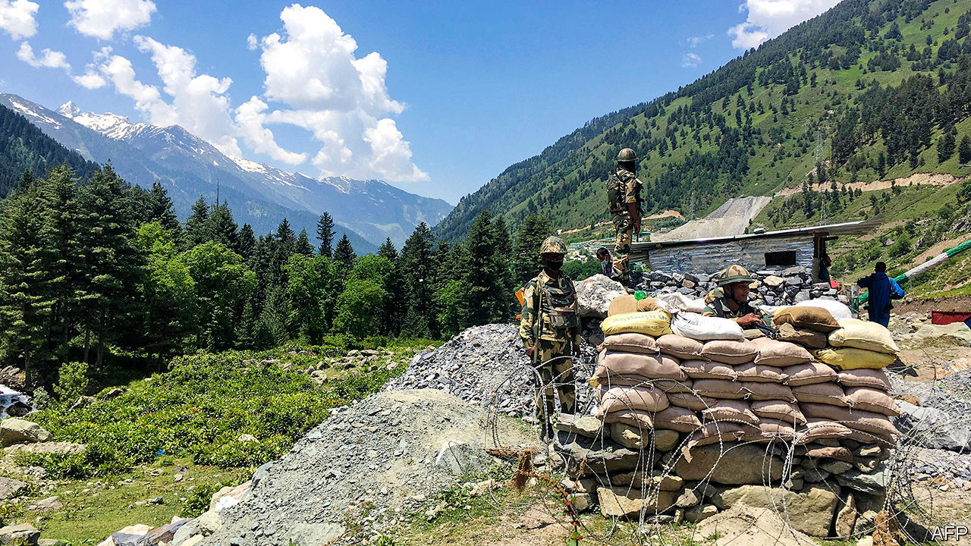

IN THE ANCIENT Chinese game of Go, clever players ignore little battles in favour of strategic plays. Leaving local disputes unresolved means that later, when the game tightens and the enemy is off-guard, you can snatch prizes at lower cost. In the 69 years since China truly became India’s neighbour by grabbing Tibet, the world’s two most populous countries have played a similar game. Even as their leaders summited and trade thrived, the Asian giants left a mess of territorial disputes to fester.

Mostly these claims, over some 130,000 square kilometres on either side of their 3,488km-long border, have not mattered much. Despite a Chinese “lesson-teaching” invasion in 1962, rare armed skirmishes and less rare fisticuffs between patrols, the border zone has remained relatively calm. Much of it is too rugged and empty to fight over. So long as neither side shifts the status quo, what difference does it make if there are no proper markers on long stretches of border, but instead just a fuzzy “Line of Actual Control”?

A brutal clash on June 15th provided a loud and ugly answer (see article). Details remain sketchy. At least 20 Indian soldiers died, many after tumbling into an icy river. India says the Chinese also suffered casualties. China says little (see article). The death toll is the worst in any clash between the two since 1967, and the first loss of life since 1975.

Even worse, the skirmish cannot be explained away as an isolated incident. This spring China deployed far heavier forces than usual. It has pushed them forward not at one point but at many, say Indian sources, in effect seizing as much as 60 square kilometres of land that India views as lying on its own side of the line. A particular concern is China’s westward extension along the Galwan river, threatening a strategic road that runs parallel to the border and forms the main link to India’s northernmost outposts. Not surprisingly, this is where the deadly clash erupted.

Why would China change the status quo, angering a big nuclear-armed trading partner? Because, say Indian cynics, India is distracted just now by a swelling pandemic and shrinking economy, and saddled with a government better at chest-thumping than at strengthening its army or building alliances. Nonsense, say India’s critics. It is India that has changed the status quo, quietly expanding infrastructure in contested regions even as, after stripping its part of Kashmir of statehood last August, its leaders boasted of soon “regaining” other parts, including a chunk that Pakistan gave to China in 1963.

China may also see an interest in teaching India that, should it continue to flirt with closer ties to America, it will pay a price. To their credit, officials on both sides have avoided whipping up popular anger, stressing instead the importance of implementing an earlier deal to pull forces back. Such gentlemen’s agreements have calmed tempers in previous clashes.

Yet whatever the efficacy of generals meeting in windblown tents, it is a reckless way to fix problems between two rising nuclear powers that are home to a third of humanity. India has previously suggested that, as a second-best to a formal agreement over where the border lies, the two sides should at least present maps showing their view of where the line of control runs in practice. China, perhaps thinking itself the more astute Go player, has always refused to do so. This allows it to claim that any Indian move is a violation of its own understanding.

It is time to stop playing games. China looks stronger just now but India, if pushed, will find ways to cause it pain. And the last thing the wider world needs is an escalating slugfest between a dragon and an elephant over a lofty patch of frozen earth.■

This article was downloaded by calibre from <https://www.economist.com/leaders/2020/06/18/how-to-end-the-perilous-indo-chinese-border-spat>

|  |  |  |  |
| --- | --- | --- | --- |
| Previous | Articles | Sections | Next |

|  |  |  |  |
| --- | --- | --- | --- |
| Previous | Articles | Sections | Next |

#### The trouble with climate finance

# Green investing has shortcomings

The financial system and climate change

Jun 18th 2020 |



THE FINANCIAL industry reflects society, but it can change society, too. One question is the role it might play in decarbonising the economy. Judged by today’s fundraising bonanza and the solemn pronouncements by institutional investors, bankers and regulators, you might think that the industry is about to save the planet. Some 500 environmental, social and governance (ESG) funds were launched last year, and many asset managers say they will force companies to cut their emissions and finance new projects. Yet, as we report this week (see [article](https://www.economist.com/node/21788179)), green finance suffers from woolly thinking, marketing guff and bad data. Finance does have a crucial role in fighting climate change but a far more rigorous approach is needed, and soon.

One of the shortcomings of green finance might be called “materiality”. Some fee-hungry fund managers make hyperbolic claims about their influence, even as big-business bashers pin most of the blame for pollution on companies. The reality is more prosaic. Fund managers have some influence over a big slice of the economy, but many emissions occur outside the firms they control. Estimates by The Economist suggest that publicly listed firms, excluding state-controlled ones, account for 14-32% of the world’s total emissions, depending on the measure you use. Global fund managers cannot directly influence the bosses of state-controlled Chinese coal-fired power plants or Middle Eastern oil and gas producers.

Some European bank regulators hope to cut emissions indirectly, by imposing climate-stress tests on lenders and insurers that penalise their exposures to dirty or vulnerable projects. But the evidence so far suggests that this will not make much difference (assuming there is no change in rules on carbon emissions). The effect on these firms’ solvency is small, because only a fraction of their assets are invested in fossil fuels or in projects whose value is sensitive to physical risks, such as flooding, after being discounted over 10-15 years. Meanwhile, despite all the fundraising, the sums being invested in renewable energy and infrastructure are only about half what would be needed to keep temperatures within 2°C of pre-industrial levels.

Another problem is measurement. Ideally, a fund manager with a portfolio, or a bank boss with a loan book, could gauge its total net carbon footprint, including the supply chains companies use and the emissions their products release—and do so without double-counting. That way you could objectively track both its carbon and financial performance and compare one portfolio with another. Unfortunately, corporate disclosure is so bad that this is impossible, at least for now. Instead, fund managers resort to using dubious ESG ratings, created by external advisers, that make subprime credit scores look like the gospel truth. Their opaque methodologies bamboozle clients and bosses. Indices and portfolios which claim to be climate-friendly often contain the securities of firms that are big polluters.

The final problem is motivation. Suppose shareholders can influence a firm and measure its emissions properly. Even then they may not have a strong financial incentive either to force it to shut down its lucrative oilfields, say, or to increase its investment in experimental energy and costly electrical grids. That is because the externalities of greenhouse-gas emissions are not accurately priced into the cost of energy. Dedicated green investors might still call for climate-friendly decisions, but they might not carry enough weight to determine how firms behave.

What to do? Governments need to force firms to improve their disclosure. Asset managers need to drop the gimmicks and set coherent and measurable objectives. Most important, widespread carbon taxes would unlock the power of finance, giving investors and banks a strong motive to shift capital away from dirty industries to clean ones and to develop instruments that allow firms to hedge and trade the price of carbon. Climate finance is still in its infancy. There is a lot of room for improvement.■

This article was downloaded by calibre from <https://www.economist.com/leaders/2020/06/18/green-investing-has-shortcomings>

|  |  |  |  |
| --- | --- | --- | --- |
| Previous | Articles | Sections | Next |

|  |  |  |  |
| --- | --- | --- | --- |
| Previous | Articles | Sections | Next |

#### Sailors are stranded at sea

# Cargo ship crews are stuck at sea

A crewing crisis

Jun 20th 2020 |

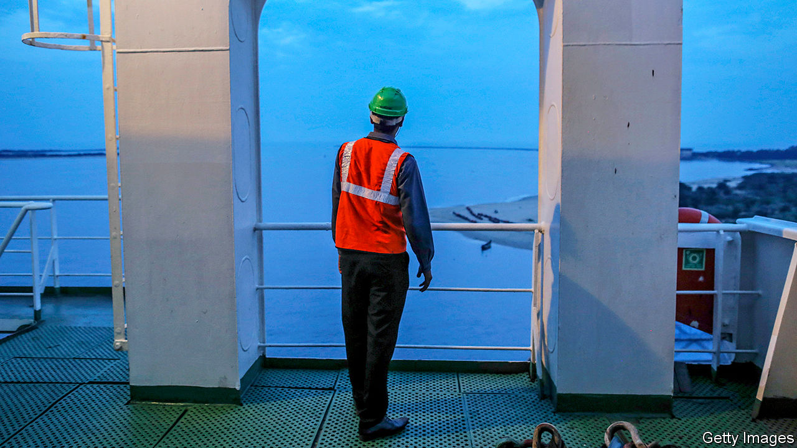

AS YOU READ this, over 60,000 cargo ships are on the high seas, laden with iPhones from China, dresses from Bangladesh, beef from Argentina, oil from the Gulf and much, much more. The industry likes to say that it is responsible for “90% of everything”. Indeed, its ships are the circulatory system of global commerce and their 1.2m merchant seamen its lifeblood. They enable nations to turn their comparative advantage into wealth. If they were to stop, much of humanity would soon begin to starve or freeze.

Throughout the covid-19 pandemic merchant seamen have kept working (see article). But they have been stuck on board. In a normal week around 50,000 finish their contracts and are relieved. The virus has cut that number to almost nothing. Over 250,000 mariners are stranded at sea, even though they are at least a month past the end of contracts that typically last three to nine months. Each day that total rises, and an essential job starts to look more like indentured labour.

Most merchant seamen are from developing countries, in particular India, Indonesia and the Philippines. They start and end their contracts in whatever port a shipping schedule stipulates. The ship-management firms that organise rosters and contracts for shipowners fly them out and back again. But most commercial flights have been grounded for months. Managers would have used charter planes, but many countries are refusing entry to non-citizens. Some are turning citizens away, too. Sailors are forbidden to disembark, and their reliefs are barred from entry.

The situation is unjust to sailors both on board and onshore. The first lot do not know when they will see their families again; the second do not know when they will next be able to earn a wage. It is also dangerous. Fatigue makes it hard to concentrate, and cargo ships are high-pressure, high-risk places. Forcing sailors to work endlessly is a recipe for accidents.

In the pandemic’s early days, governments could perhaps have been forgiven for their neglect. There was much else to worry about. But their confinement has dragged on and sailors now have every right to feel bitter. After being locked down for months, seeing nobody but the odd pilot or port official, they are some of the world’s least likely virus-spreaders. They know that they are being ignored simply because they can be. Lorry-drivers, whose goods cannot cross borders without them, were quickly classed as essential workers. Sailors, unfortunately for them, can stay on board while their cargoes are loaded and unloaded.

On June 16th an industry-wide agreement allowing emergency extensions to labour contracts expired. Unless crew-changes restart, insurance contracts could lapse—a headache for the entire industry.

But it is governments, not shipowners and managers, who must solve the problem. Last month the International Maritime Organisation, an arm of the UN, published a protocol for safe crew-changes in the pandemic. Almost no country has yet got round to implementing it. The most important step is to classify merchant seamen as essential workers, thus enabling them to cross borders and travel to and from ports during lockdowns. Ports and airports need holding facilities and accommodation for testing and quarantine for sailors. In ordinary times, all this might seem onerous. But the covid-19 world is one where hairdressers sterilise their scissors between cuts and offices allocate desks on a rota to maintain social distancing. Shipping needs to adapt to these new realities, too.

Global trade’s invisible hands must not be forgotten. When their work is done, they deserve to go home. ■

This article was downloaded by calibre from <https://www.economist.com/leaders/2020/06/20/cargo-ship-crews-are-stuck-at-sea>

|  |  |  |  |
| --- | --- | --- | --- |
| Previous | Articles | Sections | Next |

|  |  |  |  |
| --- | --- | --- | --- |
| Previous | Articles | Sections | Next |

#### The genius of Amazon

# The pandemic has shown that Amazon is essential—but vulnerable

Jeff Bezos's vision of a world shopping online is coming true faster than ever. But the job of running Amazon hasn’t got any easier

Jun 18th 2020 |

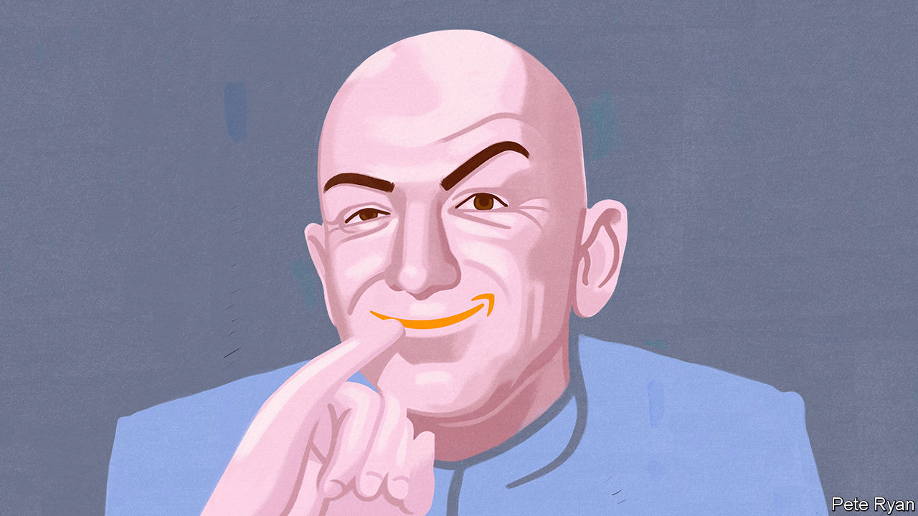

IN THE SUMMER of 1995 Jeff Bezos was a skinny obsessive working in a basement alongside his wife, packing paperbacks into boxes. Today, 25 years on, he is perhaps the 21st century’s most important tycoon: a muscle-ripped divorcé who finances space missions and newspapers for fun, and who receives adulation from Warren Buffett and abuse from Donald Trump. Amazon, his firm, is no longer just a bookseller but a digital conglomerate worth $1.3trn that consumers love, politicians love to hate, and investors and rivals have learned never to bet against. Now the pandemic has fuelled a digital surge that shows how important Amazon is to ordinary life in America and Europe, because of its crucial role in e-commerce, logistics and cloud computing (see article). In response to the crisis, Mr Bezos has put aside his side-hustles and returned to day-to-day management. Superficially it could not be a better time, but the world’s fourth-most-valuable firm faces problems: a fraying social contract, financial bloating and re-energised competition.

The digital surge began with online “pantry-loading” as consumers bulk-ordered toilet rolls and pasta. Amazon’s first-quarter sales rose by 26% year on year. When stimulus cheques arrived in mid-April Americans let rip on a broader range of goods. Two rivals, eBay and Costco, say online activity accelerated in May. There has been a scramble to meet demand, with Mr Bezos doing daily inventory checks once again. Amazon has hired 175,000 staff, equipped its people with 34m gloves, and leased 12 new cargo aircraft, bringing its fleet to 82. Undergirding the e-commerce surge is an infrastructure of cloud computing and payments systems. Amazon owns a chunk of that, too, through AWS, its cloud arm, which saw first-quarter sales rise by 33%.

One question is whether the digital surge will subside. Shops are reopening, even if customers have to pay at tills shielded by Perspex. Yet the signs are that some of the boom will last, because it has involved not just the same people doing more of the same. A new cohort has taken to shopping online. In America “silver” customers in their 60s have set up digital-payment accounts. Many physical retailers have suffered fatal damage. Dozens have defaulted or are on the brink, including J Crew and Neiman Marcus. In the past year the shares of warehousing firms, which thrive on e-commerce, have outperformed those of shopping-mall landlords by 48 percentage points.

All this might appear to fit the script Mr Bezos has written over the years in his letters to shareholders, which are now pored over by investors as meticulously as those of Mr Buffett. He argues that Amazon is in a perpetual virtuous circle in which it spends money to win market share and expands into adjacent industries. From books it leapt to e-commerce, then opened its cloud and logistics arms to third-party retailers, making them vast new businesses in their own right. Customers are kept loyal by perks such as Prime, a subscription service, and Alexa, a voice-assistant. By this account, the new digital surge confirms Amazon’s inexorable rise. That is the view on Wall Street, where Amazon’s shares reached an all-time high on June 17th.

Yet from his ranch in west Texas, Mr Bezos has to wrestle with those tricky problems. Start with the fraying social contract. Some common criticisms of Amazon are simply misguided. Unlike, say, Google in search, it is not a monopoly. Last year Amazon had a 40% share of American e-commerce and 6% of all retail sales. There is little evidence that it kills jobs. Studies of the “Amazon effect” suggest that new warehouse and delivery jobs offset the decline in shop assistants, and the firm’s minimum hourly wage of $15 in America is above the median for the retail trade.

But Amazon’s strategy does imply huge creative disruption in the jobs market even as the economy reels. In addition, viral outbreaks at its warehouses have reignited fears about working conditions: 13 American state attorneys-general have voiced concern. And Amazon’s role as a digital jack-of-all-trades creates conflicts of interest. Does its platform, for example, treat third-party sellers on equal terms with its own products? Congress and the EU are investigating this. And how comfortable should other firms be about giving their sensitive data to AWS given that it is part of a larger conglomerate which competes with them?

Amazon’s second problem is bloating. As Mr Bezos has expanded into industry after industry, his firm has gone from being asset-light to having a balance-sheet heavier than a Soviet tractor factory. Today it has $104bn of plant, including leased assets, not far off the $119bn of its old-economy rival, Walmart. As a result, returns excluding AWS are puny and the pandemic is squeezing margins in e-commerce further. Mr Bezos says the firm can become more than the sum of its parts by harvesting data and selling ads and subscriptions. So far investors have taken this on trust. But the weak e-commerce margins make it harder for Amazon to spin off AWS. This would get regulators off its back and liberate AWS, but would deprive Amazon of the money-machine that funds everything else.

Mr Bezos’s last worry is competition. He has long said that he watches customers, not competitors, but he must have noticed how his rivals have been energised by the pandemic. Digital sales at Walmart, Target and Costco probably doubled or more in April, year on year. Independent digital firms are thriving. If you create a stockmarket clone of Amazon lookalikes, including Shopify, Netflix and UPS, it has outperformed Amazon this year. In much of the world regional competitors rule, not Amazon; among them are MercadoLibre in Latin America, Jio in India and Shopee in South-East Asia. China is dominated by Alibaba, JD.com and brash new contenders like Pinduoduo.

## Imitation is the sincerest form of capitalism

The world’s most admired business is thus left having to solve several puzzles. If Amazon raises wages to placate politicians in a populist era, it will lose its low-cost edge. If it spins off AWS to please regulators, the rump will be financially fragile. And if it raises prices to satisfy shareholders its new competitors will win market share. Twenty-five years on, Mr Bezos’s vision of a world that shops, watches and reads online is coming true faster than ever. But the job of running Amazon has become no easier, even if it no longer involves packing boxes.■

This article was downloaded by calibre from <https://www.economist.com/leaders/2020/06/18/the-pandemic-has-shown-that-amazon-is-essential-but-vulnerable>

|  |  |  |  |
| --- | --- | --- | --- |
| Previous | Articles | Sections | Next |

|  |  |  |
| --- | --- | --- |
| Leaders | Sections | Briefing |

Letters

Letters to the editor: On prosecutors, the media, mercenaries, Greek, carbon pricing, the Bible, Andrew Johnson

.

|  |  |  |
| --- | --- | --- |
| Leaders | Sections | Briefing |

|  |  |  |  |
| --- | --- | --- | --- |
|  | Articles | Sections | Next |

#### On prosecutors, the media, mercenaries, Greek, carbon pricing, the Bible, Andrew Johnson

# Letters to the editor

A selection of correspondence

Jun 20th 2020 |

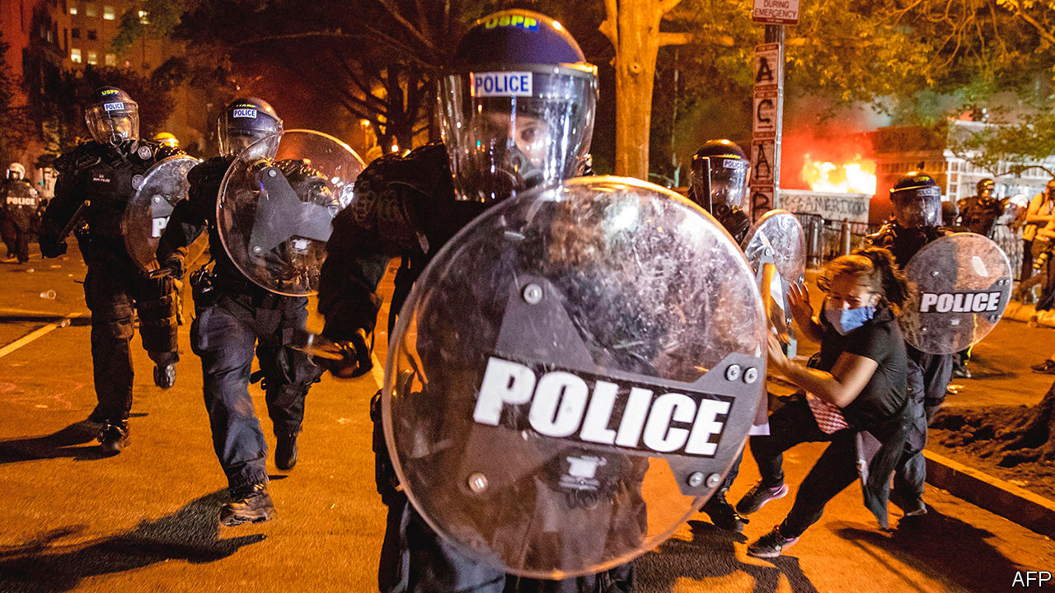

## In defence of prosecutors

As a former prosecutor, with more than a decade of experience in Miami, I take issue with your statement alleging that prosecutors are not inclined to bring charges against police because we’d rather secure convictions to advance our careers (“[Order above the law](https://www.economist.com/united-states/2020/06/04/how-to-fix-american-policing)”, June 6th). The “elaborate culture” described in your article of turning a blind-eye to police misconduct is an academic chimera. I have never met a prosecutor who engaged in that kind of unethical calculus and am confident that it would not have been tolerated by our fellow prosecutors or our managers. That being said, I’m sure that racism exists at all levels of government. But speciously suggesting that there is an unspoken quid pro quo between police and prosecutors is false and does nothing to advance the rights of victims of police brutality.

J.P. NIXON  
Westport, Connecticut

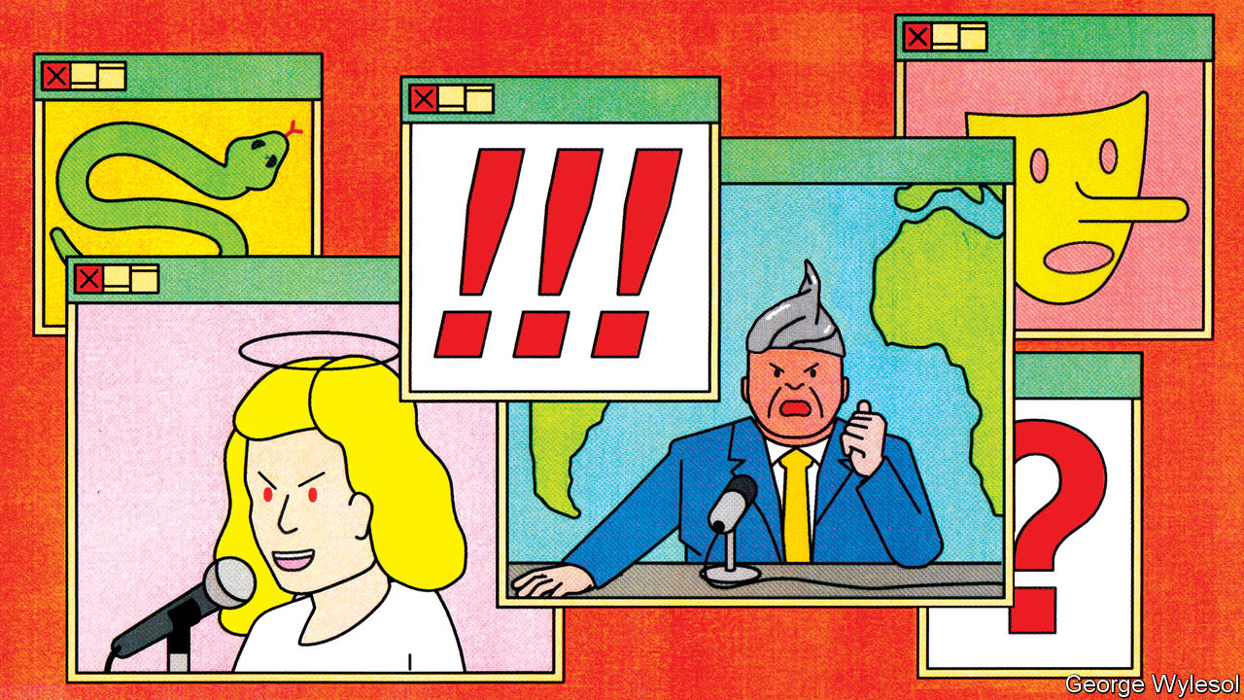

## One rule for some

There is another reason for the popularity of fake news on the political right (“[Return of the paranoid style](https://www.economist.com/international/2020/06/03/fake-news-is-fooling-more-conservatives-than-liberals-why)”, June 6th). It is the double standards found in most of the media’s reporting. This conservative complaint is not entirely a myth. Take covid-19. Widespread demonstrations in early May by right-wing anti-lockdown protesters were depicted by the media as selfish and menacing acts that would result in the virus being spread. Yet the protests that erupted over George Floyd’s horrific death just a few weeks later were praised by the same media. The same Democratic governors who supported lockdown and prevented businesses from reopening even participated in the marches.

One group of experts on infectious diseases, whom I presume supported the lockdowns, penned a letter with over 1,200 signatures stating that the protests were necessary to fight “white supremacy”. It is hard to imagine that these experts would support street demonstrations by conservatives in the middle of a pandemic. Commentators on the right had a field day pointing out the hypocrisy. A politicised scientific and medical community is deeply worrying because it boosts the argument on the far right that supposedly unbiased science and scholarship are a sham.

ARVIN BAHL  
New York

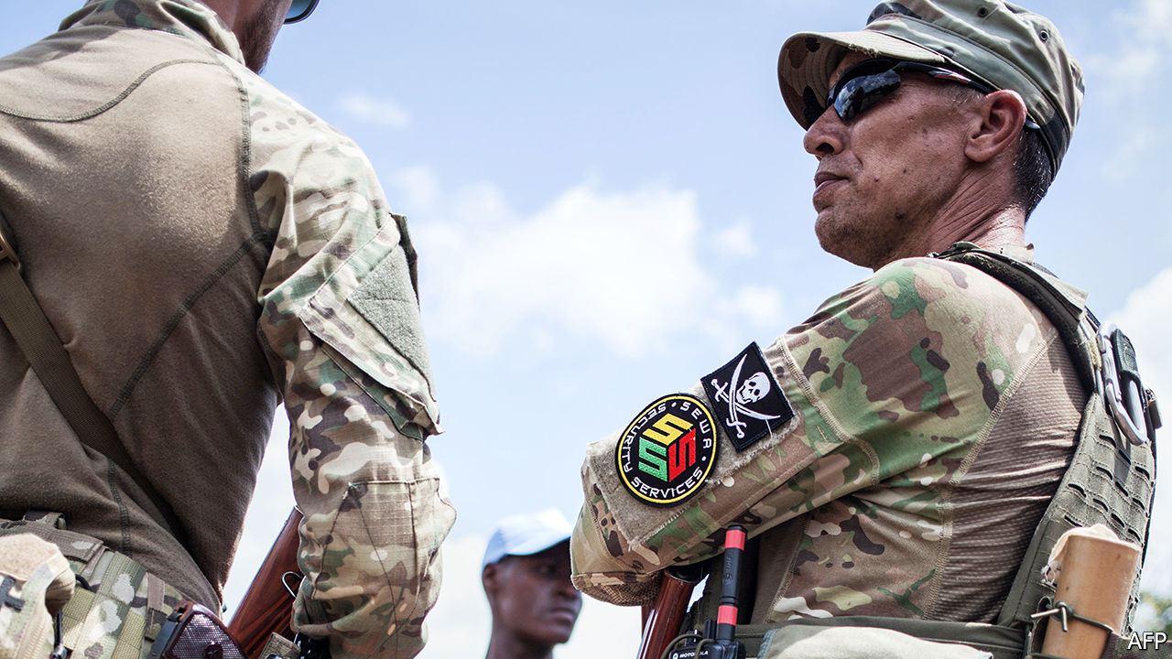

## Soldiers for hire

The trend in Africa towards using mercenaries, who work for private military companies, has been observed elsewhere (“[Are mercenaries no longer taboo?](https://www.economist.com/middle-east-and-africa/2020/05/28/why-african-governments-still-hire-mercenaries)”, May 30th). Left unabated, the privatisation of warfare will increase the risk of human-rights abuses and worsen humanitarian problems, especially where conflict persists and governance is weak.

This is why governments, civil-society organisations and private-security companies set up the International Code of Conduct Association for private security-service providers, based in Geneva. All those who use private contractors for legitimate security purposes, including governments, businesses, international organisations and NGOs, should exercise greater responsibility and due diligence. The UN now requires its own private-security providers to be members of the association, opening up their operations to continual monitoring and oversight by it. Nevertheless, more must be done to reel in rogue private contractors and to strengthen accountability.

JAMIE WILLIAMSON  
International Code of Conduct Association  
Geneva

The rise of mercenaries in the 21st century is indeed a striking, if not worrying, phenomenon. However, the term “mercenary” may be misleading because it refers to soldiers who serve any state for pay, as A.E. Housman famously put it in verse. Yet most contracted soldiers are actually employed by their own government, in whose armed forces they have served, or by its local allies. In each case, they are advancing national policy. These mercenaries might be better defined as privatised state forces, rather than dogs of war. They are closer to Francis Drake than John Hawkwood.

ANTHONY KING  
Chair of war studies  
Warwick University  
Coventry

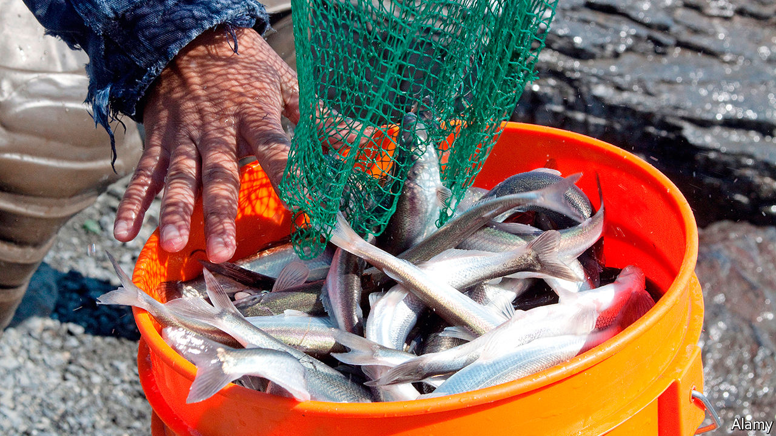

## Greek lesson

An article referred to the hooligan fish’s genus name, Thaleichthys, as Latin for rich fish (“[Alaska welcomes hooligans](https://www.economist.com/united-states/2020/06/04/in-praise-of-the-tiny-oily-candlefish)”, June 6th). The word thaleichthys does not stem from Latin but comes from ancient Greek, a merger of the words thalein (to flourish) and ichthys (fish).

HARRY CORDATOS  
Colchester, Connecticut

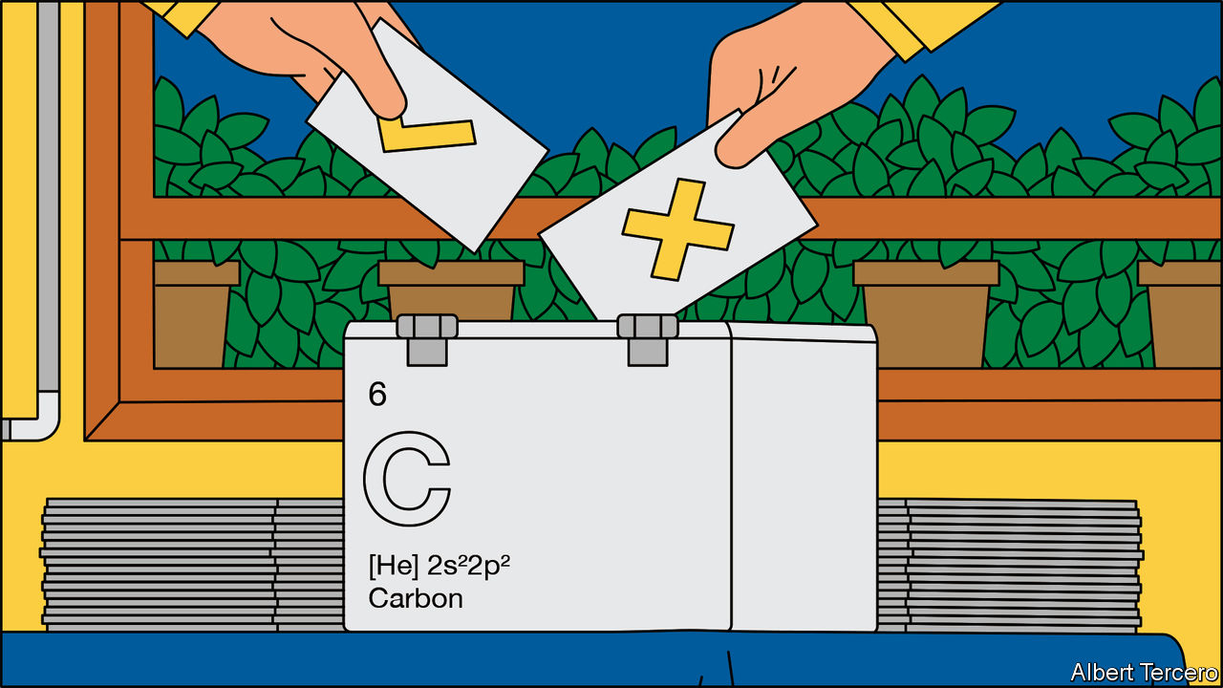

## Pricing emissions

Your briefing on carbon pricing argued that “there’s got to be something better” than border carbon adjustments, in effect tariffs on countries that are not members of the carbon-pricing scheme (“[The contentious and correct option](https://www.economist.com/briefing/2020/05/23/the-world-urgently-needs-to-expand-its-use-of-carbon-prices)”, May 23rd). But you did not propose any realistic alternatives. The European Union’s system of freely allocating emissions-trading allowances to placate concerns over carbon leakage for energy-intensive, trade-exposed industries (EITEs) is becoming unsustainable, now that the number of allowances in the EU’s carbon market must shrink to meet tighter climate goals. A global carbon market involving billions of euros in wealth transfers between Europe, America and China is Utopian.

Thus, the EU is left with two options: either introducing border adjustments or low-carbon product standards, while progressively diminishing the use of free allocation. Both are complicated, but such standards have been proven to work in other contexts, such as the Montreal protocol.

EITE products account for less than 2% of global GDP but 20% of carbon-dioxide emissions. Without a sustainable system to manage international differences in climate-policy ambition, they will not be decarbonised.

OLIVER SARTOR  
Agora Energiewende  
Berlin

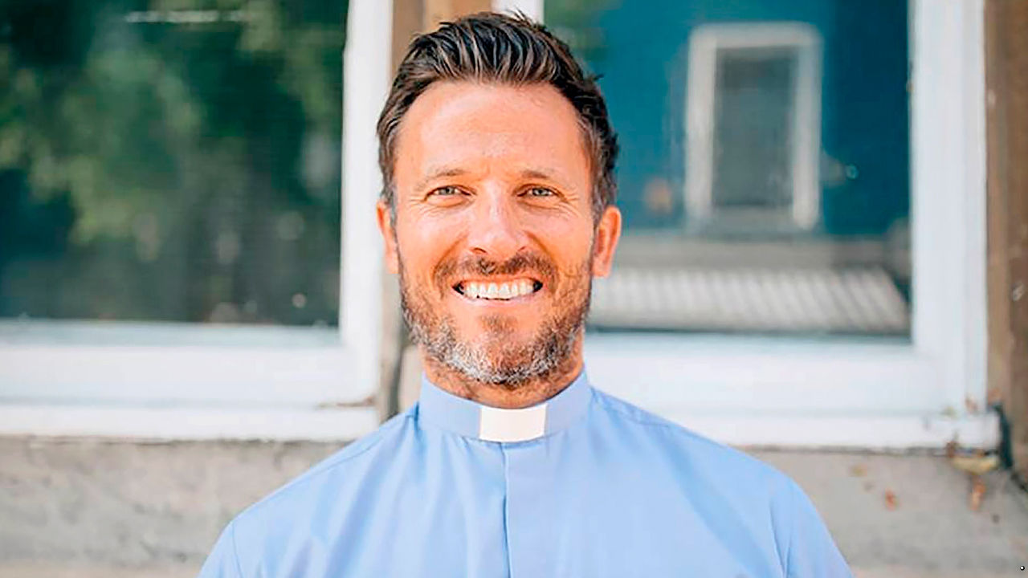

## We all stumble in many ways

It was apparently too obvious that the scriptural basis for old-fashioned Christians’ fondness for old-fashioned communal worship could only come from the Old Testament to bother checking the quote “Don’t forsake the gathering of the brethren” (“[Your own personal Jesus](https://www.economist.com/britain/2020/06/04/online-services-swell-the-church-of-englands-congregations)”, June 6th.) The reference is in fact found in the letter to the Hebrews in the New Testament. This old-fashioned priest would like respectfully to remind The Economist that the internet allows Bible references to be checked in a matter of seconds.

FR PHILIP-THOMAS EDWARDS  
London

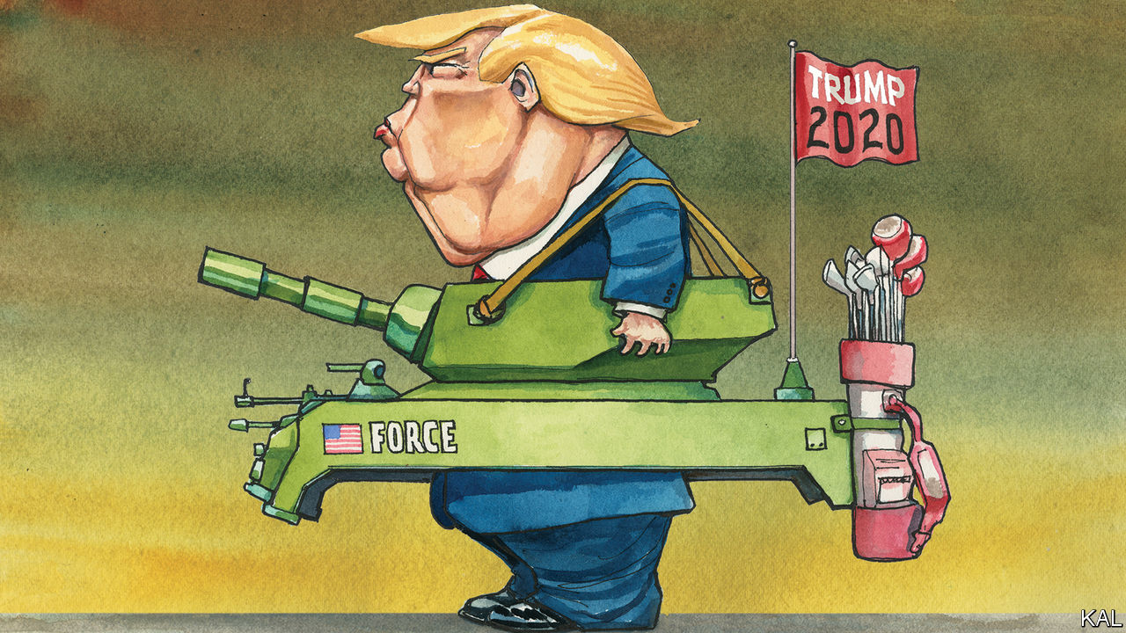

## Drunk on power

[Lexington](https://www.economist.com/united-states/2020/06/04/far-worse-than-nixon) compared Donald Trump to one of his most hapless and divisive predecessors, Andrew Johnson (June 6th). In addition to being an unreconstructed shire supremacist and notoriously thin-skinned, Johnson was one of mid-19th century Washington’s heaviest drinkers, to the point of arriving at his own vice-presidential inauguration in 1865 drunk and slurring his words.

Some of Johnson’s more erratic acts, such as comparing himself to Jesus Christ, could be chalked up to his extreme alcoholism. Trump, a life-long teetotaller, has no such excuse.

SCOTT PLATTON  
Princeton, New Jersey

This article was downloaded by calibre from <https://www.economist.com/letters/2020/06/20/letters-to-the-editor>

|  |  |  |  |
| --- | --- | --- | --- |
|  | Articles | Sections | Next |

|  |  |  |
| --- | --- | --- |
| Letters | Sections | Asia |

Briefing

Amazon: And on the second day…

.

Green investing: Hotting up

.

|  |  |  |
| --- | --- | --- |
| Letters | Sections | Asia |

|  |  |  |  |
| --- | --- | --- | --- |
|  | Articles | Sections | Next |

#### And on the second day...

# Can Amazon keep growing like a youthful startup?

Investors certainly seem to think so

Jun 18th 2020 |



NEXT MONTH Amazon will turn 9,500 days old. But for Jeff Bezos, the company’s founder and chief executive, it is always “Day 1”. Amazon, he has insisted since its founding in 1994, must forever behave like a feisty startup: innovate aggressively and expand relentlessly.

Adherence to this rule has made Amazon as convenient to consumers as it is feared by businesses which stand in its way. Today roughly $11,000-worth of goods change hands on Amazon’s e-commerce platform every second. The company delivered 3.5bn packages last year, one for every two human beings on Earth. Amazon Web Services (AWS), its cloud-computing division, enables more than 100m people to make Zoom calls during the day and a similar number to watch Netflix at night. In all, Amazon generated $280bn in revenues last year.

This year Amazon has become not just convenient, but essential. The smiling brown package left at the threshold as the neon-vested delivery worker backs swiftly away has become the hallmark of the locked-down pandemic. Shopless and officeless life would be unimaginable without deliveries and cloud-based work—and insufferable without distractions like video-streaming. Investors see this as an acceleration of a long-term trend towards life online from which the world will not turn back. “The explosive demand created by covid-19 catapults Amazon straight into 2025,” says Michael Moritz of Sequoia Capital, a venture-capital firm.

Amazon’s market capitalisation doubled to $734bn between 2016 and 2018. Since then it has close to doubled again. Its shares trade at 118 times earnings, compared with 25-35 times for Apple and Microsoft, the other members of the trillion-dollar-company club. Up and down Wall Street, brokers tell clients to hold Amazon shares if they have them, or buy them if they don’t.

But Amazon is not without problems. Rivals have emerged in both e-commerce and the cloud. Questions are being raised about its treatment of workers and independent merchants on its platform. Politicians in many capitals would like to see it broken up. So would some investors, on the basis that they would see higher returns that way. “Day 2”, which Mr Bezos characterises as “Stasis. Followed by irrelevance. Followed by excruciating, painful decline”, has not yet dawned. But it is well past noon on Day 1.

## Prime position

No firm bestrides the physical and digital worlds in the way Amazon does. In the physical world, it has a logistics system second to none. The 150m customers who subscribe to its Prime service get all their purchases delivered promptly—as well as perks like free streaming of videos and films—for a flat fee, with same-day delivery in some places. The convenience leads them to shop more. The logistics system is also used to fulfil orders for other companies. In 2018 “third-party” sales accounted for 58% of sales through the platform.

The scale of its retail operation gives Amazon an unparalleled collection of data on the desires and decision-making of hundreds of millions of shoppers—the sort of data that advertisers love. Amazon’s advertising revenues are now $11bn; its 7% share of the global online-ad market is larger than any save Google’s (38%) and Facebook’s (22%).

In the digital world Amazon dominates the cloud-computing business. In 2003 two engineers suggested that Amazon’s in-house IT infrastructure could be provided as a service to other companies, as space on its website and use of its logistics system were. That intrigued Andy Jassy, Mr Bezos’s technical adviser at the time. Today Mr Jassy is AWS’s chief executive. The division has established the company’s credentials as a developer of serious technology on a very large scale, rather than just a user of it. It also provides lots of cash. Last year AWS contributed $35bn to Amazon’s sales—and a fat $9.2bn in operating profits.

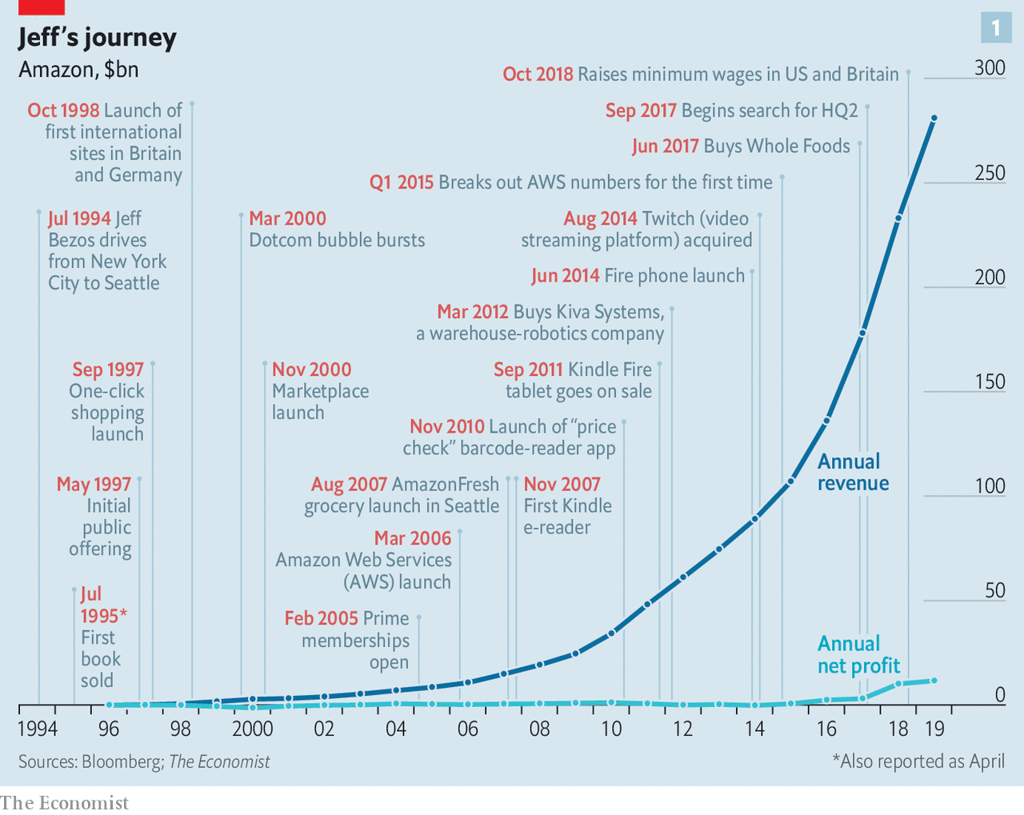

The AWS piggy bank has supported both expansion in retail—in 2017 Amazon paid $14bn for Whole Foods, an upscale supermarket chain—and new projects which the company’s engineers cook up at a prodigious rate. One of the whizziest is Project Kuiper, a satellite-broadband venture; another is Haven Healthcare, a not-for-profit aimed at reducing health-care costs, created with JPMorgan Chase, a bank, and Berkshire Hathaway, a conglomerate.

Amazon is still growing briskly, especially so for a set of multi-billion-dollar businesses. But growth is no longer accelerating in a day-one-ish way. Start with retail. Between 2016 and 2019 growth in global sales of goods, Amazon’s own and third parties’, on its websites slowed from an annual rate of 27% to 18%, calculates Sanford C. Bernstein, a broker. The effects of covid-19 might drive it back up to 23% for 2020 as a whole, but the long-term trend is not expected to change.

And the coronaviral sales boost has come at a cost. The company is hiring 175,000 new workers in America to cope with surging demand; it has invested heavily in covid-proofing its operations; and it has sacrificed earnings by prioritising the delivery of essential items, which tend to have lower margins, while barring many lucrative non-essentials from warehouses and removing ads for them to tamp down demand. Even as sales rose by 26% between January and March, profits fell by 29% compared with the previous year.

With its range narrowed and shipping slowed, Amazon could not keep up with soaring online demand (see chart 2). In America and elsewhere shoppers turned to rivals, often on a “click and collect” basis. According to data from Rakuten Intelligence, an independent subsidiary of a Japanese e-commerce firm, Amazon’s share of online spending in America was 34% in mid-April, down from 42% before covid-19. For years Amazon has led the way as an e-commerce pioneer, says Mark Shmulik of Bernstein; now every big retailer will turn to the web as never before. Long-established retailers like Target and Walmart are already making hay.

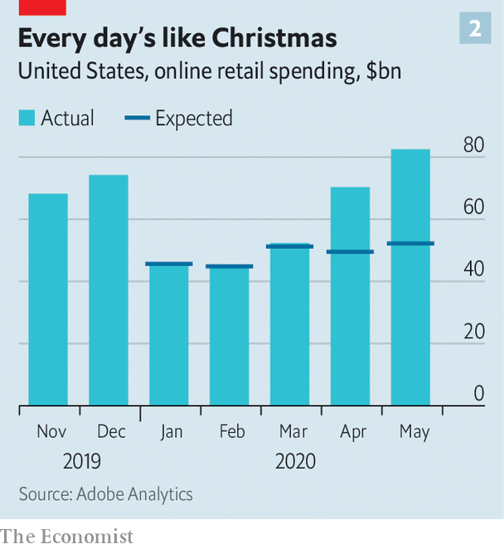

Big resurgent rivals are not Amazon’s only competition. Shopify, a Canadian firm, offers retailers a way to sell online—and obsesses over the experience it provides to the companies which use it just as much as Amazon obsesses over its customers. It has gone from nowhere a few years ago to 5.9% of America’s online-retail market, second only to Amazon. It is now to become the back-end for Facebook Shops, the social networking giant’s new e-commerce venture. Taking a lead from Alibaba, China’s dominant online retailer, Facebook hopes to provide a setting where people will browse and socialise in a way that no one does on Amazon.

Amazon can no longer count on Prime to fuel prodigious growth at home; most American households that can afford the $120 fee are already members. Future retail growth will therefore depend on markets elsewhere. These currently account for 29% of the company’s total non-AWS revenues. In western Europe, Amazon is entrenched and has been doing well. But an ageing, economically sluggish continent is not exactly a long-term growth and profits motor. Many of the region’s consumers tend to browse online then buy offline. Meanwhile, things in emerging markets are not going to plan.

A year ago, after 15 years of trying, Amazon gave up on China. In 2012 it had managed to win an e-commerce market share of 7% there, but Alibaba and the other local success story, JD.com, squeezed it out, poaching customers with screaming deals and promotions. Had Amazon fought harder it might still have lost; it is possible, even likely, that the Communist Party would not long have tolerated a big American retail presence. But it does bear some blame: it failed to recruit talented locals, and made too many decisions in Seattle.

## Failing to deliver

Elsewhere in the emerging world Amazon is still burning billions with no returns in sight. Its $6.5bn investment in India looks troubled. The nationalist government of Narendra Modi is making life hard for foreign firms—and easier for its local champion, Reliance Jio (in which Facebook is investing $5.7bn). In Latin America Amazon’s 3% share of online retail is barely one-fifth that of MercadoLibre, an Argentine firm better at dealing with bad roads, banditry and other local pitfalls. Because profits from western Europe are not enough to offset losses in the developing world, Amazon’s international division has been losing money for years.

Investors have mostly shrugged off Amazon’s global retail slowdown. The reason is simple—AWS. Its operating income usually adds up to well over half of Amazon’s total—in the most recent quarter it accounted for 77%. Bernstein estimates that Amazon’s retail business had an operating margin of -1% in 2019, and AWS 26%. But the cloud is getting crowded. Alibaba, Google and Microsoft have expanded their cloud offerings (though Alibaba Cloud still earns almost all its revenue in China). Globally, AWS’s share of cloud-computing declined from 53.7% to 47.8% between 2016 and 2018, according to Gartner, a research firm, while Microsoft’s nearly doubled to 15.5%. Revenue growth at AWS has slowed sharply, from 49% in the second quarter of 2018, year on year, to 33% in the first quarter of 2020 (see chart 3).

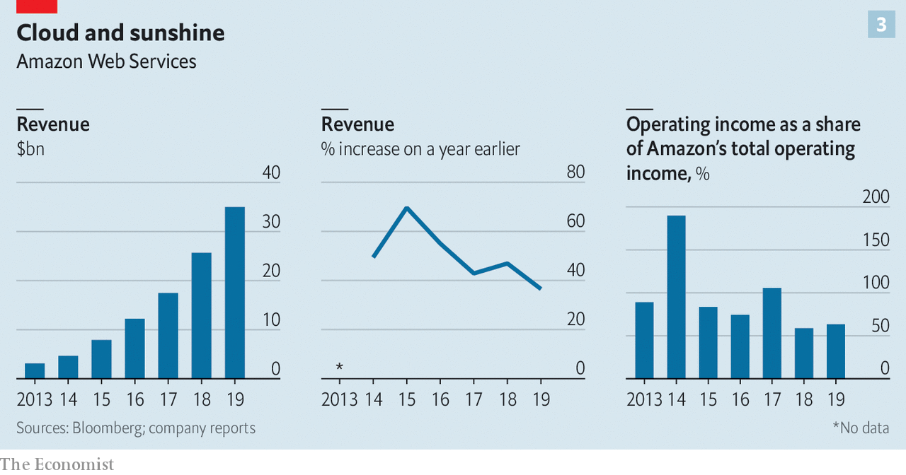

The AWS cloud is considered superior to the others in terms of reliability and speed. Azure experiences more service outages, for example. AWS also allows its customers to do more sophisticated things. But the rivals are good enough for most purposes, and improving. Large firms may prefer to deal with Microsoft because they have been dealing with it as a software provider for decades. George Gilbert of TechAlpha Partners, a consultancy, says that whereas AWS offers a wide range of platform services that suit the most technology-centric customers, Microsoft concentrates on integrating its servicesin order to make them accessible to mainstream customers.

AWS has the resources to defend its market-leading position. But in the cloud wars any handicap could cost it dearly. Its parent may be becoming one such drag. For years being part of Amazon was a huge advantage for AWS, says Heath Terry of Goldman Sachs, a bank. It needed cash from the rest of the group, as well as technology and data. But Mr Bezos’s habit of moving into new industries means that there are now ever more rivals leery of giving their data to it. Potential customers worry that buying services from AWS is tantamount to paying a land-grabber to invade your ranch. Walmart has told its tech suppliers to steer clear of AWS. Boards of firms in industries which Amazon may eye next have directed their IT departments “to avoid the use of AWS where possible”, according to Gartner.

This has fuelled talk that AWS might be better off pursuing its future as a separate company. In addition to putting a healthy distance between itself and the Amazon expansion machine, AWS would no longer need to cross-subsidise the firm’s less lucrative ventures. The transparency that would be offered into the financials of each business by a break-up would allow fund managers a better insight into how the new firms fulfil their investing criteria. In financial markets, a separation has been expected for the past year or so, according to the head of global internet banking at a leading financial institution.

Mr Jassy says that AWS was always designed to be separable from the rest of Amazon. If things get to the point where being inside Amazon is more disadvantage than advantage, says Mr Terry, AWS could go its own way.

Not that AWS gets nothing from being part of Amazon, however. Some data-driven technologies work better at scale. Data from Alexa, the virtual assistant Amazon makes available through its Echo smart speakers, helps feed Amazon’s voice-recognition algorithms, which can then be sold as a service to AWS customers, as well as back to shoppers. More shoppers and more data mean better algorithms, and so on. Yet such benefits could easily be set aside if AWS’s position inside Amazon continues to give powerful rivals such as Microsoft and Google a winning sales pitch.

Letting go of AWS would mark by far the most dramatic reorganisation in Amazon’s unremittingly accretive history. Analysts reckon the unit accounts for a third or more of Amazon’s value. A plausible valuation of $500bn would see it start out as one of America’s ten most valuable firms. And despite slowing growth it is still expanding twice as fast as the retail bit. If it grew at 20-30% a year for a decade—which is more slowly than in the past—while maintaining its margins, it could turn into the world’s biggest profit-generator.

## The great migration

There is no historical precedent for a half-a-trillion-dollar firm growing that fast for that long. But the notion is not entirely outlandish. Less than 10% of the estimated $4trn in annual global IT spending has so far migrated to the cloud. Mr Jassy is not alone in arguing that “the overwhelming majority” of computing is going to end up there one day. A company focused entirely on making that happen could become vast.

How would Amazon fare without AWS? In some ways, the change might be salutary: some close to Amazon feel that it has grown too big. Elements of unproductive bureaucracy and politicking are creeping in, they report. A lot of high-level Amazon meetings these days are about lobbying for promotion rather than innovation or operational excellence, says a former executive. A slimmed-down and refocused company might be on a better footing.

It would, though, also be one with much less cash to back its further growth. As well as helping pay for the purchase of Whole Foods, AWS money has paid for international expansion and heavy investment in “last-mile” delivery, among other things. If the e-commerce rump were to inherit a hefty chunk of the company’s $59bn cash pile it might be able to keep spending—but not for long, at its recent rates. An Amazon without AWS “might not be one I would want to own”, says a representative of a big institutional shareholder in Amazon.

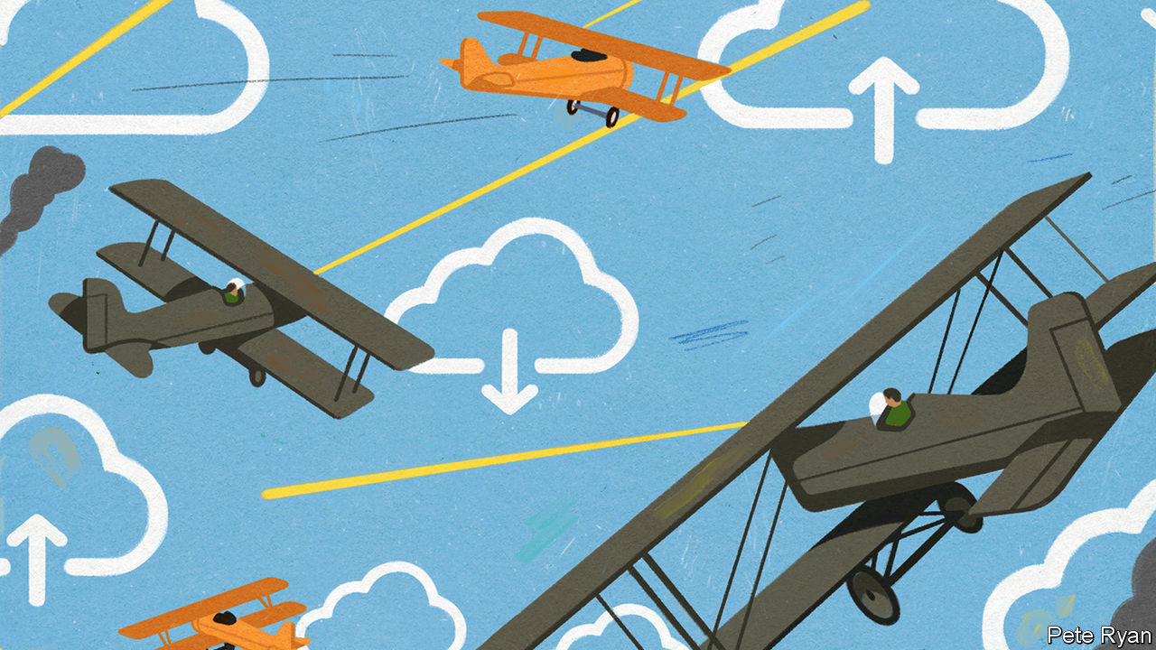

Mr Bezos’s views on a break-up are unknown (he declined to be interviewed for this article). He may believe that AWS and the rest of the group are symbiotic and would both suffer if separated. Even if he does not, though, it is a fair bet that he would be reluctant to let go of a cash-cow that enables Amazon to pursue new ventures. In time, the ad business might grow to fill that role. Last year it boasted an operating margin of 49%, and it is standing up to the current collapse of the advertising market better than its larger online rivals. But it is still small compared with AWS.

Whatever Mr Bezos’s views are, though, they will not be the final word that once they would have been. For a few years Seattle tech insiders have reckoned that Mr Bezos has been preparing to give up the top job to become executive chairman. He has already shed some of the management burden. In 2016, when Mr Jassy became chief executive of AWS, he named Jeff Wilke as “chief executive worldwide consumer”.

Though the pandemic has now brought Mr Bezos back into day-to-day involvement in the e-commerce operation, in recent years he has mostly confined himself to new projects such as Amazon Go, a till-less supermarket, and, earlier, Alexa. He has also been devoting a fifth of his working week to Blue Origin, his private rocket company, which is currently working on satellite launchers to compete with those of SpaceX and a Moon lander for NASA.

There is also the matter of his private life. In January last year Mr Bezos tweeted a bombshell: he and his wife, MacKenzie, were getting divorced. Days later the National Enquirer published details of an extramarital affair. The news shook the tight group of executives who run the company alongside him. Amazon’s meritocratic culture depends on “truth-seeking”, says a former senior executive. But it only works “if people at the top behave accordingly”, he adds. “Jeff’s episode put a dent in the company’s values.” Investors, for their part, fretted that Mr Bezos’s eventful personal life had become a distraction.

If Amazon fissions, Mr Jassy and Mr Wilke will be the obvious candidates to run the two firms—if, that is, one or other of them does not leave before then (they are both high on every recruiter’s wish list). Mr Bezos might stay on to oversee both companies as executive chairman. Amazon’s board will want to hang on to his magic touch for as long as possible, says a headhunter who knows the firm well.

But over time his influence may dwindle. He remains the company’s biggest shareholder—and thus the richest man in the world. His divorce settlement cut his economic stake from 16% to 12% (though he kept the voting rights of the portion he gave up). Still, every year he sells a slug of stock to fund Blue Origin, so in some years’ time he may come to own less than a tenth of his creation. Excluding the big three passive fund managers, the four largest institutional investors in Amazon already control 10% of the stock. And unlike many technology firms, Amazon has no dual-class shares that would let Mr Bezos control the board regardless of the size of his stake.

There might be other attractions to new leadership. While on Wall Street and in Seattle investors and insiders talk of one way of splitting up the company, in Washington, DC, they talk of another. A growing chorus of politicians, accompanied by an ensemble of antitrust experts, accuse Amazon of abusing the market power its size and reach provide.

Elizabeth Warren, a Democratic senator and scourge of big tech, has proposed sundering Amazon’s private-label business—which produces goods for sale on the site—from that of third-party sellers on its platform. The company would also have to sell Whole Foods and Zappos, an e-commerce rival it bought over a decade ago. Two Republican senators, Ted Cruz and Josh Hawley, also speak of breaking up big tech, for different reasons. Donald Trump reserves especial spite for Mr Bezos on the basis that he owns the Washington Post, a newspaper critical of the president.

## Soul-searching in Seattle

Anti-Amazon feeling grew stronger in April, after the Wall Street Journal reported that Amazon employees used data on third-party sellers to pinch ideas for the private-label business. Amazon has launched an internal inquiry into the incident, which violated the company’s own guidelines. But lawmakers who had been investigating Amazon, Alphabet (Google’s parent), Facebook and Apple for antitrust violations, still threatened to subpoena Mr Bezos if he did not voluntarily appear at an upcoming hearing. (In June Amazon signalled it was ready to send Mr Bezos.) The European Commission is reportedly preparing to file formal antitrust charges against Amazon over its treatment of third-party sellers in the coming weeks.

In America Amazon’s market share is nearly two-fifths in e-commerce, but only 6% in all of retail. The firm’s low prices and high-quality service certainly do consumers no harm. But even Amazon insiders say accusations of stealing small firms’ ideas are becoming harder to brush off.

So are criticisms with respect to Amazon’s treatment of its workers, a large proportion of whom are African-American or Hispanic. During the pandemic a number of warehouse employees have been publicising safety shortcomings to activists and the media. According to a tally by an Amazon worker, there have been 1,079 coronavirus cases among American warehouse workers. Amazon has said that the firm’s rates of infection and quarantine are never higher than those of the communities in which its facilities are located, and sometimes lower. In May a group of 13 state attorneys-general asked Amazon to hand over data on covid-related infections and deaths at its warehouses.

In May a furore erupted after Amazon fired two tech employees who worked on user-experience design, after they organised a live-stream for warehouse workers to explain their pandemic safety fears. Democratic senators have demanded more information from Amazon on the dismissals. So have a handful of shareholders.

The incident prompted the resignation of Tim Bray, a respected senior vice-president at AWS (and co-inventor of XML, an internet data-description language). The sackings, and those of other activists at the firm, Mr Bray wrote, were evidence of a “vein of toxicity” running through Amazon’s culture. A leading engineer inside Amazon’s Grand Challenge team, a secretive skunk-works unit working on ambitious projects, says morale is rock-bottom. He plans to leave.

The risk of Amazon’s labour practices inviting more regulatory scrutiny—and, possibly worse, alienating brainboxes—is not lost on investors. The firm needs to be “very, very careful”, says the institutional shareholder’s representative. Amazon raised workers’ wages by $2 an hour from mid-March until June 1st and allowed warehouse employees worried about infection to go on unpaid leave without the risk of being sacked. It made 150 changes to the way its warehouses function to ensure social distancing and more cleaning.

Still, says the shareholder rep, rather than leading by example on labour Amazon “seems to be playing catch-up”. Mr Bezos, who has added $54bn to his net worth thanks to his company’s buoyant share price while low-paid warehouse workers toil through the pandemic, “needs to lean over backwards to make sure workers are properly treated”, cautions a leading Silicon Valley venture capitalist.

The antitrust cudgel may in fact be an attempt to force Amazon to spruce up its labour track record. How far regulators are willing to go will depend on the public mood. Americans’ reliance on the company and the goodwill it has generated with consumers may help it, says an antitrust expert close to Congress. An AWS spin-off, if it occurred, might obviate the need for drastic antitrust action.

Mr Bezos has managed to keep Amazon from ageing beyond Day 1 for longer than most companies can dream of. But not even the best magician can stop the passage of time. One day, Day 2 will come. ■

This article was downloaded by calibre from <https://www.economist.com/briefing/2020/06/18/can-amazon-keep-growing-like-a-youthful-startup>

|  |  |  |  |
| --- | --- | --- | --- |
|  | Articles | Sections | Next |

|  |  |  |  |
| --- | --- | --- | --- |
| Previous | Articles | Sections | Next |

#### Hotting up

# How much can financiers do about climate change?

The role that green investing can play must not be misunderstood or overstated

Jun 20th 2020 |

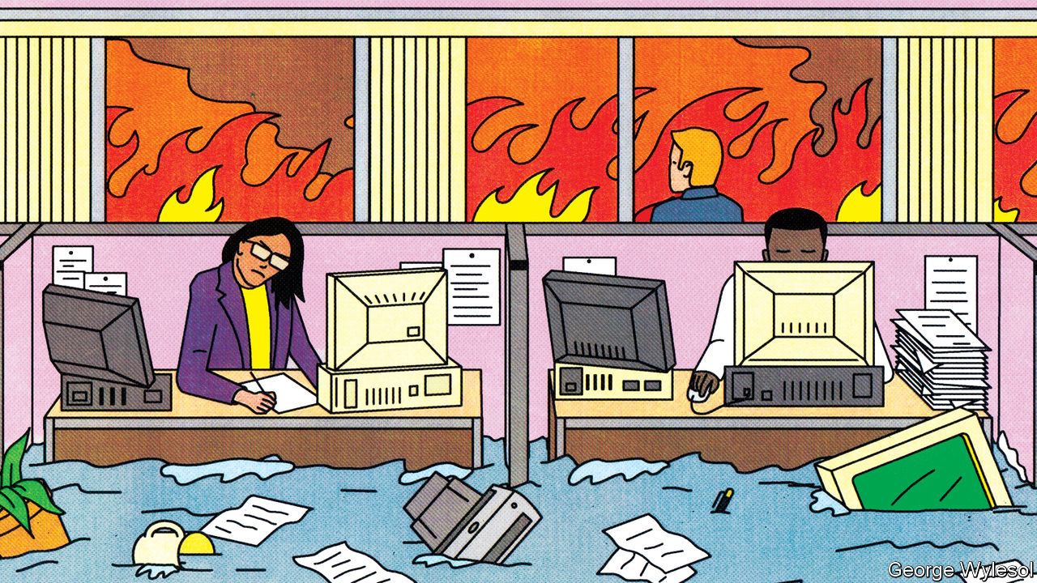

IN THE MAYFAIR office of Chris Hohn, the boss of TCI, a hedge fund, an enormous photograph of a melting iceberg hangs on one wall. Robert Gibbins, the founder of Autonomy Capital, another London hedge fund, says his desk is adorned with the deformed remains of a car bumper, melted by an Australian wildfire. An interest in modish office decor is a long-standing feature of high finance. An interest in climate change, though, was until recently rare; the preserve of boutique investment houses and pokey back offices in the large asset managers. Now it is all the rage.

One reason for this is the realisation that extreme weather events pose threats to businesses seeking investment. Last year PG&E, a Californian utility, was forced into bankruptcy for its role in sparking wildfires. Another reason is that governments are taking steps to limit the emission of greenhouse gases that could have real impacts on firms’ future revenues. A third is pressure from clients. Large asset owners, including Japan’s Government Pension Investment Fund, the world’s biggest, are badgering the companies which manage their money to attend more to the environmental, social and governance (ESG) bona fides of the companies they put money into. A fourth factor is that asset managers are facing shrinking margins. By offering their clients various sorts of greenery they can also charge higher fees.

## Hungry planet

The greening trend could be a force for good in the fight to reduce climate change. But the role that financial services can play must not be misunderstood or overstated. The sector is responding to changes in government and broader circles of opinion, not driving change itself. And there is a limit as to how much it can do. Calculations by The Economist suggest that the amount of direct control over carbon emissions exerted by companies in which investors hold sway is lower than is often thought. Less than a quarter of industrial emissions come from companies that can be influenced by investors in stockmarkets. And when one gets away from the key sectors of energy and natural resources, the amount that can be done by green investment may not be very much at all.

In 2019 the greenhouse emissions from human activity—mostly carbon dioxide, but with contributions from methane, nitrous oxide and other gases too—had the warming effect you would get from 55bn tonnes of carbon dioxide. The carbon dioxide from fossil-fuel emissions and industrial processes accounted for 37bn tonnes.

In order to see how much of this might be amenable to investor-led action The Economist analysed emissions disclosures from over 5,000 publicly listed companies which between them account for about 90% of the value of the world’s stockmarkets. The number of companies making such disclosures has been rising steadily in America (from 53% of the companies in the S&P 500 five years ago to 67% today); over the same time it has shot up in Europe and Japan, from 40% to 79% of companies in the Euro Stoxx 600 and from 13% to 46% on the Nikkei 225.

Those disclosures differentiate between the emissions that companies make directly (which the Greenhouse Gas Protocol, widely used for such reporting, calls “scope-one” emissions) and “scope-two” emissions which are produced by the companies which provide them with energy, mostly in the form of electricity. The scope-two number is vital to assessing the emissions caused by a company’s activities, but in order to look at the total emissions we considered only scope one, since adding in scope two leads to double-counting.

As you would expect, the largest emissions come from companies which burn fossil fuels in the normal course of their business: those that run fossil-fuel power stations, or fleets of aircraft or steelworks. In Europe ArcelorMittal is the biggest emitter because steelmaking requires the burning of coal. In America the biggest operational emitter is ExxonMobil, which unlike many large companies produces much of the electricity and heat that it uses itself.

Using the emissions disclosed by these companies, we estimated emissions for non-disclosing firms on the basis of those disclosed by similar firms in the same sector with comparable revenues. Given that a firm’s decision whether to disclose and its emissions intensity may not be independent, this step could introduce error.

Totting everything up reveals that each year publicly traded companies emit greenhouse gases equivalent to 10bn tonnes of carbon dioxide from their operations (see chart 1). Perhaps a quarter of those are produced by listed firms that are majority owned by governments. That leaves eight gigatonnes of emissions that stock markets can influence directly. That is 14% of the world’s total emissions, or 19% of the emissions related to energy use and industrial processes. (Those estimates undercount oil emissions. If you add the emissions from the oil sold by institutionally controlled energy firms, part of what is called “scope three” emissions, then it increases to 23% and 32%, respectively.)

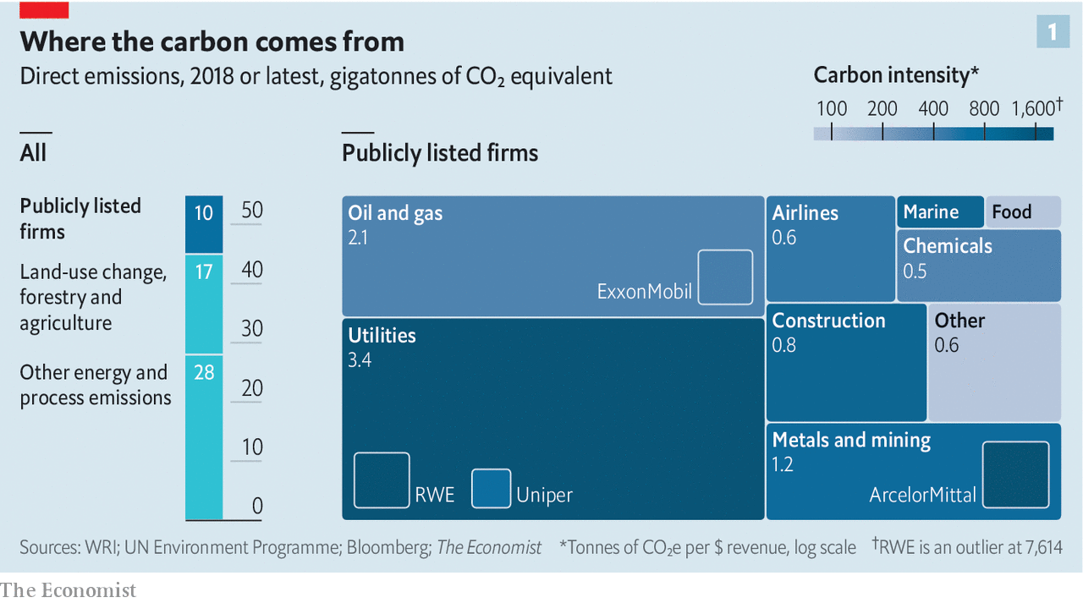

Where are the rest of the emissions coming from? In large part from consumers of those companies’ wares. An oil company’s scope-one emissions include all the carbon dioxide and methane it gives off in its operations, but not the carbon dioxide given off when its wares are burned in engines and boilers. Attempts to take this into account are found in the scope-three disclosures, which cover the entire value chain of a business from the extraction of its raw materials through its suppliers and on to its end users.

Only two-fifths of the firms in the S&P 500 and half of those in the Euro Stoxx 600 disclose a figure for their scope-three emissions. The figures are, unavoidably, larger than for scope one. They are biggest for the extractive industries. Of the companies in our dataset that disclosed their scope-three emissions, Royal Dutch Shell topped the list, followed by BHP, a mining firm.

Large scope-three emissions point to business models that depend on either suppliers or customers emitting greenhouse gases in bulk. This makes them hard to change. A company can reduce its scope-one emissions by changing its internal processes, and its scope-two emissions by changing its electricity supplier—for example, choosing one that uses a lot of renewable energy sources or nuclear power plants. To change its scope-three emissions, though, it needs to change either the practices of its suppliers or, harder still, what it sells.

The first may be feasible through investment. The Swedish furniture retailer IKEA has a €200m ($224m) fund to help its suppliers transition to using renewable energy, among other things. Changing what happens downstream, though, may be harder. As long as BHP goes on selling iron ore to steelmakers who use coal to smelt it, BHP will have high scope-three emissions; as long as Royal Dutch Shell sells oil and gas it will, too.

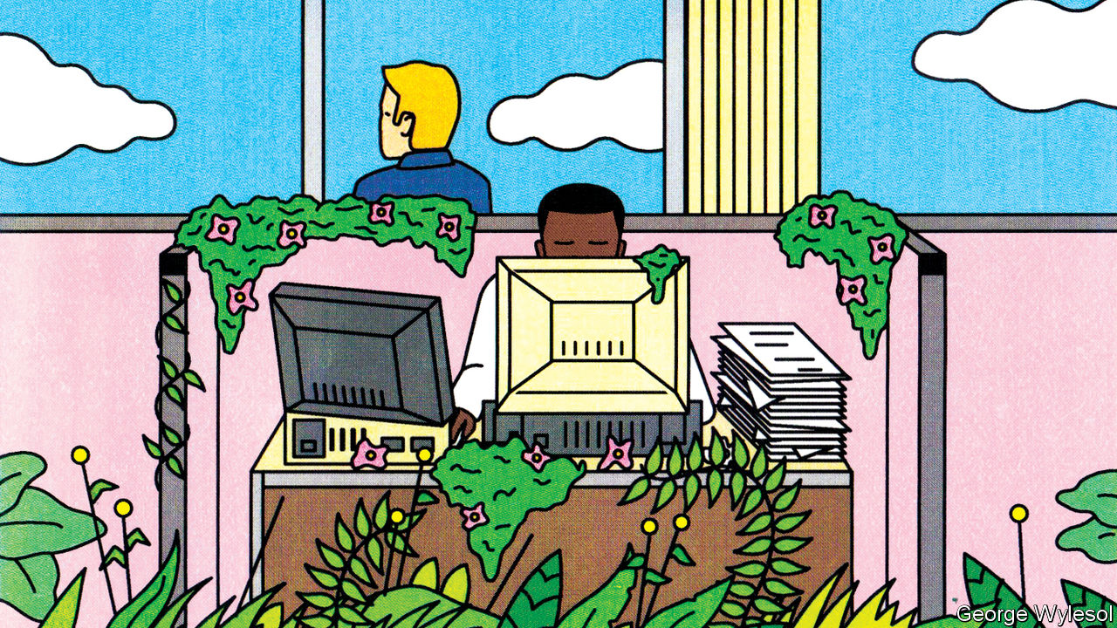

Scope-three emissions are highly concentrated within a small number of firms. When The Economist looked at scope-three emissions with the same methodology we used for scope-one emissions, 220 of our 5,000-odd companies, with a value of about $14trn, accounted for 84% of the total carbon footprint. This fits with a separate analysis by the Carbon Disclosure Project (CDP), a group which tracks firms’ climate disclosures. In 2015 the CDP looked at 224 fossil fuel firms and totted up scope-one emissions and a subset of scope-three emissions: emissions that come from the use of a firm’s products. The CDP found that between them the companies and their wares produced the equivalent of 31bn tonnes of carbon dioxide.

## Divided right in two

In our analysis 76% of the heavy emitters are majority investor-owned. And this ownership is also highly concentrated. When the stakes that they hold in a company are weighted according to that company’s emissions, the biggest 250 financial firms control about 86% of the emissions from the investor-controlled companies with the highest scope-three emissions. The financial firms with the largest holdings by this measure are the biggest asset managers, such as BlackRock (10% of the emissions from the investor-owned, heavy-emitters subgroup), Vanguard (6%) and State Street Capital (3%).

Some of these investors, including BlackRock, are part of Climate Action 100+, a group of institutional investors with over $40trn in assets. They ask firms to set emissions-reduction targets, disclose carbon-footprint data and generally clean up their act. Of the 161 firms targeted by CA100+, 70% have set scope-one emissions targets. But only 9% have set goals that a research group called Transition Pathway Initiative sees as compatible with the target of keeping global warming since the Industrial Revolution below 2°C. A similarly small proportion has made the promise no longer to lobby against green regulation that CA100+ asks for.

Rather than trying to change the actions of the companies at the heart of the climate crisis, most green investment seeks to reward and encourage companies in all sectors which either emit less than they might or help others so to do. JPMorgan, a bank, estimates that at least $3trn of institutional assets are now managed in a way that tracks ESG factors. Though that is a lot, it is only 4% of total assets under management.

Hortense Bioy of Morningstar, a research firm, says that in Europe there are about 400 green funds managing €132bn in assets. Some simply exclude fossil-fuel companies. Others seek out “climate-solution firms” developing technologies that reduce energy demand. One popular green-fund category is “low-carbon”. Low-carbon fund managers offer the chance to invest in the companies with the highest revenues per tonne of carbon dioxide emitted, either in a given sector or on a given index. They face the problem, though, that current carbon accounting does not make such comparisons easier. Apple has only a tiny fraction of Samsung’s operational emissions; but Samsung makes things, while Apple has others do that for it.

Nevertheless, carbon intensity may be a useful measure (see chart 2). The Economist looked at data from firms that disclose their operational emissions in the S&P 500 and Euro Stoxx 600. Calculating carbon intensity on a variety of measures shows that greener firms trade at a premium. Whether that means better returns in the long run, though, remains inconclusive.

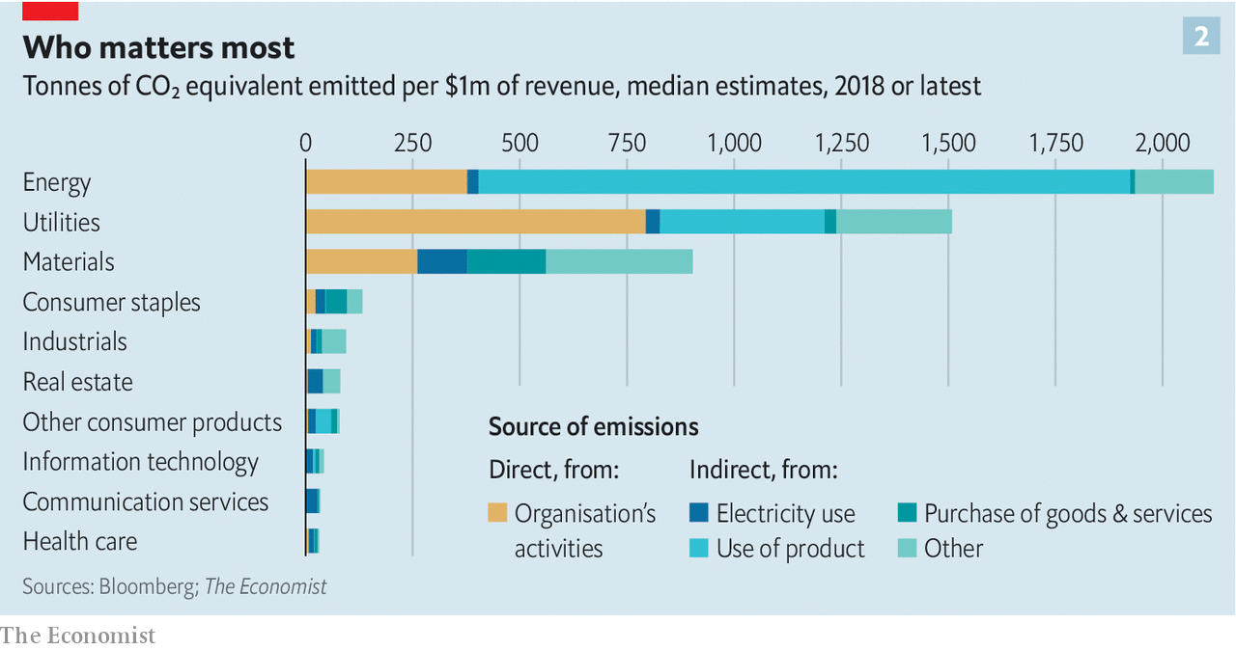

Perhaps the most obvious avenue for green investing is in firms whose technologies replace those that emit greenhouse gases on a grand scale. Renewable energy is one obvious possibility, but one which does not at the moment offer a wide range of choices to investors. Only three firms in the S&P 500 produce renewable energy, making up less than 1% of the index’s market capitalisation. Even among private-equity and venture-capital firms only $11bn were invested in renewables in 2019, according to BloombergNEF, a consultancy.

A study by Mariana Mazzucato of University College London and Gregor Semieniuk of University of Massachusetts Amherst looked at renewable-energy investments from 2004 to 2014. Institutional investors provided 7% of the funding and commercial banks provided 12%.

Another way to reduce emissions by rejigging finance is to make it harder for companies to get money if either climate change or action to avert it poses a particular problem to them. This is the idea behind the “stress tests” that central banks in England, France, the Netherlands and Singapore are forcing on banks and insurers: by modelling a 4°C world, or a $100/tonne carbon price, they seek to discover how badly the banks’ lending to their current portfolio of clients endangers them.

So far, these tests are not producing results as worrying as some might have expected. The central bank of the Netherlands found only 3% of banks’ loan books were at risk. This may be because much of the data needed for rigorous testing do not exist. Daniel Klier of HSBC, a bank, says only 12% of the companies in the bank’s loan portfolio reveal climate data. Insurance firms tend to have a better grasp on which assets are at what physical risks. But neither industry has the complete picture. For now stress tests are a work in progress.

It is also possible that the risks are not, in fact, that catastrophic. There are clearly businesses which will not survive serious action on climate change. For the world to limit warming to 2°C nine-tenths of today’s coal reserves will have to stay in the ground, according to JPMorgan. But this hardly means that, in Mr Hohn’s words, “Coal is the new subprime.” Western banks tend to have little exposure to the energy sector. The biggest ten have between 8-14% of the total credit exposure of all listed energy firms. Their share of exposure to coal will be even smaller.

Chinese banks probably have a much bigger share, though disclosure is patchy at best. One analysis by UBS, a bank, found that between January 2014 and September 2017, 60% of the financing for the world’s biggest 120 coal-plant developers came from Chinese banks. The next-biggest lenders were Japanese banks (8%) and Indian ones (7%).

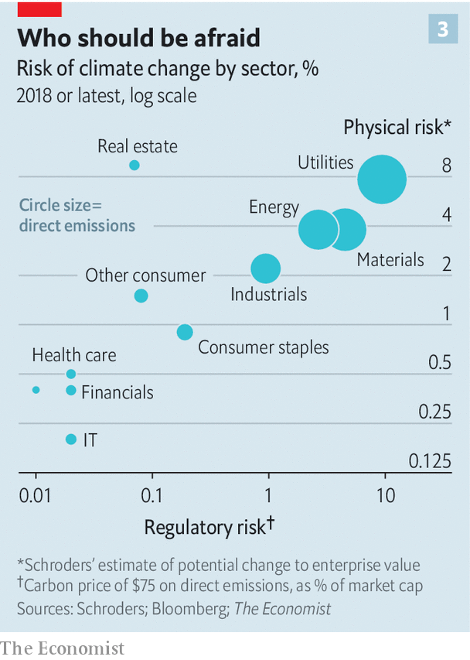

The fact that banks will stay standing if coal companies topple does not mean that efforts to reduce emissions will have no effect on the financial sector. At present only 20% of world emissions are covered by a carbon price. If prices were to increase in both their level and the share of emissions that they cover, banks and investors would need to take notice. Particularly as the pain will be spread unevenly across sectors (see chart 3).

## Shake and quake

The IMF thinks that a $75 per tonne price on all emissions might keep warming below 2°C. If you applied such a price to companies’ scope-one emissions, pre-tax profit in the S&P500 would fall by 8%, and in the Euro Stoxx 600 firms by 12%. That overstates the damage; the whole idea of carbon prices is that they make sensible reductions in emissions that were not cost effective before. But it gives a sense of the extent of change that companies and those who invest in them would face.

Axel Weber, chairman of UBS, sees that change in truly cosmic terms: “We need to build a new universe, not add some galaxies to the existing one.” He envisions a whole new financial system centred on a carbon price and tradable emission permits. Secondary markets in carbon futures and derivatives would allow investors to plan and invest for the long term.

Such calculations hint at a powerful future for finance, not as a driver of climate action, but as its enabler, making it more flexible and better able to tap insights and capital from investors around the world. If that also helps the financial firms doing the legwork, that will be all to the good. And if it shows up some of today’s green financing attempts as window dressing and marketing wheezes, that will be good, too. ■

This article was downloaded by calibre from <https://www.economist.com/briefing/2020/06/20/how-much-can-financiers-do-about-climate-change>

|  |  |  |  |
| --- | --- | --- | --- |
| Previous | Articles | Sections | Next |

|  |  |  |
| --- | --- | --- |
| Briefing | Sections | United States |

Asia

The Sino-Indian border: Death valley

.

South Asian civil servants: Manners maketh district commissioners

.

Migrant workers in Singapore: Breathing room

.

Inter-Korean relations: In the dust

.

Banyan: A bad rap?

.

|  |  |  |
| --- | --- | --- |
| Briefing | Sections | United States |

|  |  |  |  |
| --- | --- | --- | --- |
|  | Articles | Sections | Next |

#### Death valley

# India and China have their first deadly clashes in 45 years

Bloodshed on the border marks a turning point in relations between Asia’s giants

Jun 18th 2020 |

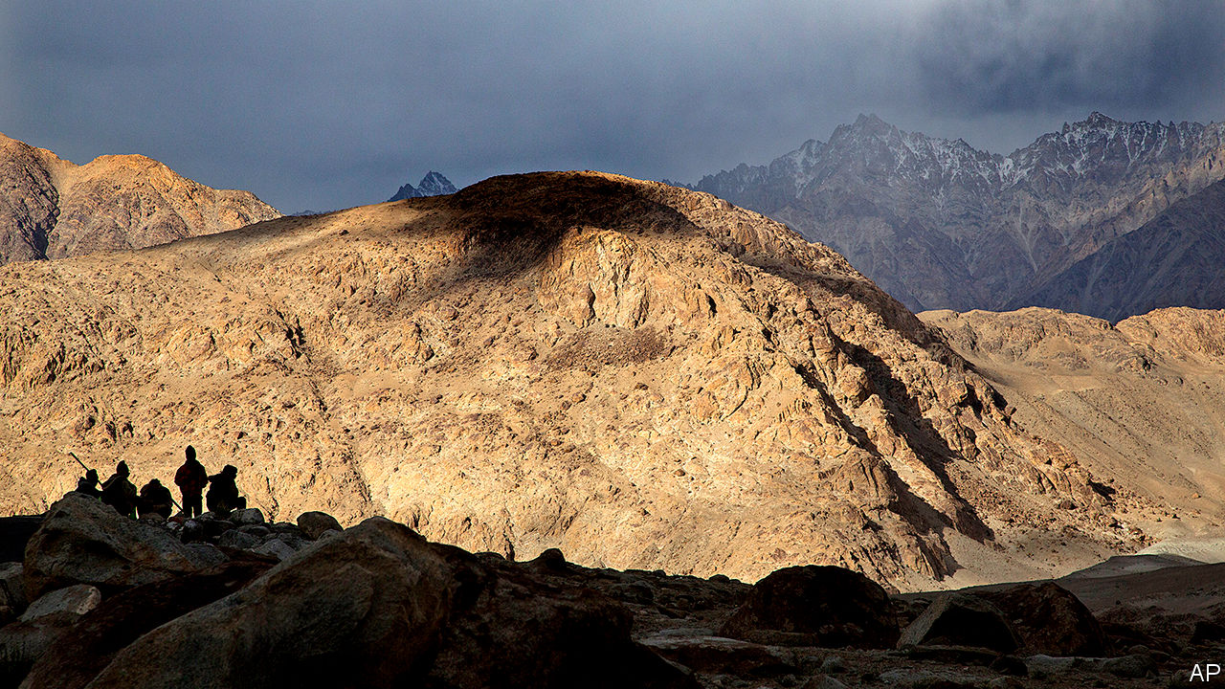

THE TWO armies each had machineguns, artillery and tanks to the rear. But they wielded only sticks and stones at the front, as night fell on June 15th. That was deadly enough. When the brawl ended, and the last rocks had been thrown, at least 20 Indian troops lay dead or dying in the picturesque Galwan valley, high in the mountains of Ladakh. Chinese casualties are unknown. These were the first combat deaths on the border between India and China in 45 years, ending an era in which Asia’s two largest powers had managed their differences without bloodshed.

The Indian and Chinese armies had been locked in a stand-off at three sites along their disputed border, known as the Line of Actual Control (LAC), since May. China’s People’s Liberation Army (PLA) grabbed 40 to 60 square kilometres of territory that India considers to be its own, estimates Lieut-General H.S. Panag, a former head of the Indian army’s northern command, including areas it had never previously contested. Both sides moved thousands of troops and heavy weapons towards the border, and brawls erupted twice in May.

India’s government played down the crisis, eager to avoid giving the impression that it had been caught napping—and mindful that a nationalist backlash would make it harder to defuse the situation. On June 6th both sides agreed to “disengage” at two of the three sites, including the Galwan valley. Talks had been “very fruitful”, enthused General M.M. Naravane, India’s army chief, on June 13th.

Not fruitful enough, it would seem. According to Indian press accounts, an argument developed after an Indian patrol tried to dislodge a Chinese position on the south bank of the Galwan river, an area that was supposed to be a buffer zone. China says that India “twice crossed the border line for illegal activities and provoked and attacked Chinese personnel”. On June 15th the PLA launched what India called a “premeditated and planned” attack with rocks and nail-studded clubs, during which Indian troops fell and were pushed down a steep slope into the river below. Some were beaten to death; others died of hypothermia.

China’s state-run media largely ignored the clashes and the PLA did not give details of its casualties, though Narendra Modi, India’s prime minister, said on June 17th that “our soldiers died having battled and killed the enemy.” India acknowledges that over 20 of its own soldiers lost their lives, with others thought to be missing. But despite Mr Modi’s threat of a “befitting reply if antagonised”, neither side seems keen to escalate matters. On the same day, both countries agreed to press ahead with their earlier disengagement agreement.

The immediate cause of the current crisis seems to have been India’s build-up of infrastructure in eastern Ladakh, including a key north-south road, making it easier to move troops and redressing China’s advantage in logistics. “What we’re seeing right now is the friction of both sides adjusting to a more capable and more resolved Indian approach to the LAC,” says Rohan Mukherjee of Yale-NUS College. But the two countries have also been carried to this point by wider geopolitical currents.

Though India and China have been rivals for a half-century—the PLA thumped India’s army in a brief border war in 1962—their rivalry has grown more intense over the past decade. The border has turned stormier, with a 73-day stand-off occurring on the edge of Bhutan in 2017. India is anxious about China’s growing economic and political clout on India’s periphery—in Pakistan, Nepal, Bhutan, Bangladesh and Sri Lanka—and about the influx of Chinese warships into the Indian Ocean.

In response, successive Indian governments have tilted closer to America, with which India signed a $3.5bn arms deal in February, and China’s rivals in Asia, such as Vietnam. A quartet of China-sceptic countries known as the “Quad”, comprising America, Australia, India and Japan, now meet regularly. Though India is at pains to stress that the Quad is not an alliance, Australia may soon join naval exercises involving the other three countries.

The violent turn in the border dispute is likely to accelerate these trends. “We are at a worrisome and extremely serious turning-point in our relations with China,” says Nirupama Rao, a former head of India’s diplomatic service and ambassador to China. She notes a “clear asymmetry of power” between the two countries. India is likely to deepen its relationship with America and increase its defence budget, says Mr Mukherjee. As both sides shift resources to the border, “there will be a period of adjustment in which things may be especially heated,” he says.

On June 17th India was elected to a two-year term as a non-permanent member of the UN Security Council. Yet it now has its hands full on its own borders. On June 12th an Indian citizen was killed by Nepalese border guards, amid a separate border row between India and Nepal. Relations with Pakistan are also fraught. An Indian soldier was killed by Pakistani shellfire in Kashmir on June 14th and, the next day, two Indian officials in Pakistan were allegedly abducted and tortured by “Pakistani agencies”. And then more soldiers were sent tumbling to their deaths by China’s troops. ■

This article was downloaded by calibre from <https://www.economist.com/asia/2020/06/18/india-and-china-have-their-first-deadly-clashes-in-45-years>

|  |  |  |  |
| --- | --- | --- | --- |
|  | Articles | Sections | Next |

|  |  |  |  |
| --- | --- | --- | --- |
| Previous | Articles | Sections | Next |

#### Manners maketh district commissioners

# In the bureaucracies of Bangladesh and Pakistan, the Raj lives on

Recruits are taught Victorian table manners

Jun 20th 2020 |

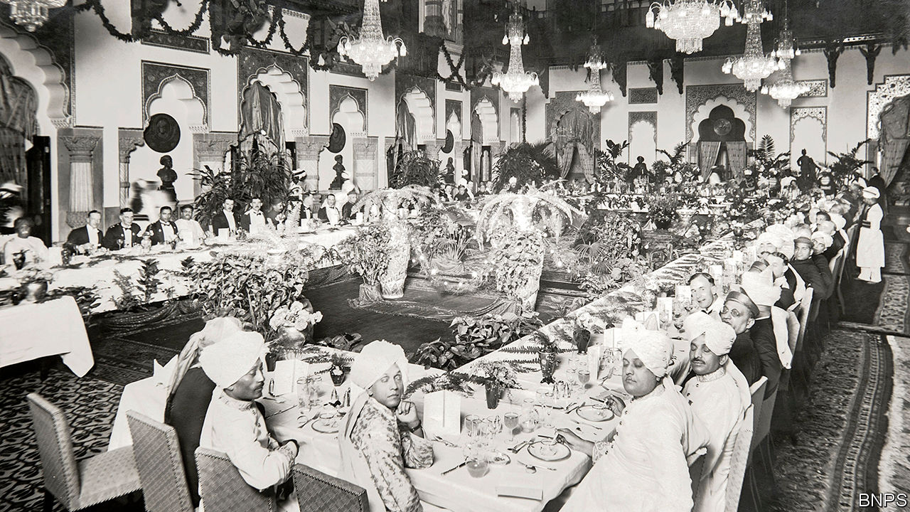

A CLINK OF the spoon against the side of the teacup: one point deducted. One too many slices of carrot on the fork: another two points lost. When Sarim was training to become a civil servant in Pakistan, he was graded on his table manners. Everyone in his class was so cautious during the test that they would barely eat, he chuckles.

Etiquette lessons are still mandatory for those aspiring to become senior government officials in Bangladesh and Pakistan, although Pakistan no longer marks candidates down for a slip of the teaspoon. During six months living and studying at the Bangladesh Public Administration Training Centre (BPATC), future civil servants must eat with knives and forks, says Mehbub, a successful graduate. A watchful instructor is quick to chastise anyone who reverts to eating directly from the right hand, as is customary for most South Asians.

The centre’s guide to etiquette includes detailed passages on how to hold and use cutlery. It recommends the “Continental” style—cutting and eating each mouthful in turn, with the fork in the left hand, tines down—over the “American” practice of cutting the entire serving into bite-sized pieces and then scooping them up with the fork, tines up. Another section explains in depth the art of “managing bread and rolls”.

Naima, a graduate of Pakistan’s Civil Services Academy, grew up with such conventions as the daughter of a civil servant. But for people coming from other backgrounds it can be a struggle, she says. The weekly lessons on the customs of polite society, little changed since the colonial era, were daunting for her rural classmates. The BPATC’s injunctions not to dip bread in sauce and to stand whenever a woman comes or goes from the table would seem impossibly stuffy to most contemporary Britons.

In India the emphasis on colonial-era etiquette for trainees has waned as the civil service has become more inclusive. Rich, cosmopolitan Indians have turned to careers in banking and business, “more than we have pushed them out”, says an Indian official who hails from a rural part of the state of Rajasthan.

Centuries of formality are hard to slough off, however. When posted abroad, the Indian official often found himself overdressed compared with Americans and Europeans. “My Pakistani friends were even more so,” he laughs. He did dispense with the formal dinner service, however, and dished up Rajasthani thalis even to foreign guests.

The old ways are the best ways for Pakistan, argues Naima. Just because the British introduced them does not make them wrong, she says. Indeed, one reason colonial habits endure in Pakistan is because they suit its conservative culture, she argues. The formal etiquette helps the bureaucracy set itself apart, in her view. In hierarchical places like South Asia, bureaucrats are the top of the pile, says Ishtiaq Jamil of the University of Bergen. Rigid decorum adds to their sense of importance.

Mehbub thinks it will take “another hundred years” for Bangladesh’s civil service to lose its Britishness and become purely Bengali. He is leading the way, however. The head of his office, he sometimes wears jeans and a T-shirt to work: “What can I say? I’m a rebel.”

This article was downloaded by calibre from <https://www.economist.com/asia/2020/06/20/in-the-bureaucracies-of-bangladesh-and-pakistan-the-raj-lives-on>

|  |  |  |  |
| --- | --- | --- | --- |
| Previous | Articles | Sections | Next |

|  |  |  |  |
| --- | --- | --- | --- |
| Previous | Articles | Sections | Next |

#### Breathing room

# Singapore promises roomier digs for migrant workers

The government wants to stop covid-19 from spreading in cramped dormitories

Jun 20th 2020 | SINGAPORE

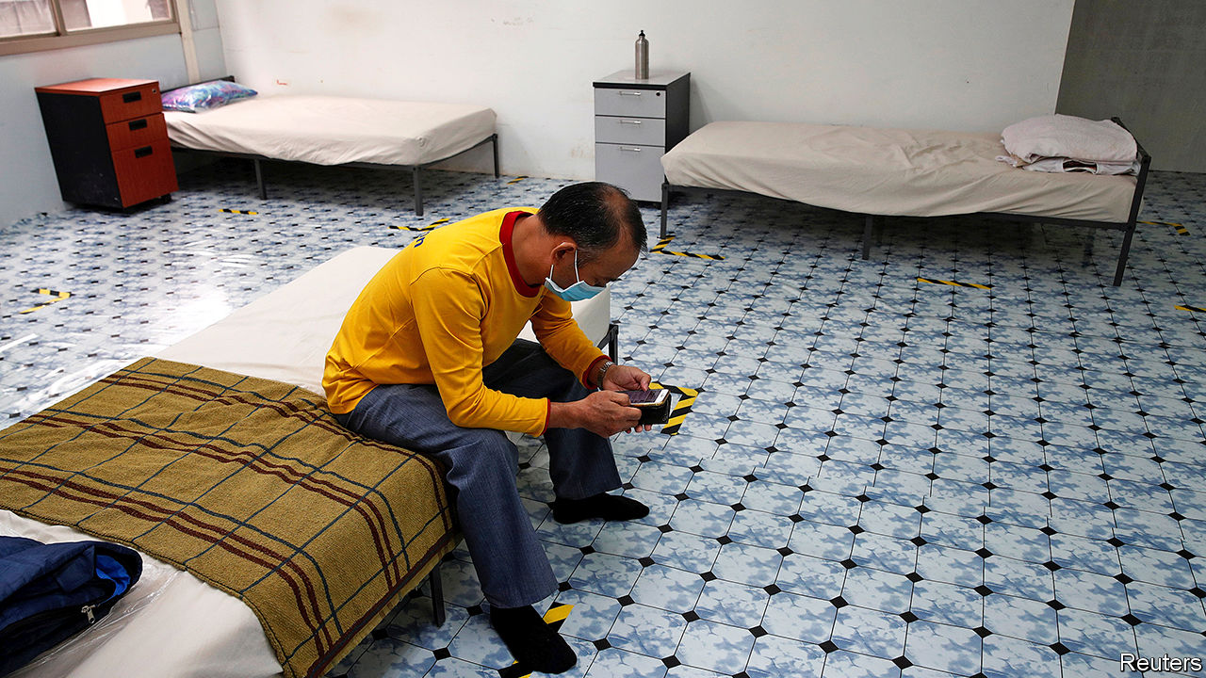

MIGRANT WORKERS are vital to Singapore’s economy, as they make up two-fifths of the labour force. But they are not a popular cause. The worst electoral showing for the ruling People’s Action Party (PAP) was in 2011, when the opposition put a call for fewer migrants at the heart of their campaign. So it is brave of the government to pick a fight with voters on the subject, with an election expected within months.

On June 1st Lawrence Wong, co-chair of Singapore’s covid-19 task-force, announced plans to build lower-density dormitories for some 100,000 migrant workers. The new housing, he warned, would inevitably encroach on other residential areas. When the government built workers’ dormitories in one central district in 2009, the PAP was subsequently thumped at the ballot box there.

Its willingness to try again is born of a public-health worry, not a surge of munificence. Nearly all Singapore’s 41,000 covid-19 cases have been among migrant workers. A quarter of them live in dorms packed with as many as 16 people per room. Regulations mandate an area of 4.5 square metres of living space per person, including shared facilities. The new dorms will boast a more salubrious six square metres each, excluding communal space, providing for ten to a room.

That is a big commitment for the world’s most densely populated country, bar Monaco. It is also a political risk. Migrant workers are a downtrodden lot, making an average of S$500 ($357) a month, says Debbie Fordyce of TWC2, an advocacy group. Most of their accommodation is hidden away in outlying areas. But when they stray into residential ones, they are often met with suspicion and scorn.

In the past decade, especially after a riot in 2013, residents have got the authorities to tighten surveillance over Little India, a district in central Singapore where 100,000 South Asian workers would gather weekly in pre-pandemic days to shop for groceries or pass the time. A member of parliament who described such gatherings as “walking time-bombs and public disorder incidents waiting to happen” petitioned the government to fence off communal areas.

Even as it promises migrants more spacious surroundings, however, the government is not getting soft-hearted. As Singapore prepares for a partial exit from lockdown on June 19th, it has insisted that migrant workers, many of whom do not own smartphones, must install and use a battery-draining contact-tracing app that most residents have rejected, largely on grounds of privacy.

But public attitudes may be softening. “Many Singaporeans have been coming forward, asking how they can help migrant workers through the pandemic,” says Michael Cheah, head of HealthServe, a charity. Many such benefactors are younger Singaporeans, he points out.

Citizen Adventures, a group of about 200 youth volunteers, led by Cai Yinzhou, befriends migrant workers. It has raised S$786,000 ($564,000) to help them through the crisis. “We don’t take for granted our relationship with the workers,” says Mr Cai. “But unfortunately that is not the case with other Singaporeans.” ■

Editor’s note: Some of our covid-19 coverage is free for readers of The Economist Today, our daily [newsletter](https://my.economist.com/user#newsletter). For more stories and our pandemic tracker, see our [coronavirus hub](https://www.economist.com/news/2020/03/11/the-economists-coverage-of-the-coronavirus)

This article was downloaded by calibre from <https://www.economist.com/asia/2020/06/20/singapore-promises-roomier-digs-for-migrant-workers>

|  |  |  |  |
| --- | --- | --- | --- |
| Previous | Articles | Sections | Next |

|  |  |  |  |
| --- | --- | --- | --- |
| Previous | Articles | Sections | Next |

#### Fighting mockery with munitions

# North Korea blows up the South’s de facto embassy

And with it, detente on the Korean peninsula

Jun 18th 2020 | SEOUL

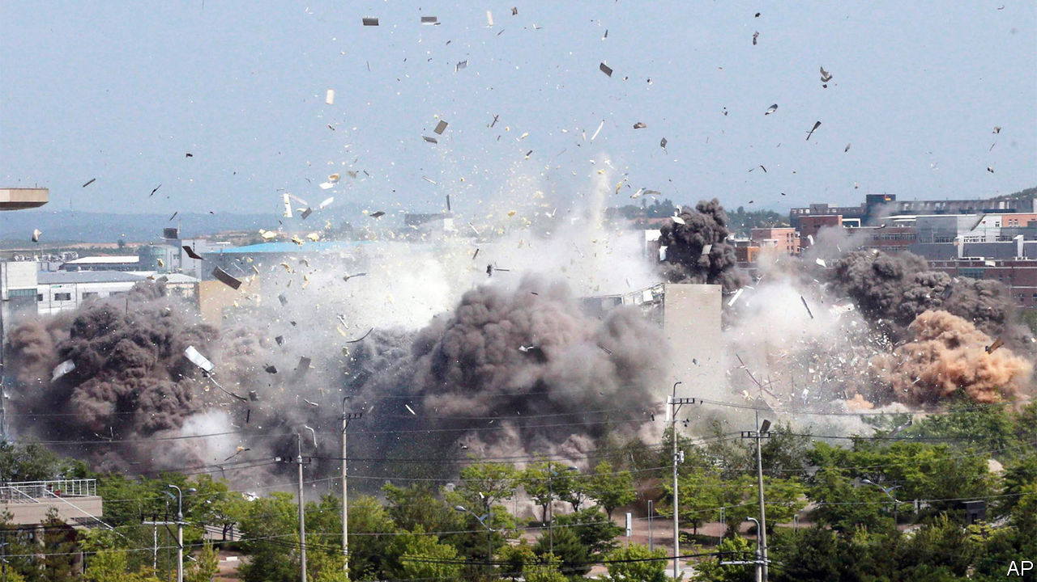

AS THEATRICS go, it was impeccable. Shortly before 3pm on June 16th, a big cloud of smoke billowed suddenly from the site of the inter-Korean liaison office in the North Korean border city of Kaesong. As the dust settled, the building and much of its surroundings re-emerged, reduced to rubble. North Korean state media triumphantly reported that the office had been destroyed in a “terrific explosion”.

Along with the liaison office, which since opening in September 2018 had operated as a de facto embassy between the two Koreas, the North blew up what little was left of a two-year period of inter-Korean detente. The move followed a spring filled with several short-range-missile tests, weeks of lurid rhetoric against the South by the regime’s propaganda organs and the severing of communication lines with the South on June 9th. The regime is clearly trying to manufacture a fresh crisis. Outsiders have no clue as to why.

The pretext for the demolition was that North Korean defectors (“human scum”, as the North calls them) continue to launch anti-regime leaflets attached to balloons into the North. The defectors have also sent over chocolate biscuits, to remind northerners how much richer the capitalist, democratic South is, and flash drives full of Wikipedia pages. Kim Jong Un, North Korea’s despot, regards both mockery and accurate information as “hostile acts”.

To soothe tensions, the South had promised to stop the leaflet-launchers in 2018. In response to the North’s threats, it recently tried again to crack down on the defector groups, outraging domestic fans of free speech. Even so, Mr Kim’s regime was not satisfied. When it comes to silencing critics, it has more exacting standards.

One theory is that the North is trying to press its neighbour to make bigger economic concessions. Or perhaps it wants the South to coax America back to the negotiating table, giving Mr Kim another chance to win sanctions relief. Even before the latest escalation, inter-Korean relations had been in poor shape. Economic co-operation (read: the South’s money flowing into the North’s coffers) between the two countries cannot go ahead without the easing of sanctions, which in turn depends on progress in talks with America aimed at removing the North’s nuclear weapons. These have made no headway since a summit between Donald Trump and Mr Kim last year broke down.

However, if extracting concessions by raising pressure is the strategy, the likelihood of success is low. Mr Trump, who is preoccupied by covid-19 and re-election, has paid little attention to North Korea in recent weeks. After the Kaesong explosion, America’s State Department blandly urged the regime to “refrain from counter-productive actions”. South Korea, for its part, sharpened its usually conciliatory tone. A general blustered that North Korea would “pay the price” if it took further military action. If anything, the affair has made Moon Jae-in, South Korea’s president, less receptive to Mr Kim’s demands.

Another possible motive for the North’s recent histrionics is domestic. The propaganda campaign that preceded the demolition of the liaison office was spearheaded by Kim Yo Jong, the dictator’s younger sister, who raged at the “rubbish-like mongrel dogs” who had the temerity to “fault...our supreme leadership”. The regime may be seeking to raise Ms Kim’s profile by strengthening her hardline credentials, reckons Andray Abrahamian of George Mason University Korea.

Kim Jong Un has been unusually absent from public view this year, prompting rumours about his health and speculation about who might succeed him. His sister tops the list of possible candidates. An added bonus of the current campaign might be to distract from domestic economic difficulties caused by North Korea’s stringent quarantine to shield itself against covid-19 (of which it still, fantastically, claims to have no cases). Whatever the motives, outsiders hope that when it comes to blowing things up, the North will continue to restrict itself to empty buildings. ■

This article was downloaded by calibre from <https://www.economist.com/asia/2020/06/18/north-korea-blows-up-the-souths-de-facto-embassy>

|  |  |  |  |
| --- | --- | --- | --- |
| Previous | Articles | Sections | Next |

|  |  |  |  |
| --- | --- | --- | --- |
| Previous | Articles | Sections | Next |

#### Banyan

# Racism in Australia is not just a thing of the past

A new generation of Aboriginal leaders is puncturing the country’s cosy self-image

Jun 20th 2020 |

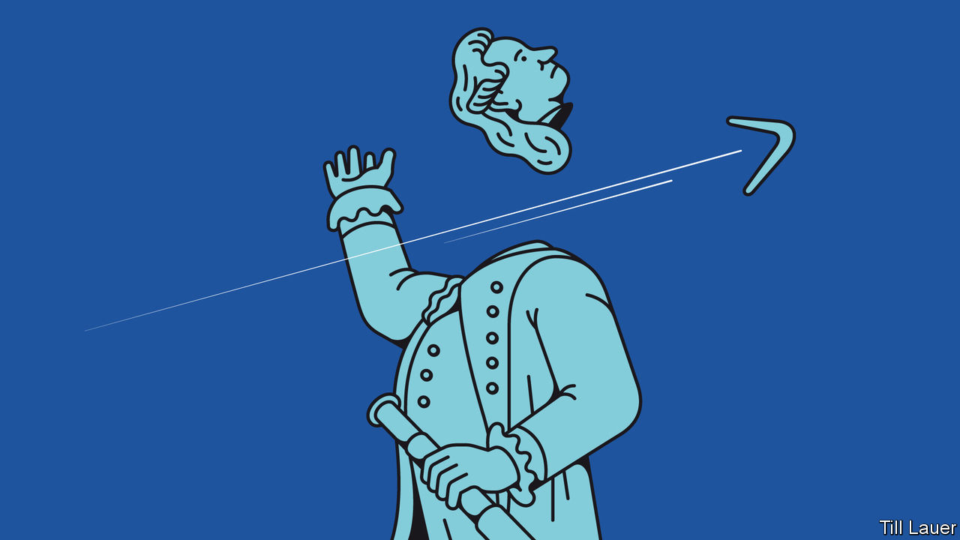

POLICE ON HORSEBACK gathered in a circle to defend the statue of Captain James Cook in Sydney’s Hyde Park. Australians inspired by American protests, and calling attention to the plight of their country’s indigenous peoples, might have toppled the statue. The moment was replete with historical irony. The “discoverer” of Australia met his end on a Hawaiian beach, at the hands of a crowd of angry natives. The police seemed determined not to let it happen to him a second time.

The whole messy issue of Australia’s past rose up and wound itself in knots around Cook’s bronze form. The conservative prime minister, Scott Morrison, condemned the protesters. But he drew a distinction between Australia’s history of white settlement and America’s. Australia had been “a pretty brutal place”, he conceded, “but there was no slavery.”

That is some gloss to the real story of white settlement. Australia’s indigenous peoples have endured land seizures, massacres, servitude and, well into the second half of the 20th century, children forcibly removed by government agencies and church missions in the name of racial assimilation—the so-called stolen generations. An uproar over his comments compelled Mr Morrison to backtrack and clarify that he had meant no legal slavery. To many of his government’s supporters, muttering over their barbies, the furore was political correctness gone mad.

Nobody denies that Australia’s indigenous peoples face bleak odds. Aboriginals and Torres Straits Islanders are 3% of the population but 27% of prisoners. Their life expectancy is eight years less than the national average. They do terribly at school.

But Australia has made strides to improve the Aboriginal condition, starting with a referendum in 1967 granting full citizens’ rights to indigenous Australians. In 1992 a High Court case over land title overturned the long-held legal fiction that Australia had been an uninhabited terra nullius for the taking. And in 2008 the then prime minister, Kevin Rudd, formally apologised to the “oldest continuing cultures in human history” over the stolen generations and other past mistreatment. Mr Rudd’s and successive governments have committed to “closing the gap” in socioeconomic outcomes.

Many Australians therefore share Mr Morrison’s contention that Australia is not a fundamentally racist country but its opposite, a “fair” one. From this some conclude that Aboriginals’ remaining problems—the drinking, the domestic violence, the supposed indolence—are of their communities’ own making, not a consequence of discrimination. One columnist even claims that the protesters are “enablers for systemic and entrenched indigenous problems to fester”.

In the past, bottom-up efforts by indigenous folk to improve their lot tended to work only if the political climate encouraged it. The “Uluru statement from the heart” in 2017, which called for constitutional change to give indigenous Australians a special voice in laws and policies that concerned them, was rejected by the ruling coalition, on the ground that the proposed body would constitute a third legislative chamber.

That argument, Mr Rudd contends, is “bullshit”: the body would have had no authority to introduce or vote on legislation. Rather, the rejection was a dog-whistle to the same kinds of voters who were encouraged to believe, after the High Court ruling on land rights, that Aboriginals would soon be camping in their back yard. Mr Morrison’s criticism of protesters was intended for much the same audience.

It is no surprise then that indigenous people believe Australia does not offer them a fair go. “There’s a view here that we’re all mates,” says Pat Anderson, an Aboriginal leader. “But this is a mythology they tell themselves.” Petty racism abounds. One Aussie-rules star, Adam Goodes, who complained when a 13-year-old called him an ape, was booed into early retirement.

Yet some think the social and political ground might soon shift. A younger generation of indigenous Australians, many better educated than their parents, is beginning to puncture the cosy self-image of Australia projected by the likes of Mr Morrison—using wit to get their point across. It was hardly salutary that a recent study concluded that three out of four Australians have a “racial bias” against Aboriginals. But it did bring cheer when Briggs, an indigenous rapper, tweeted that the fourth Australian was probably “conducting the survey”.

This article was downloaded by calibre from <https://www.economist.com/asia/2020/06/20/racism-in-australia-is-not-just-a-thing-of-the-past>

|  |  |  |  |
| --- | --- | --- | --- |
| Previous | Articles | Sections | Next |

|  |  |  |
| --- | --- | --- |
| Asia | Sections | China |

United States

State finances: The calamity ahead

.

LGBT rights: A wider umbrella

.

Midwives: Ripe for rebirth

.

John Bolton’s revelations: National security chastiser

.

Bill de Blasio: How’s he doin’?

.

Maine politics: The race of the long driveways

.

Lexington: A shovel-ready project

.

|  |  |  |
| --- | --- | --- |
| Asia | Sections | China |

|  |  |  |  |
| --- | --- | --- | --- |
|  | Articles | Sections | Next |

#### The pandemic and state finances

# The state-budget train crash

Why this could cost lives and set back economic recovery

Jun 18th 2020 |

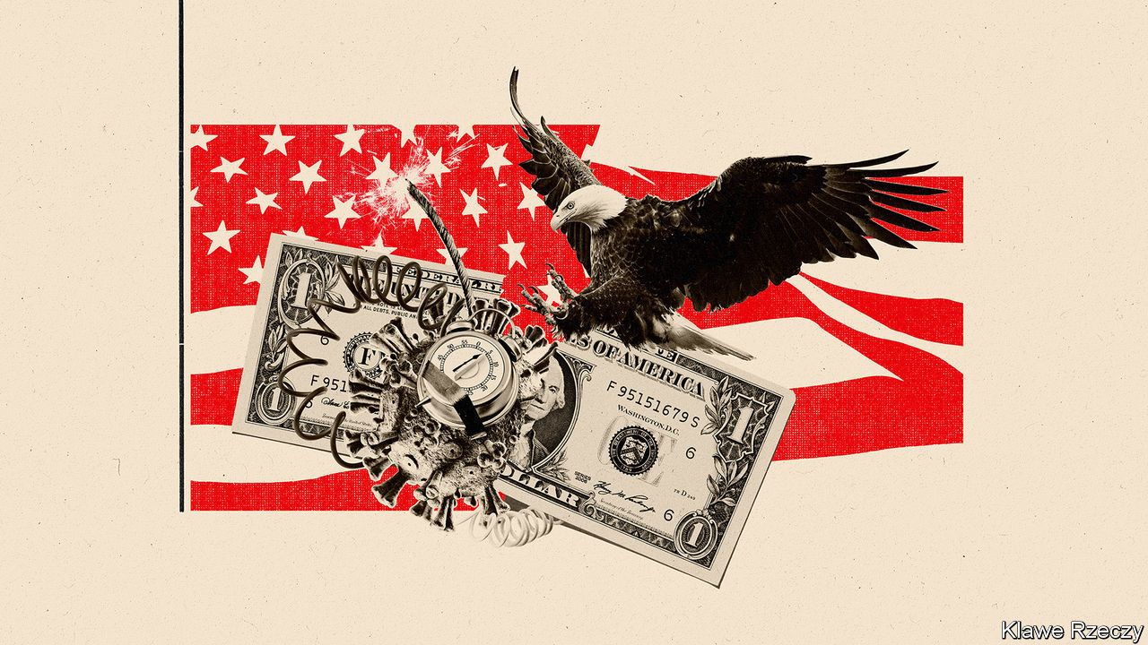

THE START of the fiscal year—July 1st in most states—is usually about as exciting as a 501(a) tax filing and as unpredictable as a Saudi weather forecast (sunny again!). Not this time. State tax revenues collapsed in April, falling on average by half, according to the Urban Institute, a think-tank. Demands on spending soared because the states are responsible for much of America’s spending on public health, unemployment and policing. By some calculations, state-budget deficits will reach a quarter of revenues in the coming fiscal year—or would do, if most states had not bound themselves by law to run balanced budgets. So instead of vast deficits, the states will have to make savage cuts to public services in the midst of a recession and pandemic. Through no fault of their own, their budgets are out of control and are about to hit the buffers.

Two-thirds of state revenues come from income taxes or sales taxes. Sales taxes have been devastated by the closure of shops and restaurants and income taxes by the rise in unemployment. The jobless rate was 13.3% in May, according to the Bureau of Labour Statistics, up from 3.5% in February. Each percentage-point rise in the unemployment rate cuts state tax revenues by over $40bn, or 4.5%.

Revenues have fallen so fast that some states do not even know by how much. Of those that have reported estimates, Louisiana saw tax revenues drop by 43% in April compared with April 2019 (“surreal”, the state treasurer called that). New York’s were down by two-thirds and California’s income-tax receipts plunged 85%. Revenues in April were doubly depressed because the federal government, with states following suit, moved tax-filing day from April to July, causing uncertainty about when income tax will be paid. Revenues may recover somewhat. But Ronald Alt of the Federation of Tax Administrators, which advises state governments, reckons that, collectively, state tax revenues will fall by $150bn between the start of April and the end of June. He expects income taxes to fall by half and sales taxes to fall by 44%. This decline is larger in nominal terms than during the Great Recession, when state tax revenues fell by $100bn from peak to trough in three years.

State and local governments spend slightly less than the federal government, about 17% of GDP, compared with a federal share of 20%. But they are disproportionately important to the coronavirus response because unemployment insurance, public health and Medicaid (which provides health insurance for the poor) are largely organised by states. Connecticut usually gets 3,000-3,500 new unemployment claims a week. In April it got 30,000 in a week. In New Jersey, enrolment in Medicaid was nine times higher in April than it had been a year earlier.

For the past nine years, states have cautiously increased spending. At the start of 2020, before the pandemic hit, states were expecting increases in both revenues and spending of about 2%. Instead, the virus has driven a wedge between the two.

Lucy Dadayan of the Urban Institute estimates that the gap will be around $75bn in fiscal 2020 and $125bn in fiscal 2021. The Centre on Budget and Policy Priorities (CBPP), another think-tank, reckons it will be even higher: $120bn in the current fiscal year, $315bn in fiscal 2021 and $180bn in 2022, a grand total of $615bn, which is six months of current spending. (These forecasts show the difference between what was expected before the pandemic and what is expected now.)

The range in estimates reflects the difficulty of forecasting the impact of the pandemic and expectations of spending cuts. The exact amounts, however, matter less than the fact that, first, the figures are large and, second, that most states cannot run deficits anyway, so the numbers indicate the extent of future spending cuts, rather than deficit-financing needs.

These cuts will be mitigated by states’ financial reserves and by federal help. The rule that states must balance budgets has made them fiscally conservative. Most used the 2010s to build up reserves. According to the Pew Charitable Trusts, a nonpartisan think-tank, these reached $75bn in 2019, the highest ever, equal to 8% of spending (or 28 days’ worth). But that is just an eighth of CBPP’s forecast of the shortfall in 2020-22. The costs of the pandemic have swept away the benefits of caution.

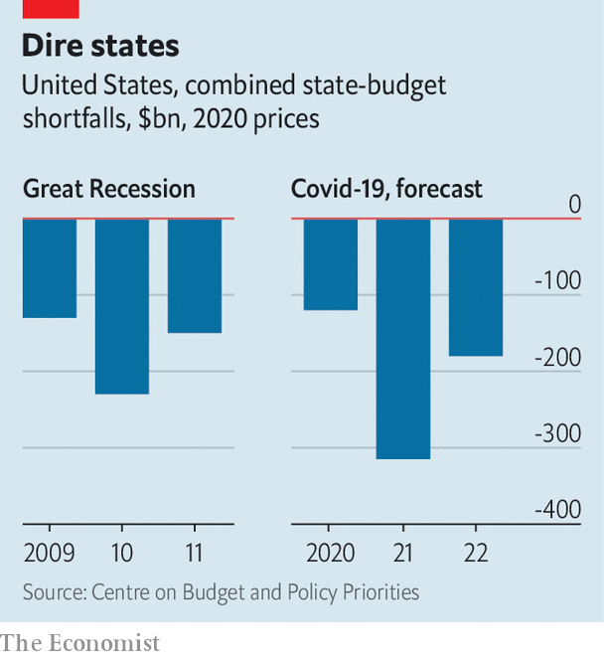

The federal government has also offered help, but not enough. It is financing new unemployment insurance introduced during the pandemic and in March gave states an extra $110bn. But the money may not be used to compensate for revenue shortfalls. And anyway, the (bipartisan) National Governors Association reckons states need $500bn. Glenn Hubbard, the former head of George W. Bush’s Council of Economic Advisers, calls the extra help “about as close to a no-brainer...as possible”. In mid-May the House of Representatives promised $500bn. But the bill stalled in the Senate, where the majority leader, Mitch McConnell, has said states should be allowed to declare bankruptcy instead (which may not be constitutional). This leaves states struggling to balance budgets largely on their own.

## Prepare for pain

With tax increases politically unfeasible at the moment, states will have little choice but to impose big spending cuts. Ohio’s governor has instructed state agencies to chop their budgets by 20% in the coming fiscal year. In Washington state, the reduction is 15%. California’s governor and legislators are deadlocked over plans for $14bn of spending cuts, but even these would not be enough to close the expected $54bn deficit. Spending cuts imply lay-offs. The states have already furloughed or sacked 1.5m workers in March, April and May, twice as many as in 2009-11.

Such cuts will be a drag on growth when recovery starts. As Pew’s Josh Goodman points out, states were reining back spending years after the Great Recession, resulting, as late as 2018, in shortages of teachers, and infrastructure spending at 50-year lows as a share of GDP. The budget squeeze now will be greater than it was then. And remember what programmes are provided by states: Medicaid at a time of covid; unemployment insurance at a time of recession; policing at a time of protest. In the absence of proper presidential leadership, governors such as Maryland’s Larry Hogan and Michigan’s Gretchen Whitmer have provided much of what useful guidance America has had during the pandemic. But they, and other governors, must now brace themselves for the coming crash. ■

This article was downloaded by calibre from <https://www.economist.com/united-states/2020/06/18/the-state-budget-train-crash>

|  |  |  |  |
| --- | --- | --- | --- |
|  | Articles | Sections | Next |

|  |  |  |  |
| --- | --- | --- | --- |
| Previous | Articles | Sections | Next |

#### LGBT rights

# America’s Supreme Court protects LGBT workers against discrimination

A momentous 6-3 ruling

Jun 18th 2020 | NEW YORK

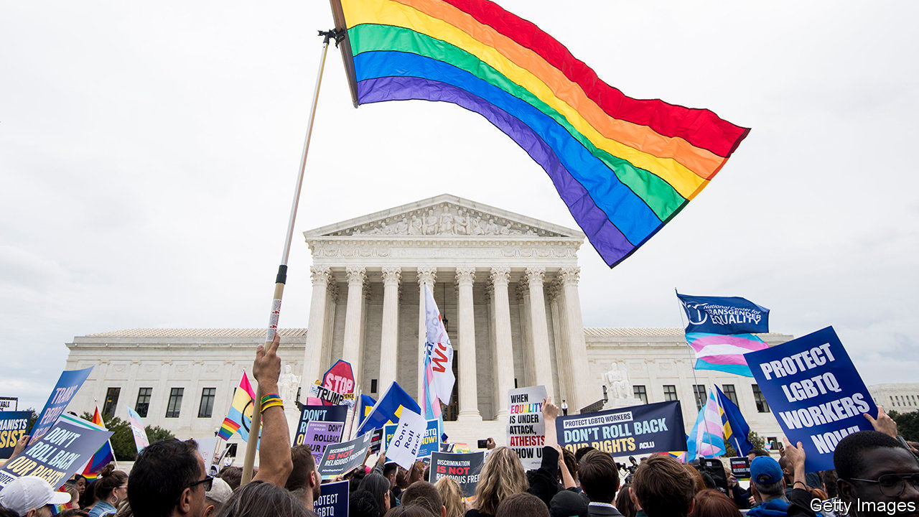

WHEN ANTHONY KENNEDY retired in 2018, gay-rights supporters fretted over the loss of a justice who had anchored four expansions of gay and lesbian rights. With his replacement by the more conservative Brett Kavanaugh, and President Donald Trump’s appointment of Neil Gorsuch 18 months earlier, LGBT activists worried the progress would come to a halt. On June 15th the Supreme Court allayed those fears with a momentous decision that protects gay and transgender people against discrimination in the workplace.

By a 6-3 margin, the court ruled that Title VII of the Civil Rights Act of 1964—a provision that bars discrimination “because of” a number of characteristics including “sex”—prohibits firing or disfavouring workers on the basis of their sexual orientation or gender identity. The majority view was penned by Justice Gorsuch.

Roughly half of America’s states have laws of their own protecting gay and trans workers; the rest do not. So until the latest decision, known as Bostock v Clayton County, an employee in much of America could legally marry a member of the same sex over the weekend and be legally sacked for being gay when returning to work. Now some 8.1m LGBT workers across America will enjoy federal protection from discrimination when they clock in.

At the oral arguments last October, Justice Gorsuch leaned towards the LGBT plaintiffs’ view. But he feared that a win for them might herald “massive social upheaval”. Now, as author of the majority opinion (attracting the votes of Chief Justice John Roberts and the four more liberal justices), his worries seem to have vanished. “Sex plays a necessary and undisguisable role” in an employer’s decision to fire a worker for being gay or transgender, he wrote, and that is “exactly what Title VII forbids”.

The matter was simple, he contended, involving “the straightforward application of legal terms with plain and settled meanings”. A host of Supreme Court precedents stand for the same principle. These include discrimination against mothers, sexual harassment against men and other types of workplace bias Congress may not have contemplated in 1964. No one might have imagined back then that Title VII would prohibit a boss from firing gay or trans workers because of their identity, but “major initiatives” like a civil-rights law often have “unexpected consequences”.

Justice Kavanaugh wrote a dissent admonishing the majority for legislating from the bench. “[W]e are judges,” he wrote, “not members of Congress.” For the more vituperative Justice Samuel Alito (joined in dissent by Justice Clarence Thomas), the “radical” result in Bostock is based on “preposterous” reasoning. Although the majority invokes the late Justice Antonin Scalia’s teaching that judges should pay heed only to the words of a statute, Justice Alito wrote, “no one should be fooled” by the ruling. Justice Gorsuch’s opinion is “like a pirate ship” sailing “under a textualist flag” but silently “updat[ing] old statutes so that they better reflect the current values of society”.

What are the broader implications of the ruling for LGBT rights? It depends whom you ask. Justice Gorsuch left open whether employers with religious objections to the gender identity or sexuality of their workers may one day claim an exemption from anti-discrimination laws. But his erstwhile concern about social upheaval is nowhere to be found in the majority opinion. Bostock is just about workplace rights, he wrote, not “sex-segregated bathrooms, locker rooms and dress codes”. The court does not “prejudge” these questions.

Justice Alito’s 54-page jeremiad berated the majority for failing to grapple with the potential implications. Many federal laws bar sex discrimination, and the majority’s “brusque refusal” to contemplate how they will be altered by the Bostock ruling is “irresponsible”. What about transgender employees challenging health plans that “do not cover costly sex-reassignment surgery”? Or women who have suffered sexual assault, for whom viewing “the anatomy of a male in a confined and sensitive location such as a bathroom or locker room can cause serious psychological harm”? Or a transgender person’s desire to compete in a sporting “competition previously reserved for members of one biological sex”?

Religious conservatives who helped elect Mr Trump and were cheered by his Supreme Court picks are shocked by Justice Gorsuch’s defection from the cause. Their dismay may do little to soften evangelicals’ support for Mr Trump in November, but the decision to stand up for gay and trans rights may undermine several of his administration’s policies targeting LGBT people. A recently announced regulatory change allowing doctors to deny health care to trans people under the Affordable Care Act is now under a cloud, as are moves to allow adoption agencies to shut out same-sex couples and let school districts discriminate against trans students.

For now, Bostock seems bound to serve conservatives with an example of two justices playing against type to burnish the image of the Supreme Court as a fair-minded tribunal. Chief Justice Roberts is particularly keen to rescue justices from the charge that they are merely politicians in robes. In 1989 Scalia joined the liberal side of the court to strike down a law banning flag-burning. That was his exhibit A of how his jurisprudence was rooted in law, not personal ideology. Justice Gorsuch, Scalia’s successor, now has a similar landmark. ■

This article was downloaded by calibre from <https://www.economist.com/united-states/2020/06/18/americas-supreme-court-protects-lgbt-workers-against-discrimination>

|  |  |  |  |
| --- | --- | --- | --- |
| Previous | Articles | Sections | Next |

|  |  |  |  |
| --- | --- | --- | --- |
| Previous | Articles | Sections | Next |

#### Midwives wanted

# The pandemic is making America rethink its shunning of midwifery

The quest for safe childbirth

Jun 20th 2020 | WASHINGTON, DC

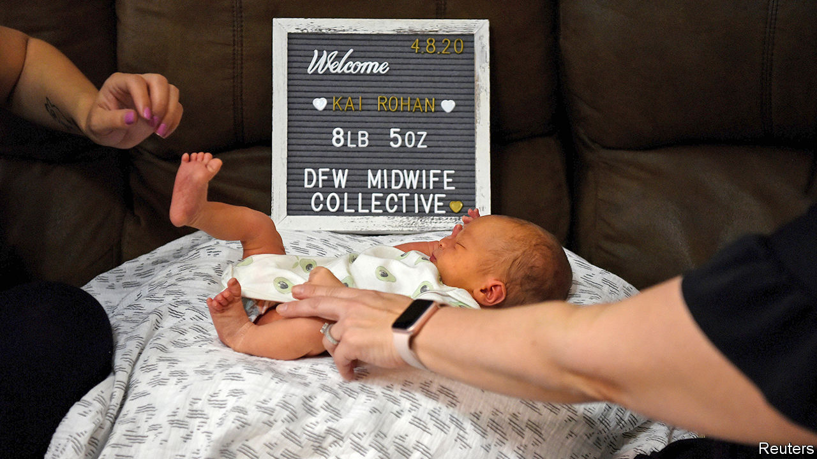

IN A NORMAL year, Robina Khalid might take on 70-80 clients at her midwifery practice in New York City. But 2020 has not been a normal year. She got around 150 calls in the first half of March alone. Some enquiring women were already late in their third trimester, she says, but were terrified of having their babies in a hospital for fear of contracting covid-19. Ms Khalid’s practice was not the only one inundated by calls from women entertaining the idea of a home birth. As the virus spread, so too did interest in alternative birthing options.

Even in cities at first less hard-hit than New York, many expectant mothers avoided hospitals where they could. Nancy Gaba, chair of obstetrics and gynaecology at the George Washington University Hospital in Washington, DC, noticed an initial uptick in unplanned home births around the time the World Health Organisation (WHO) declared the coronavirus outbreak a pandemic.

In the past, midwives have tended to be marginalised in America. Licensing rules vary across states, and insurance coverage for midwifery services is patchy. By contrast, Sweden has a 300-year-old tradition of professional midwifery. When a hospital in London recently went into partnership with a football stadium to give women a safe place for their prenatal check-ups during the pandemic, midwives were among the staff immediately brought in to help. In poorer countries, too, midwives are essential to maternal and public health.

Beyond the pandemic, American women face two problems that licensed midwives can help with. First, America is one of only 13 countries where the maternal mortality rate increased between 2000 and 2017, putting it in the august company of Venezuela and Syria. The risk of dying during childbirth can be exacerbated by a lack of trust between patients and health workers. In America that is especially true for black women, who die from pregnancy-related complications at more than three times the rate that white women do. Midwives cannot perform complex surgery or deliver babies for women with certain chronic health problems. But they can support low-risk women through labour. That frees doctors to do the harder stuff.

Second, because midwives’ calling-card is not intervening in labour, collaboration between midwives and obstetricians has been shown to lower the number of Caesarean sections. Nearly a third of babies born in America each year are delivered by C-section. But the WHO reckons that the necessary rate hovers between 10% and 15%. Caesarian deliveries can be life-saving for new-born babies and mothers, but they are major surgeries. They increase the risk of infection, haemorrhages and blood clots. George Washington University Hospital introduced midwifery services a decade ago, and has since seen its C-section rate drop by nearly 6%.

Will the interest in midwifery outlast the pandemic? It seems likely. The practice was growing even before the virus started to spread. And collaboration between doctors and midwives can prove effective. “Our doctors were willing to learn from our midwife colleagues,” says Dr Gaba. “If other places could do something like that, I think women would really benefit.”■

Editor’s note: Some of our covid-19 coverage is free for readers of The Economist Today, our daily [newsletter](https://my.economist.com/user#newsletter). For more stories and our pandemic tracker, see our [coronavirus hub](https://www.economist.com/news/2020/03/11/the-economists-coverage-of-the-coronavirus)

This article was downloaded by calibre from <https://www.economist.com/united-states/2020/06/20/the-pandemic-is-making-america-rethink-its-shunning-of-midwifery>

|  |  |  |  |
| --- | --- | --- | --- |
| Previous | Articles | Sections | Next |

|  |  |  |  |
| --- | --- | --- | --- |
| Previous | Articles | Sections | Next |

#### National security chastiser

# Details from John Bolton’s book are damning for Donald Trump

The former national security adviser accuses the president of asking China for help to win a second term and kowtowing to authoritarians

Jun 18th 2020 |

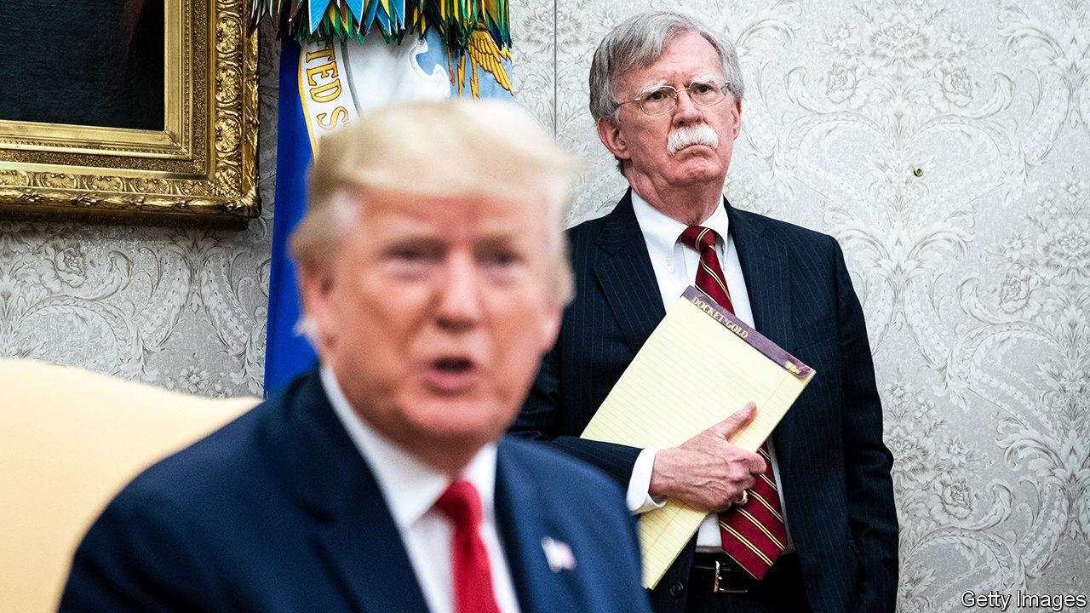

TO JUDGE BY the way he slams his former top officials, President Donald Trump clearly needs to review his hiring policies. Earlier this month he called his first defence secretary, Jim Mattis, “the world’s most overrated general”, after Mr Mattis criticised the use of force to remove protesters from Lafayette Square near the White House. This week it is the turn of John Bolton, his former national security adviser, to come in for attack: Mr Trump called him “a washed-up guy” and “a liar” whom everyone in the White House hated. Mr Bolton has infuriated his ex-boss by writing a book full of damning details from his year-and-a-half in the Trump administration.

The book, “The Room Where It Happened”, was originally scheduled for publication in March, but the administration delayed it for a review of classified information, and it is now due for release on June 23rd. Although last-ditch legal efforts to block it (and to take away Mr Bolton’s earnings from it) continue, details of the juiciest bits from its 592 pages have been emerging in the press from advance copies, and the author has started to give interviews about it. Three main embarrassments for Mr Trump stand out.

The first is on the probity of his policy. The heart of the allegation that led the House of Representatives to impeach the president was that he sought to put pressure on Ukraine not in America’s national interest but in order to boost his own re-election chances, by trying to extract dirt on his Democratic opponent, Joe Biden. Mr Bolton portrays this as part of a pattern. In particular, he says, Mr Trump asked China’s president, Xi Jinping, to help him win a second term. When the two presidents met on the sidelines of a G20 summit in Tokyo a year ago, Mr Trump “stressed the importance of farmers, and increased Chinese purchases of soybeans and wheat in the electoral outcome.”

Humouring authoritarian leaders (Mr Xi, Vladimir Putin of Russia, Turkey’s Recep Tayyip Erdogan) is also a pattern for Mr Trump, according to his former national security adviser. At the same meeting in Tokyo Mr Xi defended his mass detention of Uighurs in Xinjiang. Mr Bolton recounts that Mr Trump told Mr Xi that he thought it was “exactly the right thing to do” and he should go ahead with building the camps.

The second embarrassment for Mr Trump comes from anecdotes about his ignorance. The president is described as “stunningly uninformed” on how to run the government. He asks if Finland is part of Russia. At one point, in a meeting in May 2018 with Britain’s then prime minister, Theresa May, he seemed unaware that Britain was a nuclear power.

Third, Mr Bolton’s book adds colourful details to previous accounts of back-stabbing within the administration and criticism of the president by senior officials. Mr Bolton describes one incident during the summit in Singapore with North Korea’s leader, Kim Jong Un, when Mr Trump said he would seek Senate approval of any nuclear deal. Mike Pompeo, the secretary of state, passed Mr Bolton a note saying that he (meaning Mr Trump) “is so full of shit”.

Mr Bolton is clearly no stylist, but he was a prodigious note-taker, which lends credibility to his account. Democrats will remain angry that he has chosen to spill these beans in a memoir rather than to Congress: he refused to testify in the House impeachment hearings. Would it have made a difference to the outcome had he done so? Mr Bolton thinks not (though he accuses House Democrats of “impeachment malpractice”, in failing to pursue the broader pattern of abuse of presidential power). He is probably right, given the near-unanimous backing for Mr Trump among Senate Republicans that ensured the president’s acquittal.

The bigger question now is whether Mr Bolton’s book will make a difference in November. That is the real reason Mr Trump is furious. Unlike Mr Mattis, Mr Bolton, once a Fox News pundit, has been a darling of the right. And, as he writes, “I am hard pressed to identify any significant Trump decision during my tenure that wasn’t driven by re-election calculations.” ■

This article was downloaded by calibre from <https://www.economist.com/united-states/2020/06/18/details-from-john-boltons-book-are-damning-for-donald-trump>

|  |  |  |  |
| --- | --- | --- | --- |
| Previous | Articles | Sections | Next |

|  |  |  |  |
| --- | --- | --- | --- |
| Previous | Articles | Sections | Next |

#### How’s he doin’?

# New Yorkers turn their backs on Bill de Blasio

The Big Apple’s mayor is underperforming badly

Jun 20th 2020 | NEW YORK

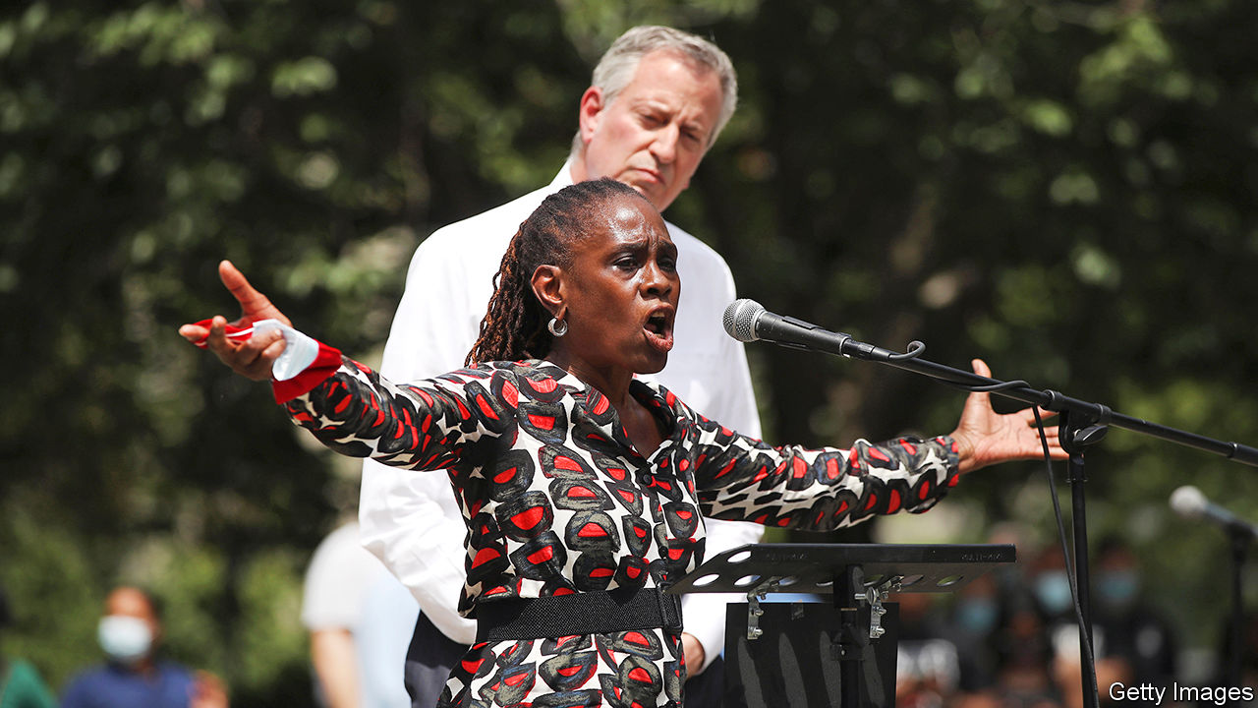

ED KOCH, New York City’s mayor in the 1970s and 1980s, used to ask New Yorkers, “How’m I doin’?” to cheers and jeers. Bill de Blasio, the city’s mayor since 2014, does not ask the question. At the recent memorial service in Brooklyn for George Floyd, the unarmed man who died under the knee of a Minneapolis police officer, Mr de Blasio heard loud and clear what many New Yorkers think of his unwavering support for the police. People there booed and turned their backs on the mayor during his short address. Some chanted “Resign!” Those booing had been his base, the very people who got him elected in 2013.

His mixed-race family attracted black and white New Yorkers alike. His son Dante, then 15 and sporting an impressive Afro, was the star of his campaign advertisements. Borrowing from Dickens’s “A Tale of Two Cities”, a book about the French revolution, to describe the gap between the Big Apple’s rich and poor, Mr de Blasio touched on something that his predecessor, Mike Bloomberg, an otherwise successful manager, had neglected.

The message resonated. His promise to reform the New York Police Department (NYPD), ending stop-and-frisk, a policy that disproportionately targeted black and brown people, was applauded. But, six years on, mothers still fear for their black sons and the gap between the two New Yorks has not narrowed.

When videos recently surfaced of aggressive police behaviour towards peaceful protesters, the mayor still defended the cops. Police appeared to use batons liberally and a police SUV drove into a crowd. Mr de Blasio did little to quell tensions.

This is a 180-degree turn from the reformer who once spoke with emotion about his worries for his black son at the hands of police. Two events might explain this shift. In 2014 Eric Garner, an unarmed man, was killed by a police officer using a banned chokehold. Protests erupted when a grand jury refused to bring charges against the officer. A few weeks later two officers were fatally ambushed by a deranged man seeking revenge for Mr Garner’s death. The rank and file felt besieged. Many turned their backs on the mayor at the funeral of one of the murdered officers. Then he was booed at a police graduation. After that, he grew closer to the NYPD’s leadership. It took nearly five years to dismiss the officer who killed Mr Garner.

His tone-deaf support of over-aggressive police action appalled his staff and former advisers. More than 1,000 of them signed an open letter calling on Mr de Blasio to reform the NYPD and divert $1bn from its budget towards social services. Hundreds of former and current staff marched from City Hall in protest against his handling of the unrest. A city councillor intends to call for a vote of no confidence.

At times, the mayor’s focus has seemed to be elsewhere. He tried to launch a national progressive movement in 2015 and ran for president last year. This national barnstorming distracted from his work at City Hall. He is chronically late to events and meetings.

His handling of the covid-19 crisis has not helped him. Some think he should have shut down the city sooner. More than 20,000 New Yorkers have died. Nor has he prepared the city for a recession. Jonas Shaende of the Fiscal Policy Institute, a local think-tank, says he should have established a rainy-day fund. The economy’s contraction has blown a $9.7bn hole in the budget. Deep cuts are inevitable. Dan Doctoroff, Mr Bloomberg’s former deputy mayor, believes New York will have to maintain quality of life to avoid going into a “vicious cycle of decline like we had in the ’70s”. That won’t be easy.

Mr de Blasio has had successes. The mayor’s roll-out of universal nursery schooling has been copied all over the country. He has kept total crime down. He passed paid sick leave. He introduced an ID card for the city’s many undocumented immigrants. Now he is belatedly shifting NYPD funding to youth programmes. And the NYPD has disbanded plainclothes units involved in many shootings. But his handling of the protests and the pandemic will taint his legacy. ■

Editor’s note: Some of our covid-19 coverage is free for readers of The Economist Today, our daily [newsletter](https://my.economist.com/user#newsletter). For more stories and our pandemic tracker, see our [coronavirus hub](https://www.economist.com/news/2020/03/11/the-economists-coverage-of-the-coronavirus)

This article was downloaded by calibre from <https://www.economist.com/united-states/2020/06/20/new-yorkers-turn-their-backs-on-bill-de-blasio>

|  |  |  |  |
| --- | --- | --- | --- |
| Previous | Articles | Sections | Next |

|  |  |  |  |
| --- | --- | --- | --- |
| Previous | Articles | Sections | Next |

#### The Maine Senate race

# The bid to unseat the last New England Republican in Congress

The race of the long driveways

Jun 20th 2020 |



WHEN CONGRESS convened in January 2001, 11 of the 35 senators and representatives from New England were Republicans. That was not unusual: just as the South is ancestrally Democratic, much of New England is ancestrally Republican. Vermont has only ever elected one Democratic senator, Patrick Leahy, and between 1850 and 2007 elected just two Democratic representatives, who both served only one term (Bernie Sanders caucuses with Democrats but is an independent). The first African-American to win popular election to the Senate was Edward Brooke, a Republican from Massachusetts. The first woman to serve in both houses of Congress was Margaret Smith, a Republican from Maine.

Today, New England Republicans in Congress are rarer than white southern Democrats. Just one remains: Susan Collins, Maine’s senior senator. Up for re-election in November, she trails her presumptive opponent, Sara Gideon, speaker of the Maine House of Representatives, by nine points, according to a poll last month. Democrats need to flip five seats—assuming Doug Jones, a Democrat from Alabama, loses—to take control of the Senate. Many see Ms Collins as among the most vulnerable incumbents. They are in for a fight.

First, reasons for Democratic optimism. Ms Gideon is telegenic and a prodigious fundraiser, raking in more this cycle than Ms Collins. Politicos praise her for the same set of qualities Ms Collins possesses: toughness, preparation and work ethic. ActBlue, a liberal fundraising platform, amassed a $4m war chest for Ms Gideon, much of it before she declared herself a candidate, from donors angry at Ms Collins’s support for Brett Kavanaugh’s nomination to the Supreme Court. Although Ms Gideon has yet to clinch the nomination officially, the Democrats’ Senate campaign arm has endorsed her (her progressive opponent, Betsy Sweet, calls herself an “intuitive healer”, and has worked as a medium, connecting the living to the dead).

At the same time, Ms Collins’s independent reputation has been dented. “She speaks earnestly and slowly, and makes you feel like she’s weighing both sides,” says Carolyn May, a longtime resident of Waldo County who has previously voted for Ms Collins. “But if you watch her votes, it’s been more and more following the party line...she’s not the person that Maine needs.” Indeed, her voting record aligns more closely with Donald Trump’s preferences than with those of any other president during her time in office. That has not helped her approval ratings.

Democrats feel they have the wind at their backs. Mr Trump trails Joe Biden in state polls, and in 2018 Democrats flipped both the swing second congressional district, with Jared Golden, and the governor’s mansion, with Janet Mills. Ms Mills did well with the same sort of “long-driveway Democrats” that Ms Gideon will need to win—meaning often independent-minded, well-off voters in the wealthy southern coastal towns near Portland, Maine’s biggest city. Ms Mills ran up sizeable margins in the state’s populous southern counties, while performing respectably in the more conservative north.

Ms Gideon may find that a hard path to follow. Ms Mills was running against a businessman from southern Maine who had never held office before, while she herself has deep roots in rural Maine. Ms Gideon, who did not move to the state until 2004, is a candidate with impressive credentials from a rich town in Maine’s south, and talks like it; Ms Mills has an unaffected demeanour and a chewy Maine accent.

Ms Collins, as one of her supporters put it, is “a daughter of northern Maine”, raised in the small town of Caribou. She remains a familiar presence at small-town parades and high-school basketball games, and has a sterling reputation for constituent service and bringing money back to the state. None of which is to say she will win. Perhaps Ms Gideon will run up even better numbers down south than Ms Mills. Perhaps she will persuade enough voters from the rural white second district to break with their longtime senator. But it’s a narrow road to the deep north. ■

This article was downloaded by calibre from <https://www.economist.com/united-states/2020/06/20/the-bid-to-unseat-the-last-new-england-republican-in-congress>

|  |  |  |  |
| --- | --- | --- | --- |
| Previous | Articles | Sections | Next |

|  |  |  |  |
| --- | --- | --- | --- |
| Previous | Articles | Sections | Next |

#### Growing your own food

# America rediscovers the joys of vegetable-growing

A shovel-ready project

Jun 20th 2020 |

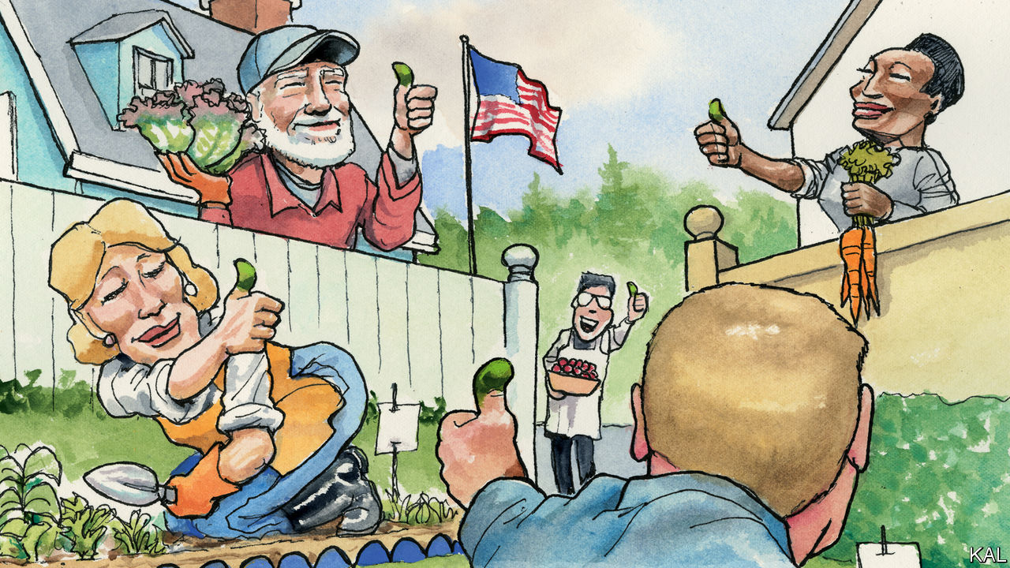

FROM A SELFISH perspective, this hot, quarrelsome month has brought two great joys to your columnist. It gave him his first opportunity to take part in American democracy, in the form of a local election for which his foreign citizenship was no bar. (The contest was also fiery, of which more shortly.) And it was the first June in which he has overseen a vegetable garden ripening at New World pace. Zucchini seedlings planted in late May provided their first sleek squashes to Lexington’s table this week. Tomato seedlings that went in at the same time are now heavy with green fruit. This is nothing like gardening in cloudy England.

Your columnist is not alone in growing more veg this year. The coronavirus lockdown has inspired a surge in gardening not seen since the second world war. Seed firms have struggled to keep up. Even the 144-year-old Burpee company, a fabled name in American horticulture, briefly stopped taking individual orders. On Memorial Day, a traditional marker for planting tomatoes along the east coast, many garden centres had no seedlings available. “In 40 years in this business, I’ve never seen anything like it,” marvelled Ian Baldwin, a Sacramento-based expert (who kindly shared a picture of his enviable potato bed).

European countries have seen a similar surge, presumably for much the same pandemic-related reasons: anxiety about food security, combined with an aversion to going shopping and a glut of enforced time at home. Yet America’s enthusiasm is more remarkable for coming off a lower base. Around a third of British households grew at least some of their own food before the pandemic. Even after a significant increase over the past decade, only a quarter of American ones did. And they have nothing like Britain’s national gardening culture, including popular TV shows and celebrity growers, to encourage them. Michelle Obama’s valiant effort to relaunch the White House’s kitchen garden was chiefly remarkable for its novelty. This contrast points to a few broader American peculiarities—which may now be diminishing.

Like so much in popular culture, America’s rejection of gardening has its roots in the long post-war boom. Where frugal Britons retained some of their wartime allotments, America’s Victory Gardens were abandoned with the gusto of a country remaking the future in a way that left no place for composting and hoeing peas.

In the country’s vast new suburbs, a pristine lawn, visible through a picket fence, was a statement of middle-class belonging. Zoning laws often permitted no deviation from it—so that verdant but sterile suburban yards, drenched in chemicals, soon covered America. Refrigerators and frozen food meanwhile revolutionised the way Americans fed themselves. Between 1945 and 1949 they bought 20m fridges—and filled them with precooked meals, such as the TV Dinners that Ronald and Nancy Reagan loved.

To this day vegetable patches, clotheslines and other non-lawn deviances are often forbidden in the suburbs. Yet America is vast and contradictory. The 1950s also saw J.I. Rodale’s pioneering experiments in organic farming. The 1970s brought a revival of community gardens in many cities. America’s continental scale (it has 13 growing zones to Britain’s four) kept regional horticultural traditions alive. And over the past decade these tendrils have become interwoven in the many gardening blogs, chat-rooms and YouTube stars that have blossomed online. If America still lacks a national gardening culture, it has a diverse and organic one.

This regrowth began during the recession of 2007-09, when millions turned to veg-growing to save money. Those most scarred by that crisis—millennials, who are now less likely to own any sort of property than their parents—have tended to stick with it. Plummeting trust in the food industry and rising interest in organic food have supported this change. So too, industry surveys suggest, has rising interest in growing marijuana.

The trend has almost inevitably been politicised. Egged on by the food industry, the right lambasted Mrs Obama’s garden as elitist and anti-business. In an attack on the former first lady’s appearance, Rush Limbaugh also accused her of hypocrisy: “If we are supposed to eat roots, berries and tree bark, show us how.”

In Donald Trump, who so disdains greens that the White House physician resorted to smuggling cauliflower into his mashed potatoes, the reactionaries have found a champion. His administration has reversed the few gains made by the campaign for better nutrition that Mrs Obama’s garden was meant to spearhead. The township election that Lexington has just voted in also featured a jumbled echo of this politics. It pitted left-wing environmentalists, eager to curb the use of garden chemicals, against a more businesslike group, concerned about the effect of such nannying greenery on local property prices.

To a European transplant, the notion of vegetable gardening having any kind of partisan hue is nuts. Yet Lexington’s experience suggests that such politicking will not stop its resurgence. He expanded his vegetable plot—to the sunny front of his house—not because of the pandemic but after he finally mustered the courage to risk his neighbours’ wrath. Far from objecting, however, several have constructed raised beds of their own. One neighbour, a distinguished law professor, even followed your columnist into the local dumpsters in search of the necessary planks.

## America digs digging

This has led to an intense neighbourly exchange of seedlings, observations and advice. (And commiseration, after the rapacious chipmunks strike.) Great as it is to eat a home-grown squash, cultivating vegetables in a modern economy is fundamentally about such things, not producing calories. It is a useful activity, a blissful therapy, an adjunct to community. It is liberating and equalising. No wonder Thomas Jefferson ranked his best horticultural innovations alongside the Declaration of Independence. In returning to veg-growing, America is rediscovering its better self.■

This article was downloaded by calibre from <https://www.economist.com/united-states/2020/06/20/america-rediscovers-the-joys-of-vegetable-growing>

|  |  |  |  |
| --- | --- | --- | --- |
| Previous | Articles | Sections | Next |

|  |  |  |
| --- | --- | --- |
| United States | Sections | The Americas |

China

The South China Sea: Identify yourself

.

Fighting the pandemic: It’s back

.

Chaguan: Why China bullies

.

|  |  |  |
| --- | --- | --- |
| United States | Sections | The Americas |

|  |  |  |  |
| --- | --- | --- | --- |
|  | Articles | Sections | Next |

#### Identify yourself

# China’s next move in the South China Sea

Is it about to claim the skies above it?

Jun 18th 2020 |

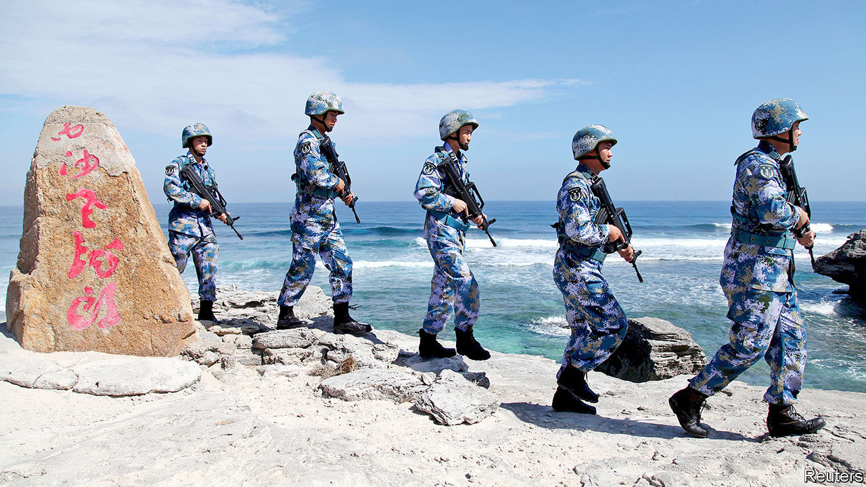

THE LAST time that three American aircraft-carriers prowled the Pacific Ocean was in 2017, shortly after President Donald Trump had threatened to “totally destroy” North Korea. In mid-June a trio of carriers returned—the USS Ronald Reagan and USS Theodore Roosevelt in the Philippine Sea and USS Nimitz farther east. Together they brought more fighter jets than most countries in Asia possess. Chinese commentators had little doubt what the point was this time: to show China that despite covid-19, America still has muscle.

American officials are not so explicit about the meaning of the exercise. But they are clearly disturbed by recent Chinese moves in the South China Sea. On April 3rd China’s coastguard sank a Vietnamese fishing boat near the Paracel islands (see map). On June 10th another one was rammed in the same area by a Chinese ship. In April and May Chinese coastguard vessels harassed West Capella, a Malaysian drillship near Borneo, prompting America and Australia to send warships. In the Spratly archipelago, China’s “maritime militia”, disguised as a fishing flotilla, has been swarming near Thitu, an island controlled by the Philippines but claimed by China. America’s secretary of state, Mike Pompeo, has accused China of taking advantage of distraction caused by covid-19 to engage in “provocative behaviour”.

Jostling in the South China Sea is nothing new. For decades, China and other littoral countries, including Brunei, Malaysia, the Philippines and Vietnam, have competed and clashed over its atolls, shoals, reefs and sandbars. China has largely emerged the victor. And despite promising America in 2015 that it would not militarise the area, it has built ports, runways and bunkers in the Spratlys and installed missiles on these island fortresses.

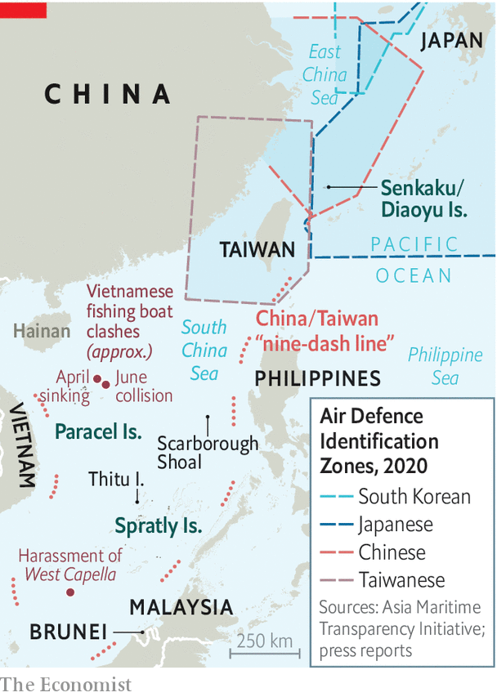

Recently China has been tightening its grip in symbolic ways. In April it created two administrative districts covering the Spratlys and Paracels. They are under Sansha, a notional “city” that China established in 2012 as the sea’s government. It also named 80 new geographical features in the South China Sea, including 55 submerged ones. Now there is speculation that China may turn to the skies above.

For a decade, Chinese leaders have mulled the creation of an Air Defence Identification Zone (ADIZ) over the South China Sea. America was the first country to declare an ADIZ, in 1950. Fearing a surprise nuclear attack, it demanded that planes approaching its airspace follow various rules, such as radioing their course and destination. At least half a dozen other countries now also have such zones.

China established its first ADIZ in 2013 over the East China Sea. Controversially, it covered the uninhabited Senkaku islands. These are controlled by Japan but claimed by China (which calls them the Diaoyu). America promptly sent two bombers to fly through the zone without permission, to show it would pay no heed. But most countries, including America, grudgingly told their civilian airlines to play safe and comply with the new rules. Chinese leaders are now “waiting for the right time” to declare plans for an ADIZ in the South China Sea, according to the South China Morning Post, a newspaper in Hong Kong.

China’s recent moves in the South China Sea have fuelled concern that the time may be nigh. An ADIZ there might be easier for China to monitor than the one in the East China Sea, says Zack Cooper of the American Enterprise Institute, a think-tank. It could use not only radars on Hainan island or the Chinese mainland coastline, but also the new ones it has placed on the Spratlys and Paracels. China could fill in any gaps using surveillance planes or fighter jets, both of which it has deployed on these islands, or else with radar-equipped destroyers. China could probably track “the vast majority of foreign aircraft” entering the ADIZ, says Mr Cooper.

American military planes would undoubtedly ignore China’s rules, as they do in the East China Sea. So why bother? The answer is that even a partially successful ADIZ might benefit China. Although an ADIZ does not imply sovereignty over the airspace it covers, it can be used to show authority. In 2010, for instance, Japan extended its ADIZ to cover a Japanese-held island claimed by Taiwan, which Taiwan had included in its own ADIZ. There is no evidence that China has used its existing ADIZ to disrupt civilian air-traffic, but it may see it as a tool for doing so in a crisis. And China may see an ADIZ in the South China Sea as a way of justifying more air patrols there.

But there are drawbacks. China’s claim to the South China Sea is vague. Its maps show a “nine-dash line” which loops around the entire sea, but the government does not give the line’s co-ordinates nor say what it means. In the East China Sea, China’s ADIZ largely follows its claimed continental shelf. If an ADIZ in the South China Sea were to be drawn only around the scattering of Chinese-held features, it could “fatally undermine” any attempt by China to claim everything within the line, says Alessio Patalano of King’s College London. But if it were to follow that line, there would be a bigger uproar. For years, the ten-member Association of South-East Asian Nations has been divided over how to handle China. Several members are keen to mollify it, while a few would prefer to be tough. A virtual summit is due later this month. An ADIz could tip the diplomatic balance, says Collin Koh of the S. Rajaratnam School of International Studies in Singapore. The bloc’s efforts to negotiate a code of conduct with China to regulate behaviour in the sea could be a casualty.

America’s decision to send warships, drones and bombers to patrol near the beleaguered West Capella (until the drillship left the area in May), and its current deployment of the three carriers, is a signal of support for China’s rivals. In a letter to the UN on June 1st America decried China’s “excessive maritime claims”. It has been sending growing numbers of warships to challenge those claims by sailing through waters that China says it owns. The most recent such “freedom of navigation operation”, on May 28th, was the fifth this year. Even without an ADIZ, the sparring will intensify. ■

This article was downloaded by calibre from <https://www.economist.com/china/2020/06/18/chinas-next-move-in-the-south-china-sea>

|  |  |  |  |
| --- | --- | --- | --- |
|  | Articles | Sections | Next |

|  |  |  |  |
| --- | --- | --- | --- |
| Previous | Articles | Sections | Next |

#### It’s back

# An outbreak in Beijing of covid-19 is causing alarm

It is a setback for a government that thought it had conquered the virus

Jun 20th 2020 | BEIJING

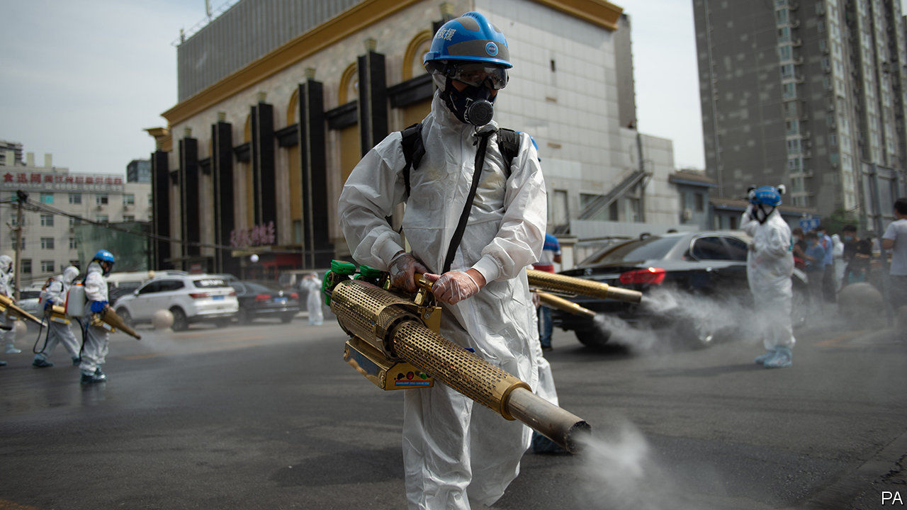

“THE SAFETY and stability of the capital has a direct impact on the overall work of the party and government.” So Xi Jinping, China’s leader, reminded officials in February, as he urged them to pay particular attention to keeping Beijing free of covid-19. For most of the past eight weeks, city officials have had reason to feel chuffed, with no new cases involving local transmission (and usually only a handful at most every day elsewhere in China). Indeed, life had returned almost to normal in the capital, except for the rarity of foreign faces—the country’s borders remain shut to most non-citizens. Then the mood in Beijing suddenly changed.

Officials confirmed an outbreak of new infections on June 11th, concentrated in Fengtai, a south-western district. The number of cases in the city climbed steeply each following day. By the time The Economist went to press, 158 people in Beijing had been confirmed to have the disease. Many of them had visited or worked in Xinfadi, a sprawling wholesale market that is the single largest source of the city’s fresh fruit, vegetables, meat and seafood. The discovery of the coronavirus on a board on which salmon had been chopped prompted speculation by officials that the imported fish was a possible source. Many scientists deem this unlikely.

Officials describe the situation as “grim” and say the city is now in “wartime mode”. Two officials in Fengtai have been sacked “for misconduct in office during epidemic prevention and control”. The manager of the market has also been dismissed. The surrounding neighbourhood and dozens of others have been designated “high” or “medium” risk, meaning their residents are not allowed to leave the city. Other Beijingers will only be allowed to go elsewhere after securing a negative test result for the coronavirus. A massive campaign has been launched to trace and test the 356,000 people who, officials say, have been to the market since May 30th, have had close contact with someone who has gone there, or live nearby.

Officials are trying to show that they are responding decisively, while not appearing to panic. On June 16th, at a press conference held to announce the government’s response, officials who attended did not wear face masks. They spoke of “restrictions” and avoided the word “lockdown”.

But it feels like one. Many flights to and from Beijing, as well as many train and bus services, have been cancelled. Schools and universities, which had only recently started to reopen, have been ordered to shut down again. Businesses, including shops and restaurants, may remain open, but must step up precautions. People have been urged to work from home.

Smaller clusters have emerged in other parts of the country and have been met with similarly decisive countermeasures. But the stakes are higher in Beijing, because of its symbolic importance. A failure to control an outbreak in the capital would undermine the government’s efforts to portray its success in combating covid-19 as evidence of China’s political superiority.

Many of Beijing’s 21m people, like others elsewhere in China, appear confident in the government. “Dammit!” blurts a Mr Li, a shopkeeper in Chaoyang, a district in eastern Beijing. “I really thought we had made it through. It’s awful!” he says. But he says he accepts the need for new restrictions and that he believes they will succeed. If normal life is severely disrupted for long, however, patience may wear thin among those who have suffered blows to their livelihoods or education. That may have been on Mr Xi’s mind when he stressed stability. Officials will go all out in their efforts to crush this outbreak, not least to keep him happy. ■

Editor’s note: Some of our covid-19 coverage is free for readers of The Economist Today, our daily [newsletter](https://my.economist.com/user#newsletter). For more stories and our pandemic tracker, see our [coronavirus hub](https://www.economist.com/news/2020/03/11/the-economists-coverage-of-the-coronavirus)

This article was downloaded by calibre from <https://www.economist.com/china/2020/06/20/an-outbreak-in-beijing-of-covid-19-is-causing-alarm>

|  |  |  |  |
| --- | --- | --- | --- |
| Previous | Articles | Sections | Next |

|  |  |  |  |
| --- | --- | --- | --- |
| Previous | Articles | Sections | Next |

#### Chaguan

# Why China bullies

It sees a world distracted by covid-19, and too economically weak to hold it back

Jun 18th 2020 |

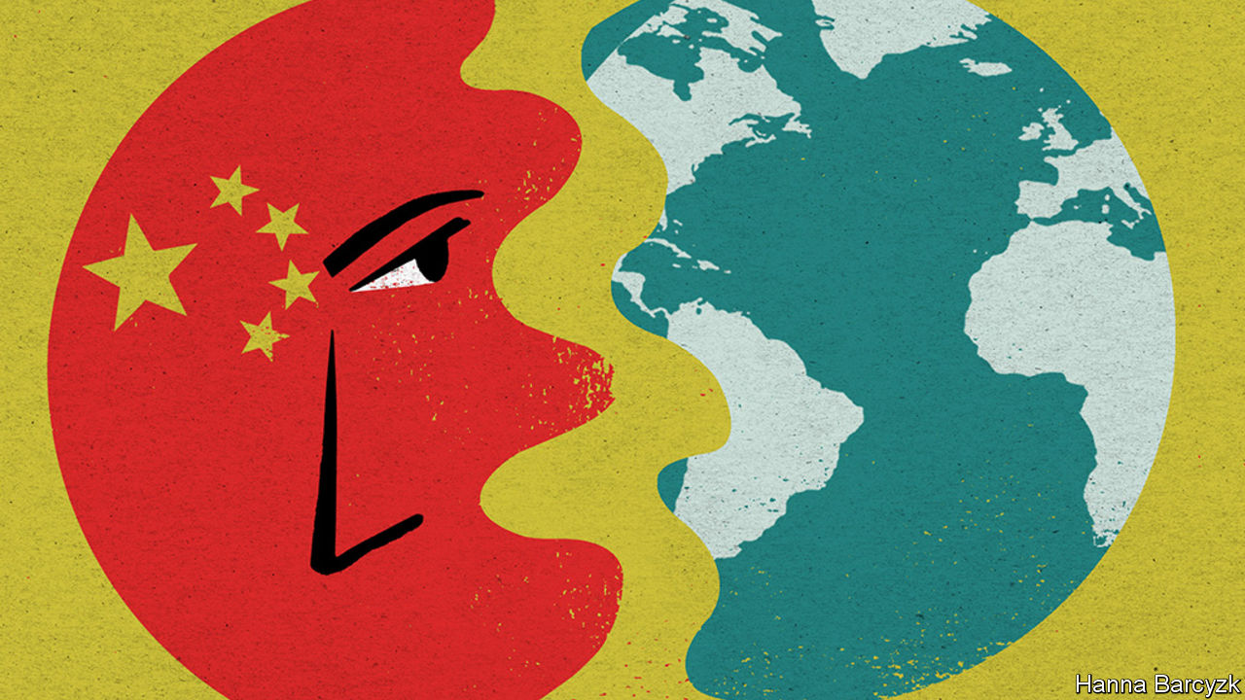

CHINA IS OFTEN called a country in thrall to nationalism. The reality is more complex than that, and more cynical. For proof, look at the remarkable calm (so far, at least) that has reigned since June 15th, when Chinese and Indian troops fought their deadliest border skirmish in almost half a century. On a sweltering afternoon in Beijing, nearly three days after that Himalayan clash, a couple of bored-looking police were the only sign of extra security around India’s embassy.

China’s state-run media had by then issued terse reports of a violent border incident. Lots of internet users reposted news items about dead Indian soldiers. There was only limited grumbling about the failure of official Chinese sources to reveal details of casualties suffered by the Chinese army. Indeed, some netizens treated the story as a joke, mocking India’s soldiers as feeble.

Compare that muted response with the rage provoked last October by the manager of an American basketball team, Daryl Morey of the Houston Rockets, when he retweeted the slogan: “Fight for freedom, stand with Hong Kong”, in support of anti-government protests in that territory. Millions of Chinese demanded Mr Morey’s sacking. Within two days Chinese broadcasters announced that they would not show Rockets games.

Chinese nationalism is often compared to a tiger which Communist Party bosses have fed for years—and which they are now condemned to ride, for fear of being eaten if they dismount. In reality, popular nationalism resembles a deep, man-made reservoir, created by the damming-up and channelling of long-existing forces. Most of the time, Chinese leaders can restrain or unleash public rage at will. Only in the biggest crises do they feel constrained to open the floodgates to ease dangerous pressure.

Public grievances are especially strong when America, Japan or other much-condemned countries are involved. Chaguan was a reporter in Beijing in May 1999 when NATO warplanes bombed China’s embassy in Belgrade, killing three journalists. Chinese leaders dismissed American promises that this was an accident, and for four days let students hurl rocks at the American and British embassies. Violence was controlled like water from a tap. Smashing windows and diplomats’ parked cars was allowed. But when youngsters tried to burn the American embassy’s flag with a flaming rag on a long bamboo pole, Chaguan watched paramilitary police beat them back. “Traitors!” howled the crowd.

Often dismissed by Chinese as poor and chaotic, India is not in the rogue’s gallery of imperialist bullies that China’s young learn about at school. Vitally, two-way trade with India is rather modest: 11 countries are larger trade partners for China. All those factors leave Chinese rulers free to downplay a crisis with India. For even when China appears reckless, it is calculating rewards and risks.

## Opportunistic yes, reckless no

A revealing paper published last year by Ketian Zhang of George Mason University, in Virginia, charts how China has been throwing its weight around in its region. Titled “Cautious Bully: Reputation, Resolve and Beijing’s Use of Coercion in the South China Sea”, it tests claims that China’s willingness to use force is explained by its growing military strength or the assertiveness of its leaders. Actually, China used its armed forces more in 1990s, when they were weak, the paper notes. Today China prefers to use its coastguard, its maritime militia and other agencies to bully neighbours. China was rather aggressive under Hu Jintao, the country’s distinctly cautious leader in 2002-12. Drawing on Chinese archives and interviews with officials, Ms Zhang offers a “cost-balancing theory” of decision-making: that China uses coercion “when the need to establish a reputation for resolve is high and the economic cost is low”. Thus China was quiet in the South China Sea in the early 2000s, when it wanted a free-trade deal with the Association of South-East Asian Nations. Later it became assertive after deciding that this group needed Chinese trade more than the other way round—and had to be deterred from seeking international help in the South China Sea. China especially likes to inflict asymmetric economic pain, as when it banned imports of bananas from the Philippines during a territorial dispute in 2012, devastating Filipino farmers but barely hurting its own consumers.

That pattern continues. Recent Chinese boycotts have targeted things like Australian beef or Houston Rockets games, but not more vital commodities. All this casts another light on China’s assertiveness during this pandemic year, and the notion that China is taking advantage of a world distracted by covid-19 to throw its weight around. It is true that China has been aggressive in recent months. Beyond its readiness to skirmish on the Indian border, it has decided to impose a draconian national-security law on Hong Kong, slapped trade boycotts on Australia and other Western nations, and sent coastguard ships to sink or harass foreign vessels in the contested waters of the South China Sea. It is also true that the world is geopolitically distracted. It is hard for governments to chide China over democracy in Hong Kong, say, while also negotiating to buy Chinese ventilators. But economics matters, too.

This is a time of slumping global demand for China’s goods and interrupted supply chains. Chinese officials are betting on domestic demand to drive their country’s recovery from covid-19. To control the virus, the mainland’s borders are closed to almost all foreigners. Chinese parents are thinking twice about sending students to universities in America, Australia and Europe. Chinese officials growl that Hong Kong-based foreign banks must support the national-security law, for they are eminently replaceable.

All in all, China feels less reliant on other countries than it has for a while. That same China is also being unusually assertive. Follow the logic through, and having limited economic ties with China may not make other countries safer. India is the latest country to be confronted with that dilemma. It will not be the last. ■

Editor’s note: Some of our covid-19 coverage is free for readers of The Economist Today, our daily [newsletter](https://my.economist.com/user#newsletter). For more stories and our pandemic tracker, see our [coronavirus hub](https://www.economist.com/news/2020/03/11/the-economists-coverage-of-the-coronavirus)

This article was downloaded by calibre from <https://www.economist.com/china/2020/06/18/why-china-bullies>

|  |  |  |  |
| --- | --- | --- | --- |
| Previous | Articles | Sections | Next |

|  |  |  |
| --- | --- | --- |
| China | Sections | Middle East & Africa |

The Americas

Covid-19: Leaving lockdowns

.

Uruguay: Standing apart

.

Bello: Breaking a gentlemen’s agreement

.

|  |  |  |
| --- | --- | --- |
| China | Sections | Middle East & Africa |

|  |  |  |  |
| --- | --- | --- | --- |
|  | Articles | Sections | Next |

#### Leaving lockdowns

# Latin America opens up before it’s ready

Mexico’s failure to contain covid-19 shows why the region is now the centre of the pandemic

Jun 20th 2020 | MEXICO CITY

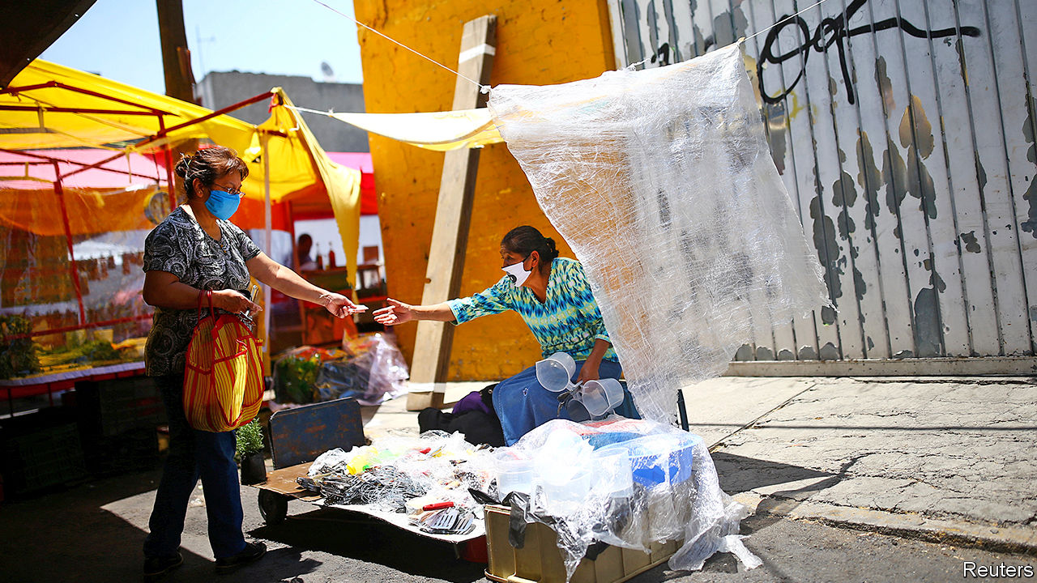

ON A SPRING afternoon in Mexicali, in northern Mexico, Erick Mercado pondered what was coming. The private Hispanic American Hospital, where he runs the accident-and-emergency service, had cancelled all elective surgery and made plans to seal off the second floor. In half an hour, he explained, the governor of Baja California would confirm the state’s first coronavirus cases. People with flu-like symptoms, Dr Mercado predicted, would “go into a panic” and rush to hospitals for testing. Sure enough, a queue appeared in the car park by nightfall.

Three months later, Dr Mercado and his hospital are at breaking point. For every covid-19 patient to whom he can offer a bed, he must turn away five. More than 90% of the city’s hospital beds are taken, and the number of registered deaths nearly tripled to 660 in the first half of June. Dr Mercado’s days are filled with suffering patients, exhausted staff and visitors who cannot approach loved ones. Most distressing of all is knowing that “people who do not comply” with government orders to stay at home, wear masks and keep social distance have made the pandemic worse.

His frustration is provoked by the messiness of Mexico’s response to covid-19. The government shut down the formal part of the economy on March 30th, when fewer than 1,000 cases had been registered. But—unlike in richer countries—its lockdown order failed to contain the outbreak (see chart). Mexico has 159,793 confirmed cases and 19,080 deaths. Although the number of new cases nationally has lately fallen, it is still rising in 27 of the 32 states. Yet with covid-19 on the rampage, the country is easing its controls.

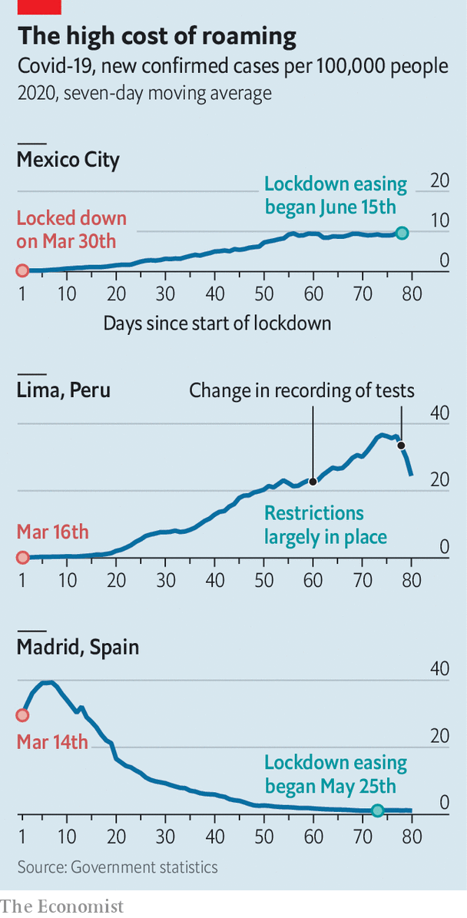

The rest of Latin America shares its plight. The region is reporting more cases each day than Europe did during its covid-19 peak in April. By some measures it is the world’s most urbanised region, which may help explain the virus’s spread. Governments’ responses have varied greatly. Brazil’s President Jair Bolsonaro has been cavalier, dismissing covid-19 as “sniffles” and breaching his own health ministry’s social-distancing advice. Nicaragua’s Daniel Ortega imposed no lockdown. Governments in Peru, Argentina and elsewhere acted early and sternly, using the police to enforce quarantine orders. Yet with few exceptions (see [article](https://www.economist.com/node/21788193)), the spread of the virus has been swift.

Even where the rules are strict, many people have not obeyed. The rich have adhered to lockdowns more than the poor. Many informal workers—street vendors, cleaners and the like—must work to eat. Few Latin American countries have European-style safety nets. Many have nonetheless provided emergency aid. In Brazil, El Salvador and elsewhere beneficiaries flocked to cashpoints, potentially spreading the virus. In a region where trust in government is low, citizens are detached from the state “not just legally, but emotionally and cognitively”, says Hugo Ñopo, a Peruvian economist. That makes them less inclined to listen to pandemic pleas from officialdom. The resignation, firing or arrest of six Latin American health ministers since March is unlikely to have bolstered citizens’ confidence in governments.

Despite the region’s leaky lockdowns, its economy will shrink by 7.2% this year, more than anywhere else, predicts the World Bank. Small wonder that governments besides Mexico’s are contemplating ending lockdowns before they have tamed the disease. They are taking a gamble.

A quasi-quarantine is better than none. Andrés Manuel López Obrador, Mexico’s president, has said in private meetings that his priority is to avoid the apocalypse that struck Guayaquil, Ecuador’s largest city, where corpses lay in the streets in April. Mexico’s quarantine achieved that, buying time for the government to find extra beds, doctors and ventilators, educate citizens and review research about how to halt the virus. It was loose by design, avoiding “authoritarian” restrictions on movement and allowing workers in informal jobs to continue to practise their trades. Nonetheless, the government expects up to 10m people to fall below its poverty line this year.

In Iztapalapa, a suburb of Mexico City that has the country’s highest confirmed infection rate, both the lockdown and the government that ordered it seem distant. On Callejon 57, a tiny colourful street, life carries on as normal. Although Mexican media dubbed it “Covid Alley” after it saw 45 deaths in three months, many residents downplay the threat. One man says the powers that be want to kill off pensioners. Another, whose uncle died recently (“not from covid-19”), thinks the government is exaggerating to keep the poor under its thumb. Others doubt the virus is real. Yet most residents make some effort to protect themselves and others. “When the deaths started the masks came out,” says Miguel Contreras from behind a sheet of plastic at his hole-in-the-wall convenience store.

Joaquín Reyes recalls that when his 90-year-old grandmother died, he could say farewell only by phone, through a doctor. The doctor said covid-19 “probably” killed her, though the death certificate does not mention it. Mr Reyes, who wears a mask as he flattens chicken breasts at the stall outside his house on Callejon 57, is unsure. His till, a margarine tub packed with coins, is filled with water to ward off germs. This reassures customers, he explains. As ever, he is working long hours and resting only on Sundays. “If I had money, I would stay in my house all day,” he says.

Covid-19’s devastation is greater than the government admits. Among the 25 countries with most cases, none tests fewer people than Mexico as a share of population. Two in five tests are positive, a sign that the outbreak is being badly undercounted. An analysis of death certificates shows that between April 1st and June 7th Mexico City had 17,000 more deaths than it normally does over that period. This suggests a toll nearly four times the government’s count. The capital’s excess deaths are nearing New York’s 25,000, even though its people are on average younger.

Despite this, Mexico’s government is desperate to end lockdown. It expects the pandemic to peak this month. The government has introduced a traffic-light system, which encourages states that are taming the virus ease lockdowns. Just one state qualified for any colour other than red. But the government tweaked its criteria so that 16 could begin to reopen on June 15th. Mexico City, which remains red, is starting to reopen anyway.

Other countries that left lockdowns prematurely have suffered. Guatemala and Venezuela have tried alternating between tough and loose regimes, only to find that cases rise after streets fill up during lax phases. Panama City and Santiago, Chile’s capital, have reinforced lockdowns after authorities declared victory too early. Chile now has the highest confirmed infection rate of any non-tiny country.

Even so, many countries, suffering lockdown fatigue along with economic pain, are moving towards gradual easing. Bolivia, Colombia and Honduras, whose president, Juan Orlando Hernández, was hospitalised after testing positive for the virus, plan to phase out their lockdowns this month. Governments hope thereby to support their economies. They run the risk of boosting the virus, too.■

Editor’s note: Some of our covid-19 coverage is free for readers of The Economist Today, our daily [newsletter](https://my.economist.com/user#newsletter). For more stories and our pandemic tracker, see our [coronavirus hub](https://www.economist.com/news/2020/03/11/the-economists-coverage-of-the-coronavirus)

This article was downloaded by calibre from <https://www.economist.com/the-americas/2020/06/20/latin-america-opens-up-before-its-ready>

|  |  |  |  |
| --- | --- | --- | --- |
|  | Articles | Sections | Next |

|  |  |  |  |
| --- | --- | --- | --- |
| Previous | Articles | Sections | Next |

#### Standing apart

# How Uruguay has coped with covid-19

Low density and high trust help

Jun 20th 2020 | BUENOS AIRES

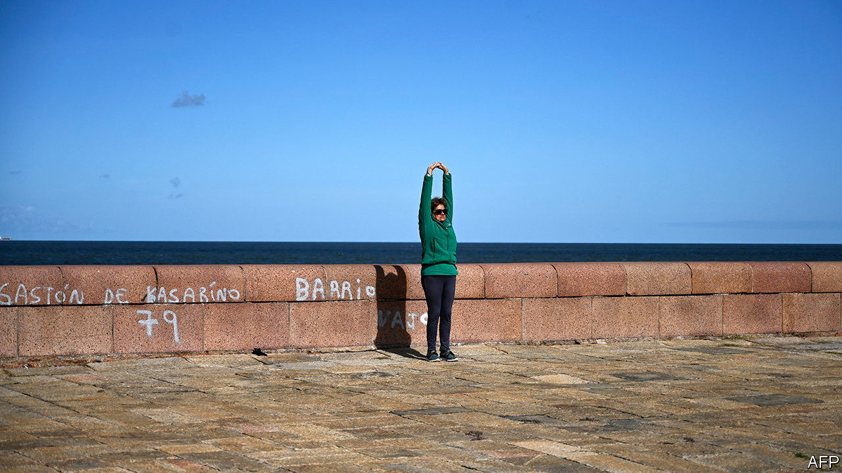

BETWEEN TAKING calls on his radio show, Horacio Abadie explains to a journalist Uruguay’s success in curbing the spread of covid-19. Rather than locking people down, the government trusted them, he says. And people behaved responsibly. “Mutual trust has us controlling the virus.”

By June 18th Uruguay had reported 849 confirmed cases and 24 deaths from covid-19, the lowest number as a share of population of any country in South America. Uruguay has administered 55,215 tests, a regional record.

Luis Lacalle Pou, the centre-right president, was swift but not strict. On March 13th he declared an emergency and shut the borders. Like the populist leaders of Brazil and Mexico, he is at pains to shield the economy. Unlike them, he does not make light of the disease. “It was such a surprise to see a president listen to a doctor, or a mathematician, digest the advice, then communicate a message to the public free of any politics,” says Eduardo Savio, an epidemiologist who advised the government.

The government calls its policy libertad responsable (responsible liberty). It shut down schools, cinemas and shopping malls. It urged people to work from home, wear face masks and keep their distance from each other, but did not confine them to their houses. Mr Lacalle Pou “was not going to imprison people”, says an adviser.

They seem to be paying heed. Alberto, a pensioner, wears a face mask as he jogs on the beach in Montevideo, the capital, and does not linger to sunbathe. “The government trusts me to behave, and I trust the government to look after me,” he says.

Alberto is among the 14% of Uruguayans older than 65, the largest share in the Americas. That should make the country more vulnerable to the pandemic’s ravages, but its advantages matter more. They have little to do with its new president.

Montevideo, which has 1.4m people, two-fifths of Uruguay’s population, is the only largish city. It has no metro. Its network of buses, on which the virus can easily spread, is small. Uruguay’s century-old welfare state, the first in Latin America, created “confidence that the state looks after you”, says Adolfo Garcé, a political analyst. Free, reasonably good health care is available to everyone. Three-quarters of workers have formal jobs, well above the regional norm.

In a poll by Latinobarómetro in 2018, 39% of respondents in Uruguay said they trusted the government, the highest share in Latin America. When the president enlists them to fight an emergency, they are disposed to listen. Mr Lacalle Pou won the election in November by less than two percentage points, but 77% of Uruguayans support his handling of the pandemic.

The president campaigned as a reformer of the welfare state, the cost of which has led to large budget deficits. He promised to slash the bureaucracy while maintaining the level of service it delivers. He imposed a temporary tax increase on public-sector employees, including himself, during the pandemic. The $12m in extra revenue is to be spent on boosting the economy. He is pressing ahead with an omnibus “law of urgency”, which has 476 measures to shrink the government payroll, strengthen the police, reform education and weaken trade unions. On June 5th the Senate reassembled to debate and then approve it. The opposition called the rush to pass it an “abuse of power”.

The trust Mr Lacalle Pou enjoys may drop if the recession caused by covid-19 is long and deep. The IMF expects the economy to shrink by 3% this year, less than the regional average but painful enough.

The president is putting Uruguay back to work. Nine-tenths of businesses have reopened. On June 1st the government began reopening schools, with sample testing of teachers and students. If that reveals an outbreak, they will shut again. “Uruguay looks like the exception in Latin America,” with an economy that can rebound from the pandemic, says Aldo Lema, an economist. If it can contain covid-19 at the same time, its neighbours will look to the one-time buffer state for lessons. ■

Editor’s note: Some of our covid-19 coverage is free for readers of The Economist Today, our daily [newsletter](https://my.economist.com/user#newsletter). For more stories and our pandemic tracker, see our [coronavirus hub](https://www.economist.com/news/2020/03/11/the-economists-coverage-of-the-coronavirus)

This article was downloaded by calibre from <https://www.economist.com/the-americas/2020/06/20/how-uruguay-has-coped-with-covid-19>

|  |  |  |  |
| --- | --- | --- | --- |
| Previous | Articles | Sections | Next |

|  |  |  |  |
| --- | --- | --- | --- |
| Previous | Articles | Sections | Next |

#### Bello

# A gringo takeover bid for the Inter-American Development Bank

The United States breaks a gentlemen’s agreement

Jun 20th 2020 |

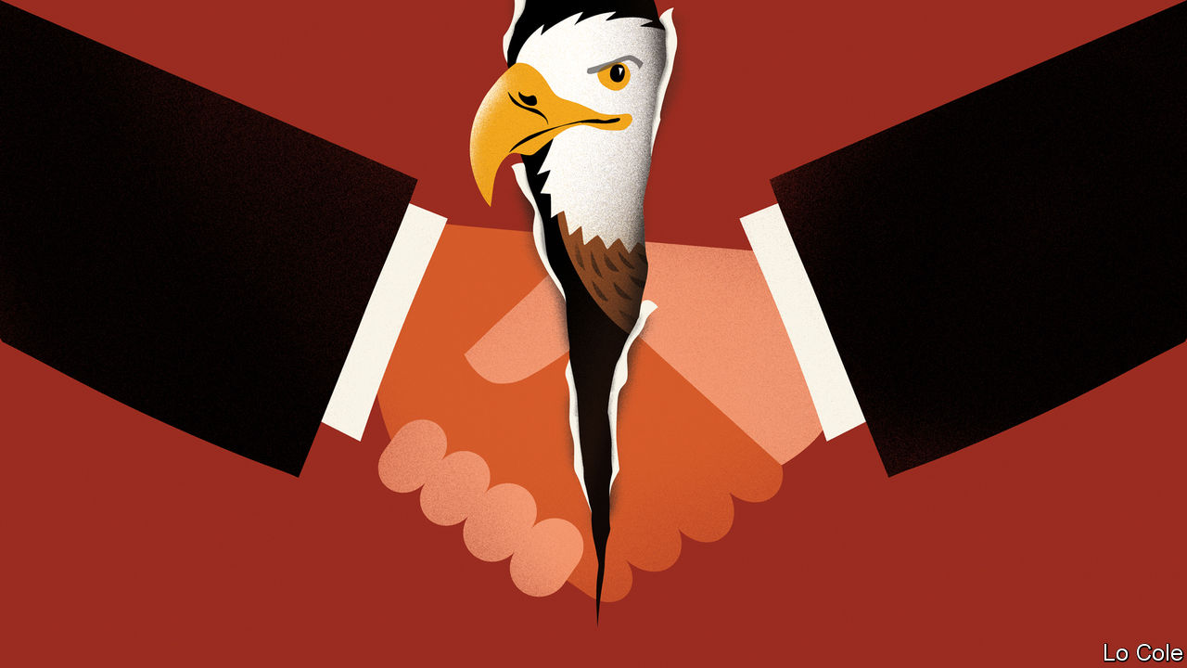

SINCE IT was founded in 1959, the Inter-American Development Bank (IDB) has had just four presidents: a Chilean, a Mexican, a Uruguayan and, since 2005, Luis Alberto Moreno, a Colombian. Under the gentlemen’s agreement by which it was founded, Latin America has the presidency and a small majority of the capital while the United States has the number-two job and some informal vetoes over how the bank is run. The IDB has not been free of the faults of such institutions, such as bureaucracy and a degree of cronyism, but it has played an important role in the region. It lends around $12bn a year for infrastructure, health, education and so on, does some useful research and advises governments. It has also been a channel of communication between the two halves of the Americas.

Donald Trump doesn’t believe in gentlemen’s agreements, and his administration this week broke this one. The Treasury Department named Mauricio Claver-Carone, the top official for Latin America at the National Security Council (NSC), as its candidate to replace Mr Moreno, who is due to step down in September. Mr Claver-Carone, a Cuban-American, is technically qualified for the post. He has been an adviser to the Treasury and a representative to the IMF, and was involved in the Trump administration’s initiatives on development finance. He has told interlocutors that he would serve only one term at the IDB, would bring fresh ideas and would be better placed than a Latin American to get the Treasury’s crucial support for a capital increase that would give the bank resources to mitigate the covid-19 slump in the region. These are things that many in Latin America might welcome.

But Mr Claver-Carone is a controversial choice, and not just because his nomination breaks with tradition. At the NSC he has been the chief architect of Mr Trump’s Venezuela policy, which has failed in its aim of getting rid of the dictatorship of Nicolás Maduro. “He’s a guy who comes with very Miami-type baggage, adversarial to Cuba and Venezuela and representing a conservative alliance,” says a Latin American diplomat. “He would bring ideology directly into the bank.” Mr Claver-Carone walked out of the inauguration of Argentina’s president, Alberto Fernández, in December because of the presence of a Venezuelan minister. Many who have dealt with him describe him as arrogant and confrontational.

Given the Trump administration’s cold war against China, Mr Claver-Carone’s appointment as head of the IDB might force Latin America to choose between the two countries, which the region is reluctant to do. Although China is granting fewer loans to Latin America than it did recently, it remains one of the region’s most important trade partners. The Trump administration was furious with Mr Moreno for agreeing to hold the bank’s annual meeting in China in 2019 (though in the event it was delayed and moved to Ecuador because of a row over who represented Venezuela). Mr Claver-Carone has his own animus against Mr Moreno, who vetoed his appointment as the bank’s vice-president.

For Latin America the loss of the IDB presidency would be a big diplomatic defeat, reflecting the region’s weakness and ideological division. Its leaders are a generally unimpressive bunch. They have failed to unite behind a candidate of their own. Diplomats expected the job to go either to Brazil or to Argentina. Jair Bolsonaro’s government in Brazil informally canvassed support for Rodrigo Xavier, an experienced banker. Argentina’s putative candidate, Gustavo Béliz, is a competent former IDB official, but its centre-left government has few allies in the region. Brazil looks likely to back Mr Claver-Carone, mainly because Mr Bolsonaro has aligned himself closely with Mr Trump. Other smaller countries may, too, because they are desperate for money.

The new president must secure a double majority, of countries representing 50% of the IDB’s shares (the United States has 30% and Brazil 11%) and separately of the 28 members in the Americas. That may yet be a problem for Mr Claver-Carone.

The biggest reason to oppose his nomination is that he represents a polarising administration that may well lose an election in November, making him “the earliest lame duck in history”, as a South American official puts it. The sensible course would be to extend Mr Moreno’s term until next year, both to give time for other candidates to emerge and to see whether Mr Claver-Carone really represents the United States.

Editor’s note: Some of our covid-19 coverage is free for readers of The Economist Today, our daily [newsletter](https://my.economist.com/user#newsletter). For more stories and our pandemic tracker, see our [coronavirus hub](https://www.economist.com/news/2020/03/11/the-economists-coverage-of-the-coronavirus)

This article was downloaded by calibre from <https://www.economist.com/the-americas/2020/06/20/a-gringo-takeover-bid-for-the-inter-american-development-bank>

|  |  |  |  |
| --- | --- | --- | --- |
| Previous | Articles | Sections | Next |

|  |  |  |
| --- | --- | --- |
| The Americas | Sections | Europe |

Middle East & Africa

Covid-19 in Africa: Testing times

.

Malawi: President v people

.

Football and war: More than a game

.

African cities: A tax on all your houses

.

Syria: From bad to worse

.

|  |  |  |
| --- | --- | --- |
| The Americas | Sections | Europe |

|  |  |  |  |
| --- | --- | --- | --- |
|  | Articles | Sections | Next |

#### Testing times

# African countries are struggling to keep track of covid-19

Not enough tests are being done to contain the virus

Jun 20th 2020 | JOHANNESBURG

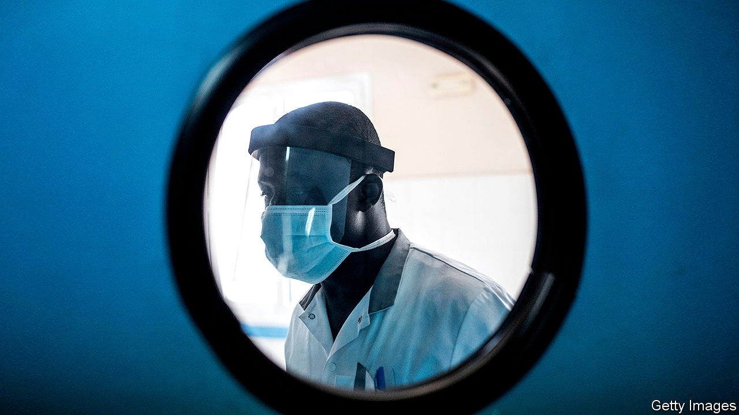

SOUTH AFRICA had a plan for slowing the spread of covid-19. As outlined by Salim Abdool Karim, chair of the medical committee advising President Cyril Ramaphosa, on April 13th, the country would draw on its earlier experience using community health workers to deal with HIV and tuberculosis. It would screen millions of people in poorer areas. Those with symptoms would be tested and then treated and quarantined if necessary.

Yet a sound strategy has been undermined by, among other things, testing failures. State-run laboratories suggested they could do 36,000 tests per day by the end of April. Since April 5th they have managed to do just one-fifth of that. Results have also taken too long. As of June 6th the average turnaround time was 12 days.

Such delays mean the HIV-inspired strategy is “totally futile”, argues Marc Mendelson, an infectious-disease specialist at Groote Schuur Hospital in Cape Town. Waiting 12 days for an HIV test is agonising, but the patient will probably not infect anyone during that time. In the case of covid-19, by the time a result arrives, a patient may have infected scores of others.

Delays put more pressure on hospitals. In the wider Western Cape province, which has 0.5% of Africa’s population and 17% of its known coronavirus cases, intensive-care units are filling up. Others in South Africa may soon follow suit. The country had the 11th highest five-day moving average of confirmed new cases as of June 16th—and the rate of growth is accelerating.

If South Africa—which with Ghana accounts for about half of all tests in sub-Saharan Africa—is not testing enough, then nor are most other countries in the region. At the start of June African countries had tested, on average, fewer than 1,700 people per 1m, a fraction of the number in rich countries (America had done 26 times more per million people). “Testing is our Achilles heel,” says John Nkengasong of Africa CDC, a pan-African health institution. It is also symbolic of broader weaknesses in African health systems that mean the continent is less able to cope with mass outbreaks than rich parts of the world.

The challenge of testing has long been recognised. In February the World Health Organisation (WHO) overhauled African labs. Today 43 of the 47 countries in its Africa region can do molecular testing for covid-19, up from just two at the start of the year. Nevertheless, most countries still lack resources. Nigeria has the capacity to do at least 10,000 tests per day, but has averaged fewer than 900 since announcing its first case on February 27th. Some countries have had to wait more than two months for orders of test kits to be delivered.

The problem is that African countries are competing in the market for testing materials with rich countries, many of which are regular customers of the manufacturers and often buy in bulk. Some small African countries have placed orders for fewer than 10,000 kits, as many as Germany uses in a few hours.

Philanthropy has helped. In most African countries most of the testing kits used are those donated by the charitable foundation of Jack Ma, Alibaba’s founder. He has given at least 20,000 kits to every country in Africa. Yet this is far short of what is required. On June 3rd Dr Nkengasong said Africa needed at least 20m new test kits within 100 days.

To try to meet that goal, countries are pooling their resources and placing large joint orders. Africa CDC has agreed with manufacturers that 90m kits will be bought over the next six months. A bulk purchase establishes trust, argues Fatoumata Ba, a Senegalese venture capitalist and one of several African executives lending their expertise to the Partnership to Accelerate Covid-19 Testing (PACT) scheme.

PACT is a step forward, but problems remain. The first kits bought under the agreement are due to arrive only by the end of the month. And having kits does not obviate the need for technicians; South Africa laboured to keep pace even when it had enough materials.

The struggle to increase testing augurs ill for the broader response. The number of confirmed cases in Africa has been rising by about 30% a week over the past month. But that glosses over trouble spots, such as South Africa or Guinea-Bissau, where almost one-tenth of health workers have been infected. And it means that the absolute number of cases is mounting: it took 98 days for Africa to go from 1 to 100,000 cases, but only 18 days to reach 200,000.

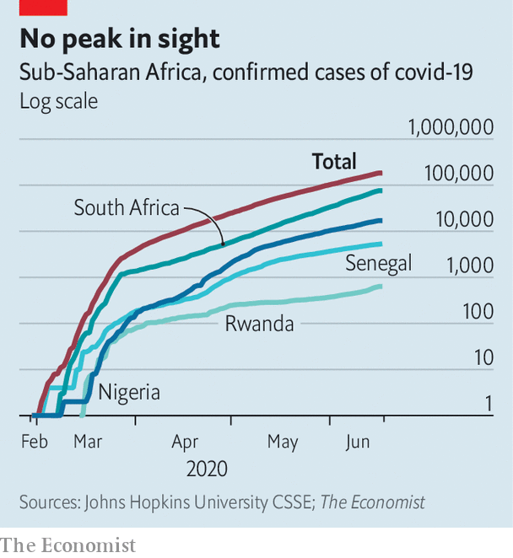

The overall numbers matter, because African health systems will tend to be overwhelmed at an earlier point than those in Asia or Europe. Such weaknesses are the main reason why a study published by the Centre for Global Development, a think-tank, projected that death rates in Africa could be many times higher than predicted by other models that do not account for scant staff and cash-strapped hospitals. Already countries such as Kenya and Nigeria are planning ways to care for people in their homes rather than in hospitals.

Others are trying new ways of gauging the disease’s progress. Just four African countries keep high-quality records showing causes of deaths, according to the UN. In many places most deaths are not recorded, let alone their cause. That makes it hard to calculate whether death rates are higher than average, a useful measure of the disease’s effects. In the absence of excess-mortality data, countries such as Rwanda and Senegal are doing “verbal autopsies”, where next of kin are interviewed.

South Africa does have mortality data going back years. In the three weeks to June 9th deaths from natural causes were unusually high in Cape Town, and on the rise elsewhere, too. At this point more testing would help, says Dr Mendelson, but the focus must be on reducing deaths. With that in mind the Western Cape is rationing public testing to those over the age of 55 and opening field hospitals. “We cannot test our way out of the crisis,” he says. ■

Editor’s note: Some of our covid-19 coverage is free for readers of The Economist Today, our daily [newsletter](https://my.economist.com/user#newsletter). For more stories and our pandemic tracker, see our [coronavirus hub](https://www.economist.com/news/2020/03/11/the-economists-coverage-of-the-coronavirus)

This article was downloaded by calibre from <https://www.economist.com/middle-east-and-africa/2020/06/20/african-countries-are-struggling-to-keep-track-of-covid-19>

|  |  |  |  |
| --- | --- | --- | --- |
|  | Articles | Sections | Next |

|  |  |  |  |
| --- | --- | --- | --- |
| Previous | Articles | Sections | Next |

#### Wigged men v Big Man

# A court in Malawi tries to guarantee a fair election

After a rigged vote was annulled, President Peter Mutharika is trying to cling to power

Jun 20th 2020 | LILONGWE

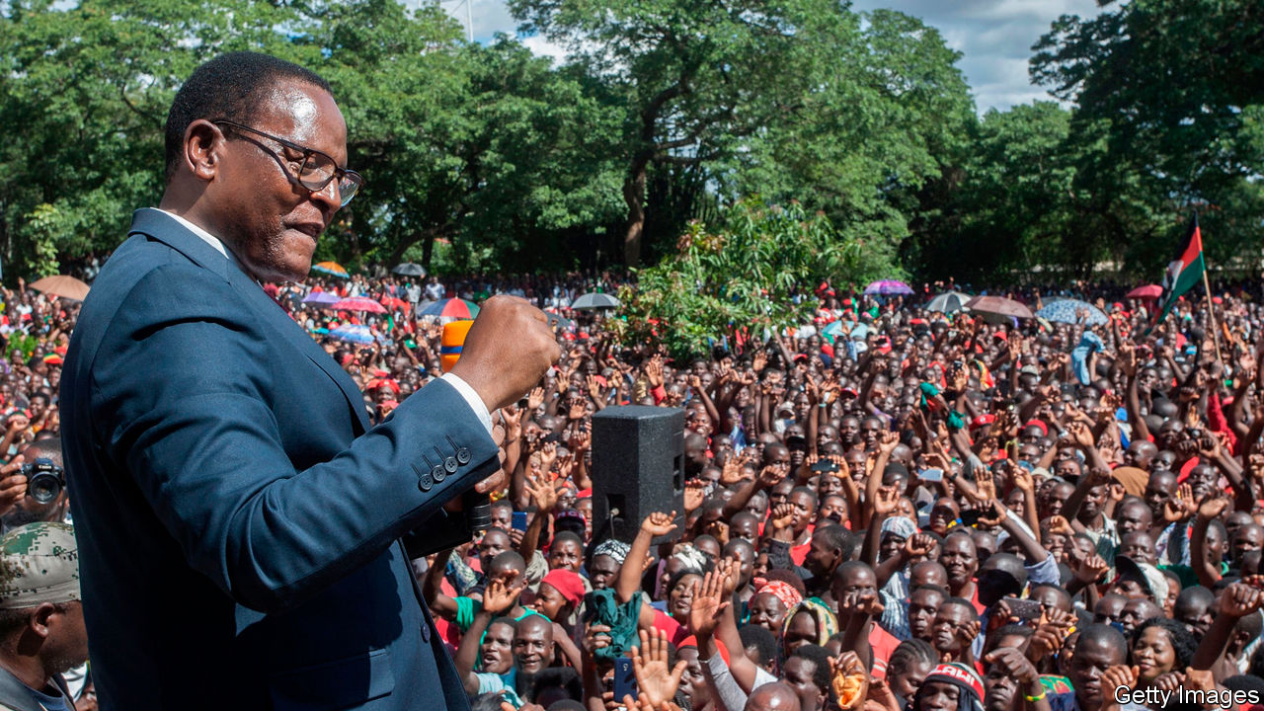

GARTON KAMCHEDZERA is a man of reason. The professor of law at the University of Malawi teaches contracts, trusts and constitutions. But over the past year, as President Peter Mutharika has repeatedly been foiled in his efforts to distort the electoral process, Mr Kamchedzera has wondered whether there might be a higher power at work: God, perhaps, or “some kind of deus ex machina”.

It must feel that way for many in the southern African country of 18m people. A general election in May 2019, which Mr Mutharika was at first declared to have won, involved the liberal use of Tipp-Ex, a correction fluid, to adjust voting tallies. It seemed that credible allegations of rigging were not going to change the outcome. Observers from the European Union noted an “unlevel playing field”, but said the vote was “well managed, inclusive, transparent and competitive”.

Malawians, however, did not accept such whitewashing. Protesters took to the streets. The two largest opposition parties, the Malawi Congress Party (MCP) and the United Transformation Movement (UTM), went to the constitutional court. Its judges refused parcels of cash that were allegedly offered by a businessman linked to the president. On February 3rd the court cancelled the presidential portion of the election and ordered a re-run.

It was only the second time in African history that judges have nullified a vote. A fresh election is scheduled for June 23rd. Yet Malawi is far from out of trouble. Much depends on what happens in the next few weeks. If Malawi, one of the world’s poorest countries, can have a fair election, it will not just be good for Malawians. It will also undermine the argument, used by autocrats everywhere, that covid-19 means democracy ought to wait.

Mr Mutharika has tried to hobble the process. He appealed to the Supreme Court. He delayed appointing a new electoral commission until June 7th. He dithered over the date for the election. And earlier this month his government tried to force the chief justice to retire early.

But the president has been thwarted at every turn. Lawyers rallied around the chief justice. The Supreme Court rejected the appeal. Opposition parties got the election date onto the statute book, in part by defying covid-related restrictions so they could pack the chamber with their MPs.

The opposition’s determination makes sense. Mr Mutharika, who took office in 2014, is the fourth president since Hastings Banda’s long authoritarian rule ended in 1994. The current government has faced myriad allegations of corruption. Fully 85% of Malawians feel the country is heading in the wrong direction, according to a recent poll by the Institute of Public Opinion and Research (IPOR).

The survey suggests that the candidate of the opposition alliance, Lazarus Chakwera of the MCP, will win the re-run. Roughly half of respondents supported him, compared with about a third for Mr Mutharika; the rest were undecided or refused to say. Mr Chakwera, a pastor turned politician, bonded with his running-mate, Saulos Chilima (of the UTM), as they sat together for months in the constitutional court. Their support bases are complementary, says Boniface Dulani, a political scientist at the University of Malawi, Chancellor College. The MCP is strong in rural areas, especially in the middle of the country; UTM does best among young urbanites.

But the duo are far from home and dry. There is still a dash to organise the vote. Ballot papers are being printed in Dubai and are not expected to arrive until June 19th. The timetable is tight. If there are procedural hiccups, Mr Mutharika may use them as an excuse to get his supporters onto the streets and to ask the courts for another nullification.

But that may not work. If the margin of victory is wide, the court will probably forgive a snafu or two. The judges have not only upheld the constitution in the past year. They have also reflected the mood of the people: 80% of Malawians wanted a re-run, says IPOR.

Brave judges ensured that Malawi has a chance of a fair election. But they can do only so much. “Malawians will need to stay vigilant,” says Mr Kamchedzera. ■

This article was downloaded by calibre from <https://www.economist.com/middle-east-and-africa/2020/06/20/a-court-in-malawi-tries-to-guarantee-a-fair-election>

|  |  |  |  |
| --- | --- | --- | --- |
| Previous | Articles | Sections | Next |

|  |  |  |  |
| --- | --- | --- | --- |
| Previous | Articles | Sections | Next |

#### More than a game

# How winning big football matches promotes peace

A study finds that when African national teams are victorious, ethnic tensions wane

Jun 20th 2020 |

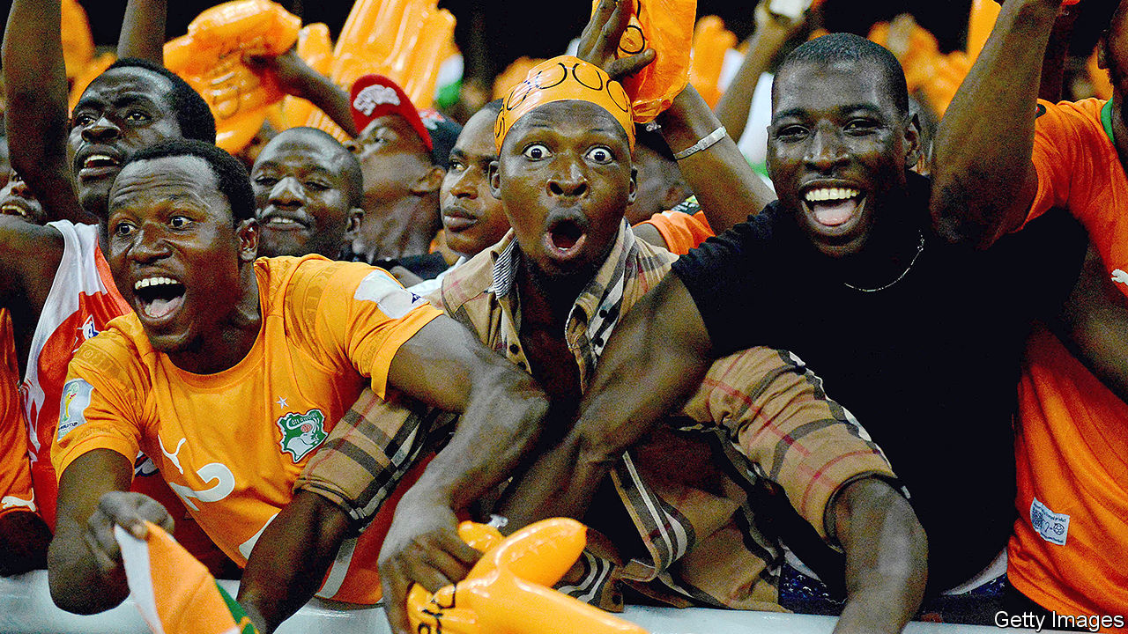

DID A MISSED penalty kick help bring peace to Ivory Coast? In 2005 its national football team was on the brink of qualifying for the World Cup for the first time. Having won its final qualifying match, it just needed Cameroon to lose or draw the match it was playing against Egypt. The awarding of a late penalty set the Cameroonians up for a win. But Pierre Womé hit the post. The ball flew wide. Ivory Coast was in.

Listening on the radio, the Ivorian players erupted. Then they pleaded for peace in their war-torn country. “We proved today that all Ivorians can coexist and play together,” said Didier Drogba, the captain. The team knelt. “We beg you on our knees...please lay down your weapons and hold elections,” said Mr Drogba. The clip was played again and again on Ivorian television. In the months that followed the warring parties began talking and, eventually, agreed to a ceasefire. In 2007 they agreed to peace.

There were, of course, factors in play other than Ivory Coast’s win, Mr Womé’s missed shot and Mr Drogba’s impassioned plea. But, according to a new study, the outcomes of important football matches can have a dramatic effect on national unity and, thus, civil wars.

The study’s authors, led by Emilio Depetris-Chauvin of the Pontifical Catholic University of Chile, looked at how Africans identified themselves and how much they said they trusted each other in the days after important national-team matches. They found that people surveyed after their national squad had won were 37% less likely to identify primarily with their ethnic group, and 30% more likely to trust other ethnicities, than those interviewed just before. “This is entirely driven by national-team victories, whereas defeats have no discernible impact on that self-identification,” say the authors.

The bigger the match, the bigger the boost to national solidarity and trust. This does not merely reflect a general post-victory euphoria, say the authors. Incumbent politicians and ruling parties got no bounce in approval from a win. Nor was there any impact on respondents’ optimism about the economy.

Victories also lead to less violence. The authors compared countries that narrowly qualified for the African Cup of Nations in recent years with those that narrowly missed out. The countries that squeaked in experienced almost 10% less conflict in the next six months than those that did not. The make-up of the squad probably matters, too. Mr Drogba noted that his team hailed “from the north, south, centre and west” of Ivory Coast. “The effect of victories is stronger the more diverse the ethnic composition of the national team,” say the authors.

So could more football reduce conflict in Africa? Perhaps, but the positive results only hold for high-stakes matches, not friendlies (matches unrelated to a competition). And the bonhomie can be fleeting. A second civil war broke out in Ivory Coast in 2010. Calm returned in 2011, after Mr Drogba and many others again appealed for peace.

This article was downloaded by calibre from <https://www.economist.com/middle-east-and-africa/2020/06/20/how-winning-big-football-matches-promotes-peace>

|  |  |  |  |
| --- | --- | --- | --- |
| Previous | Articles | Sections | Next |

|  |  |  |  |
| --- | --- | --- | --- |
| Previous | Articles | Sections | Next |

#### A tax on all your houses

# A mayor is reforming Sierra Leone’s rotten property tax

Other African cities should follow suit

Jun 20th 2020 | FREETOWN AND KAMPALA

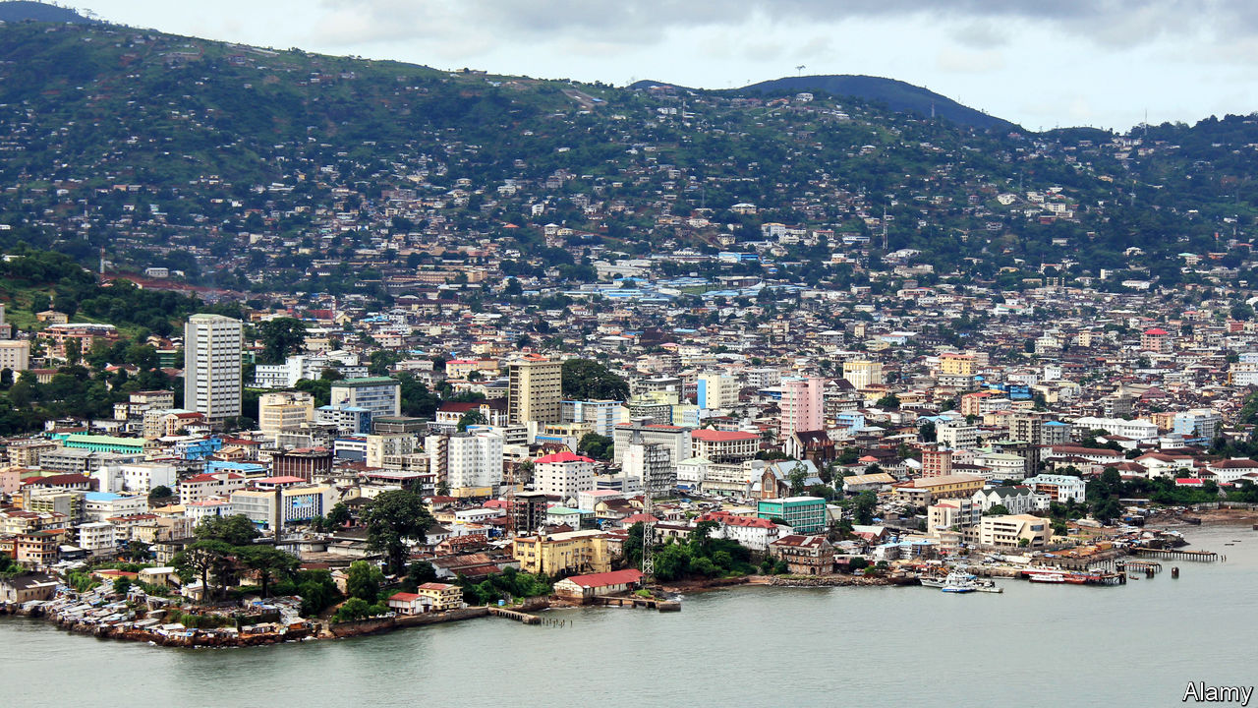

WHEN ASKED why she wanted to be mayor of Sierra Leone’s capital, Freetown, Yvonne Aki-Sawyerr answers without hesitation: “My heart was breaking at what the city was becoming.” In her two years a lot has improved. Gutters have been dug in flood-prone districts. Dustbins have proliferated throughout the city. Grass is sprouting from a roundabout once strewn with litter. But there is still much to do. Electricity flickers. Taps run dry. Rubbish heaps bigger than football fields still fester.

Last year the cash-strapped city council got around 70% of its budget from foreign donors. The mayor is revamping property taxes, which she hopes will bring in five times more revenue this year. Not only does she want the rich to cough up more, she also wants payments to go directly into the bank, rather than be paid in cash. These are big reforms on a continent where property taxes bring in less than 0.4% of GDP, compared with about 2% in the rich world.

Taxing property should reap big benefits, but it is hard to value buildings when you’re not even sure if they exist. Many African cities will triple in size by 2050. But taxmen tend to live in the past: officials in Kenya’s capital, Nairobi, use a property register dating back to 1982. Freetown’s register, until Ms Aki-Sawyerr came along, was a bundle of papers covered in ink scrawls.

It has since been digitised with the help of the International Growth Centre and International Centre for Tax and Development (ICTD). Researchers used satellite photos to count properties and sent staff traipsing around the city with smartphones, plugging in data such as the size of the roof and whether a house was made of brick or tin. A points-based system lets them value properties consistently. Under the old method “they were cheating us,” says Victor Obofor-Smith, who owns a tin shack but has been paying the same in tax as his neighbour in a three-storey brick edifice. In Kampala, Uganda’s capital, the city council is also revaluing property.

Systems can be too simple. For instance, some cities in Congo, Eritrea and Burundi tax a wooden hut at the same rate as a brick one with similar dimensions. Freetown’s new system has found a “sweet spot”, says the ICTD’s Wilson Prichard, as it is simple to administer, efficient and fair. Still, citizens need convincing that they should pay taxes in cities with crummy services. Counting houses is only half the battle. ■

This article was downloaded by calibre from <https://www.economist.com/middle-east-and-africa/2020/06/20/a-mayor-is-reforming-sierra-leones-rotten-property-tax>

|  |  |  |  |
| --- | --- | --- | --- |
| Previous | Articles | Sections | Next |

|  |  |  |  |
| --- | --- | --- | --- |
| Previous | Articles | Sections | Next |

#### From bad to worse

# Bashar al-Assad has no solutions to Syria’s crisis

Even former loyalists are turning on the dictator. But he will not go easily

Jun 20th 2020 |

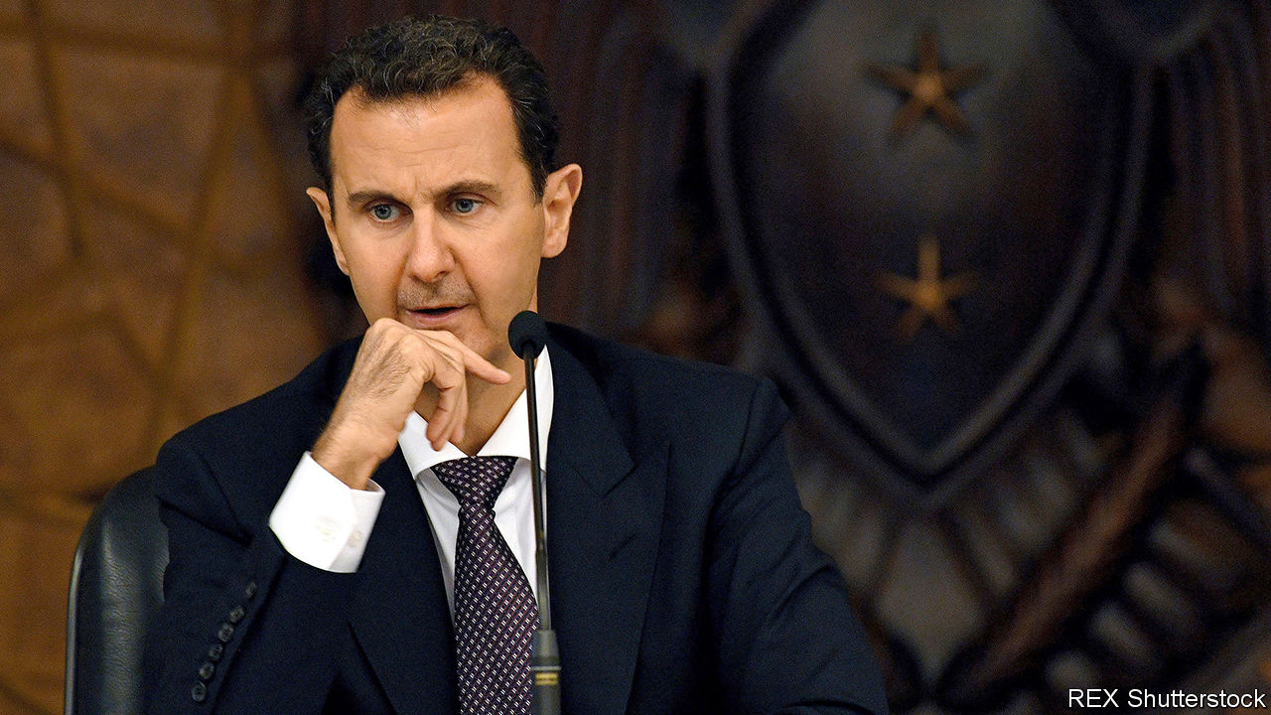

THOUGH IT HAS suffered through nine years of civil war, leaving hundreds of thousands dead, in some ways Syria is back where it started. Protesters in the south-east have been chanting anti-regime slogans, the same ones that triggered the fighting. “God, the nation and freedom,” they cry, dropping Syria’s dictator, Bashar al-Assad (pictured), from the official trinity. A reporter on state television, covering a sparsely attended counter-rally, struggled to find bystanders willing to praise Mr Assad. Most Syrians still complain of poverty, corruption and social inequality. “The grievances that sparked the uprising are even more pronounced today,” says a university lecturer in Damascus.

With help from Iran and Russia, and by bombing and gassing his own people, Mr Assad has all but won the war. Idlib is the last big rebel stronghold in Syria (see map). But the regime now faces new challenges that cannot be resolved with force. A collapsing currency is pushing ever more Syrians into poverty. A new raft of American sanctions will make matters worse. Opposition has cropped up even within Mr Assad’s own ranks. He offers no solutions to the growing crisis.

When Mr Assad inherited the presidency from his father two decades ago, Syria was a middle-income country. Now over 80% of its people are poor. Last year GDP was thought to be about a third of what it was before the war. This year it will be even lower. A covid-19 lockdown is partly to blame. Then there is the situation in neighbouring Lebanon. Syria’s biggest foreign market and main supplier of dollars is mired in a financial crisis. With dollars scarce in both countries, the value of the Syrian pound has fallen to record lows. The currency traded at about 50 to the dollar before the war. Today a greenback fetches about 3,000 pounds on the black market. The rebels in Idlib recently adopted the Turkish lira to replace the pound.

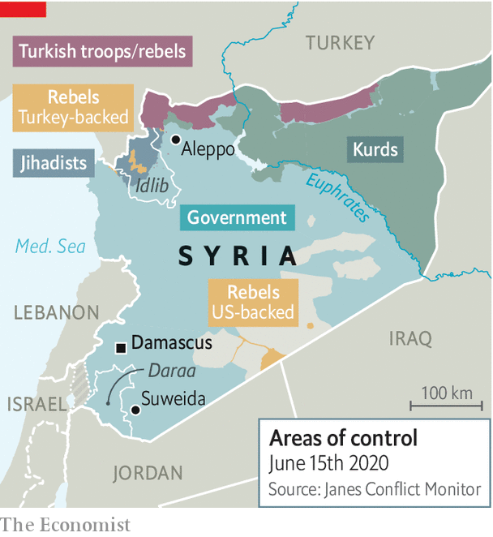

The value of government salaries is also sinking, as prices rise. The upshot, says the UN, is that many people can no longer afford food. Even a local football hero posted a picture of himself on the street with his belongings. Pharmacies have run out of medicines because producers don’t have enough money to pay for ingredients from abroad. Shops and cafés which reopened after the lockdown was lifted have quickly closed again for want of custom. In an effort to prop up its reserves of hard cash, the government has made things worse. Banks have been told to stop lending. They have switched off their cash machines and limited withdrawals. People wait outside in queues, hoping to recover what savings they can before the currency drops again.

Short on answers, as well as cash, Mr Assad has begun fleecing his own wealthy supporters. Many have acquiesced—but not Rami Makhlouf, Syria’s wealthiest tycoon and Mr Assad’s cousin. In May he began posting videos on social media in which he complained about the regime’s heavy-handedness and its confiscation of his assets. Earlier this month Mr Assad seized Syriatel, the country’s biggest mobile-network provider, from Mr Makhlouf.

Other former supporters are also turning their backs on the regime. Hundreds of members of the Alawite sect, an offshoot of Shia Islam from which Mr Assad hails, have protested along the coast. The Druze, followers of a small esoteric religion, have taken to the streets of Suweida. “The regime’s problem is with its loyalists, not with the opposition,” says Ibrahim Hamidi, a Syrian journalist. But violence is also flaring in places such as Daraa, where the uprising began—and which the regime thought it had pacified.

On June 11th Mr Assad dismissed his prime minister, Imad Khamis. The president now relies on a diminishing circle of cronies. But his problems are growing. On June 17th America implemented tough new sanctions on Syria, under what is known as the Caesar Act (named after a former Syrian military photographer who smuggled pictures of torture out of the country). They target any person, company or institution—Syrian or foreign—that does business with or provides support to the regime. The legislation’s net has been cast so wide that it is expected to deter investors and firms which hoped to participate in Syria’s reconstruction.

Mr Assad is undoubtedly weak. Still, he is probably not going anywhere. His people are worn out; millions depend on him to allow the delivery of UN food aid. Four decades of sanctions have taught the regime how to cope with pressure and redirect blame. It says the West is waging an economic war on Syria, after failing to unseat Mr Assad by arming the rebels. It castigates America for handing the territory containing Syria’s oilfields and its bread basket to the Kurds. It is falling back on old smuggling routes, mostly through Lebanon, and creating new ones. Most importantly, Russia and Iran continue to prop up the dictator. They are still hoping for a return on their investment. ■

This article was downloaded by calibre from <https://www.economist.com/middle-east-and-africa/2020/06/20/bashar-al-assad-has-no-solutions-to-syrias-crisis>

|  |  |  |  |
| --- | --- | --- | --- |
| Previous | Articles | Sections | Next |

|  |  |  |
| --- | --- | --- |
| Middle East & Africa | Sections | Britain |

Europe

Poland’s election: Playing the family card

.

Belarus: The slipper revolt

.

The covid economy: Spending big to save jobs

.

France: The call of the wild

.

Charlemagne: How a dining club took over the EU

.

|  |  |  |
| --- | --- | --- |
| Middle East & Africa | Sections | Britain |

|  |  |  |  |
| --- | --- | --- | --- |
|  | Articles | Sections | Next |

#### Playing the family card

# Gay “ideology” is worse than communism, says Poland’s president

Facing a tough election, Andrzej Duda needs enemies

Jun 20th 2020 | WARSAW

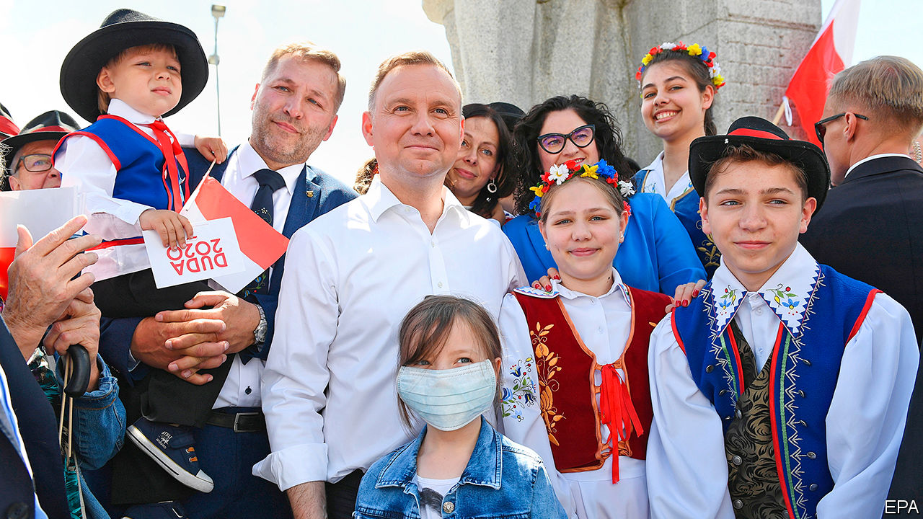

POLES WILL go to the polls on June 28th to vote for their next president, a mostly ceremonial position but with the crucial power to veto laws. The election will be the latest popularity contest between the ruling populist Law and Justice (PiS) party and the centrist Civic Platform, which governed from 2007 to 2015. PiS lost ground in parliamentary elections last year, and it looks as though the contest will go to a run-off on July 12th.

The two candidates, barring a big surprise, will be Andrzej Duda, the PiS-backed incumbent, and Rafal Trzaskowski, Warsaw’s mayor, who joined the race at the last minute. If the liberal, pro-European Mr Trzaskowski beats Mr Duda, his supporters will surely greet it as the beginning of the end of PiS rule.

This will be Poland’s second shot at holding an election during the covid crisis, after the original exercise set for May was called off. Mr Duda faces five main challengers, all men, ranging from the centre-left to the nationalist far-right. Like Mr Duda they all came of age after 1989, a generational shift in Polish politics which has long been dominated by politicians shaped by the struggle against communism.

Mr Trzaskowski joined the race after Civic Plaform’s previous candidate, Malgorzata Kidawa-Blonska, pulled out in mid-May after a lacklustre campaign in which support for her dropped to single digits. On paper, he and Mr Duda are remarkably similar. Both were born in 1972; Mr Duda to a pair of academics in Krakow and Mr Trzaskowski in Warsaw, the son of a jazz composer. Both have doctorates and served as members of the European Parliament. (Mr Trzaskowski also served as Europe minister in 2014-15.)

Yet their politics have placed them on opposite sides in the bitter struggle between PiS and Civic Platform that has gripped the country since the mid-2000s. Mr Duda’s unexpected election as president in 2015 paved the way for PiS’s return to power later that year after eight years in opposition (he resigned from the party after his victory). Three years later, Mr Trzaskowski’s victory in the Warsaw mayoral election, crushing the PiS candidate, showed the limits of the ruling party’s brand of populism.

Mr Trzaskowski won in Warsaw by appealing to liberals. Soon after taking office he signed a declaration in favour of lesbian, gay, bisexual and transgender (LGBT) rights, with proposals including a shelter in Warsaw, anti-discrimination measures and more sex education in schools. This led to a backlash from PiS, supported by the Catholic church. Poland faces an “attack on the Polish family”, warned Jaroslaw Kaczynski, the party’s leader.

## Beating them at their own game

This time Mr Trzaskowski is casting his net wider. He is appealing to moderate conservatives tired of PiS’s radical streak and its disregard for checks and balances (especially judicial ones), which the European Commission has warned undermines the rule of law. “Conservatism rejects radicalism, conservatism rejects nationalism,” he told a crowd in Krakow, Mr Duda’s hometown, on June 6th. He has also pledged to support the PiS government on matters of state interest. The president cannot be in “total opposition” to the government, he says. However PiS does not have nearly enough seats in parliament to override a presidential veto, which could well be applied on a number of other issues.

Suddenly on the defensive, Mr Duda is trying to mobilise socially conservative voters by presenting himself as the defender of the traditional family (56% of Poles oppose gay marriage and 76% are against adoption by same-sex couples, according to a poll last year). LGBT is an “ideology” worse than communism, he told supporters on June 13th in Brzeg, a town in south-western Poland. A “Family Card” of policies presented by him last week includes continuing hefty handouts for children introduced by PiS and not allowing gay couples to marry or adopt. He has been supported by the public-television broadcaster, which PiS took over shortly after it came to power in 2015. “LGBT ideology is destroying the family,” read a caption on its evening news programme also on June 13th.

Since Poland’s rapid and strict lockdown in mid-March, the government has eased most of its coronavirus restrictions. Infections remain lower than in many European countries (30,701 cases and 1,286 deaths, according to official figures from June 17th), despite some recent new outbreaks among coal miners. The government has introduced measures to protect businesses and workers from the economic effects of the epidemic, including a 100bn zloty ($25bn, or around 4.5% of GDP) support package for local firms.

Mr Duda continues to lead in the polls, but the distance between him and Mr Trzaskowski is narrowing. One poll conducted on on June 12th and 13th gives him 40.7%, ahead of Mr Trzaskowski’s 28%, with the other candidates below 10%. With no candidate above 50%, a run-off seems inevitable. The polls suggest that it will be close. The winner will not only claim the presidential palace, but shape whether Poland becomes more open or closed. ■

This article was downloaded by calibre from <https://www.economist.com/europe/2020/06/20/gay-ideology-is-worse-than-communism-says-polands-president>

|  |  |  |  |
| --- | --- | --- | --- |
|  | Articles | Sections | Next |

|  |  |  |  |
| --- | --- | --- | --- |
| Previous | Articles | Sections | Next |

#### Miffed in Minsk

# Waving slippers at the “cockroach” president of Belarus

Alexander Lukashenko, who touted vodka for covid-19, faces real opposition

Jun 20th 2020 |

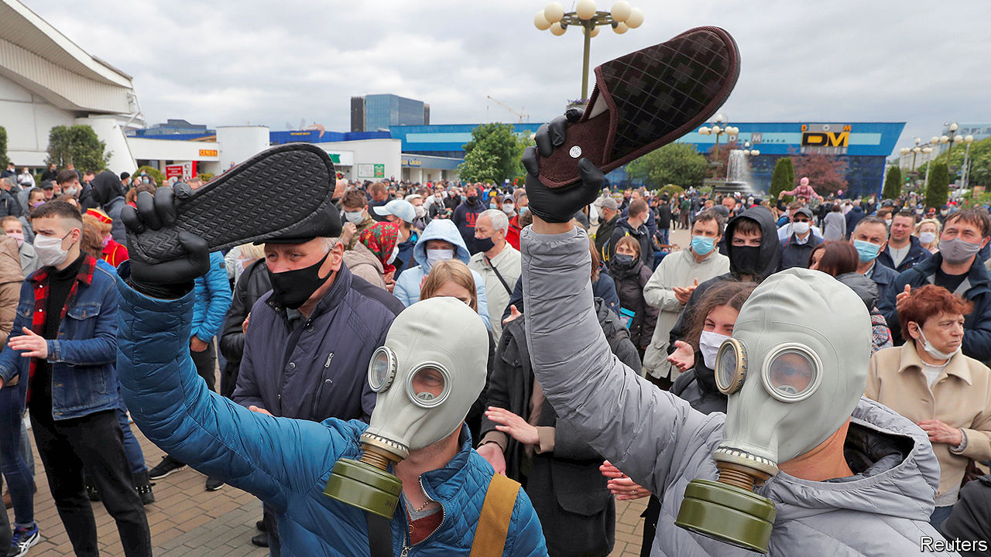

THEY CAME wielding slippers, with which to squish the man they call “the cockroach”. Alexander Lukashenko, an idiosyncratic autocrat, has retained many of the oppressive structures and symbols of the Soviet Union in Belarus for the past quarter-century. But as the country heads towards a presidential election on August 9th, there are signs that the long-preserved edifice is crumbling.

After years of economic stagnation and falling incomes, discontent is as widespread as it was in the early 1990s. That earlier wave of protest swept Mr Lukashenko, a former collective-farm boss, to power. Since then he has kept winning elections with a mixture of populism, paternalism, repression and subsidies from Russia. How many Belarusians really support him is unknown—he has banned independent opinion polls. However, a hint of his unpopularity can be found in the fact that people are queuing for hours to nominate someone else as a presidential candidate.

Mr Lukashenko’s handling of covid-19 has been almost comically inept. He dismissed it as a “psychosis”. He urged people to protect themselves by drinking vodka, driving a tractor and steaming in a banya (sauna). He staged a military parade on May 9th, claiming “it is better to die on your feet than live on your knees.” Now he wants a sixth term in office.

Belarusians have largely ignored his advice. Many wear face masks and maintain social distance. Volunteers have raised money to buy protective gear for doctors and kit for hospitals. “Who else, if not us?” read a post on the volunteers’ Facebook page. Private businesses have joined in. The energy generated by all this activism has flowed into politics, says Franak Viacorka, a Belarusian journalist.

Sergei Tikhanovsky, a former businessman and vlogger, saw an opportunity. He launched a movement called “A country for life”. Mr Tikhanovsky is a charismatic populist, sometimes likened to Volodymyr Zelensky, a former TV comedian who is now the president of Ukraine, and Alexei Navalny, a blogger turned opposition leader in Russia. Mr Tikhanovsky vowed to “stop the cockroach”, as he called Mr Lukashenko (alluding to his moustache, which makes him look like a character in a children’s poem called “The Mighty Cockroach”). Mr Tikhanovsky tied a giant slipper to the roof of his car—a popular weapon for splatting pests of the order Blattodea—and drove around the country talking to ordinary people and streaming live videos.

Within days, the police arrested him. They also “found” $900,000 in his apartment, and suggested that he was a foreign agent. So Mr Tikhanovsky’s wife put herself forward as a candidate. Thousands of people came out to sign her nomination papers. Some carried slippers.

Unlike previous protests in Belarus, the current wave involves lots of middle-class urbanites and parts of the elite, who have spotted a viable alternative as two other independent challengers have emerged from within the system. One is Valery Tsapkalo, a former ambassador to the United States and a founder of Belarus’s successful IT cluster. The other, more serious, challenger is Viktor Babaryko, a former banker. (He was the boss of Belgazprombank, a subsidiary of Russia’s Gazprombank.)

Mr Lukashenko appears rattled. He fired his moderate prime minister, allegedly for his links to Mr Babaryko, and ordered his security services to raid Belgazprombank. In the past week a dozen cases have been launched against Mr Babaryko’s allies. Belgazprombank, which Mr Lukashenko alleges to be a tool of Russian influence, has been placed under the administration of the central bank. To all of this, Mr Babaryko responds that the authorities do not understand that “the Belarus that existed before, and which they trampled under their feet, no longer exists.” ■

This article was downloaded by calibre from <https://www.economist.com/europe/2020/06/20/waving-slippers-at-the-cockroach-president-of-belarus>

|  |  |  |  |
| --- | --- | --- | --- |
| Previous | Articles | Sections | Next |

|  |  |  |  |
| --- | --- | --- | --- |
| Previous | Articles | Sections | Next |

#### Why furlough works

# Germany spends big to save jobs

Other Europeans are following its example

Jun 20th 2020 | BERLIN

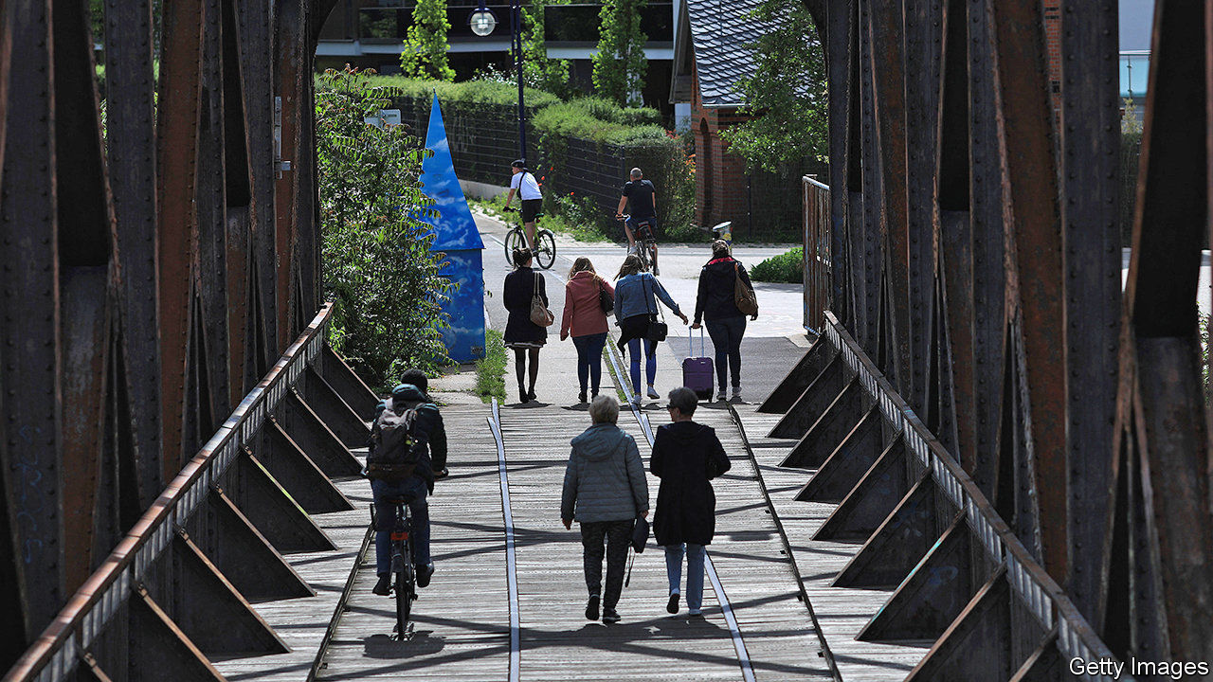

FOR MANY economists, the model for a covid-19 furlough scheme has been Germany’s. It already had a good record, managing to avoid big job losses during the global financial crisis of 2008-09. Then, the German government paid the bulk of wages of people who had temporarily stopped working, rather than letting their employers fire them altogether. It did not prevent a nasty recession, but remarkably few jobs were lost.

Can other countries successfully copy Germany? German economists answer “Jein”—both yes and no. First of all, Kurzarbeit (Germany’s furlough scheme) is being tested on an unprecedented scale. Whereas at the peak of the financial crisis in May 2009 just under 1.5m German workers were furloughed, 7.3m employees in Germany were on short-term work in May, according to the Ifo Institute for Economic Research, a think-tank.

Second, no one knows when the effects of the pandemic will end, or whether there will be a second wave, whereas during the financial crisis it was generally (and rightly) assumed that the recession would be brutal but short. Also, Germany’s scheme dovetailed well with other aspects of German corporate governance, such as workers’ representation on company boards. These stopped bosses firing employees as soon as the economy turned sour.

Nearly all pundits agree that Kurzarbeit is a useful tool. Alexander Herzog-Stein of the Hans Böckler Institute, a think-tank close to trade unions, likens it to a bridge—“but there must be a shore on the other side.” The German scheme is limited to 12 months. The state usually pays 60% of net wages (67% for employees with children), though the government recently decided to raise those contributions incrementally to a maximum of 80% (and 87%) for employees who have been furloughed for seven months or more. During the financial crisis many furloughed workers had well-paid jobs at manufacturing plants. This time, many come from low-paid jobs in retail or hospitality. They would find it hard to make ends meet on 60% of their pay.

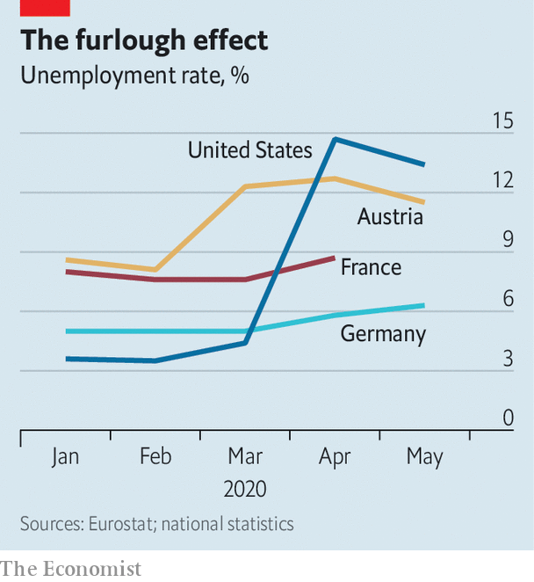

The German scheme has been doing the trick. The registered unemployment rate rose to 6.3% in May, up from 5.8% in April. But mass lay-offs have been avoided. The same goes for furlough programmes in France, Italy, the Netherlands and Spain. France’s chômage partiel was benefiting 8.6m workers at the end of April. The state pays up to 84% of net salary, to a ceiling of €4,608 a month. Employees on the minimum wage still get the full amount. As with the German scheme, it is flexible: firms can claim just a part of a worker’s salary if he or she is putting in reduced hours.

These generous schemes in France and Germany have attracted crooks. The French labour ministry has spotted several types of fraud. Some companies have claimed subsidised wages for employees who have kept working (sometimes even on overtime). Others have submitted claims for more than employees actually earn. By some estimates, as much as 10% of furlough pay is lost to fraud. Muriel Pénicaud, France’s labour minister, has announced that 50,000 companies’ returns will be scrutinised until the end of the summer.

Those sceptical of furlough schemes argue that they are costly and keep alive badly run companies that should die. The cost is indeed gargantuan, but so is the cost of deep recessions. The usual German Kurzarbeit pay is the equivalent of what, on average, people younger than 50 are paid in their first year at work. Some workers would stay in employment anyway, so the payment is wasted on them. Yet it is probably worth subsidising them, saving tens of thousands of jobs, even if that keeps some corporate duds alive for a bit longer.

Oliver Stettes of the Cologne Institute for Economic Research says Austria illustrates why such schemes are working. The registered unemployment rate there rose to 12.8% in April (5.5 percentage points more than a year before). However, once a much improved scheme was brought in, replacing up to 90% of wages, the jobless rate steadied at 11.5% in May. Short-time work schemes are a useful way to bridge a short period of low demand for economies that do not suffer from fundamental structural weaknesses. Depending on the shape of the recovery, unemployment in euro-zone countries may eventually rise once the money runs out—but less than it would have done without furlough schemes. ■

Editor’s note: Some of our covid-19 coverage is free for readers of The Economist Today, our daily [newsletter](https://my.economist.com/user#newsletter). For more stories and our pandemic tracker, see our [coronavirus hub](https://www.economist.com/news/2020/03/11/the-economists-coverage-of-the-coronavirus)

This article was downloaded by calibre from <https://www.economist.com/europe/2020/06/20/germany-spends-big-to-save-jobs>

|  |  |  |  |
| --- | --- | --- | --- |
| Previous | Articles | Sections | Next |

|  |  |  |  |
| --- | --- | --- | --- |
| Previous | Articles | Sections | Next |

#### Townies v tractors

# French urbanites fuss about rustic noises and smells

Some second-home owners have sued over loud livestock and church bells

Jun 20th 2020 | VAISON-LA-ROMAINE



FRANCE’S SENSE of itself has long been rooted in the land, even though three-quarters of French people live in towns. Now, however, having locked down in small airless spaces, many city-dwellers feel the call of the wild. Estate agents report an uptick in searches for homes with gardens. Diehard urbanites talk wistfully of a bucolic existence in la France profonde. In a poll, 61% of the French think confinement will encourage people to move to the country or buy a second home. But do today’s townsfolk know what rural life really entails?

The question arose late last year, when Pierre Morel-À-L’Huissier, a deputy from the Lozère, a remote rural area, introduced a bill to protect France’s “sensory heritage”. By this, he meant “the crowing of the cockerel, the noise of cicadas, the odour of manure”, and other rural sounds and smells. Some of his fellow citizens, it turned out, had judged these intrusions into their romanticised idyll a form of intolerable pollution.

Last year second-home owners on the Ile d’Oléron, off the west coast, brought a case against a cockerel for crowing too early. The court ruled against them, rescuing Maurice, the unfortunate bird, from banishment or worse. In Soustons, in the south-west, a case was brought against the owner of 50 ducks and geese which made a din. Near the Pyrenees, a new resident in Foix filed a complaint against the village because the church bells were too noisy.

Rural people are pushing back against this nonsense. The mayor of Saint-André-de-Valborgne, in southern France, has put up a sign outside his village warning visitors that they are entering a risk zone. Church bells ring often. Tractors make a racket. All because “farmers are working to give you what you eat.” These noises are “not a nuisance but intrinsic and authentic characteristics” of rural life, said Mr Morel-À-L’Huissier. And on its first reading, the National Assembly unanimously backed his bill.

This article was downloaded by calibre from <https://www.economist.com/europe/2020/06/20/french-urbanites-fuss-about-rustic-noises-and-smells>

|  |  |  |  |
| --- | --- | --- | --- |
| Previous | Articles | Sections | Next |

|  |  |  |  |
| --- | --- | --- | --- |
| Previous | Articles | Sections | Next |

#### Charlemagne

# How a dining club briefly took over the EU

What next for the Eurogroup?

Jun 20th 2020 |

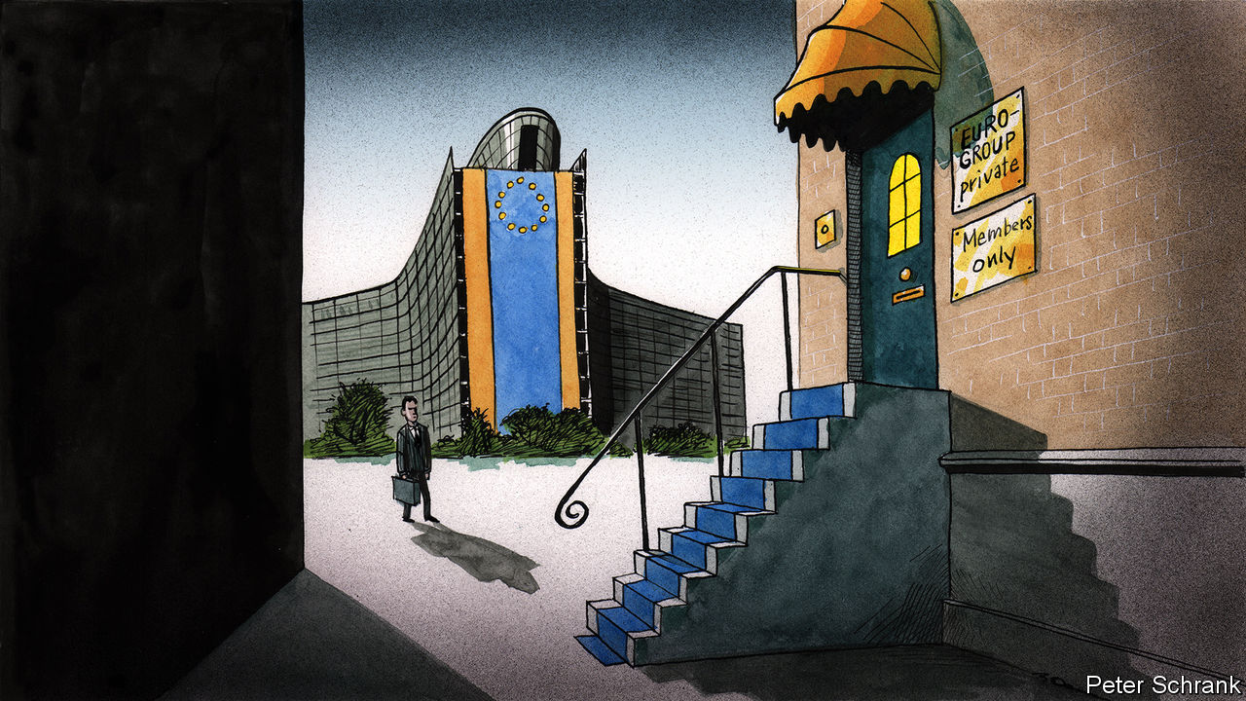

THE EUROGROUP is arguably the European Union’s strangest institution. It started life as a dining club for euro-zone finance ministers to gossip before the official meetings of ministers from the whole EU, yet morphed into a forum where the fate of nations was decided. During the euro-zone crisis, the terms of bail-outs totalling more than €500bn ($550bn) were agreed at its informal, closed-door meetings, at which no minutes were taken (but alcohol and cigarettes were). Even its legal existence is a matter of debate. A recent opinion from a legal adviser at the European Court of Justice suggested that any cases brought against the Eurogroup were inadmissible. The club’s only official rules are that euro-zone finance ministers shall meet for regular informal chats and give its presidents two-and-a-half-year stints. Beyond that, it is a free-for-all. Its working methods can be changed at will. It is Brussels as its best and worst: unaccountable, opaque and brutally efficient. At times it was the closest thing the euro zone had to a government.

Now, the hunt is on for a new jockey to steer this peculiar beast. After two-and-a-half years as the group’s president, Mário Centeno, the Portuguese finance minister, is stepping down. Haggling over his replacement is already under way. Nadia Calviño, Spain’s economy minister and a former official in the European Commission, is in the running and well-regarded. But that is only part of the battle.

The EU is a club that includes a preponderance of small countries. Their ministers may opt for one of their own, lest their bigger peers start to throw their weight around. When it comes to selecting the new president, each euro-zone minister has one vote. This means the three Baltic states (collective population: 6m; combined GDP: €110bn) will have greater say than France and Germany (collective population: 151m; GDP: €6trn). So Paschal Donohoe and Pierre Gramegna, the finance ministers of Ireland and Luxembourg respectively, also have a shot at the job.

Whoever wins will take over a less prominent institution. The Eurogroup reigned almost supreme in the euro-zone crisis. But in the current mess it cuts a smaller figure. When the euro teetered, the Eurogroup was a useful intergovernmental forum for the two sides: those who had money (such as the German government) and those who needed it (such as the Greek one). It operated as a ministerial fight club, where governments could brawl without diplomatic incident. Heads of government “needed a place where you could have a more bare-knuckled exchange”, said George Papaconstantinou, a former Greek finance minister, who was often on the wrong end of such exchanges.

In the current crisis, however, the pain is not limited to the euro zone. All EU economies have collapsed simultaneously, albeit to different degrees. Coming up with a solution that covers only the currency area is no longer necessary now that Britain—the largest and most veto-ready non-euro member—has left the bloc. Without Britain, the remaining non-euro countries—eight out of 27—are vastly outnumbered in terms of population and economic clout. All bar Denmark are obliged to join the euro eventually, even if some drag their feet deliberately. “Multi-speed Europe is dead,” says Lucas Guttenberg from the Jacques Delors Centre, a think-tank, referring to the idea that willing EU members could integrate while others stayed put. “It is one-speed Europe with some laggards.” In such circumstances, the Eurogroup seems a relic.

Fundamentally, the Eurogroup was a stopgap, a way of papering over the cracks inherent in a monetary union without fiscal transfers. Now, however, European leaders are showing a willingness to plug these holes themselves. In April the Eurogroup tried to cook up a fiscal response to the coronavirus crisis. While ostensibly large—it included €540bn-worth of loans—it was deemed inadequate by countries such as Spain, which demanded that any cash come in the form of grants, never to be paid back. EU leaders—led by France and Germany—went even further, channelling their inner federalists by discussing a proposed €750bn package, including €500bn in handouts paid for by debt issued collectively by the EU, rather than individual governments.

## The last supper

The next president of the Eurogroup has the task of making the body relevant again, or reading its last rites. Pessimists think the club will not last long. “In the long term the Eurogroup is destined to fade away,” says one commission official. It could easily be ingested into other EU institutions, which have a proper legal footing. Not all are so sure. Old hands offer reminders that Eurogroup meetings were happily ignored at the start of the millennium, before the EU began a decade of crises after the financial crash. Its time may come again. If someone taps the euro zone’s bail-out funds, then finance ministers will happily stick their beaks into the spending of their peers once more. Plus, the current enthusiasm for bold steps towards integration among EU leaders may not last, leading to a return of the wheeling and dealing of finance ministers in their strange meeting.

Others propose more radical schemes to keep the Eurogroup relevant. After a decade in retreat, Europe’s federalists are on the offensive. Handing the group’s presidency to an EU commissioner rather than a finance minister would create a de facto EU treasury, argues Andrew Duff of the European Policy Centre, a think-tank. Appointing someone like Paolo Gentiloni, the EU commissioner in charge of the economy and a former Italian prime minister, would make sense, given that the commission is likely to be the one in charge of the €750bn in extra crisis spending. Current members of the club are less keen. Finance ministers prefer someone with skin in the game. Ultimately, the EU’s money comes from national capitals. But without such a move, the Eurogroup may end up searching for a new, more modest role. Perhaps being a plain old dining club is not so bad after all. ■

This article was downloaded by calibre from <https://www.economist.com/europe/2020/06/20/how-a-dining-club-briefly-took-over-the-eu>

|  |  |  |  |
| --- | --- | --- | --- |
| Previous | Articles | Sections | Next |

|  |  |  |
| --- | --- | --- |
| Europe | Sections | International |

Britain

Covid-19: Trust me, I’m a prime minister

.

Drug discovery: Small ticket, big difference

.

Anti-racism protest: What next?

.

Diplomacy and foreign aid: Will charity begin at home?

.

Bookshops: Just browsing

.

Bagehot: Losing his grip

.

|  |  |  |
| --- | --- | --- |
| Europe | Sections | International |

|  |  |  |  |
| --- | --- | --- | --- |
|  | Articles | Sections | Next |

#### An unfortunate case study

# The British state shows how not to respond to a pandemic

It faced difficult circumstances. And has so far failed to rise to them

Jun 18th 2020 |

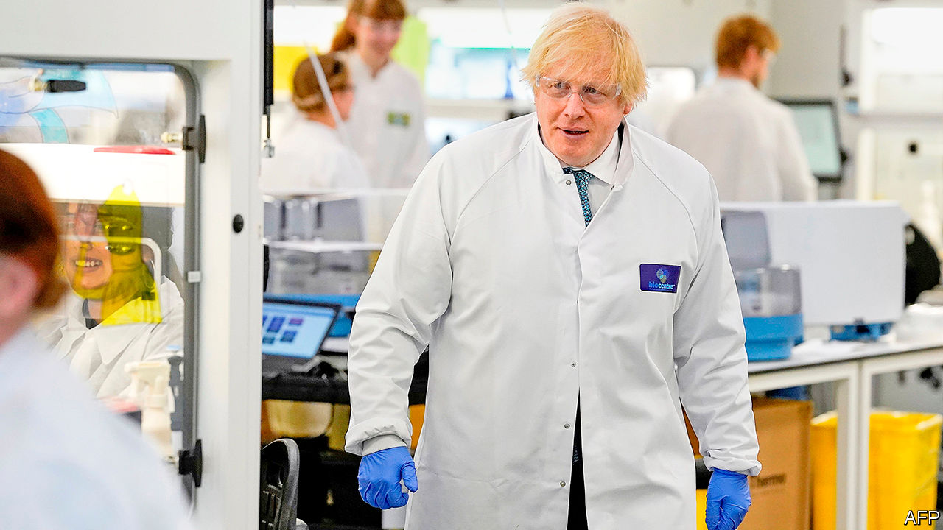

COVID-19 WAS sweeping Europe. Images of overwhelmed hospitals in Lombardy played on television every night. Governments were beginning to put in place restrictions that would last for months. And Mike Padgham, the owner of four care homes in Scarborough and Pickering, in the north-east of England, faced a dilemma. Should he shut his homes to visitors?

If they had been in Alsace or Umbria, the government would have told him to. In Britain, it did not. Despite the lack of national guidance, Mr Padgham nevertheless went for it, closing the homes to all but essential visitors; something which annoyed relatives. “People thought we were jumping the gun,” he recalls. Two days later on March 13th, Public Health England, a government agency, advised those who were unwell to stay away from homes, but also noted the “positive impact” of visits. It took another fortnight for the government to tell care homes to turn visitors away.

Mr Padgham’s foresight was not enough to keep out the virus. There were five deaths in his homes—a small part of a bigger tragedy. Altogether, one in 14 residents in British care homes at the start of the pandemic is thought to have died from the virus. A comparison in May by the International Long-Term Care Policy Network found that a higher proportion of people in care homes in Britain had died than in France, Germany, Canada or Sweden.

Some aspects of the British response to the pandemic have been admirable. Its researchers are leading the search for drugs; an Oxford University trial has found the most promising one yet (see [article](https://www.economist.com/node/21788220)). The National Health Service has weathered the storm. Sweeping organisational changes—including postponing elective surgeries, discharging inpatients and buying private beds—saved it from being overwhelmed. But measured by the number of deaths over and above those that would normally be expected, Britain nevertheless appears to have the highest death rate in the developed world (see chart 1).

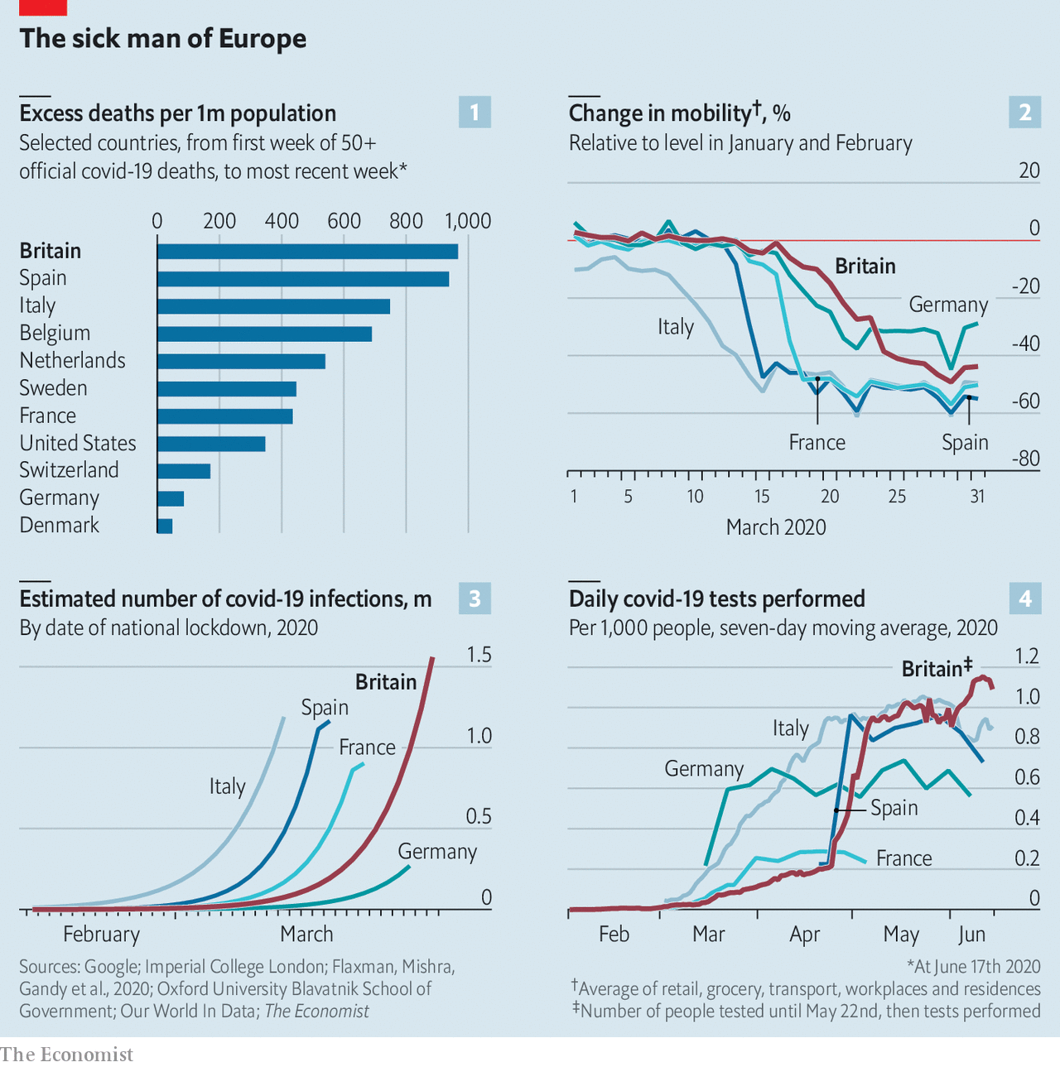

Lots of factors beyond the government’s control contributed to this. Care homes are a popular way to look after old folk. Britons are fatter than their fellow Europeans. The large ethnic-minority population is disproportionately likely to suffer from diabetes and heart disease, which increase the risk of severe covid-19. Genomic analysis suggests Britain imported lots of cases from Spain, before it was clear how prevalent the virus was there. One in seven Britons live in London, an international travel hub which prior to the pandemic received nearly 1,500 flights a day.

Yet the government’s poor response has contributed. On March 12th, having joked two weeks earlier about shaking hands in a hospital with covid patients, Boris Johnson, the prime minister, turned serious: “families are going to lose loved ones before their time.” But the restrictions he announced were light: those with symptoms were told to stay at home for a week; those older than 70 instructed to avoid cruises. Meanwhile, continental Europe was already beginning to lock down.

Given the government’s well-publicised suspicion of “experts’” views about Brexit, some worried it would ignore the scientists’ advice on dealing with the pandemic. These fears were unfounded. The government’s advisory committee (the Scientific Advisory Group on Emergencies, or SAGE) helped shape policy—which was, in early March, to protect the vulnerable, while tailoring restrictions on others to ensure the health service was not overwhelmed. The virus would spread among the general population, which would build immunity to the disease.

At that stage, there was great uncertainty about numbers. Even so, some of SAGE’s advice seems questionable. On March 3rd the committee minuted that: “There is currently no evidence that cancelling large events would be effective,” on the grounds that those who might have attended would go to the pub instead. But not all would, and if they did, there would have been less risk of the infection spreading across the country, which it did. So large events went ahead, including a football match on March 11th between Liverpool and Atletico Madrid, attended by 3,000 Spanish fans.

Perhaps the government should have questioned the experts more closely. But it “was getting advice it wanted to hear”, notes Sir Lawrence Freedman of King’s College London, who worked on the inquiry into the Iraq war and has reviewed the government’s early response. Boris Johnson was focused on protecting the economy, and his instincts are liberal. “Of course people must make their own decisions,” he told a press conference. “I’m a believer, as I say, in freedom.” He was unlikely to scrutinise advice that went with his grain.

Then it became clear just how fast the disease was spreading. On March 13th, Neil Ferguson of Imperial College London, whose team has produced the outbreak’s most influential modelling, presented analysis to SAGE which showed hospitals would soon be overwhelmed. Policy changed—but not swiftly enough. On March 16th Mr Johnson advised people to avoid all unnecessary contact. On March 18th he announced that schools would close. It was not until March 23rd that he ordered people to stay at home.

As a result of the government’s tardiness, Britons were slower to change their behaviour than people in France, Spain or Italy (see chart 2). When the country finally locked down, the virus had spread further than in those countries (see chart 3). Professor Ferguson now estimates that, since the epidemic was doubling in size every three to four days, if the country had locked down on March 16th, the death toll would have been reduced by at least half.

Choosing when to lock down was a difficult decision. The same was not true of building testing and tracing capacity. In the middle of February, SAGE noted that PHE could trace only five new cases a week, and that it might be possible to raise this to 50 cases a week. By the time the virus was spreading fast PHE still only employed a couple of hundred contact tracers. The route that some of the most successful countries, such as Denmark, Germany and Switzerland have followed, of tracing infected people’s contacts and containing outbreaks of covid-19 locally, was thus closed to Britain.

The lack of testing was a bigger problem still. Early on, the shortage made it hard for scientists to get a true picture of how far the virus had spread, and SAGE repeatedly emphasised the need to increase capacity, to little avail. Even by the middle of April Britain was testing people at a third Germany’s rate. For six weeks, it lagged the rest of Europe (see chart 4).

At the time, PHE had sole responsibility for testing. In contrast to Germany, which used a large number of private and university laboratories, PHE tried to boost its own capacity. “They had shown they couldn’t ramp up supply, and that was because they were using homebrewed tests,” says an insider. It was only after the government belatedly set out a plan in early April to use university and private-sector facilities to run commercial tests, and passed responsibility for this to the Office for Life Sciences, a smaller, more agile government body, that capacity jumped.

The shortage had particularly grim consequences in care homes. With limited testing available, staff with symptoms were instructed to stay at home, which resulted in a spike in the use of agency workers, who moved from one home to another. Care homes also took lots of those rushed out of hospitals to free up beds, without the ability to test many of the new arrivals. Asymptomatic care-home workers gained access to testing only on April 29th. Scientists at Imperial College London tested staff at three care homes in the capital in April. In two homes, staff tested negative; in one, three of 19 were positive but asymptomatic, meaning they could have been spreading the virus unknowingly.

The decision on whether to make people wear face-coverings ought to have been a simple affair. Many scientists were lobbying for it, on the grounds that they cost nothing, laboratory tests show that even home-made masks can block transmission and countries that adopted them early also succeeded in containing the disease swiftly. On April 14th Sadiq Khan, the mayor of London, asked the government to make such an order. SAGE was ambivalent; on April 21st it said it regarded the evidence for them as “weak” but recommended that they should be worn in crowded public spaces. By June 4th, when the government announced that people should wear face-coverings on public transport, they were worn universally in East Asia and much of Europe had made them compulsory. Britain, along with America, was an outlier.

Why Britain took so long to follow is unclear; most likely it was because of a parochial failure to observe best practice abroad and an Anglo-Saxon fear of appearing nannying. It still does not require them in shops: most of the Britons crowding back into newly reopened retail outlets have their faces uncovered.

Economic life is restarting in Britain, but more slowly than elsewhere. Hospitality remains shuttered. While the best London offers is a takeaway pint from a handful of pubs, in Paris or Berlin one can enjoy a bottle of wine in a restaurant. According to a tracker maintained by the Blavatnik School of Government at the University of Oxford, the cumulative stringency of the government’s lockdown is now about 10% higher than the rich-country average.

Britain’s economic structure—it is under-represented in the worst-hit businesses, such as transport and hospitality, and has a lot of service jobs that can be done from home—should have insulated it somewhat against the covid-19 shock. But because of the long lockdown, it looks likely to be near the bottom of the global league table for growth in 2020 (see chart 5).

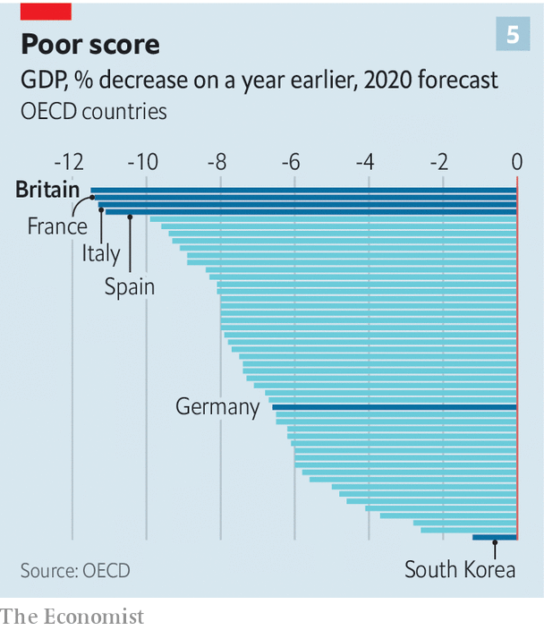

The best performing rich countries, such as South Korea, are those that managed to keep the pandemic under control. The worst hit economically, such as Spain and Italy, are those with much higher death rates. When public opinion will not tolerate elevated death rates, the trade-off between public health and the economy dissolves. A healthy population and a healthy economy go hand in hand.

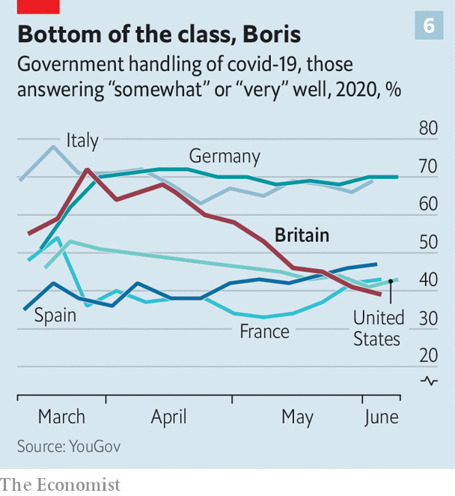

That the British government has provided its people with neither is reflected in opinion polls (see chart 6). The prime minister himself remains fairly popular, but his ratings are in decline. He won sympathy when he succumbed to the disease, but has lost it in other ways. The revelations that he missed five consecutive meetings of the COBRA emergency committee when the virus was taking hold, and that Dominic Cummings, his chief adviser, broke the lockdown rules he helped design, fuelled suspicions that the government did not take the crisis sufficiently seriously.

The political consequences of this failure are likely to stay with Mr Johnson during his time in power (see article). The man who expected to be defined by his ability to “Get Brexit Done”, as his election slogan went, will be remembered for something else altogether. As one of his Conservative predecessors, Harold Macmillan, responded when asked what was most likely to blow a government off course: “Events, dear boy, events.”

Those events are far from over. Every day throws up a difficult new decision. It is unclear how to get schools to reopen or persuade parents to take their children back to the classroom. The government is under pressure to reduce the two-metre social-distancing rule, but more than 1,200 new infections a day are being identified in Britain, compared with a few hundred in Italy, France and Germany. Loosening social-distancing rules and reopening the economy under these circumstances is a risk.

Mr Johnson has a knack for getting away with things, and perhaps this gamble will come off. The previous ones he took with the nation’s health, however, did not. ■

Editor’s note: Some of our covid-19 coverage is free for readers of The Economist Today, our daily [newsletter](https://my.economist.com/user#newsletter). For more stories and our pandemic tracker, see our [coronavirus hub](https://www.economist.com/news/2020/03/11/the-economists-coverage-of-the-coronavirus)

This article was downloaded by calibre from <https://www.economist.com/britain/2020/06/18/the-british-state-shows-how-not-to-respond-to-a-pandemic>

|  |  |  |  |
| --- | --- | --- | --- |
|  | Articles | Sections | Next |

|  |  |  |  |
| --- | --- | --- | --- |
| Previous | Articles | Sections | Next |

#### Drug discovery

# Dexamethasone cuts covid-19 deaths

A cheap drug can make a big difference

Jun 20th 2020 |



THE GOVERNMENT’S public-health performance may not look good, but Britain’s scientists are still top-notch when it comes to inventing and discovering drugs. On June 16th researchers at the University of Oxford announced that they had identified the first drug proven to reduce mortality from covid-19. Dexamethasone, a cheap steroid, reduces deaths by a third among the most severely ill patients. It is set to become the standard of care for the National Health Service (NHS) across Britain. Doctors around the world will, undoubtedly, follow suit.

The results came from RECOVERY (Randomised Evaluation of COVid-19 thERapY), the world’s biggest clinical trial for covid-19 drugs. The trial, run by Oxford and the NHS, is testing a range of drugs on covid-19 patients in 176 hospitals across Britain. Dexamethasone is an anti-inflammatory that is already used to treat a variety of health problems, such as rheumatoid arthritis, eczema, asthma and some cancers. It was included in the covid-19 trial because steroids were tried as a treatment for SARS (severe acute respiratory syndrome), a related lung disease, with mixed results.

As part of the British trial 2,104 patients were randomly assigned to receive dexamethasone and compared with 4,321 patients who received the usual standard of care alone (which includes treatment for dehydration and pre-existing health problems, plus oxygen or a ventilator if needed). Among those who received only the usual care, 41% of patients ill enough to need ventilators died within 28 days; so did 25% of those on only supplemental oxygen and 13% of those who did not need help to breathe. For patients treated with dexamethasone, the 28-day death rate was 28% for those on ventilators and 20% for those on oxygen. There was no benefit from the drug for the rest.

This is big. If doctors in Britain had known from the start what they know now about the effectiveness of dexamethasone, they could have saved as many as 5,000 lives since the country’s covid-19 epidemic began. That is roughly 10% of the number of people who have died from the illness in Britain. It is a generic drug that hospital pharmacies usually have on their shelves. A course of treatment costs the NHS about £5 ($6.30). In poor countries it would cost about $1.

Clinical trials of various drugs are going on in many other countries. But Britain has been particularly committed to doing large, rigorous trials while battling a big covid-19 wave. Such trials are easier to do in the NHS than in more fragmented health-care systems, especially when results are needed urgently. As the pandemic gathers speed around the world, dexamethasone can make it a little less deadly.■

Editor’s note: Some of our covid-19 coverage is free for readers of The Economist Today, our daily [newsletter](https://my.economist.com/user#newsletter). For more stories and our pandemic tracker, see our [coronavirus hub](https://www.economist.com/news/2020/03/11/the-economists-coverage-of-the-coronavirus)

This article was downloaded by calibre from <https://www.economist.com/britain/2020/06/20/dexamethasone-cuts-covid-19-deaths>

|  |  |  |  |
| --- | --- | --- | --- |
| Previous | Articles | Sections | Next |

|  |  |  |  |
| --- | --- | --- | --- |
| Previous | Articles | Sections | Next |

#### Anti-racism protest

# What next for Black Lives Matter UK?

A generational divide opens

Jun 20th 2020 |

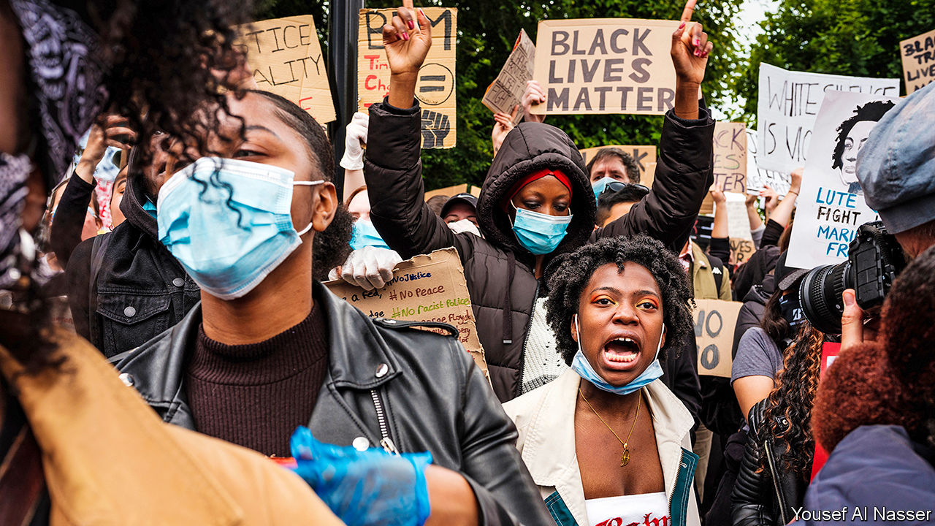

THE KILLING of George Floyd by cops in Minneapolis on May 25th sparked anti-racism protests across Britain, from obvious spots like Trafalgar Square in London to odd places like St Albans, a wealthy commuter town, and Cobham, a village in Surrey. Statues have been toppled and arguments aired. The government will set up a race-equality commission. But, having achieved so much so quickly, the British wing of Black Lives Matter (BLM) finds itself split between older revolutionaries and younger pragmatists.

BLM UK appeared in 2016, following several high-profile shootings of black people in America and in protest against Donald Trump and Brexit. Hundreds marched on Parliament, and a handful shut down a road at Heathrow Airport and a runway at City Airport. Its leading lights, many of whom came from the Occupy movement, wanted to dismantle capitalism through civil disobedience. These people, now in their 30s and 40s, are not responsible for recent protests.

A different lot of people have organised the gatherings over the past few weeks. Mostly young and more often black, they are a mixture of students and aspiring creatives. They ignored BLM UK’s advice not to gather in large groups because of the threat from covid-19. Many of them believe that the ambition of destroying capitalism is a frivolous distraction.

“We’ve talked to a lot of the older generation,” says Aba Amoah, a 22-year-old graduate who helps run a group called Justice for Black Lives that is part of the loosely constituted BLM galaxy. “They were like, ‘you need to stop doing what the system tells you to do.’” A self-described liberal, she believes that the movement must talk to powerful people if it is to get anywhere. They are influenced by writers like Reni Eddo-Lodge, who believes that raising awareness among whites is essential to fighting racism, and from black entertainers who expose racism without getting bogged down in theory.

Whereas the younger activists often see black musicians and other entertainers as models of empowerment, the older activists look on in exasperation as such people are invited onto news programmes to speak about black issues. “It’s part of the British media establishment’s ignorance of how seriously to take issues of racism,” says Adam Elliott-Cooper, a sociologist and co-founder of BLM UK. “They can just cart on any black person they want to come and talk, rather than it actually being something where people need to do research.”

Although the younger activists do not have a fully worked-out agenda, many want to see BLM UK become a British black caucus. This would create “battle funds” to spend money on, for instance, increasing black representation in white-dominated industries such as law and engineering. It would also act as a non-partisan pressure group, which would encourage political parties to compete for its approval. “Black people need to be able to get into white spaces,” explains Ms Amoah. “Otherwise another four years comes and everyone’s doing another protest.”■

This article was downloaded by calibre from <https://www.economist.com/britain/2020/06/20/what-next-for-black-lives-matter-uk>

|  |  |  |  |
| --- | --- | --- | --- |
| Previous | Articles | Sections | Next |

|  |  |  |  |
| --- | --- | --- | --- |
| Previous | Articles | Sections | Next |

#### A Boris bombshell in Whitehall

# British diplomats and donors are told to merge

Melding the Foreign Office and the Department for International Development leaves big issues unanswered

Jun 20th 2020 |

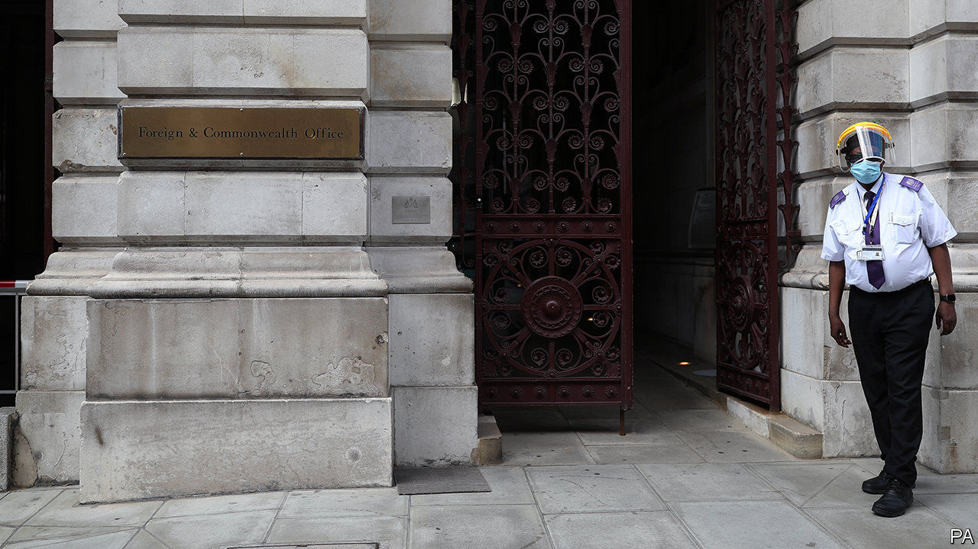

FOR THE PAST two decades Britain’s Foreign and Commonwealth Office has been steadily hollowed out, while a separate ministry that hands out aid to poor countries has grown in wealth and stature. As Brexit grinds on and co-operation with the EU in diplomacy and development dwindles, Boris Johnson wants to reinvigorate the Foreign Office to prepare Britain to stand alone. With much bombast on June 16th, he declared that the Department for International Development (DFID) would be folded back into the Foreign Office, from which Tony Blair had detached it with much fanfare in 1997. Will this move beef up British foreign policy or help to reduce poverty abroad?

Judging by the reaction of an array of aid pundits and former bigwigs in the diplomatic service, the answer to both questions is no. Mr Johnson’s declaration was met with lamentation from all sides, including Conservatives such as David Cameron, his predecessor-but-one as prime minister, and a bevy of Tory former ministers in charge of dispensing aid. One called the decision “mystifying...a quite extraordinary mistake”. Tony Blair said he was “utterly dismayed”. His Labour successor as prime minister, Gordon Brown, was “sad”.

Mr Johnson may have been thinking more of the many British voters, especially hard-pressed ones from blighted parts of the country, who consider foreign aid an extravagance. He sought to touch a chord among them by claiming that British aid has been treated by recipients as “some giant cashpoint in the sky that arrives without any reference to UK interests”.

Using typically colourful language, he went on to deplore what he claimed was a lack of co-ordination between the diplomatic and aid-giving arms of government. “It’s no use a British diplomat going in to see the leader of a country and urging him not to cut the head off his opponent...if the next day another emanation of this government is going to arrive with a cheque for £250m.” Emphasising rugged realpolitik over kind-hearted zeal for reducing poverty abroad, he went on to complain that Britain gives as much aid to Zambia as to embattled Ukraine, and ten times more to Tanzania than to the six countries of the western Balkans that need bolstering in the face of Russian meddling.

It was nonetheless notable that Mr Johnson ducked any suggestion that he would drop the pledge by Mr Cameron’s government, currently enshrined in law, to spend 0.7% of GDP on development each year. At last count Britain disbursed more than £14bn in foreign aid, mainly through DFID. The Foreign Office’s core budget has shrunk to £1.1bn. Aid agencies fear that Mr Johnson’s government will try to fiddle the definition of foreign aid in order to hit the 0.7% target. Folding DFID into the Foreign Office, they argue, may make it harder to scrutinise how aid is dispensed and whether it goes to the truly poor.

Getting the balance between hard and soft power is tricky at the best of times. Especially in Africa, where most British aid is disbursed, diplomats involved in conflict resolution have complained that their punch has weakened as DFID’s has grown. One called it “the DFID-isation of foreign policy”. Rory Stewart, a former minister for DFID who competed against Mr Johnson to lead the Conservatives last year, has bemoaned the shrinkage of the Foreign Office. “It is no longer staffed or funded to act as a global power,” he says.

But folding DFID into it is not the answer, he argues. At Mr Johnson’s request a historian, John Bew, has been reviewing Britain’s foreign policy with the aim of integrating diplomacy with commerce, security and aspects of soft power such as development aid. Friends and foes of the new arrangement are equally puzzled by the prime minister’s decision to act before Lord Bew reports. ■

This article was downloaded by calibre from <https://www.economist.com/britain/2020/06/20/british-diplomats-and-donors-are-told-to-merge>

|  |  |  |  |
| --- | --- | --- | --- |
| Previous | Articles | Sections | Next |

|  |  |  |  |
| --- | --- | --- | --- |
| Previous | Articles | Sections | Next |

#### Shopping is back

# Britain’s bookshops reopen

They face a fight for survival. They’re used to that

Jun 20th 2020 | ALDEBURGH

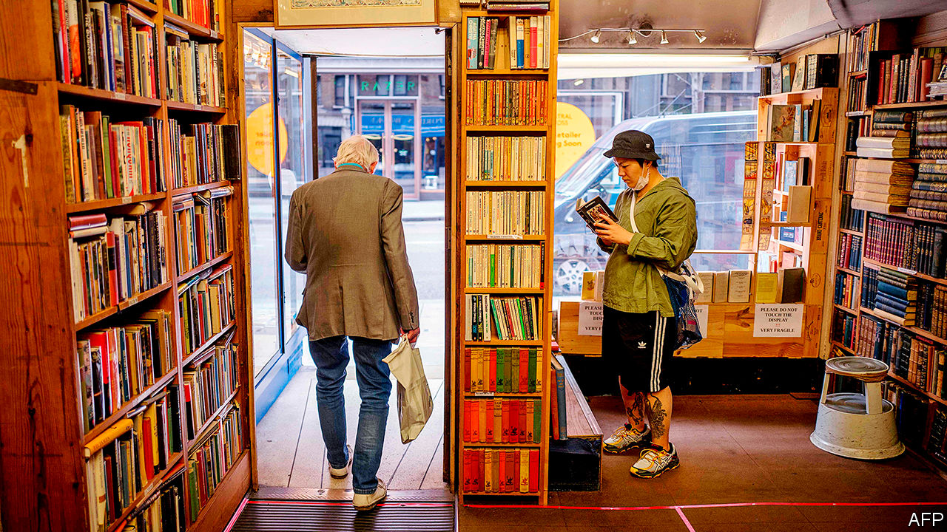

AT FIRST, THEY are tentative. Hovering about the door of the bookshop in the Suffolk town of Aldeburgh, they wait to be invited in. “Can I look at the cards?” a woman whispers, as if enquiring about contraband. A man spends several minutes forensically scrubbing his hands with sanitiser gel before wrestling on a pair of latex gloves. “I’m going to have to buy something now,” he quips. But once inside, the customers pootle absent-mindedly with no regard for the marked-out route, hunting for that paperback they heard about on the radio, something for the grandkids or just a bloody good yarn. Mary James, who owns the shop with her husband John, smiles indulgently. “People are finding the one-way system quite challenging,” she concedes.

England’s high streets, which were closed for nearly three months, are slowly returning to life. Bookshops and other stores deemed “non-essential” were permitted to reopen on June 15th. Almost all branches of Waterstones, a big chain, did so. Roughly half of England’s several hundred independent booksellers—including the Aldeburgh Bookshop—opened straight away. A steady flow of customers are returning. “It’s not like Primark,” Mrs James tells a customer over the phone, alluding to pictures of snaking queues outside a clothing retailer. “But there are people.”

That is welcome after a nervy start to the year for bookshops, which hardly make bumper profits even in boom years. The Jameses are typical: they furloughed their “four-and-a-half” employees at the start of lockdown and dispatched mail orders themselves. Like many such shops, they expect to scrape through, but will keep a tight rein on spending for some time. James Daunt, who runs Waterstones, is also taking a cautious approach. In the first two days of trading, sales at the Crouch End branch were up year-on-year but were down by 80% at Hatchards, a posh shop owned by Waterstones in central London. Mr Daunt thinks that customers are keen to return to their local high street but are wary of travelling to city-centre branches.

Bookshops are used to existential crises. They got a head start in learning to compete with Amazon, which challenged booksellers before taking on the rest of the high street. “We’ve had 25 years of practice,” says Meryl Halls of the Booksellers Association, a trade group. “We’re battle-hardened. Some retailers are just going into that firestorm now.” The number of independent bookshops in Britain plummeted from 1,894 in 1995 to 867 in 2016. But in recent years more have been opening than closing; smart owners are tempting back customers with events, book groups and cafés. “I don’t think anybody has fallen out of love with Amazon,” says Mr Daunt. “The pressure was so extreme they’ve had to improve themselves. Good independents have become exceptionally good.”

Mr Daunt points to another advantage that booksellers have over other retailers: “We’re very fortunate that we’ve got something people want.” Clothes shops that closed in March are sitting on stockpiles of this season’s fashions that will soon be old hat. But books hardly age. And bookshops provide a sense of community and serendipity that cannot be replicated online. Shoppers in Aldeburgh who come in for Jeffrey Archer’s or Lee Child’s latest novel might go out with “The British Herring Industry: The Steam Drifter Years 1900-1960”.

Some come in on a mission (“I know what I want: ‘The Salt Path’”). But, for most, browsing is the point. One woman picks up a large haul, including the latest title for the local book group. “We had one very unsatisfactory Zoom meeting because everybody in the club likes to talk at once,” she says. They now meet outdoors. Your correspondent, who pledged to spend lockdown working through a backlog of unread doorstoppers, comes out with four novels (two of them recommendations) and a wallet £51 ($64) lighter. Perhaps they should have stayed shut after all.■

Editor’s note: Some of our covid-19 coverage is free for readers of The Economist Today, our daily [newsletter](https://my.economist.com/user#newsletter). For more stories and our pandemic tracker, see our [coronavirus hub](https://www.economist.com/news/2020/03/11/the-economists-coverage-of-the-coronavirus)

This article was downloaded by calibre from <https://www.economist.com/britain/2020/06/20/britains-bookshops-reopen>

|  |  |  |  |
| --- | --- | --- | --- |
| Previous | Articles | Sections | Next |

|  |  |  |  |
| --- | --- | --- | --- |
| Previous | Articles | Sections | Next |

#### Bagehot

# Boris Johnson loses his grip

The prime minister’s poor management of the covid crisis is undermining his ability to govern

Jun 20th 2020 |

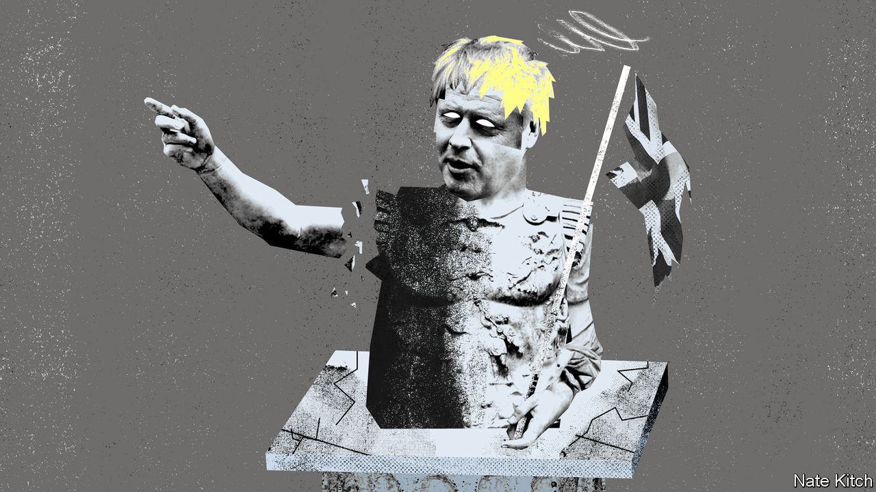

BRITAIN’S CHAOTIC departure from the European Exchange Rate Mechanism on “Black Wednesday” in 1992 destroyed John Major’s premiership and condemned the country to five years of agony, as the Tory government stumbled from crisis to crisis. The coronavirus debacle now threatens to do the same to Boris Johnson. He has a bigger majority than Sir John (87 compared with 23) and is more loved by Tories. But the corona crisis is much bigger than the ERM episode and will be harder to escape from.

Mr Johnson’s poor handling of the crisis has wrecked the government’s most important asset, its sense of authority. The government may already have lost the public: ratings for “being in charge of the situation” have been negative since May. It is beginning to lose its own party, too. Tory MPs have a litany of complaints about government policies. They especially dislike the insistence that strangers must stay 2m apart when other countries have settled on 1.5m or less, the back-tracking over reopening schools, the decision to quarantine those arriving from abroad for a fortnight, the abolition of virtual voting, which forces MPs to stand in a mile-long “conga line” to cast their votes, and the unruly streets, with up to 40 police officers injured in a fortnight of protests and counter-protests. Habitual critics of Mr Johnson ask: what did you expect? Others are “worse than despondent”, says one. “Despondent implies that you think that there might be a way out.”

Mr Johnson’s authority, like that of the Roman emperors he studied at university, rested on fear and charisma. He struck fear into his colleagues by repeated shows of brutality, expelling half the Cabinet when he took over as prime minister, purging 21 MPs who voted against the party and dispatching his chancellor, Sajid Javid. He also used his considerable political charisma to help win an audacious general election in December. Dominic Cummings, Mr Johnson’s key adviser, was central to this regime of fear and charisma, picking fights with all and sundry but also earning a reputation as a campaigning genius.

But fear and charisma only work so long as they are accompanied by competence. The backbenchers who once feared Mr Johnson and Mr Cummings are now more worried about the fury of their own constituents. There is talk of emperors without clothes and wizards behind the curtain. The ministers Mr Johnson demoted in his early months may now have a chance for revenge.

Downing Street has woken up to the fact that it has a party-management problem on its hands and is making an effort to hold more meetings with backbenchers and ministerial assistants. The “town hall” faction in Downing Street—people who worked with Mr Johnson when he was mayor of London, led by Sir Eddie Lister—are much more emollient than Mr Cummings. The whips should regain some power when they can do their arm-twisting in person rather than over Zoom. The leadership can also take some comfort from the fact that, despite much bad news, the nine polls taken since June 1st show the Tories leading Labour by between two and eight points.

But righting the ship will be difficult. The public’s growing distrust of the powers-that-be has been exacerbated by the progression from simple messages (“don’t go out”) to more nuanced ones (“be aware”), and there are plenty of timber-shaking covid storms on the horizon. Unemployment could surge to over 3m when the furlough scheme winds down. Britain’s poor performance is becoming painfully obvious as locked-down Britons watch images of continentals relaxing in cafes and returning to work.

More and more people worry that Mr Johnson was brought in to solve one problem—getting Brexit done—but is now confronted with an entirely different one. A Cabinet that was selected on the basis of ideological soundness rather than competence seems overwhelmed by events. Two figures, Gavin Williamson, the education secretary who has blown hot and cold over whether children can go back to school, and Robert Jenrick, the local-government minister, who is entangled in a scandal with an insalubrious party donor, look particularly dismal. Mr Cummings’s formidable skills in running campaigns have not translated to governing the country. You can’t gaslight a pandemic.

The new intake of Tory MPs is proving to be surprisingly hard to manage. A veteran observer of the party says that he expected rebellions from Europhile MPs and ageing Brexiteers who have been muscled aside by Mr Cummings. But what has surprised him is the rebelliousness of Tories from the largely working-class “red seats” who were carried to the House of Commons on Mr Johnson’s coat-tails. These neophytes have not been inculcated with loyalty to the party by several failed runs for seats; some are local figures who do not have an eye on national office. They are unlikely to become more obedient as the unemployment numbers mount.

## Rome didn’t fall in a day

All this points to a future in which the Conservative Party stumbles from crisis to crisis. Tory rebellions will become part of the political landscape, just as they were under Theresa May. Climb-downs and U-turns will become routine. On June 16th the government reversed its opposition to providing poor children with free school meal vouchers over the summer in the face of a campaign mounted by Marcus Rashford, a 22-year-old footballer. With the exception of Brexit, on which it is likely to remain adamantine, Downing Street may even reverse itself on some big questions. Mr Johnson’s support for Huawei is beginning to soften under pressure from the newly formed China Research Group.

For a while it looked as if the new government had put an end to the era of political chaos that began four years ago with the referendum and consumed Theresa May’s premiership. Now, thanks to a pandemic that not even the most Eurosceptic MP can blame on the EU, another era of chaos has been unleashed and another Tory prime minister is condemned to years of agony.

This article was downloaded by calibre from <https://www.economist.com/britain/2020/06/20/boris-johnson-loses-his-grip>

|  |  |  |  |
| --- | --- | --- | --- |
| Previous | Articles | Sections | Next |

|  |  |  |
| --- | --- | --- |
| Britain | Sections | Special report |

International

Pandemics and war: Horsemen of the apocalypse

.

|  |  |  |
| --- | --- | --- |
| Britain | Sections | Special report |

|  |  |  |  |
| --- | --- | --- | --- |
|  | Articles | Sections | Next |

#### Horsemen of the apocalypse

# Covid-19 raises the risks of violent conflict

War and disease feed upon each other

Jun 18th 2020 | BUNIA AND BOGOTÁ

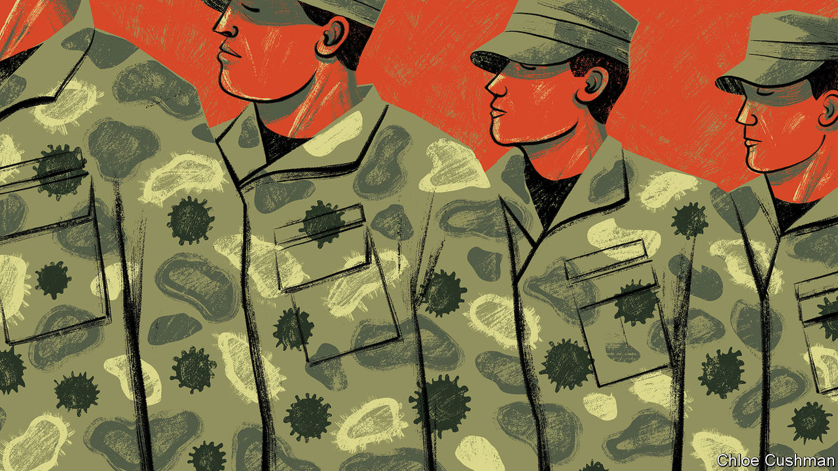

BUNIA, A DUSTY city of perhaps 650,000 in Ituri, a province of eastern Congo, has long known war. Since the start of this year, rebels have burned dozens of villages to the ground and hacked hundreds of people to death with machetes. A rebel group made up of assailants from the seed-sowing Lendu tribe has launched a series of attacks on the pastoralist Hema. The government hospital in the city is overrun with patients. “We have people wounded with machetes, with gunshots, women with amputated limbs, people with fractures,” says John Katabuku, a doctor working there. “When the displaced arrive we look after them for free—they have lost everything. But it is difficult for the hospital. We really do not have the means.”

With war comes disease. Ituri is still recovering from an outbreak of Ebola which started in 2018 and killed 2,262 people in the region before subsiding. Now it has covid-19. Though there are just two recorded cases in the province, that is surely a woeful undercount. If the disease is spreading, it would not be easy to tell. Tests have to be sent 1,800km to the capital, Kinshasa. And few people can get tested. Some 22 clinics have been burned down. One man living in the nearby war-torn area of Djugu says that there is nowhere to go if you are sick—all the clinics are either ruined or occupied by rebels. The hospital in Bunia has no working ventilators and only enough space to isolate up to ten people, in the area that was previously being used for suspected Ebola patients. “We have to hospitalise two to three displaced children per bed, so you can see that we do not have infection prevention under control,” says Dr Katabuku.

Covid-19 has thus far taken its most serious toll on rich, peaceful countries. America, Britain, Italy, France and Spain, five of the six worst-affected, have collectively borne over half of recorded deaths from the virus worldwide. But the disease is now rippling through less stable places. What will happen as it does? There are reasons to fear not only that conflict will help the virus to spread, but also that its spread may worsen wars. The two could feed upon each other, creating a cycle of misery it is difficult to arrest.

At the outset of the Peloponnesian war with Sparta, which raged from 431BC to 404BC, Athens was ravaged by a plague that swept through the city for three years, killing thousands of soldiers and a third of its inhabitants. “Such was the nature of the calamity, and heavily did it weigh on the Athenians; death raging within the city and devastation without,” recalled Thucydides, a Greek historian and general. The Spanish flu of 1918, another world-shaping pandemic, festered in the trenches and barracks of the first world war and killed more people than the conflict itself. Over 36,000 American soldiers died before ever reaching France, with 12,000 dying on troop transports. In total, more American soldiers, sailors and Marines died of flu and pneumonia than bullets and bombs.

Some still hope that confronted with an indiscriminate killer, human beings on all sides of a conflict would put down their guns—at least briefly—and confront the shared enemy. In March António Guterres, secretary-general of the United Nations (UN), began urging a global ceasefire. Encouragingly, fighters in more than a dozen countries seemed to heed his call. The National Liberation Army (ELN) in Colombia, which has been trying to “liberate” the country for a half century, declared a ceasefire on March 30th. So did the New People’s Army (NPA) in the Philippines, a communist guerrilla group that has been in the field since 1969. Saudi Arabia has sought to draw down its forces in Yemen and declared a unilateral ceasefire. In Syria there were just 71 civilians killed in May, the lowest monthly toll since the start of the civil war in 2011, according to the Britain-based Syrian Observatory for Human Rights.

But in many places the tranquility has proven short-lived. By the end of April, both the ELN and the NPA announced that they were not extending their ceasefires and would return to violence. The Philippine government argued that the NPA had violated its ceasefire early on and that peace talks were pointless after the guerrillas killed two soldiers at the end of March. The Security Council, the UN’s cockpit of big powers, has been deadlocked by squabbling between America and China, including over weighty matters such as what to call the virus. Political violence has risen in 43 countries and remained steady in 45 since the start of the pandemic, according to data collected by the Armed Conflict Location & Event Data Project (ACLED). Some of the largest increases were in Libya, Yemen and Mali, each enmeshed in civil wars with a web of international links.

## Behold a pale horse

Battlegrounds are easy pickings for the virus. But they also help it spread. War displaces civilians, shifting disease from one place to another, while their immune systems are worn down by hunger, trauma and ill health. Trust in government tumbles, making it harder to enforce social distancing or deliver vaccinations. And those who normally provide succour are driven away. UN humanitarian agencies have already cut staff in places like Yemen and placed limits on where their staff can travel, notes Robert Malley, the president of the International Crisis Group, a research outfit.

In Congo, some 480,000 people have fled their homes since violence escalated in late March. This number accounts for 75% of the total number of people displaced worldwide during the pandemic. Near Bunia, over 27,000 displaced people live in rows of white tarpaulin tents in a camp. Twenty-nine-year-old Charlotte Tabu sleeps in a tent that she shares with nine others. She fled when rebels attacked her village. “The rebels burned my house while I was working in the fields,” she says. “We are suffering here. It is not easy to find food in the camp. We need this war to end. I had seven children, two were burned inside my house.”

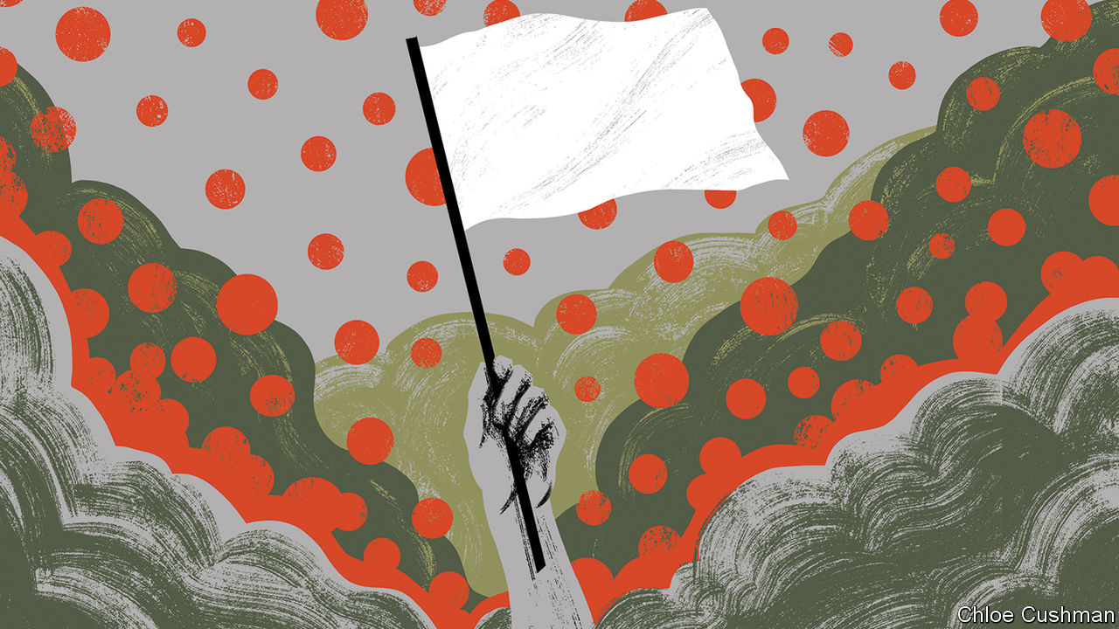

Health workers worry about the spread of the virus through and among such wretched communities. In Cox’s Bazar in Bangladesh, for instance, 900,000 Rohingya Muslims, driven out of Myanmar, live in packed camps. In a survey conducted from April 11-17th, researchers at Yale found that 25% of respondents in camps had experienced at least one common covid-19 symptom. Most had attended a communal prayer in the previous week, a setting in which transmission is especially likely. Several refugees have already died.

Those with the guns—governments and rebel groups alike—are exploiting opportunities created by the virus and its shock to economic and social life. Since March Islamic State has switched its focus from intimidating civilians to attacking government and government-backed forces in Iraq and Syria. It killed more than 30 Syrians soldiers in two days of fighting in April and briefly seized a small town, Mubarak, in Diyala province north-east of Baghdad. In early May it launched its biggest attack in Iraq since the coalition declared its defeat in 2017, killing 10 fighters from Hashad al-Shaabi, a mostly Shia militia.

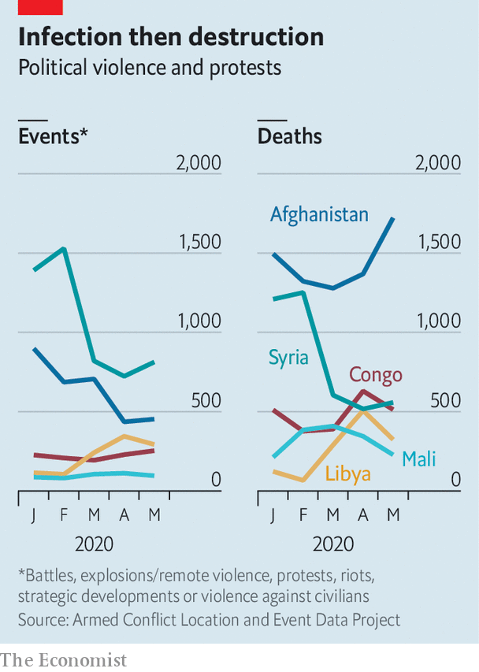

In Colombia, the Simon Bolivar bridge on the border with Venezuela has closed. That means that many of the 35,000 Venezuelans who crossed on an average day are now being forced to use illegal crossing points controlled by armed groups. Authorities in Colombia fret that this flow of untested people might unleash a health disaster. It also gives rebels a fresh source of recruits among desperate Venezuelans.

That is one of many ways in which Colombia’s armed groups have consolidated their position. Many have jumped at the opportunity to expand their control and build something resembling legitimacy by imposing cordons sanitaires and lockdown. In parts of Nariño, in southwestern Colombia, the Oliver Sinisterra, a “dissident” group descended from FARC, a guerrilla organisation that is now a political party, threatened to “sanction”—in practice, attack—any shop found open or any pharmacy with too many customers inside. In Bolivar, in northern Colombia, the ELN has said only bakeries, food stores and pharmacies may open. In Arauca, on Colombia’s border with Venezuela, the ELN has even offered to educate the children of farmers, while schools are closed. Such indoctrination could breed another generation of rebels.

The crisis has also made it easier for the government to target insurgent groups and their illegal coca crop. Because road traffic has plummeted and the army has been put in charge of supplying towns and cities with food, illicit vehicles heading to rebel hideouts stick out like lines of powder cocaine on a mirror. That has enabled the armed forces to mount a string of attacks in Cauca, on the Pacific coast. The government is also eradicating coca in areas which they previously avoided, because farmers, who would otherwise offer vigorous resistance, are safely locked down.

Armies and navies are also fertile ground for contagion. Troops are packed into barracks; sailors, into cramped ships. Men in uniform gather in large numbers for drills and exercises. They cross oceans and borders. Marauding land armies are rarer than they once were, but many war zones pull in spooks, soldiers and insurgents across borders. In Iran, one of the worst-hit countries in the Middle East with nearly 9,000 deaths, Mahan Air, an airline affiliated with Iran’s Islamic Revolutionary Guard Corps (IRCG), continued to operate between China and Iran for weeks after other airlines had suspended flights. Several commanders contracted the virus. The movement of IRGC-financed Shia fighters between Iran, Iraq, Syria, Lebanon, Pakistan and Afghanistan also spread the disease. Syria’s first documented cases occurred in Saida Zeinab, a Shia shrine near Damascus under the control of IRGC-backed armed groups.

Rich countries’ armies are affected too—in ways that may have lasting consequences. In America over 8,000 military personnel have tested positive for covid-19, with three deaths (the case fatality rate for those with military ties is 0.3%, considerably lower than the rate for the broader public, perhaps because soldiers tend to be young and fit). Foreign governments have sharply cut ground forces and military trainers, including most of Iraq’s 29 coalition partners pursuing Islamic State (IS). In March America withdrew from six bases in Iraq and NATO suspended its training programme. Defender-20, a military exercise slated to be the largest movement of American troops to Europe since the cold war, was halted, not long after a Polish general involved in its planning was taken ill. At the same time, America’s armed forces, like many others, have been tied up on the home front, to support beleaguered civilian authorities with everything from logistics to testing.

The most dramatic impact, however, has been on navies, whose confined spaces are ripe for disease. “It is a Petri dish of virus,” says one former commander of an American carrier strike group. “There is no social distancing of 5,000 people on a vehicle that’s three football pitches long...and one football pitch wide.” America’s navy comprises a quarter of the country’s military personnel but a third of all cases among them. The USS Theodore Roosevelt, one of America’s largest carriers, was forced to halt operations in the Pacific and return to port in Guam in March after an outbreak of covid-19 that eventually infected 1,000 of its crew, out of 5,000 or so in total, including its captain. It limped back to sea only at the end of May. France’s sole aircraft-carrier, the more diminutive Charles de Gaulle, was also taken out by covid-19, with two-thirds of its crew infected (though only half were symptomatic).

Many countries are anxious that such self-evident disruption to their armed forces reeks of vulnerability. On May 6th the UN’s Mr Guterres warned that some “may see opportunities because the attention of governments and the international community is absorbed by the health crisis”. That is presumably why Thomas Modly, America’s then navy secretary, rashly sacked the Roosevelt’s captain, who had sounded the alarm about conditions on the ship. In a speech to the Roosevelt’s ailing crew, Mr Modly told them to “stand strong as warriors, not weak like victims”. The ship, he said, “has to demonstrate to the citizens back home that it has its act together, and that it is knocking down this virus, just as it would knock down the Chinese or the North Koreans or the Russians if any one of those nations were ever so stupid enough to mess with the Big Stick”. (Mr Modly himself was later forced to resign for his poor judgment.)

## Opening the seals

The urge to downplay weakness and project strength has resulted in a form of nervous muscle-flexing that Nick Childs of the International Institute for Strategic Studies, a think-tank, calls “pandemic deterrence”. In mid-April China steamed its own aircraft-carrier through the Miyako Strait between Taiwan and Japan, an “opportunistic” act “almost calculated to contrast with the plight” of the stricken Roosevelt, notes Mr Childs. On May 22nd America’s navy pointedly noted that it had seven out of eleven carriers at sea, though it is implausible that all are fighting fit. In mid-June three were sent to the Pacific for the first time in three years (see [article](https://www.economist.com/node/21788204)).

Covid-19 has not had the shattering effect on military power the Spanish Flu had a century ago. Modern health care is vastly better. Today’s pandemic, unlike the earlier one, largely spares the young adults who fill the ranks of armed forces. But as governments have been preoccupied at home and distracted abroad, the virus has deepened geopolitical tensions—between America and China, above all—and worsened what was already a febrile international mood. “Some leaders may... see covid-19 as cover to embark on destabilising foreign adventures, whether to deflect domestic discontent or because they sense they will face little pushback amid the global health crisis,” warns the ICG.

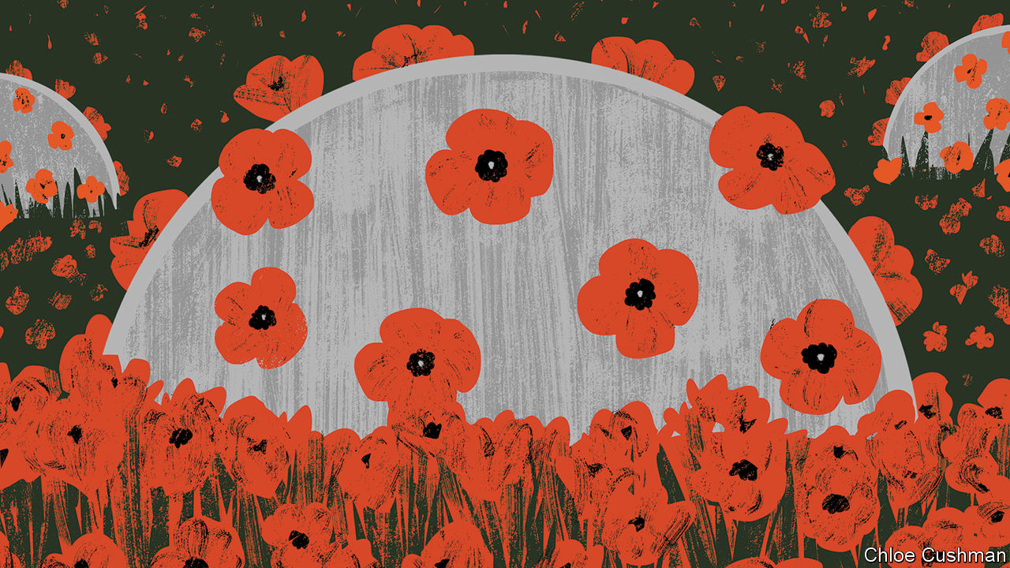

The line between pandemic deterrence and adventurism can be hard to draw. But some of the geopolitical manoeuvring has already taken a more violent turn. In early March, Indian troops in Ladakh, a Himalayan region abutting China, delayed their annual summer exercise after soldiers were infected by covid-19. China went ahead with its own matching drill. But the People’s Liberation Army (PLA) peeled away from exercises and dashed to several disputed areas on the mountainous border, where it dug in to strategic territory. India’s army stumbled upon them at the end of April, prompting it to rush forces to the disputed area.

The entanglement of virus and war was encapsulated in a series of videos and photographs showing PLA troops in the aftermath of a brawl in May, wearing masks as they leant over trussed and bloodied Indian captives, mindful of good respiratory hygiene even during a skirmish between nuclear-armed rivals. Another fight erupted on June 15, resulting in serious casualties on both sides (see article). “A section of the Chinese leadership believes that the …pandemic is a window of opportunity for China to expand its regional and global influence,” reflected Shyam Saran, India’s former top diplomat, in May. “China stabbed us in the back,” complained an Indian officer to News18, a television channel. “In the middle of a pandemic, this was not expected”. ■

This article was downloaded by calibre from <https://www.economist.com/international/2020/06/18/covid-19-raises-the-risks-of-violent-conflict>

|  |  |  |  |
| --- | --- | --- | --- |
|  | Articles | Sections | Next |

|  |  |  |
| --- | --- | --- |
| International | Sections | Business |

Special report

The new world disorder: Missing in action

.

Power plays: Who’s in charge?

.

Global firefighting: Missions impossible

.

New START’s end?: Avoidable Armageddon

.

Reform: Grand redesigns

.

Reflections at 75: The wisdom of youth

.

Three future scenarios: Bedlam, bumbling or boldness?

.

|  |  |  |
| --- | --- | --- |
| International | Sections | Business |

|  |  |  |  |
| --- | --- | --- | --- |
|  | Articles | Sections | Next |

#### The new world disorder

# Global leadership is missing in action

Seventy-five years ago the world’s leaders designed the peace even as they fought the war. Today’s leaders need to do something similar, says Daniel Franklin

Jun 18th 2020 |

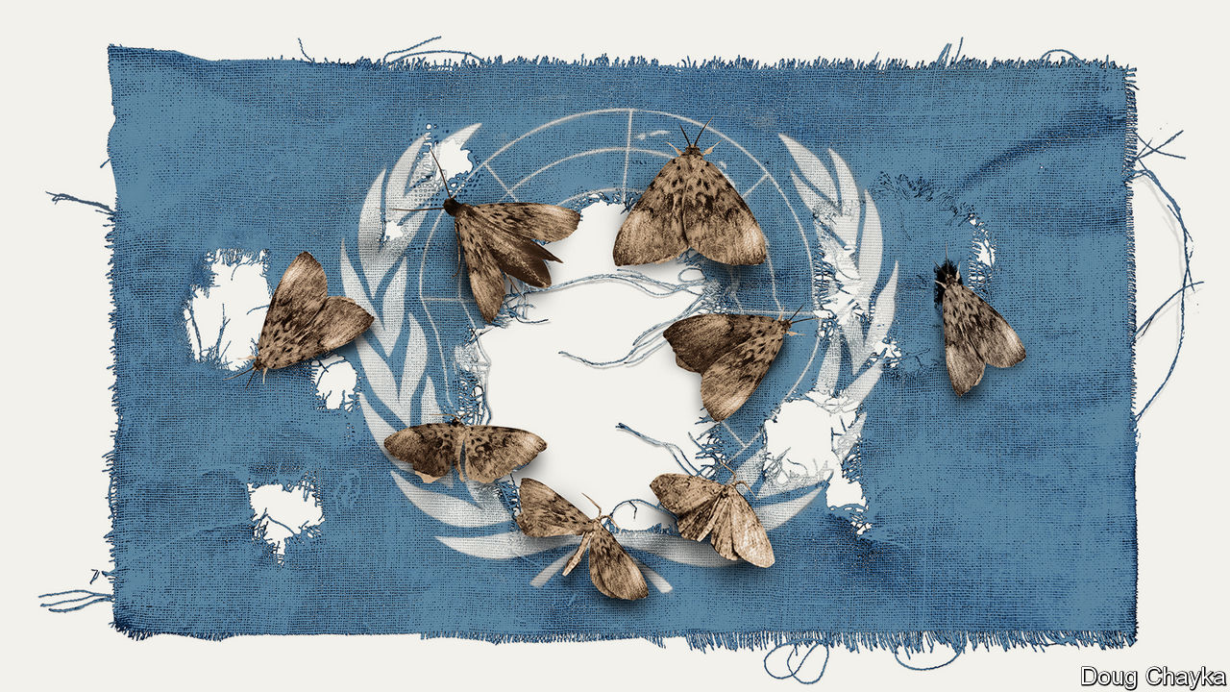

A FEW WEEKS after Japan’s attack on Pearl Harbour, Winston Churchill was a guest at the White House. President Franklin Roosevelt was so eager to tell him he had come up with a name for what would become a new world security organisation that, the story goes, he hurried into Churchill’s bedroom, to find the prime minister naked save for a bathrobe. What is striking about the origins of the “United Nations”, Roosevelt’s choice, is not this unorthodox manner of communication (a modern American president might have tweeted his idea) but that, in the midst of war, statesmen were already planning for the peace.

On the economic front, this led to the creation, in 1944 at Bretton Woods in New Hampshire, of the World Bank and the International Monetary Fund (IMF). On the security side, plans for the UN were fleshed out at Dumbarton Oaks in Washington, DC, agreed to in outline by Churchill, Roosevelt and Stalin at Yalta in the Crimea and finalised at a conference in San Francisco after Roosevelt’s death. “Oh what a great day this can be in history,” proclaimed President Harry Truman at the concluding session on June 26th 1945, when the founding charter was signed. Countries had put aside their differences “in one unshakable unity of determination—to find a way to end wars.”

Euphoria soon gave way to frustration as the cold war set in. Yet, as the new organisation’s second secretary-general, Dag Hammarskjold, observed, the UN “was not created to take mankind to heaven but to save humanity from hell”. For 75 years there have been no world wars (though too many smaller ones). Unlike its precursor, the League of Nations, the UN has proved resilient. Its membership has grown from 51 countries to 193, through decolonisation and the break-up of the Soviet empire. It sits at the centre of a rules-based world order, and its activities and those of its specialised agencies span almost every aspect of life.

Yet no international order lasts for ever. Over time the balance of power shifts, systems fail to adapt and the rot sets in. The peace after the Congress of Vienna in 1815 eroded slowly; that after the Treaty of Versailles in 1919 collapsed fast. A change from one dominant power to another has usually meant war (the shift from Britain to America over a century ago being a rare exception).

Covid-19 is a new challenge. A vacuum exists where the world would normally look for American leadership. Instead it sees President Donald Trump making a fool of himself, suggesting wacky cures. Mr Trump has been more interested in blaming China for the pandemic than rallying an international response, his most prominent move being to suspend funding to the World Health Organisation (WHO) and threaten to leave it. In March G7 foreign ministers could not even issue a statement because Mike Pompeo, America’s secretary of state, insisted it refer to the “Wuhan virus”.

China’s initial response to the virus was a bungled cover-up, but since its harsh lockdown brought covid-19 under control, it has touted its successes around the world and supplied protective kit to thankful countries. The Europeans, meanwhile, closed borders, including in their supposedly frontier-free Schengen area. A divided UN Security Council has been missing in action.

The world order was already looking wobbly. The global financial crisis of 2007-09 fed populism and a wariness of international institutions. These often reflect the realities of decades ago, not today (the Security Council’s five veto-holding permanent members are the victorious powers of 1945), yet they resist reform. The rules remain, but the big powers increasingly feel free to ignore them. Russia has brazenly grabbed a piece of Ukraine. China has occupied disputed territories in the South China Sea.

America has long complained about the cost of propping up the multilateral system and fretted about “Gulliverisation”, being tied down by punier powers. Along with Britain it invaded Iraq in 2003 without a mandate from the Security Council. President Barack Obama, prioritising “nation-building at home”, began a semi-retreat from the burdens of global leadership. But the principal architect of the system now has a president who seems to delight in taking a wrecking ball to it.

Mr Trump has withdrawn from the Paris agreement on climate change and the nuclear deal with Iran. He has cast doubt on America’s commitment to NATO (though he has strengthened its forces in many parts of Europe). He has continued to undermine the World Trade Organisation (WTO) by blocking the appointment of new judges to its appellate body. He has called the European Union a “foe”. His love of sanctions causes further friction, prompting complaints that America is abusing the “exorbitant privilege” of having the world’s reserve currency and stimulating interest (among allies and rivals alike) in reducing the dollar’s dominance.

At the UN, America’s allies complain that Mr Trump “cherry-picks”. What is new is not pulling out of an agency or two (Mr Trump has pulled out of the Paris-based education and cultural agency, UNESCO, and the Geneva-based Human Rights Council, complaining of anti-Israel bias), but the lack of commitment to the system. His America First rhetoric echoes the language of Henry Cabot Lodge, an isolationist senator who successfully fought against joining the League of Nations in the 1920s. It is a stark contrast with the internationalism of Roosevelt and Truman. “The future does not belong to globalists,” Mr Trump told the UN General Assembly last September. “The future belongs to patriots.” All this means that, far from looking forward to a happy birthday, the UN approaches its 75th anniversary in a state of high anxiety.

Its secretary-general, António Guterres, a jovial former prime minister of Portugal, divides the UN’s history into three periods. The first was “bipolar”, characterised by cold-war rivalry between America and the Soviet Union. Although the Security Council was largely frozen, there was a certain predictability in the stand-off, and the UN was inventive enough to expand into areas such as peacekeeping, which is not even mentioned in its charter.

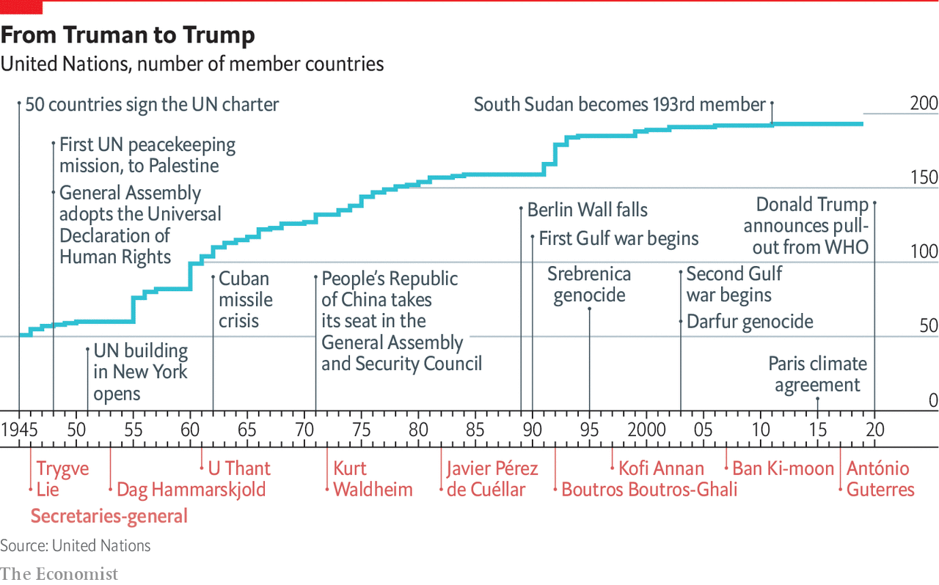

After the collapse of communism came a brief “unipolar” period, when America’s dominance was barely contested. The Security Council was able to function as its founders envisaged, launching a flurry of peace missions as well as authorising the American-led liberation of Kuwait in 1991. George Bush senior hailed a “new world order”. The UN developed the principle of a “responsibility to protect” populations against mass atrocities.

But, bogged down in the Middle East and Afghanistan, America has grown weary and inward-looking. In the wider world, wariness about the West imposing its values, especially by force, has increased. A revanchist Russia and a soaring China increasingly challenge America’s supremacy. The Security Council is once again stuck, reflecting renewed great-power rivalry. This third period, as Mr Guterres sees it, is still unsettled. “The world is not yet multipolar, it’s essentially chaotic,” he says.

## America, first

A degree of chaos is not surprising, given the dramatic shifts that are starting to divide the world into competing spheres of influence. Take the economy. Since 2000 China’s share of global GDP at market rates has gone from less than 4% to nearly 16%. Its technology giants, such as Alibaba, Tencent and Huawei, are spreading Chinese digital infrastructure abroad, especially in emerging markets. China is the world’s largest exporter, and although a relative newcomer (having joined the club only in 2001) now presents itself as chief defender of a WTO under assault from America.

In finance, though the dollar still dominates, the yuan is poised to gain ground. At the IMF, China remains underrepresented, with a quota and voting share of only 6%. But as the fund strives to support a stricken global economy, China will be a core consideration, whether in the design of debt relief (China is reckoned to have lent more than $140bn to African governments and state-owned enterprises since 2000) or in increasing quotas.

These upheavals spill over into the diplomatic and security dimensions that are the focus of this special report. Are the UN, and the collaborative global governance it embodies, doomed to be less relevant in a world of great-power competition? It is surely too soon to give up on them. But to retain its clout and character the liberal order needs restored leadership and difficult reforms.

The multilateral system has important strengths. One is that it is patently needed. The biggest problems cry out for international co-operation—as the pandemic powerfully illustrates. The world needs to work together on vaccines, on economic recovery and to support the most vulnerable countries. The head of the World Food Programme, David Beasley, a former Republican governor of South Carolina, has said speedy action is necessary to prevent “multiple famines of biblical proportions”. Concerted efforts are also needed on climate change, another challenge no country can tackle on its own. The risk of nuclear proliferation is growing.

A second advantage is that the UN is popular. It has made shameful mistakes. It failed to prevent genocide in Rwanda and Srebrenica. UN peacekeepers are blamed for bringing cholera to Haiti and sexual abuse to many of the places they were meant to protect. The UN’s oil-for-food programme with Iraq led to a $1.8bn scam. Yet it is more trusted than many governments, according to the 2020 Edelman Trust Barometer. Across 32 countries surveyed by Pew last year, a median of 61% had a favourable opinion of the UN, against 26% with an unfavourable view. A comfortable majority of Americans think well of it, though there is a growing partisan divide: 77% of Democrats approve, but only 36% of Republicans.

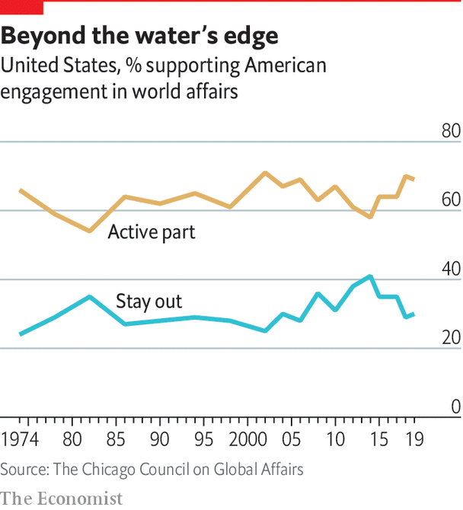

In another survey last year, by the Chicago Council on Global Affairs, seven out of ten Americans said it would be best if the country took an active part in world affairs, close to the highest on record. That points to a final force that should not be underestimated: the potential for American re-engagement. America remains a more powerful economy with greater reach in hard and soft power than any rivals. It could again be the standard-bearer for a liberal world order.

It would be naive to expect sudden enthusiasm for multilateralism from Mr Trump—and even beyond him. American suspicion of foreign entanglements is as old as the republic. Frustration with the WTO, NATO and the rest was mounting before Mr Trump tapped into it. The divisions at home that have deepened under his presidency make leadership abroad harder. Still, victory for Joe Biden in the presidential election in November would be, if not exactly a game-changer, at least a game-restarter. “We will be back,” Mr Biden promised last year’s Munich Security Conference.

The UN wants to use its 75th anniversary for a grand consultation on the future of multilateralism. Covid-19 has hijacked the global agenda. But it also creates an opportunity. Rather than destroying the system, the upheaval could spur countries into strengthening it. That will require planning for the future while tackling the crisis of the present. Today’s leaders need to emulate what their predecessors achieved so magnificently in 1945.■

This article was downloaded by calibre from <https://www.economist.com/special-report/2020/06/18/global-leadership-is-missing-in-action>

|  |  |  |  |
| --- | --- | --- | --- |
|  | Articles | Sections | Next |

|  |  |  |  |
| --- | --- | --- | --- |
| Previous | Articles | Sections | Next |

#### Power plays

# Who runs the world?

As America gets tired, China gets busy

Jun 18th 2020 |

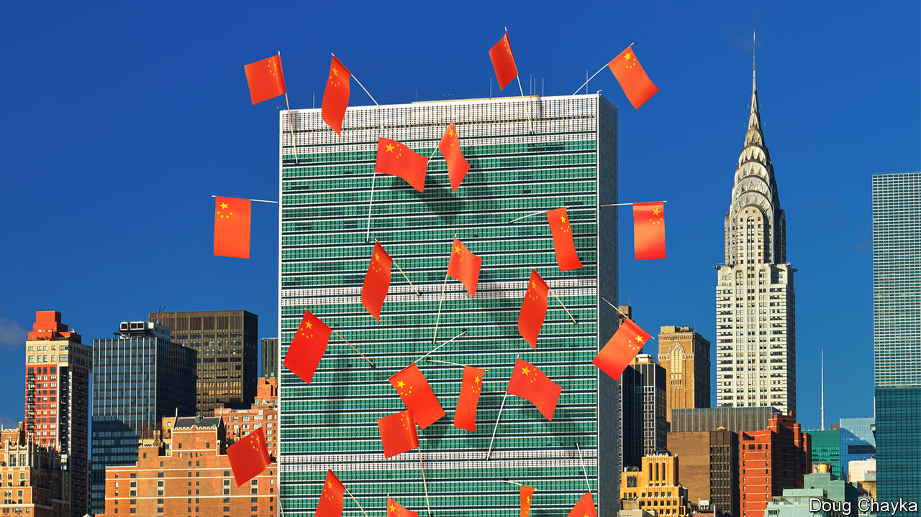

CRISES CAN bring clarity. In the financial crisis of 2008-09, the G20 club of big economies came into its own, reflecting how economic power had spread beyond the rich world’s G7. One thing the covid-19 pandemic has laid bare is an absence of global leadership. This time the G20 has done little beyond a rhetorical pledge to “do whatever it takes” and supporting debt-repayment suspension for poor countries. America, which led global campaigns to defeat HIV/AIDS and Ebola, has been absorbed in its internal arguments. And the UN Security Council has confirmed its dysfunctionality.

The council’s five permanent members (P5) are split between the Western three and Russia and China; some suspect the authoritarian duo of having a formal pact. Russia wields its veto often, sometimes alongside China. Instead of leaping into action over covid-19, the council mustered its first discussion of the crisis only in April. France and Russia have both been keen for the leaders of the P5 to get together in the UN’s anniversary year, but have found this hard to arrange.

The pandemic hit when competition between America and China, the world’s dominant and emerging superpowers, was already intense, stretching from trade and technology to finance and regional dominance in Asia. In America there is a bipartisan perception of China as a rival that steals intellectual property, takes advantage of America’s openness and is intent on chipping away at America’s lead. For its part, China is increasingly brazen in pushing back against America (or any country that resists it).

Any retreat by America from global leadership is an opportunity for China

The covid-19 crisis is proving a telling case study of this rivalry, as America blames China for causing the pandemic and China positions itself as the country most capable of dealing with it. Any retreat by America from global leadership is an opportunity for China to gain ground. Whereas America has suspended funding to the WHO, China has promised $2bn to fight the pandemic.

President Xi Jinping portrays China as a champion of multilateralism and talks of taking “an active part in leading the reform of the global governance system”. China has been building channels of influence outside the institutions that America designed. It set up the Asian Infrastructure Investment Bank, encroaching on the World Bank’s territory. It has championed the BRICS (bringing it together with Brazil, Russia, India and South Africa) and the Shanghai Co-operation Organisation, an eight-member group that includes Russia and Central Asian countries as well as India and Pakistan. And then there is Mr Xi’s Belt and Road Initiative (BRI), an all-embracing infrastructure and development campaign.

China has also been methodically increasing its influence in existing institutions, not least the UN. It has raised its financial support even as America became stingier, becoming the second-biggest contributor to both the general and the peacekeeping budgets. It has grown more assertive. “Ten years ago, China was pretty discreet, pretending to be just an emerging country,” says one European diplomat at the UN. “Now I can tell you they are totally uninhibited, they want to run the system.”

China has been patiently placing high-fliers to work their way up through the ranks. Chinese nationals now head four of the UN’s 15 specialised agencies, including the Food and Agriculture Organisation in Rome and the International Telecommunication Union in Geneva. Americans lead only one. Chinese officials toil away at inserting into documents favourable references to the BRI and language friendly to their interpretation of human rights, stressing national sovereignty and development (“mutual respect and win-win co-operation”). Behind the scenes China twists arms to avoid criticism of its repression in Xinjiang or Tibet.

Small victories for China have mounted up, often in obscure documents and little-noticed forums, but occasionally raising eyebrows. In the 15-member Security Council, for example, the West and its friends can normally count on the requisite nine votes to get their way on procedural matters. But in March 2018 an American-backed proposal for the UN high commissioner for human rights to brief a formal session on abuses in Syria was defeated when, after Chinese pressure, Ivory Coast switched sides at the last minute.

The aim may not be to replace America as a superpower that bears burdens all around the world. More likely, China simply wants an unencumbered path for further development. “People’s Republic of the United Nations”, a report last year from the Centre for a New American Security (CNAS), a think-tank, concluded that China was “making the world safe for autocracy”. For a long time America paid little attention, but it is now pushing back. In January the State Department appointed a senior diplomat, Mark Lambert, to counter the “malign influence” of China and others at the UN. In March these efforts succeeded in thwarting China’s bid for the top job at a fifth UN agency, the World Intellectual Property Organisation in Geneva.

At least such moves reflect a recognition by the American administration that multilateral institutions matter. Just as Mr Trump no longer calls NATO “obsolete”, as he did before coming to power, he may yet find more use in the UN. He would not be the first American president to come to believe that, annoying as international forums are, they are better than a constant free-for-all, and they can take some of the load off a superpower. But his transactional approach has unnerved allies, and badly dented their trust in American leadership.

## In search of a middle way

As a result, “middle powers” have been searching for other ways to defend the liberal order. A white paper presented last year by Norway’s foreign ministry to its parliament identified preventing the erosion of international law and multilateral systems as a “primary foreign-policy interest”. In New York, France and Germany launched an Alliance for Multilateralism, with the aim of forging varied coalitions to take the initiative on issues ranging from fake news and responsible use of cyberspace to gender equality and strengthening international institutions.

Coalitions of like-minded countries have proliferated. After Mr Trump abandoned the Trans-Pacific Partnership, a free-trade deal, Australia, Japan and nine other countries pressed ahead on their own. The EU and Japan completed a trade agreement covering a third of the world’s GDP. On defence, President Emmanuel Macron of France has gathered 13 other countries into a European Intervention Initiative and is ever keener on “strategic autonomy” for Europe. Asian countries worried about growing Chinese assertiveness, and unsure of America’s commitment, are deepening ties.

In such “minilateralist” or “plurilateralist” ventures, national governments are not the only actors. Regional states, non-governmental organisations (NGOs) and business leaders are on stage too. In the response to covid-19, the Bill & Melinda Gates Foundation, a philanthropic giant, is taking a more prominent part than many governments. Several American states have been busy since Mr Trump withdrew from the Paris agreement. California’s governor, Jerry Brown, hosted a Global Climate Action Summit in 2018. Totting up actions at subnational levels that collectively would amount to the world’s second-biggest economy, one estimate suggests they could reduce America’s greenhouse-gas emissions by 2030 by as much as 37% from 2005 levels.

Whether these scattered mid-level moves can amount to more than the sum of their parts is unclear. Michael Fullilove of the Lowy Institute, an Australian think-tank, suggests that like-minded countries should form a “coalition of the responsible”. Since some middle powers, such as Taiwan and South Korea, have distinguished themselves by their response to the pandemic, he also proposes “coalitions of the competent”. Further bungling by the big powers over covid-19 could make a concert of middle powers more urgent. But do not bank on this being a middle-power moment, says Kori Schake of the American Enterprise Institute, another think-tank. Without a dominant power to set an agenda, force momentum and provide a chunk of funding, it is very hard for co-operation among lesser countries “to reach escape velocity”. At best it may slow rather than stop the erosion of the liberal order.

If middle powers are active, so are smaller ones. By clubbing together, even minnows can have influence. Under its charter the UN is “based on the principle of the sovereign equality of all its members”, so each of the 193 countries in the General Assembly has one vote. India (1.4bn people) counts the same as Tuvalu (12,000).

The Group of 77, formed in 1964 and now embracing 134 members, pushes the interests of developing countries. It is less homogenous than it was but it can have influence (eg, over the choice of secretary-general) and get attention (picking Palestine to serve as its chair last year). The Alliance of Small Island States helped put the climate-change issue on the map. Samantha Power, America’s UN ambassador during Barack Obama’s second term, made a point of visiting her counterparts from every member country at their New York missions: she managed all except North Korea’s.

With just six embassies around the world, the diplomatic footprint of the Caribbean state of St Vincent and the Grenadines (population: 111,000) is tiny, but a good example of small-country influence. One of its embassies is in Taipei: it is among a handful of states that officially recognise Taiwan. Its mission in New York has been expanding, since St Vincent currently has one of the ten non-permanent seats on the 15-member Security Council. “The bedrock principle that all small states advocate for is adherence to international law,” says Inga Rhonda King, St Vincent’s ambassador. They’re “very hard core” over sovereign equality, non-interference and non-intervention, she adds. The Security Council seat gives her a chance to press core concerns (especially climate security and relations with Africa) and, hers being a small country, to do so nimbly. Ms King would like to see similar nimbleness in the council’s response to covid-19, drawing attention to Africa as the pandemic’s likely next frontier.■

This article was downloaded by calibre from <https://www.economist.com/special-report/2020/06/18/who-runs-the-world>

|  |  |  |  |
| --- | --- | --- | --- |
| Previous | Articles | Sections | Next |

|  |  |  |  |
| --- | --- | --- | --- |
| Previous | Articles | Sections | Next |

#### Global firefighting

# The UN has too much on its plate

Missions impossible

Jun 18th 2020 |

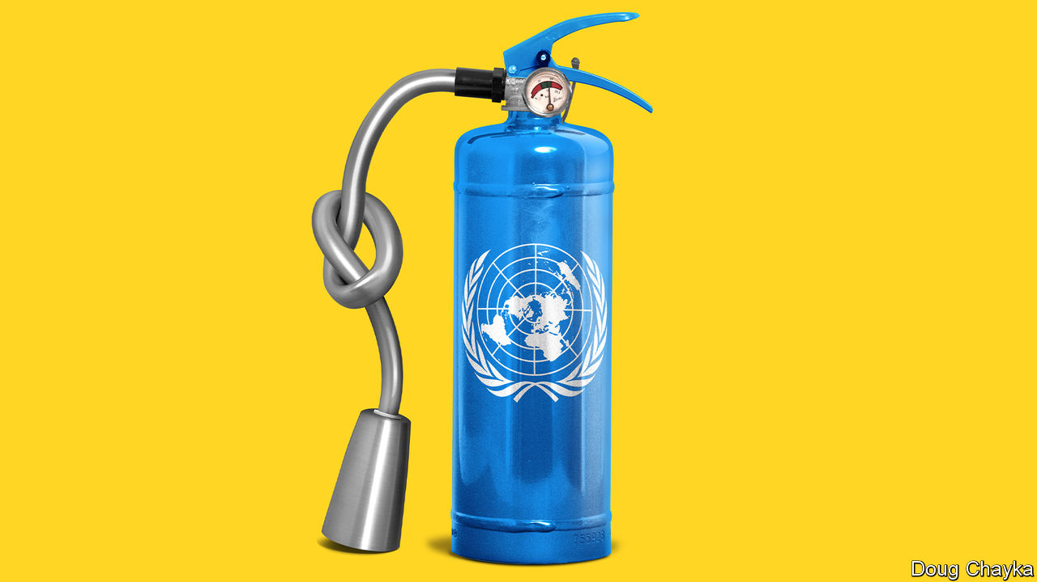

MANKEUR NDIAYE, a former foreign minister of Senegal who heads the UN’s peacekeeping mission in the Central African Republic (CAR), is a tall man with a tall task. The peace agreement between the CAR and 14 armed groups signed in February 2019 is the eighth since 2013, when French intervention narrowly averted a genocide. The situation remains fragile in a country that is rich in diamonds and gold but poor in other respects. Elections loom in December. With a budget of $1bn, twice that of the national government, the UN mission’s 12,000-odd soldiers and 2,000 police operate across a territory the size of France and Belgium combined. In some areas the state has no effective presence. The CAR has porous borders with other troubled places, such as the Democratic Republic of Congo, Sudan and South Sudan. The hope is that peacekeepers plus international aid give the brittle state a chance.

The idea of a non-violent, international military operation was invented to clear up the Suez mess in 1956, with a lot of imagination and improvisation (the first “blue helmets” were created by spraying the liners of American army helmets readily available in Europe). Today, peacekeeping is one area where the Security Council operates well. Some 100,000 people from 120 countries serve in 13 missions, which range from ceasefire monitoring in Cyprus and Lebanon to large, complex operations such as those in the CAR, Congo and Mali. The UN claims to protect about 125m vulnerable people around the world on a budget not much bigger than that of New York City’s police department.

The peacekeepers’ role has expanded into supporting fragile states and protecting civilians. At its best, this is admirable. In 2013 the UN opened its military compounds in South Sudan to tens of thousands of people fleeing slaughter. “No decision taken since 1945—at any level in the UN—ever resulted in the direct saving of more lives than that one,” believes Andrew Gilmour, until last December the UN’s assistant secretary-general for human rights.

But the peace business is getting harder. The blue helmets’ job used to be to preserve stability after a settlement. “Now you have peacekeeping forces in areas where there is no peace at all to keep,” says Mr Guterres. In Congo, for example, rebels hiding in the forests close to the north-eastern city of Beni frequently abduct people and hack them to death with machetes. Protests against MONUSCO, the UN peacekeeping mission, are common. “The rebels are killing us, if you cannot kill them, then go home,” says Kizito bin Hangi, a civil-society leader in Beni. When eight people were killed less than 2km from MONUSCO’s offices last November, a protest the next day got out of hand. Furious civilians tossed in Molotov cocktails, setting the place on fire and sending staff fleeing. Today, the former offices consist of some blackened bricks, strewn around a grassy field.

The changing nature of conflict doesn’t help. Wars between states, which the UN was set up to stop, have become rare. Most fights are now within countries, often involving many parties. The humanitarian consequences are disastrous. The number of internally displaced people has more than doubled in a decade to a record 51m, according to the Norwegian Refugee Council. Of those, 46m have been displaced within their own countries by conflict and violence. Civil wars are especially difficult to stop through negotiation, since laying down arms can seem too risky.

Many organisations are crowding in to help. The art of peace is increasingly the art of partnerships, with the likes of the African Union, the World Bank and the European Union. Private diplomacy is also on the rise, as groups such as the Centre for Humanitarian Dialogue (HD) in Geneva or the Berlin-based Berghof Foundation try to build bridges where official channels are missing or mistrusted. Both the UN and private outfits are striving to get more women involved, to make peace work more inclusive.

In spite of these efforts (and sometimes because of them, as the many actors trip over one another), frustration abounds. Conflicts are still starting, but big new peace agreements have become rarer: only seven or eight in the past decade, says David Harland of HD, compared with 30 or so in the 20 years after the fall of the Berlin Wall. In the Middle East since 2011 a succession of UN envoys—three in Yemen, four in Syria and six in Libya—have tried to resolve civil wars, without success. Well-intentioned mediation can end up favouring one side over others. In Syria, for example, local ceasefires gave President Bashar al-Assad a chance to regroup.

Mr Guterres has tried to leverage the pandemic for peace. On March 23rd he called for a global ceasefire, to fight the virus. A surprising number of armed groups seemed interested in an excuse to give talks a chance. In Yemen the Saudi-led coalition announced and then extended a unilateral ceasefire. In Afghanistan, for the first time in years, the UN convened a digital meeting of the Afghan government and six neighbours plus America and Russia (a “six plus two” formula that also brought Iran and America around the same table). But war persists in Afghanistan, and ceasefires in Colombia and the Philippines were broken. And, as America and China squabbled over the wording of a resolution, the Security Council failed to throw its weight behind the initiative.

If ending conflicts has become tougher, what about tackling their causes and consequences? That opens vast vistas for helping humanity. Perhaps too vast.

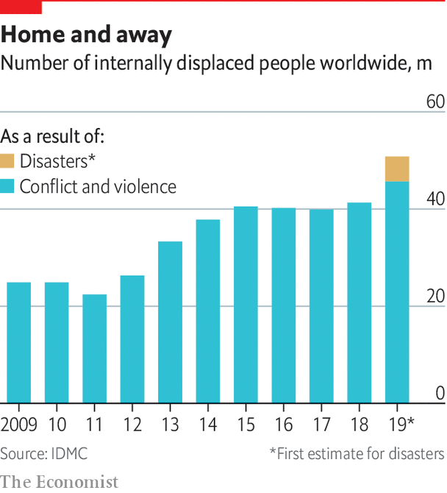

The short-term task is humanitarian relief, whether from man-made or natural disasters. That job—feeding the hungry, housing refugees, protecting health—is huge. Last year about $18bn in humanitarian funding, some 70% of the world’s total, was channelled through the UN, estimates Mark Lowcock, the UN’s emergency-relief co-ordinator, helping more than 100m people. Roughly 60% of the money comes from America, Germany, Britain and the EU. China provides very little.

## The long and the short of it

Early this year extra troubles loomed, with the assault on Idlib in Syria as well as locusts swarming across Africa. Now covid-19 threatens to multiply the misery. Mr Lowcock suggests that humanitarian relief this year may need to rise by 20% or so; and perhaps $60bn in cheap finance from international financial institutions should be targeted at social protection. He believes this could largely protect 700m people across several dozen of the world’s poorest and most vulnerable countries. It could also help to prevent a one-year problem from becoming a ten-year one.

Acting early makes sense, and not just over covid-19. Rigidities in funding (much of which is tied to specific programmes) restrict Mr Lowcock’s room for manoeuvre, but he is keen to get ahead of crises through risk pooling and smart use of data. He reckons that some 10% of global emergencies, including hurricanes and droughts, are insurable. And a further 10-15% are to some extent predictable. More effort on “anticipatory action” would mean achieving cheaper, faster responses with less suffering.

In Bangladesh, for example, giving money to people early to get out of the way of floods has proved to be efficient. Some scientists think they can predict outbreaks of cholera in Africa before a single case is recorded, once a threshold is reached in trigger metrics; early action could greatly reduce the damage. Mr Lowcock would like to experiment with a commitment to release money against pre-agreed problems that lend themselves to this approach. “You can be wrong on a lot,” he says, “and it can still make sense.”

In the medium term, attention turns to the Sustainable Development Goals (SDGs), a set of aspirations in 17 broad categories (with 169 targets) agreed upon by the UN General Assembly in 2015 and meant to be achieved by 2030. They make a comprehensive list of human development, covering everything from ending poverty and hunger to fighting inequality and pollution. If all the goals were achieved, humanity would be happy. But in many areas they are badly behind schedule, and covid-19 will set them back further. This year, for the first time this century, the proportion of people in extreme poverty is expected to grow, wiping out almost all the gains of the past five years, if not more. The SDGs are anyway more of a call to action than a realistic plan. In that vein, the UN is campaigning for a “Decade of Action” to honour these promises.

Mr Guterres started as secretary-general by emphasising crisis prevention, but this has proved heavy going, given the divisions among the big powers and the growing complexity of conflicts. The climate crisis has since come to the fore, both because of its intrinsic, long-term importance and because it seems to offer the UN a way to resonate with young people. In New York last September Mr Guterres organised a climate-action summit. Greta Thunberg, a teenage Swedish activist, warned leaders that “young people are starting to understand your betrayal”.

The pandemic has meant the postponement of the COP26 climate summit in Glasgow (as well as a biodiversity summit in Kunming and an ocean conference in Lisbon), to which countries were meant to bring bolder national commitments to cut carbon emissions. But the delay has a green lining. Mr Guterres has tried to link the twin crises, arguing for policies that ensure that the recovery from covid-19 helps to save the planet.

On Earth Day, April 22nd, he proposed a six-point framework to that effect. His suggestions are extremely broad—tie business rescues to creating green jobs, for example, end fossil-fuel subsidies and, unsurprisingly, “work together as an international community”—but they are a taste of a campaign to come. Advocacy of drastic climate action has become something of a rallying cry for the UN. As Richard Gowan, UN director at the International Crisis Group (ICG), an NGO, points out: “UN optimists are mostly people with the bleakest view on climate, because they imagine it’s what draws the UN back together.”

Has Mr Guterres got his priorities right? The criticism that stings most is personal. It is that the secretary-general puts politics over core principles and pulls his punches in an area that is neither short-, medium- nor long-term but timeless: human rights. Mr Guterres is accused of failing to defend the charter (which commits the UN to promote “universal respect for, and observance of, human rights”) by speaking out against abuses by powerful governments, including China’s detention of Uighurs and Saudi Arabia’s murder of Jamal Khashoggi, a critic of the regime. Some predecessors, such as Kofi Annan, were more forceful. Even the often invisible Ban Ki-moon launched Human Rights up Front, a campaign to insert the issue across the UN’s work. Zeid Ra’ad al-Hussein, a former UN human-rights commissioner, has condemned Mr Guterres’s “weakness”. Kenneth Roth, head of Human Rights Watch, an NGO, has warned that his term was becoming “defined by his silence on human rights”.

Mr Guterres’s defenders say such attacks are unfair. He has picked his moments to speak up in public, whether on Uighurs in China or Rohingyas in Myanmar, and has championed women’s rights, within the UN and beyond. Yes, he avoids confrontations that would be counter-productive (he never criticises Donald Trump by name, for example). But this gives him the ability to deliver a strong message behind the scenes. What powder he has must be kept dry. “At the UN there is practically no power at all,” he says. “When you’re in government you have some power. Here it’s basically a bluff, or an illusion.”

A second, broader, criticism of the UN is that it simply does too much. It is, in effect, trying to save the world several times over. Its many aims may be wonderful, and interconnected, but it lacks the capacity to pursue them all effectively. It has taken on more than it was designed for. And the design itself needs a fresh look.■

This article was downloaded by calibre from <https://www.economist.com/special-report/2020/06/18/the-un-has-too-much-on-its-plate>

|  |  |  |  |
| --- | --- | --- | --- |
| Previous | Articles | Sections | Next |

|  |  |  |  |
| --- | --- | --- | --- |
| Previous | Articles | Sections | Next |

#### New START’s end?

# The clock is ticking for nuclear arms control

Avoidable Armageddon

Jun 20th 2020 |

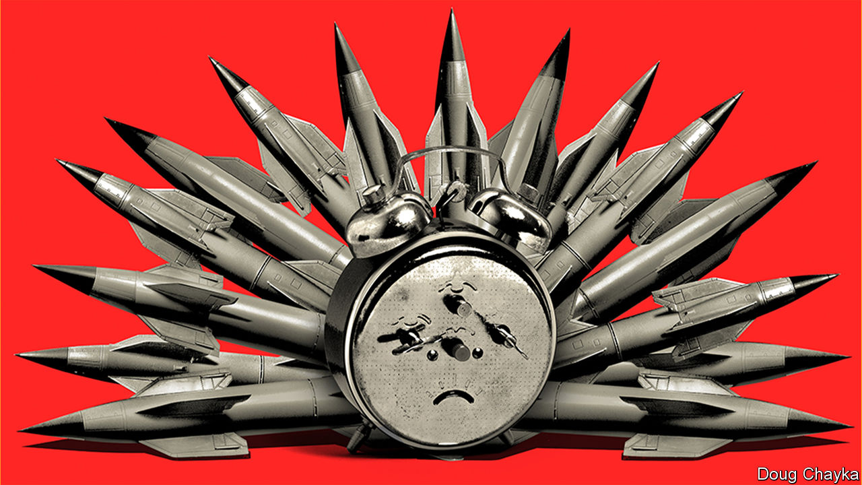

TIME IS RUNNING out for the last remaining nuclear arms-control treaty between America and Russia. New START limits their arsenals of long-range nukes and allows intrusive mutual inspections. Without agreement to extend it, the treaty will expire on February 5th 2021.

That is not the only reason why the five-yearly review of the 50-year-old Nuclear Non-Proliferation Treaty, scheduled this spring but postponed because of covid-19, promises to be bitter. Nuclear have-nots complain that the P5 countries permitted to have nukes are not keeping their side of the bargain, to work in good faith towards giving them up. Nuclear fears are rising. Whether through miscalculation or otherwise, the risk of a nuclear detonation is at its “highest since the peak of the cold war”, warns Nakamitsu Izumi, the UN’s undersecretary-general for disarmament.

Donald Trump has pulled out of the nuclear deal with Iran. His nuclear summitry with North Korea has stalled. If constraints are seen to be failing, more countries may feel tempted to go nuclear. Turkey’s Recep Tayyip Erdogan has mused aloud about it. Seeking to occupy the moral and legal high ground, more than 80 countries have signed a Treaty on the Prohibition of Nuclear Weapons, which will come into force once 50 have ratified it. The nuclear haves will ignore it.

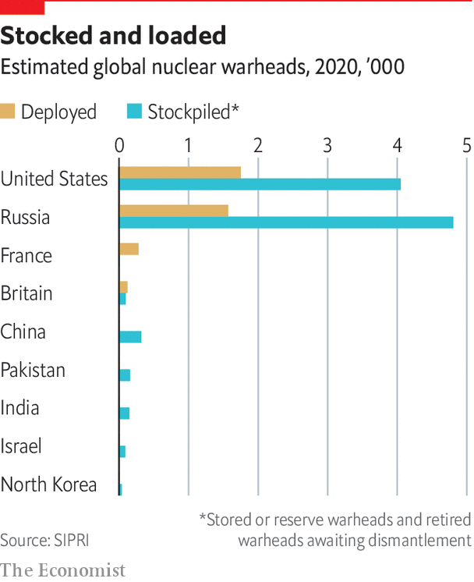

Even during the cold war America and Russia managed to reach nuclear deals. They signed their first such treaty, SALT I, in 1972. But recently accords have been falling apart. The Intermediate-range Nuclear Forces Treaty collapsed last August, because of Russian cheating. New START’s demise would open the way for a new nuclear arms race, amid worries about emerging threats from hypersonic weapons. This comes on top of growing concerns about future conventional systems controlled by artificial intelligence.

Russia says it wants to extend New START, but Mr Trump dislikes the treaty, partly because it was signed in 2010 by his predecessor, Barack Obama, and more reasonably because it does not restrain China, which has a smaller nuclear arsenal but one that is getting larger and fancier. Mr Trump favours a bigger treaty, including China. His arms-control envoy, Marshall Billingslea, has said that, if Russia wants an extension, it must bring China to the table. But China shows no interest in letting itself be tied down. Some suspect that Mr Trump’s insistence on three-way talks is a poison pill, allowing America to engage in a nuclear race that hawks think it would win.

New START can be extended for five years by mutual agreement (with no need to ask Congress). Arms-control advocates say this would buy time for a wider future deal involving China, and perhaps including all types of nukes. Russia might insist that the smaller British and French arsenals be counted in any such negotiations, if limits on the numbers of weapons were reduced much further. There is plenty here for the P5 to work on, if they could only get round to it.

This article was downloaded by calibre from <https://www.economist.com/special-report/2020/06/20/the-clock-is-ticking-for-nuclear-arms-control>

|  |  |  |  |
| --- | --- | --- | --- |
| Previous | Articles | Sections | Next |

|  |  |  |  |
| --- | --- | --- | --- |
| Previous | Articles | Sections | Next |

#### Reform

# The UN’s structures built in 1945 are not fit for 2020, let alone beyond it

Grand redesigns

Jun 20th 2020 |

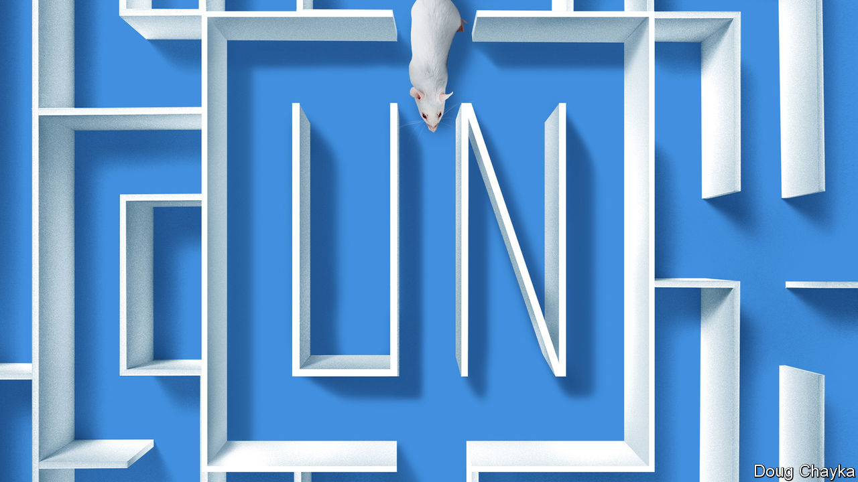

“IF YOU DIDN’T have the UN you really would have to reinvent it,” says Stephen Schlesinger, author of a history of its founding. Maybe, but nobody in their right mind would design it as it exists today. Insiders complain of a tangle of overlapping agencies, senseless silos and barricaded budgets. “If you locked a team of evil geniuses in a laboratory, they could not design a bureaucracy so maddeningly complex,” one departing official despaired. Outsiders face a forbidding confusion of agencies with acronyms. Many do great work (WFP and UNHCR), others have a mixed record (WHO and FAO), a few are useless (UNIDO). And at the top the structure reflects the world of 1945, as if little had changed since.

This was not what the founders envisaged. Hailing the charter, Truman said it had “not been poured into a fixed mould”, but would be adjusted in line with changing conditions. In fact the only changes have been minor ones, to take account of the growth of UN membership. In 1965 the Security Council expanded from 11 members to 15. But whereas it included 22% of General Assembly members in 1945, it now has just 8%. Its veto-wielding P5 remain the victorious powers of 75 years ago, with no representation from Latin America, Africa or South Asia. Without change, the legitimacy gap will only grow.

This might matter less if the council were working effectively, but it is not. There have been worse periods. In 1959 the council passed just one resolution, to appoint a committee to report on Laos. “By historical standards, this is still a reasonably active institution,” says Mr Gowan of the ICG. But it is increasingly crippled by great-power rivalry. The relationship between the three biggest powers, America, China and Russia, “has never been as dysfunctional as it is today,” says Mr Guterres.

Veto use has risen. In the past five years Russia has wielded 14 vetoes, China five and America two (Britain and France have refrained from using theirs since 1989). In response to the Ebola crisis in west Africa in 2014 the Security Council passed a resolution calling the outbreak “a threat to international peace and security”. Over covid-19 it dithered for weeks and then struggled to agree to a resolution calling for a 90-day pause in hostilities in conflict-ridden countries, as China and America quarrelled over whether to refer to the WHO (China said yes, knowing America would say no). Instead of putting momentum behind the secretary-general’s ceasefire appeal, the council stayed paralysed.

Its credibility is slipping. The arms embargo on Libya is ignored. Russia’s behaviour is a big worry. “The existential problem is that countries respect the decisions of the Security Council less and less,” says Karen Pierce, until recently Britain’s ambassador at the UN, now its ambassador in Washington. Normally the P5 is there to uphold the rules, says Ms Pierce, but, referring to Russia’s support for Syria, “for a P5 member to think it’s OK to condone the use of chemical weapons is quite a major shift.”

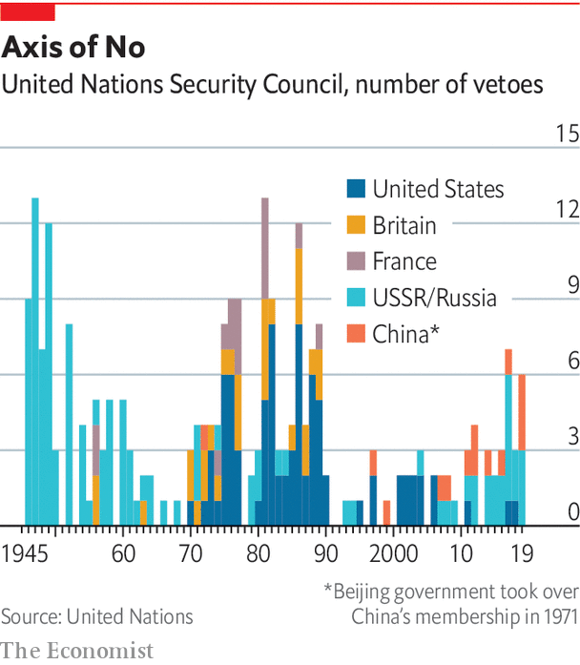

Could reform help? To ensure that the council remains representative, suggests Stewart Patrick of the Council on Foreign Relations, an American think-tank, “ideally you’d have something like the Premier League, with relegation and promotion.” But try agreeing on a formula. For over a decade, an intergovernmental group at the UN has grappled with how the council might take in more countries. Which ones? Should they be permanent with a veto, or non-permanent without one? Or perhaps something in-between, with longer non-permanent terms?

A group of four (G4) countries with the strongest claims to the top table—Brazil, Germany, India and Japan—are keen to get a move on. Africans see it as a historical injustice that they did not get a permanent seat at the outset, but their own rivalries stop them specifying which countries they would pick, so they stick with an overall demand for two permanent seats plus an expansion of non-permanent ones. Another group of a dozen countries wary of the G4, including Argentina, Italy, Pakistan and South Korea, argue against expansion of permanent members and instead want more non-permanent ones. One approach could be to look at non-permanent ones first, and come back to the permanent ones later. But the G4 resist this as a recipe for denying their claims.

If new permanent members were agreed to, a bigger Security Council might not be more effective

In this process, you get “some of the most creative, passionate, articulate speeches that I see permanent representatives give,” says Lana Nusseibeh, the United Arab Emirates’ ambassador to the UN, who co-chairs the intergovernmental group, “because this issue speaks to their core national interests.” And even if new permanent members were agreed to, a bigger Security Council might not be more effective. Any change needs an amendment of the charter, which requires the votes of two-thirds of the General Assembly and the approval of the current P5. In short, many stars would have to align. In the meantime, lesser changes could help. For example, many would like the Security Council to become more transparent in its work.

## To be the very model of a modern multilateral

In the UN secretariat itself, reform is also a hard slog. Power rests in the member countries, which limit freedom of manoeuvre, not least over the budget. The regular budget of about $3bn (there is a separate one for peacekeeping) relies on national contributions, assessed through a formula based largely on economic size. America’s share, at 22%, remains the biggest, though China’s has risen fast, overtaking Japan’s. Once the budget is set, countries are supposed to pay up within 30 days. But roughly 30% of the money comes in the final two months of the year, creating the risk of a cash crunch in September, just when the UN hosts its General Assembly. It has a reserve of only about $350m and is not allowed to borrow. Last year escalators were switched off for a while at the New York headquarters to conserve cash. Earlier this year payments for peacekeepers were delayed.

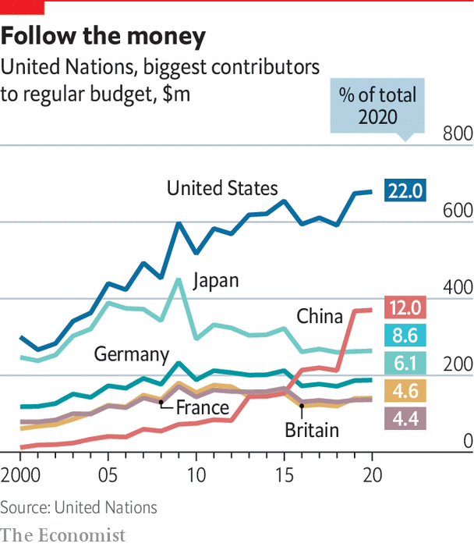

Worse still is the budget’s rigidity. Bosses cannot use savings in one area to spend in another. Decisions have to go laboriously through the bureaucracy, with scrutiny from something called the Fifth Committee and a fun-sounding Advisory Committee on Administrative and Budgetary Questions. Even moving a mid-level post requires the unanimous approval of all 193 countries. “It’s crazy that the secretary-general doesn’t have more flexibility,” says one Western diplomat on the Fifth Committee.

Mr Guterres has sought to break down silos and improve co-ordination. But the pandemic has shown the need for a stronger form of governance, he believes. “Today we have a multilateralism that has no teeth,” he says, “and wherever there are teeth, as in the Security Council, there is no appetite to bite.” Multilateralism needs to evolve in two ways, he argues: it must become more “networked” and more “inclusive”. By networked he means working closely with other organisations, to achieve joined-up action on interconnected issues affecting a specific region or problem.

Take the Sahel. No single organisation can tackle its intertwined security, development and political troubles. Collaboration is needed with the African Union, the African Development Bank, the World Bank and other institutions. The UN’s co-operation with the AU is “fantastic in all areas”, Mr Guterres says, and that with the World Bank and IMF deeper than ever. So he reckons this side of things is already on track. But inclusivity is not. National governments that control multilateral institutions resist letting businesses, trade unions, NGOs, cities and regional administrations have any voice. Mr Guterres is using the 75th anniversary as an excuse for a campaign to open up global governance.■

This article was downloaded by calibre from <https://www.economist.com/special-report/2020/06/20/the-uns-structures-built-in-1945-are-not-fit-for-2020-let-alone-beyond-it>

|  |  |  |  |
| --- | --- | --- | --- |
| Previous | Articles | Sections | Next |

|  |  |  |  |
| --- | --- | --- | --- |
| Previous | Articles | Sections | Next |

#### Reflections at 75

# The UN is mobilising for the next quarter-century

The wisdom of youth

Jun 18th 2020 |

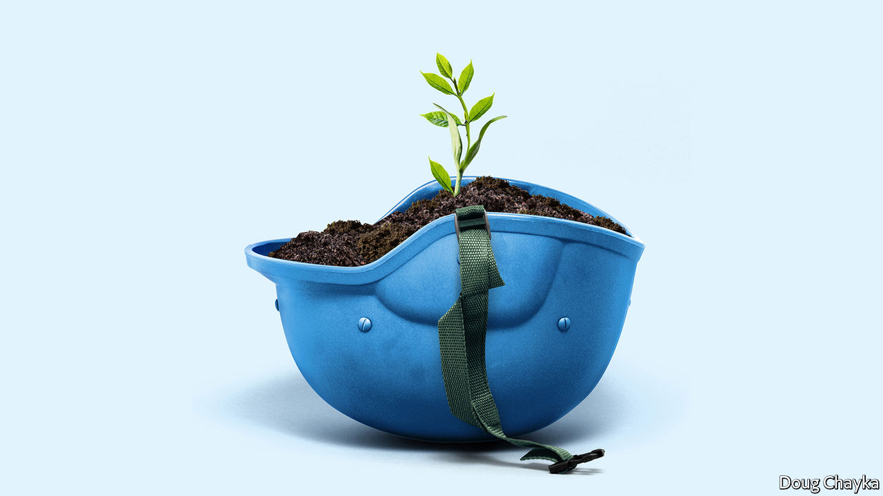

LUCKILY, GIVEN the pandemic, the UN did not plan a boastful birthday. Instead, it decided to ask what the world thinks. It has launched an effort to to gather views from everywhere, in the spirit of the opening words of its charter, “We the peoples”.

With the help of a mass online survey, in-depth polling across 50 countries, hundreds of live “dialogues” and a trawl of research, the plan is to find out what people would like to see 25 years from now, when the UN reaches 100. The views of young people are a special focus. Half the world’s population is under 30, points out Jayathma Wickramanayake, the secretary-general’s youth envoy, yet they have little say in how it is run.

The aim of UN75 is “to give a vitamin shot to what at times feels like quite a fatigued enterprise and come up with new ideas,” says Fabrizio Hochschild, the official in charge. The results will be presented to the General Assembly in September. Preliminary findings released in April suggest the world thinks pretty much what the UN was hoping. The priorities were environmental protection, human rights, less conflict, equal access to basic services and zero discrimination. Fully 95% of survey respondents thought international co-operation was “essential” or “very important” (the number ticked up as covid-19 took hold). As for how co-operation might work better, ideas included a more bottom-up approach, more effective partnerships and more involvement of women, young people and the vulnerable.

All this aligns nicely with themes the UN hopes to use to breathe life into the “inclusive” multilateralism that Mr Guterres espouses. On climate change, it wants business, finance, NGOs, youth movements and others to pile pressure on governments to make more ambitious carbon-cutting pledges at the COP26 climate summit in Glasgow next year. Beyond that, the green theme will run and run. The covid-19 crisis will pass, but the climate one will remain a priority for years to come.

Gender equality is a second test. The UN is trying to lead by example. Half the 180 senior leaders in its secretariat were women at the start of this year, up from a third three years ago. Achieving parity out in the field is harder. In peacekeeping operations the aim is for at least a quarter of military observers and staff officers to be women by 2028, compared with 15% last year. Overcoming resistance from governments is harder still, so the UN is trying to build alliances with businesses, NGOs and local authorities, to achieve change from the bottom up.

## You say you want a revolution

A third area that lends itself to innovative efforts is digital. The pace of change is such that regulation struggles to keep up. If governments take years to negotiate agreements and even more to ratify them, by the time rules are ready the real world (and even more the virtual one) has moved on. The UN favours a nimbler way, involving not just governments but companies, research centres and NGOs in a form of soft regulation to exchange best practices and set boundaries for new technologies such as artificial intelligence. Mr Guterres set up a high-level panel, co-chaired by Jack Ma and Melinda Gates (philanthropists of, respectively, Alibaba and Microsoft fame), to draw up a report on digital interdependence. Working groups on digital human rights and digital public goods have picked up its recommendations. In this “new multilateralism”, says Mr Guterres, what was once done only by governments is now done through “permanent platforms of co-operation, with a multi-stakeholder approach”.

Inclusive multilateralism has other attractions. The UN, which has the convening power to bring parties together, sees a chance to play a leading role. Wider participation could deepen trust, and give more opportunities to hold governments to account. Flexible approaches could also help tackle other frontier issues that are likely to grow in importance, such as the interface between Earth systems and the international system (the recent clash over the Amazon between the Brazilian and French presidents may be a foretaste) and the governance of everything from genetic engineering and new weaponry to the ocean and space.

Multi-stakeholder initiatives are not new. Various sorts have proliferated in recent years, whether to chivvy particular sectors (the Extractive Industries Transparency Initiative or the Roundtable on Sustainable Palm Oil), run the internet (ICANN) or improve government (Open Government Partnership). But inclusiveness is not a panacea. It raises accountability issues of its own. A bigger role for businesses and NGOs sounds good, but they don’t answer to voters. Some initiatives find it easier to issue broad pleas for good behaviour (like the Paris Call for Trust and Security in Cyberspace) than to produce rules, let alone ensure compliance. In authoritarian countries it is not easy to include voices from civil society; one tactic in China’s efforts to influence international organisations, according to the CNAS study, is the creation of “government-organised non-government organisations”, or GONGOs.

And for all the good intentions of the secretary-general’s panel on digital interdependence, the biggest development is the stand-off between America and China over technology, amid arguments over who will dominate the next generation of telecoms infrastructure and fears that a “splinternet” of rival digital spheres is in the making. The covid-19 crisis has reinforced the power of states, from massive intervention in economies to monitoring people’s movement. Opening up the multilateral system to more voices is welcome, but as the UN looks ahead to life at 100, it is governments—especially the big beasts among them—that will still shape the future world order.■

This article was downloaded by calibre from <https://www.economist.com/special-report/2020/06/18/the-un-is-mobilising-for-the-next-quarter-century>

|  |  |  |  |
| --- | --- | --- | --- |
| Previous | Articles | Sections | Next |

|  |  |  |  |
| --- | --- | --- | --- |
| Previous | Articles | Sections | Next |

#### Time to rediscover statesmanship

# Three future scenarios for the UN

Bedlam, bumbling or boldness?

Jun 20th 2020 |

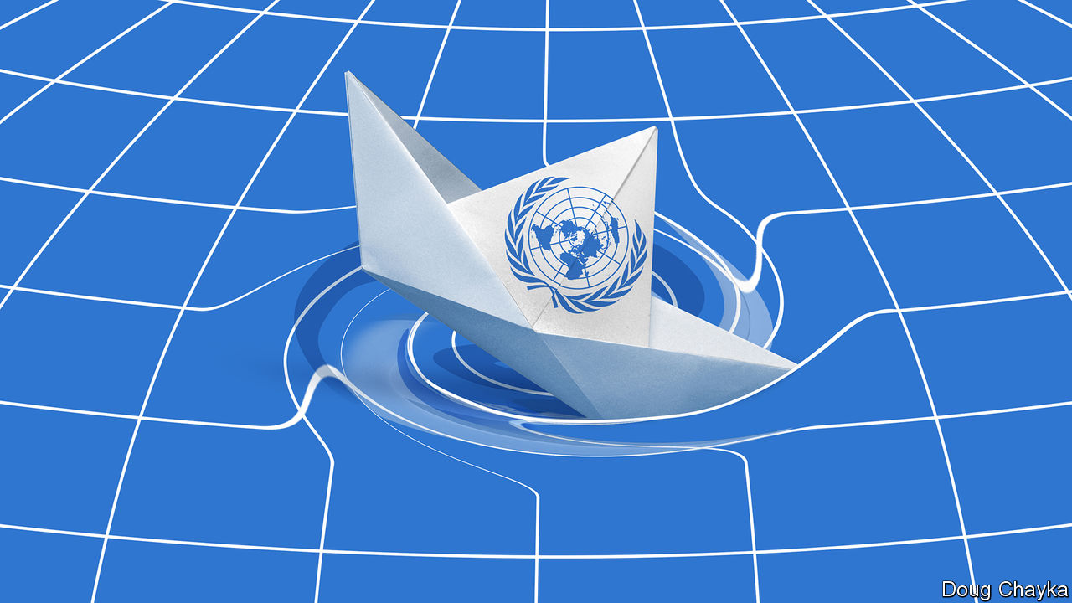

IN A SPEECH in January Mr Guterres conjured up “four horsemen” to describe the challenges facing the world. The first represented the worst geostrategic tensions in years, with a real risk of a “great fracture”. Next, said the secretary-general, the planet was burning, and an existential crisis was close to a point of no return. His third horseman took the form of rising global mistrust, often spilling into hatred, amid discontent over inequality and the sense among too many that globalisation is not working. Lastly, the dark side of digital technology threatened to invade privacy, disrupt work and unleash lethal autonomous machines in war.

If this was not apocalyptic enough, a fifth horseman is now galloping around the globe. Covid-19 has claimed hundreds of thousands of lives and plunged the world into a recession far deeper than that of 2008-09. Worse could be to come if the virus proceeds to devastate poorer countries before boomeranging back into rich ones. And in response the world has seemed rudderless. National leaders have been too preoccupied fighting the disease in their own countries to have much appetite for international efforts. And at the UN, the Security Council has been a bystander.

The nightmare scenario is a descent into deepening disorder. Imagine that after the covid-19 crisis is over, Mr Guterres’s horsemen run rampant. Any hope that the world can summon the will to tackle climate change vanishes. Under pressure, institutions that have sustained a rules-based system buckle. Unrestrained protectionism kills the WTO. America abandons NATO, as its European partners slash defence spending to prioritise economic recovery. Divisions between northern and southern members prove too much for the EU. The UN goes the way of the League of Nations, failing to stop rival powers from provoking each other and, in the end, fighting.

While such bedlam is possible, a likelier scenario is less dramatic: bumbling along. Inertia helps the main multilateral institutions survive, despite their inability to modernise themselves, and second-tier powers keep co-operation alive. Future American presidents restore a degree of confidence in the country’s commitment to the international order, although the trauma of transactional Trumpism casts a long shadow. America’s return to the Paris agreement lends weight to efforts to tackle climate change.

The tussle between America and China continues. But America makes a more concerted counter-push, working with its European and Asian allies, with a revived championing of universal values. In many parts of the world mistrust of China runs deep. Russia still makes mischief, but less often, since a more coherent West gives it fewer opportunities. The multipolar system becomes less “chaotic” and more contained, settling into an uneasy stalemate. Perhaps this is enough to keep the four horsemen in their stables.

Just possibly, extraordinary times could provide the jolt the world needs to be bolder

Bumbling along in this way would not be the worst outcome. But it would be a waste of a crisis. Just possibly, extraordinary times could provide the jolt the world needs to be bolder, even if for now this seems improbable. Little or no global leadership can be expected from America under Mr Trump. The pandemic has pushed most other issues aside: planned gatherings on big global issues, such as climate change and nuclear non-proliferation, have been postponed. Yet the delay may be a blessing in disguise, giving fresh thinking a chance.

Already, some see opportunities ahead. In Europe Mr Macron is alive to the idea that the time may become ripe for big ideas. Britain’s Boris Johnson always welcomes a chance to play Churchill. Ideas for making the post-covid-19 economy greener are sprouting, as are concerns to make it fairer. Perhaps China could be persuaded to take part in a new round of nuclear arms control, which could serve as a start to rebuild relations with Russia.

Global organisations have a shot at change, too. Just as the second world war prompted leaders to create institutions to prevent wars, Bill Gates believes the covid-19 crisis will lead them to build institutions to prevent pandemics and, alongside national and regional bodies, to guard against bioterrorism. Co-operation on viruses could serve as a model for collaboration to strengthen resilience in cyberspace. The shock to the system could even be profound enough to prompt a serious go at reforming the UN Security Council before it grows even less representative of the realities of power in the 21st century. Ample groundwork has been done. What is missing is political will.

## Let’s go to San Francisco

None of this can happen overnight. A start could come from a P5 summit, with a further push at the 75th-anniversary meeting of the Global Assembly in September. Because of the pandemic, this will be a more limited affair than originally envisaged, perhaps with a mix of physical and virtual presence, but it can still dignify the occasion and show a worldwide wish for closer collaboration. It should also be an opportunity to look ahead, mapping the way to reforms designed to ensure that the UN is still in business at 100.

If the wartime model were followed, the road might even lead to a grand convention, as in San Francisco in 1945. The main actors at that conference were the delegates of the governments involved, especially the big powers. But in all—counting the secretariat workers, the press, interpreters, security personnel and assorted lobbyists and observers—about 5,000 people crowded into town, in a foretaste of the General Assembly that clogs New York every September. “Consultants” representing industries, labour, religions, professions, women and minorities were accredited. They managed to influence the charter on education and human rights, and successfully pushed for an article allowing the UN’s Economic and Social Council to consult NGOs. A rethink of the rules ought to be even more inclusive.

Such a prospect looks far-fetched when the world is consumed by the fight against a virus, and when America and two other big powers are waging a new cold war. But in the midst of the second world war it was hard to imagine that institutions would emerge that would keep the peace for three-quarters of a century. The statesmanship that created them is now needed once again.■

This article was downloaded by calibre from <https://www.economist.com/special-report/2020/06/20/three-future-scenarios-for-the-un>

|  |  |  |  |
| --- | --- | --- | --- |
| Previous | Articles | Sections | Next |

|  |  |  |
| --- | --- | --- |
| Special report | Sections | Finance & economics |

Business

Luxury in the pandemic: Fashion victims

.

Race in Silicon Valley: Beyond the pale

.

Bartleby: Waging war on recessions

.

Samsung: No end in sight

.

Business in China: Chopped and screwed

.

JAB Holding: The Reimann hypothesis

.

Schumpeter: Zoom and gloom

.

|  |  |  |
| --- | --- | --- |
| Special report | Sections | Finance & economics |

|  |  |  |  |
| --- | --- | --- | --- |
|  | Articles | Sections | Next |

#### Fashion victims

# How slow times in the luxury world will separate the bling from the chaff

Posh purveyors are having to rethink their business model in a hurry

Jun 20th 2020 | PARIS

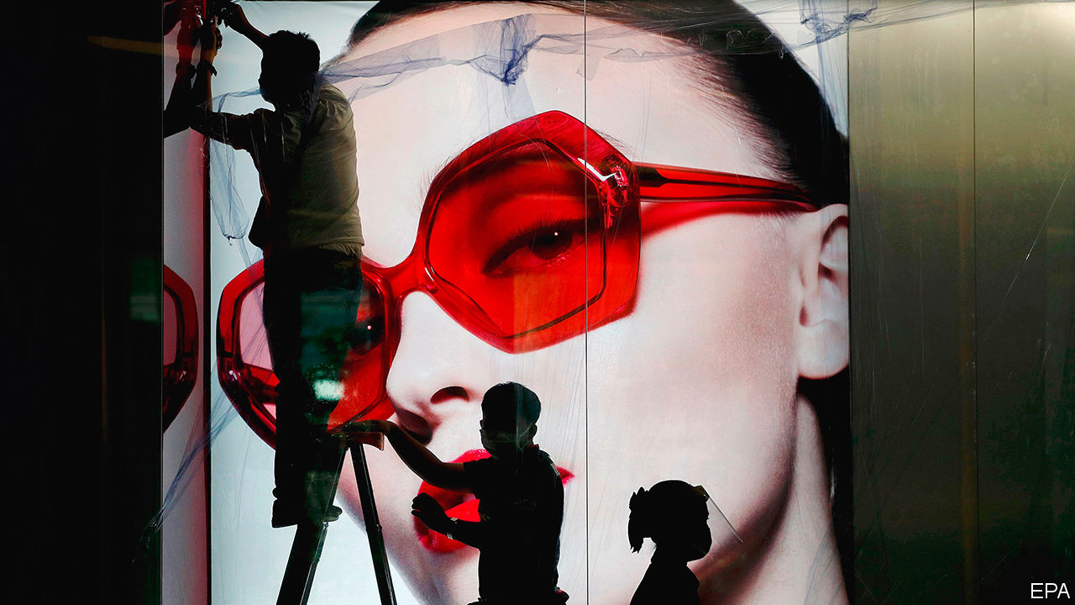

MILAN, PARIS or New York this time of year would usually be teeming with fashionistas scrambling to get from the Balenciaga show to the Chanel party. Not in 2020. Fashion weeks have been cancelled, repurposed as posh catwalk webinars. Shops selling Hermès ties and Prada pumps are only just reopening, wondering what to do with stock of pre-covid-19 vintage. Instagram influencers normally on hand to feed the hype have nothing to snap.

The world of personal luxury goods—from handbags and haute couture to diamond rings and pricey Swiss watches—has been in hibernation. At the height of the pandemic between March and May sales slumped by 75% or so on a year earlier, according to the Boston Consulting Group. They have slowly picked up as Asia, then Europe and America, started reopening. Even so, the outlook for the luxury world is far from glittering.

The global recession hangs over a sector fuelled by consumer confidence. Beyond that short-term shock, the industry is facing an overhaul in how its baubles are made, where they are sold and to whom. Trends once expected to play out over a decade may unfold in mere quarters. Rapid change has set nerves jangling in a business meant to exude timeless tradition.

Start with who is buying and where. Although most purveyors of luxury are European (with America home to some of the lesser marques), most of their customers come from Asia. Asians bought more than half of the €281bn ($315bn) in bling sold last year. Chinese buyers alone have gone from 1% of purchases in 2000 to 35% last year, according to Bain, another consultancy. But most of that—perhaps 70%—was purchased overseas, often on jaunts to Europe. Just over a tenth of all luxury sales were actually booked in mainland China.

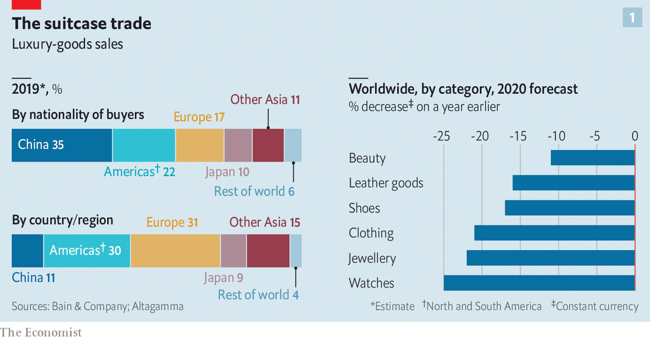

Unless intercontinental tourism rebounds faster than expected, new ways will have to be found to get Euro-chic into Chinese hands. Firms hope that shopping sprees will simply move from Paris to Shanghai. In the short run, this might boost margins: the likes of Louis Vuitton (part of LVMH, the biggest luxury group) and Gucci (part of Kering, another French giant) charge a third more in China than in Europe for the same products. Closing a few flagship stores in high-rent tourism hotspots such as Paris or Milan, which usually sell half their stock to tourists, could save firms money in property costs.

Yet any boost to margins may be short-lived. The difference between European and Chinese prices has narrowed. Those in China have been declining as apps make international price comparisons easier and firms woo shoppers facing ever more restrictions from Chinese authorities on bringing luxury items home from abroad. And more shops on the mainland, in cities they would once have deemed déclassé, may diminish the aura of exclusivity that shopping on Avenue Montaigne in Paris or New York’s Fifth Avenue confers. The de facto discounts were aimed at luring buyers to the West precisely for that reason.

The pandemic has accelerated other trends. Online sales of luxury goods, at 7-8% of the total on average, are around half those of mass-market fashion retailers like H&M and Zara. The closure of shops has, predictably, eased some of the reservations brands may have about selling their wares on the internet. LVMH has said online purchases are “significantly higher” as a share of sales than pre-pandemic. Sales through department stores—which are in terrible financial shape, notably in America—are also likely to shrink.

Meanwhile, costs may rise. Though they love to show off in-house “artisans” stitching handbags and the like, even the poshest maisons quietly outsource some of their production. Many rely on outsiders for more than half their products. These suppliers are often small family firms in Italy, which went into the pandemic with slim margins and slimmer financial buffers. Luxury groups are now having to assist them financially in a hurry lest they disappear for good.

All this paints a drab financial picture. Sales are forecast to fall by a third in 2020, and recover only by 2022 at the earliest. That will crimp margins, since luxury firms’ costs are largely fixed. Rents must still be paid and brands advertised—the poshest ones spend the best part of $1bn a year on marketing—even as sales droop.

In many industries, squished margins and falling sales might lead to a slew of takeovers. Few expect that to happen in luxury. Most of the big players have healthy balance-sheets and are expected to find ways to return to profitability (see chart 2). Many smaller marques are controlled by founders or their families, who are loth to sell in a downturn. If anything, consolidation might slow; all eyes are on whether LVMH will complete its $17bn takeover of Tiffany, an American jeweller, agreed weeks before covid-19 struck.

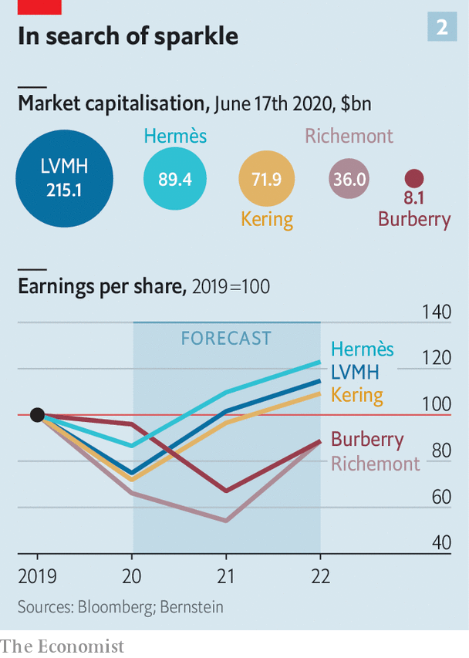

Not all parts of the industry are equally vulnerable. In a crisis, buyers stick to more established brands. “They want the best of the best,” says Luca Solca of Bernstein, a broker. Good news, then, for the likes of Louis Vuitton and Chanel, which have in fact pushed up prices in recent months. In contrast, brands hoping for a turnaround in their fortunes—Burberry is a perennial candidate—are less able to gain the attention a relaunch might otherwise garner.

Some segments have also been hit harder than others. Perfumes and cosmetics have held up best: a lockdown is no reason to forgo a skincare regime, apparently. Fashion houses face bigger problems, as cooped-up fashionistas see less need to replenish their wardrobes. Worse, unlike jewellery or handbags, surplus stock of apparel is rapidly going out of style. Overt discounts are frowned upon in luxury for fear of cheapening precious brands. Most at risk are fancy watchmakers like Richemont, which attract sellers at fairs and trade shows that have now been cancelled.

The question is whether amid this shake-up the luxury world can keep its grip on the wallets of the world’s big spenders. Fears that consumers would opt for a more ascetic post-pandemic future are dissipating: reports of “revenge shopping” as China emerged from lockdown implies that rich folks’ appetite for status symbols remains intact. But these worries are being replaced by those over Chinese shoppers developing a taste for nascent local brands, at the expense of the old-world stalwarts.

The biggest potential changes may concern the designers themselves. By late June the most exalted would normally start displaying autumn and winter collections in shop windows. This year they will make up for lost time by selling their summer season through the summer, as might seem sensible anyway. Giorgio Armani, an Italian veteran, has argued this should become the new norm. What a bold fashion statement that would be.■

Editor’s note: Some of our covid-19 coverage is free for readers of The Economist Today, our daily [newsletter](https://my.economist.com/user#newsletter). For more stories and our pandemic tracker, see our [coronavirus hub](https://www.economist.com/news/2020/03/11/the-economists-coverage-of-the-coronavirus)

This article was downloaded by calibre from <https://www.economist.com/business/2020/06/20/how-slow-times-in-the-luxury-world-will-separate-the-bling-from-the-chaff>

|  |  |  |  |
| --- | --- | --- | --- |
|  | Articles | Sections | Next |

|  |  |  |  |
| --- | --- | --- | --- |
| Previous | Articles | Sections | Next |

#### Beyond the pale

# Will Silicon Valley face up to its diversity problem?

The tech industry’s response to the killing of George Floyd has been stronger even than in other parts of the economy

Jun 20th 2020 | PALO ALTO

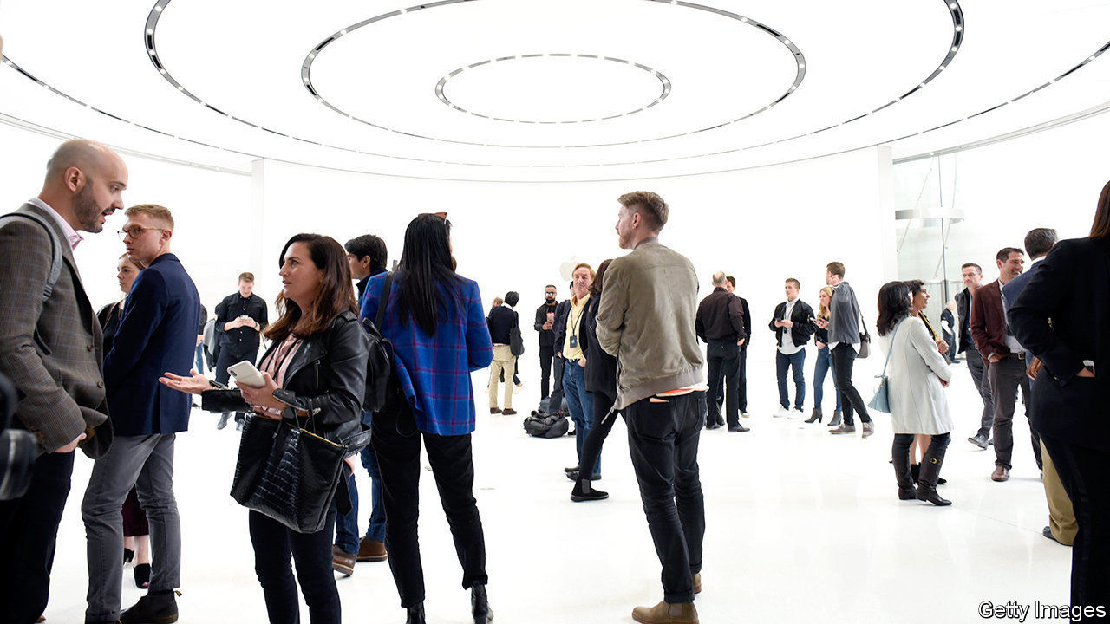

TO GET A sense of diversity in tech, take a stroll on University Avenue in Palo Alto, a city at the heart of Silicon Valley. Before the pandemic, if you encountered a black person, the chances were they worked in a local shop. African-Americans account for 3% of workers at America’s five biggest technology firms (see chart) and probably less at smaller ones. About one in 50 partners at venture-capital (VC) firms is black. The figure among VC-financed entrepreneurs is one in 100. Such dismal numbers, and Silicon Valley’s meritocratic pretensions, help explain why tech’s response to the killing of George Floyd has been louder even than other industries’. Will outrage lead to lasting change?

Pushed by a left-leaning workforce, big tech now regularly takes an activist stance on important issues, from immigration to the pandemic. Yet even by these standards, the reaction to the Black Lives Matter protests has been remarkable. Firms offered donations to race-related charities, set up funds to finance startups by non-white founders, stopped selling controversial technologies such as facial recognition and vowed to purge their software of racist language. Apple and YouTube (part of Google) each pledged $100m to combat racism with educational schemes and support for black artists. On June 17th Google said it would raise the share of “under-represented groups” in leadership by 30% by 2025.

Yet corporate activism will amount to little if tech firms and their financiers do not change how they operate, says Sydney Sykes, co-founder of BLCK VC, a group on a mission to swell the ranks of black venture capitalists in America. Companies must make more of an effort to promote and retain minority employees. VC firms have to examine why they often reject pitches by minority entrepreneurs; a simple “just can’t get excited about this” is no longer enough. They should also broaden their professional networks beyond the usual lily-white crowd, argues Elliott Robinson of Bessemer Venture Partners, a big VC firm.

Since diversity, particularly on gender, became a hot topic in the tech industry a few years ago, progress has been slow. But Ms Sykes believes things will speed up now. Customers and employees want it. And the firms have started to twig that lofty statements and charity do not suffice. Facebook’s chief diversity officer, Maxine Williams, now reports directly to Sheryl Sandberg, the firm’s number two (though not to its boss, as some would like). At Reddit, a popular discussion website, a white co-founder, Alexis Ohanian, stepped down from the board to make way for a black replacement, Michael Seibel, boss of Y Combinator, a startup school. On June 17th Apple said it would replace its diversity chief.

Mr Robinson has long lamented the tech industry’s “diversity theatre”: grand statements followed by little action. But even he is somewhat hopeful. Thanks to smartphones, he says, whites can see for themselves how black people are treated—and want it to stop. He knows all too well: he has been forcibly restrained by police three times in his life, for no reason other than the colour of his skin. The last time was not far from University Avenue.■

This article was downloaded by calibre from <https://www.economist.com/business/2020/06/20/will-silicon-valley-face-up-to-its-diversity-problem>

|  |  |  |  |
| --- | --- | --- | --- |
| Previous | Articles | Sections | Next |

|  |  |  |  |
| --- | --- | --- | --- |
| Previous | Articles | Sections | Next |

#### Bartleby

# Waging war on recessions

An early analysis of furlough schemes

Jun 20th 2020 |

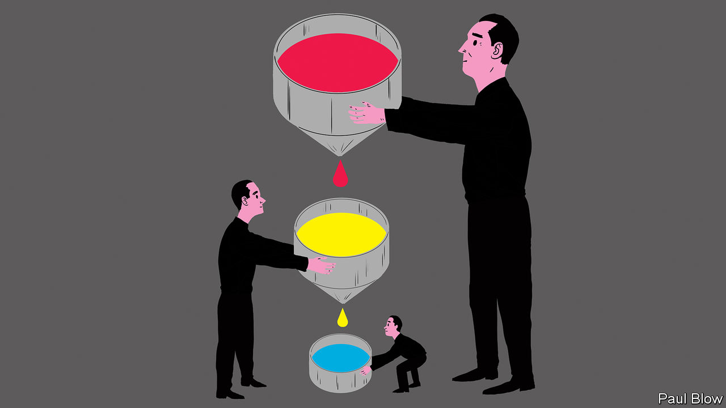

SINCE THE emergence of the welfare state, adults who want to work have generally found themselves in one of two positions: earning a wage from their job or receiving unemployment benefits. The pandemic has led many people to find themselves in a halfway stage—furlough. This often involves the state paying a large slice of employees’ wages so that firms can keep them on the payroll during the lockdown.

How effective is this approach? A new paper* by Morten Bennedsen of INSEAD business school in France and colleagues surveyed 8,781 Danish firms with anywhere between three and 2,000 employees. Around two-thirds of the firms said that the effect of the pandemic on their revenues had been negative, or very negative. Of those companies that had experienced a fall in revenues, the median decline was 35%.

The Danish government offered a variety of financial-aid programmes to firms, including a furlough scheme which paid 75% of salary costs (subject to a cap) to eligible companies. The academics found that 56% of the firms surveyed had taken some form of government aid and this was true of almost all businesses that had suffered a revenue decline of more than 50%. Unsurprisingly, companies in the most distressed industries were most likely to have taken assistance.

The aid seemed to work. Firms that received it laid off fewer workers and furloughed more people than firms which received no aid at all. But, as the authors of the study point out, this definition of success might be subject to a selection bias—firms that wanted to furlough workers may have been likelier to apply for aid.

So they also asked firms a counterfactual question: what decisions would they have taken had they been unable to get aid? On this basis, the researchers estimate that taking the aid increased a firm’s furloughed workers as a share of its total workforce by about 20 percentage points, and decreased the share of laid-off workers by almost the same amount.

If these findings are replicated elsewhere, furlough schemes may be adopted in future recessions. Some commentators point to the record of Germany, which suffered a much smaller rise in unemployment than other rich countries during the recession in 2008-09 because of a scheme that subsidised short-term working.

There are two obvious concerns about such support schemes. The first is the cost. The British scheme, which started in March, is expected to cost around £60bn ($75bn) by the scheduled end in October, or a bit less than 3% of GDP. The second problem is that such schemes may prevent the necessary role that recessions play in “creative destruction”, whereby resources are reallocated from failing businesses to successful ones (see article). The survival of “zombie” companies may make the next recovery less vigorous.

On cost, the counterargument is that widespread job losses lead to deep recessions and thus sharp declines in government revenues. They can also be bad news for laid-off workers who may take years to find another job. Paying money upfront to reduce the severity of a recession can thus be a good investment in both social and economic terms.

It would be great if governments could save only companies that have a viable long-term future. The analogy might be an old rule of thumb among central bankers that they should lend money in financial crises to banks that have a liquidity problem, not a solvency one. In practice, however, financial crises in recent decades have been so acute that central banks have mostly been unable or unwilling to discriminate. Similarly, while governments have imposed conditions on wage-support schemes in the current crisis, their main priority has been to dole out aid as quickly as possible in order to save jobs.

A lot more research is clearly needed to see whether furlough support schemes will have adverse long-term economic effects. The longer the schemes are in place, the more likely it is that market distortions will occur. But the principle that governments should intervene to support struggling banks and unemployed workers, as a way of reducing the severity of recessions, has long been established. It is conceivable to think that furlough schemes might eventually be viewed in the same light.

* “The impact of public aid programs on distressed firms: Evidence from COVID-19 in Denmark”, by Morten Bennedsen, Birthe Larsen, Ian Schmutte and Daniela Scur■

Editor’s note: Some of our covid-19 coverage is free for readers of The Economist Today, our daily [newsletter](https://my.economist.com/user#newsletter). For more stories and our pandemic tracker, see our [coronavirus hub](https://www.economist.com/news/2020/03/11/the-economists-coverage-of-the-coronavirus)

This article was downloaded by calibre from <https://www.economist.com/business/2020/06/20/waging-war-on-recessions>

|  |  |  |  |
| --- | --- | --- | --- |
| Previous | Articles | Sections | Next |

|  |  |  |  |
| --- | --- | --- | --- |
| Previous | Articles | Sections | Next |

#### Much ado about Samsung

# No end in sight for Samsung’s legal troubles

South Korea’s biggest conglomerate faces more scrutiny from prosecutors—and the public

Jun 20th 2020 | SEOUL

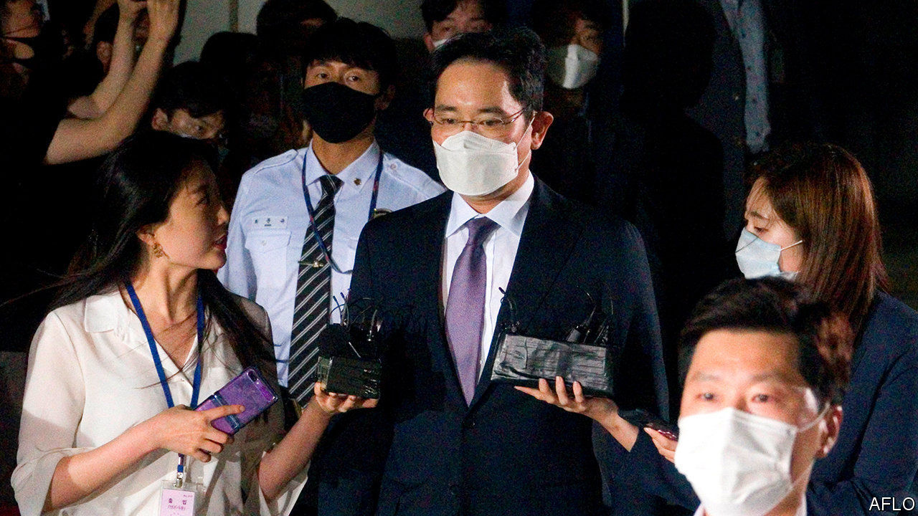

LEE JAE-YONG has seen a fair share of prison cells. Samsung’s de facto boss, and grandson of its founder, spent nearly a year behind bars for bribery before his sentence was suspended in February 2018. Then, on June 4th, prosecutors asked a court to have Mr Lee and two other executives from South Korea’s biggest conglomerate arrested ahead of indictments on fresh charges of unfair trading, stock-price manipulation and violating accounting rules, citing concerns that they might destroy evidence.

The judge demurred and declared that Mr Lee could await the start of his latest trial at home, rather than in police custody, arguing that the prosecution had already amassed enough relevant evidence. Although critics spied a certain leniency towards Mr Lee at work in the ruling, it does not mean that his or Samsung’s legal troubles are anywhere near over.

The latest allegations by state prosecutors relate to the role Mr Lee allegedly played in manipulating the terms of a merger between two Samsung affiliates, Samsung C&T and Cheil Industries. The tie-up cemented his control over the group in 2015. (Three executives have already been sentenced to prison for hiding or destroying evidence related to the investigation.) The bribery charges that saw him locked up were also related to the merger. Last year South Korea’s Supreme Court ordered a retrial in that case. (Samsung and Mr Lee deny any wrongdoing.)

Shortly before prosecutors requested the latest arrest warrant for Mr Lee, Samsung asked them to convene an external committee to opine on whether the charges merited a trial. (The committee is due to issue its non-binding recommendation by July.) Neither case is likely to be resolved before 2021. Both could land Mr Lee behind bars once again.

The heightened legal scrutiny and uncertainty casts a shadow over the group’s decent performance in the pandemic. Samsung Electronics, the group’s listed crown jewel, reported higher sales and stable profits in the first quarter. In April Samsung Biologics, a biotech arm part-owned by Samsung C&T, signed a $362m deal to make an antibody treatment against covid-19.

The affair may also hurt the group’s efforts to get back in South Koreans’ good graces. In May Mr Lee apologised to his compatriots, acknowledging that the group had “not always strictly followed laws and ethics”. He pledged betterment, including an end to dynastic succession and to the group’s hostility towards labour unions. Samsung has also joined the fight against covid-19 by keeping its factories running and donating equipment to hospitals at home and abroad. All the self-flagellation was working: one widely cited analysis of online comments found that public sentiment towards Samsung improved following Mr Lee’s apology.

More images of him emerging from courtrooms looking sheepish may reverse that trend. That may be a reason why Samsung has been unusually vocal in defending its boss against the latest charges. On June 7th, three days after the prosecutors requested Mr Lee’s arrest, Samsung Electronics sent a statement to reporters reiterating that all activity relating to the merger had been “legal in compliance with relevant regulations and procedures”. It pleaded with them to refrain from “immoderate reports” that could damage the firm, and by extension the national economy, at a time of crisis.

Stressing lofty principles such as the national interest over petty concerns like law-abidance is a well-worn argument among South Korean conglomerates that get into trouble. The coming months will show if it is wearing thin.■

This article was downloaded by calibre from <https://www.economist.com/business/2020/06/20/no-end-in-sight-for-samsungs-legal-troubles>

|  |  |  |  |
| --- | --- | --- | --- |
| Previous | Articles | Sections | Next |

|  |  |  |  |
| --- | --- | --- | --- |
| Previous | Articles | Sections | Next |

#### Chopped and screwed

# Why corporate disputes in China still revolve around rubber stamps

Who controls the chop controls the company

Jun 20th 2020 |

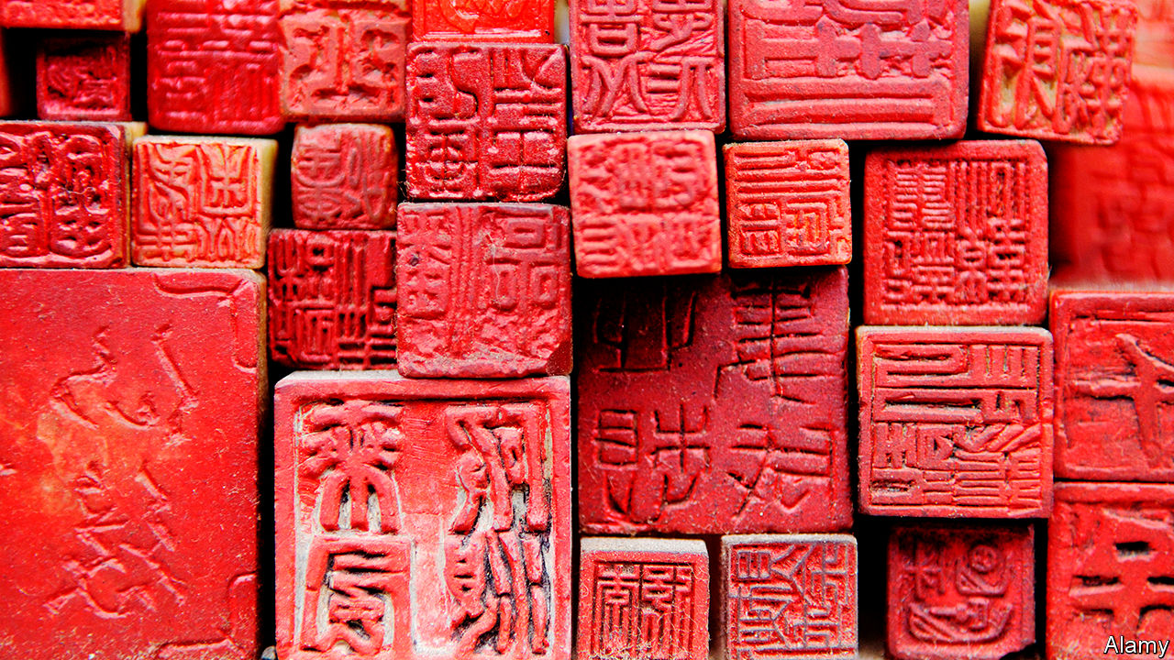

CHINA IS IN the vanguard of new technology, from facial recognition to 5G networks. Many Chinese firms, though, rely on something from an earlier age: a hard, usually rubber chop with a firm’s name engraved on it, to be dipped in crimson ink and stamped on important documents. Chopping is seen as more authoritative than a mere signature. The 2,000-year-old tradition may seem quaint. But in China, who controls the chop controls the company.

Consider three ongoing kerfuffles. On June 4th the board of Arm China, the Chinese joint venture of a chip designer owned by Japan’s SoftBank, voted to remove its boss, Allen Wu. Just one snag: Mr Wu refused to go. Because he still holds the chop, he has continued to act in Arm China’s name, and threatened legal actions to defend his position. A week later Bitmain, which makes bitcoin-mining computers, announced that it had replaced its old chop with a new one. They looked virtually identical—Bitmain’s Chinese name in a red circle around a star—except for a new serial number. But it was enough to indicate that one of the feuding co-founders, Micree Zhan, now has the upper hand.

The oddest recent chop bust-up occurred in April. Li Guoqing, the ousted co-founder of Dangdang, a once-popular e-commerce platform, broke into its headquarters and, in a bid to retake the company, removed dozens of its official chops (besides the main chop, others are used for things like contracts and tax receipts). Dangdang declared the seized chops to be invalid. But on June 13th it was reported that the police had cleared Mr Li of wrongdoing, implying the chops are his for now.

Chops have figured in business fights elsewhere. In 2007 Russian police seized seals from Hermitage, an investment firm owned by Bill Browder, a deported financier, and used them to re-register its companies under others’ names. But in 2015 Russia eliminated the need for company seals. In Japan and South Korea, where chops are still used, tussles over them are rare.

In China’s sharp-elbowed business world chop rows remain more common—and mostly unreported. Managers sometimes misuse seals to enter side contracts. Lawsuits to reclaim a chop can drag on, says Eric Carlson of Covington & Burling, a law firm, so many cases are resolved out of court. But, he notes, technology is catching up with tradition. China is starting to deploy electronic chops, which are easier to monitor—and to strip from aggrieved wielders.

This article was downloaded by calibre from <https://www.economist.com/business/2020/06/20/why-corporate-disputes-in-china-still-revolve-around-rubber-stamps>

|  |  |  |  |
| --- | --- | --- | --- |
| Previous | Articles | Sections | Next |

|  |  |  |  |
| --- | --- | --- | --- |
| Previous | Articles | Sections | Next |

#### The Reimann hypothesis

# A peek inside JAB Holding

One of Europe’s biggest family-owned companies is also among its most taciturn

Jun 20th 2020 | BERLIN



THE REIMANNS are as fabulously rich as they are faceless. On turning 18, each of Albert Reimann’s nine children signed a codex, pledging to stay out of Benckiser, the family chemicals business in Ludwigshafen, Germany, and never show their face in public. Reimann died in 1984, leaving each of his offspring with 11.1% of his company. Good luck finding a photograph of any of them, including the five who have sold their stakes in the family concern. Its public face is Peter Harf, a Harvard-educated manager whom Albert hired in 1981 as an adviser. A restless sort, with a sharp mind and a dislike of sharp suits, which he spurns for jeans and colourful shirts, Mr Harf transformed Benckiser from a medium-sized manufacturer typical of Germany’s Mittelstand into an international consumer-goods powerhouse overseeing operating companies worth some $120bn.

JAB Holding, as the Luxembourg-based group was renamed in 2012 in honour of its founder, Johann Adam Benckiser, is as anonymous as its camera-shy owners. Its assets are anything but. Having sold off the last of its stake in Reckitt Benckiser, a London-listed consumer-goods group, in 2019, JAB has focused on three main business lines. The first two revolve around caffeine and carbs. Over the years JAB has snapped up purveyors of coffee (like Keurig and Jacobs) and places to consume it (Peet’s Coffee and Pret A Manger, among others), as well as makers of sugary drinks (Dr Pepper) and sellers of snacks (such as Krispy Kreme Doughnuts and Panera Bread). These operations accounted for 85% of JAB Holding’s estimated €25bn portfolio in 2019.

Most of the rest sat in beauty. In 1992 Mr Harf orchestrated JAB’s purchase of Coty, a maker of perfume, from Pfizer, an American drugmaker, for $440m. Coty was listed in New York in 2013, and in 2016 Mr Harf added to it 41 beauty brands, including Wella (shampoo), Max Factor and Covergirl (make-up), bought from Procter & Gamble (P&G), an American giant, for $12bn.

Alongside JAB Holding, which manages the Reimanns’ money (and that of Mr Harf, whom they treat almost like a family member) is a larger sister holding, JAB Consumer Fund (JCF), with investments in the same group of businesses. It was set up in 2014 with cash from other wealthy families, including the Peugeots, a French carmaking clan, and Colombia’s Santo Domingo beer dynasty.JCF adds complexity to the federation, which comprises several intermediate holding companies co-owned by JAB and JCF that in turn control underlying operating assets. But it enables the structure to take on more debt, which Mr Harf has used to enlarge the empire with deals like the $19bn purchase of Dr Pepper Snapple in 2018. The two vehicles are run jointly by Mr Harf and Olivier Goudet, a former finance chief at Mars, a huge American confectioner (which is also family-owned). An admirer of Warren Buffett, Mr Harf likes to refer to the JAB-JCF as Benckiser Hathaway.

Like the famed American investor’s conglomerate, JAB favours long-term bets on businesses that are easy to understand. What sets it apart from Berkshire Hathaway, and many family offices, is a focus on a few big assets. According to Moody’s, a credit-rating agency, 96% of JAB Holding’s funds were in the three biggest last year (see chart). Investor AB, another large and complex investment fund, controlled by Sweden’s Wallenberg clan, has 37% of its portfolio in its top three assets. Mr Harf wants JAB Holding to own a stake of 30-40% in each portfolio firm, so that even if JCF’s backers exit, the Reimanns would retain the ear of the operating firms’ CEOs.

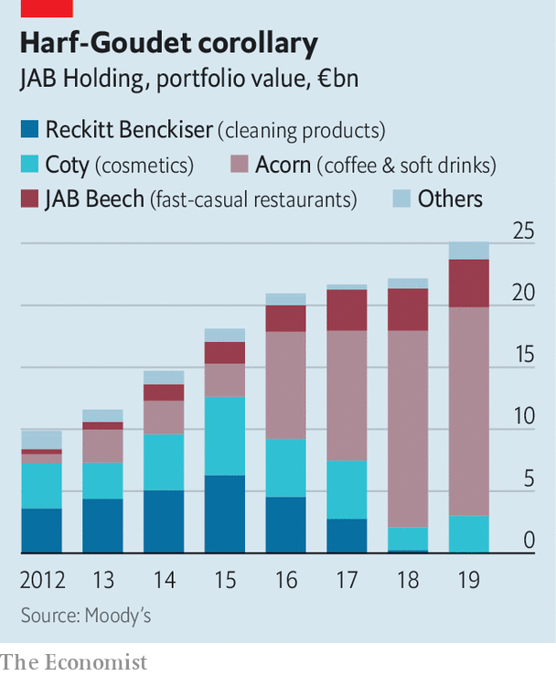

Such concentration is a boon when things are going well, as they have been with the coffee business, which Mr Goudet envisaged as a rival to Switzerland’s Nestlé. Defying the covid-19 pandemic, JAB listed 16.5% of shares in JDE Peet’s, the result of a merger between Jacobs Douwe Egberts and Peet’s Coffee, at the end of May in Amsterdam. Out of ten “smart investors”, nine warned Mr Harf to wait with the IPO, he says. In the event, the offering raised a caffeinated €2.25bn, making it Europe’s biggest IPO this year and valuing the firm at €15.6bn. The share price surged by 15% on the first day of trading. The outlook for JAB’s other cafés, starved of customers amid pandemic lockdowns, may improve as economies reopen.

The same cannot obviously be said of the cosmetics arm. Mr Harf may have overpaid for P&G’s brands and folding them into Coty has proved tricky. Coty’s market capitalisation has shrunk by more than 80% since 2016, to $3.7bn. In May KKR injected €750m into the debt-laden business, which will eventually give the private-equity firm a 60% stake in a professional-beauty firm to be hived off from Coty. Mr Harf himself will run the consumer operation. On June 1st he took over as Coty’s CEO after it went through four chief executives in five years, to clean up what he calls “the greatest blemish on my vest”.

“Overall Mr Harf has done well for the Reimanns,” says Jean-Philippe Bertschy at Vontobel, a Swiss bank. Despite Coty’s pallid record, JAB investor returns have averaged 15% a year since 2012. But Mr Bertschy cautions JAB against more break-neck acquisitions. Previous ones provoked the departure last year of JAB Holding’s chairman, Bart Becht, who reportedly quit after failing to convince the other partners to scale back expansion and focus instead on running the companies under their wings better.

Mr Harf will now try to do just that. The spry 74-year-old plans to overhaul Coty, starting with distribution. That will not be easy. Cosmetics is cut-throat and Coty must find a niche between the two giants of the industry, L’Oréal and Estée Lauder, and trendy “indie” brands. At least Mr Harf has plenty of coffee to keep him going. ■

This article was downloaded by calibre from <https://www.economist.com/business/2020/06/20/a-peek-inside-jab-holding>

|  |  |  |  |
| --- | --- | --- | --- |
| Previous | Articles | Sections | Next |

|  |  |  |  |
| --- | --- | --- | --- |
| Previous | Articles | Sections | Next |

#### Schumpeter

# Can Zoom be trusted with users’ secrets?

Kowtowing to China is a big threat to its business

Jun 20th 2020 |

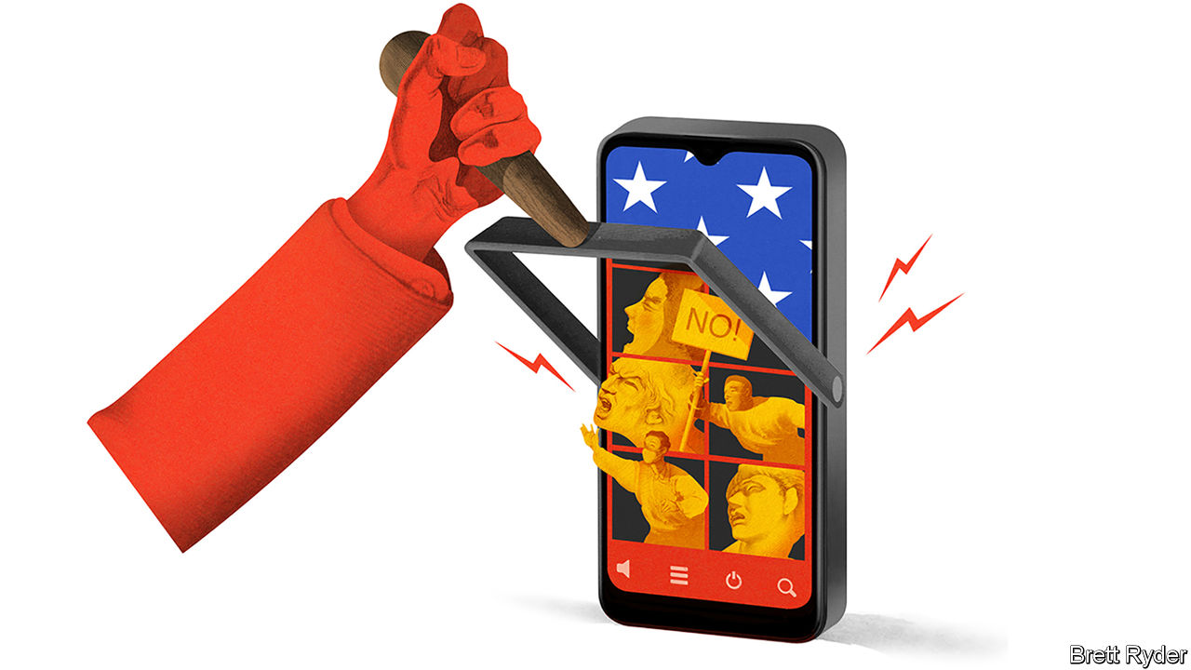

FEW AMERICAN companies have done as well during the covid-19 crisis as Zoom. The lifesaver of lockdown joins a small coterie of tech firms whose product, like Google’s, you no longer need to explain to grandmas. Zoom’s staggering success was made clear this month when it reported a 169% surge in year-on-year sales during the three months to April 30th. Daily users ballooned from 10m in December to 300m in April; profits soared alongside. Even analysts, rarely the most expressive of writers, let rip. One report started with “Wow”. Another, with “Holy Cow”.

Zoom’s achievements go beyond mere lucre. Its videoconferencing tools have the intuitive simplicity of an Apple product. It has made working from home feel not clunky, but chic. Moreover, its 50-year-old founder, Eric Yuan, cuts an intriguing figure. He has ridden an emotional roller-coaster this year as his company faced not just adulation, but scathing criticism for privacy lapses, data breaches and Zoom-bombings. Yet the speed with which he acknowledged the setbacks, and rolled out a 90-day plan to fix them, offers a case study of a leader who tries to learn from his mistakes. On June 17th, for instance, Zoom said it was introducing end-to-end encryption for all users.

But Mr Yuan, an American citizen, has a more intractable problem. It concerns his country of birth, China. On June 11th it became clear how vulnerable Zoom was to the long arm of the Communist state when the firm, which prides itself on “the open exchange of ideas”, admitted it had temporarily shut down the accounts of three critics of the regime outside China. Investors barely noticed. Four days later Zoom’s market capitalisation reached a record high of $67bn. But it showed with devastating clarity how tech firms struggle to bridge the digital chasm between China and America. This poses an acute business risk for Zoom.

Zoom’s relationship with China is complex. The American company has meagre sales on the mainland. But 700 of its staff are based there, developing global products. It also has servers in China that it says are geo-fenced to store Chinese data only (though in April it admitted the rule may have been breached by mistake). It says having its engineers in China helps reduce costs. It also hopes to increase sales to China. But its operations there force it to abide by Chinese law. Hence it suspended Zoom meetings with users in China and beyond commemorating the 21st anniversary of the massacre around Tiananmen Square on June 4th, which the Chinese government, hearing about them on social media, considered illegal. It also temporarily blocked an activist’s account in Hong Kong. Zoom admits it went too far, says it is developing tools to tackle the problem and pledges that requests from the Chinese government will no longer affect anyone outside mainland China.

That is a hard promise to keep for any company with operations in China. American values of free speech are at odds with those of a surveillance state. American firms that do business in China are used to treading a fine line. Those with a lot of Chinese customers and operations, such as Apple, seek to obey Chinese rules, but only in China. They argue that their Chinese businesses are ring-fenced from the rest of the world. Free speech and data security elsewhere are not compromised. Firms which, like Facebook, are barred from penetrating the Great Firewall can ignore China’s rules completely.

Zoom is different. It cannot easily fence off its Chinese operations from the rest of the world because its Chinese product developers are integral to its global business. Yet its activities in China mean it falls under laws that require companies to co-operate with the state and its intelligence services. That raises security and free-speech concerns not just within China but beyond it, too.

The repercussions have started. Some governments, such as Britain’s, have reportedly been warned by spy agencies to avoid secret discussions about China on Zoom. China hawks in America’s Congress are demanding that the company answer questions about its relationship with the Chinese government. Academics note that Chinese students at American universities may be particularly at risk if their inability to travel to America for covid-related reasons means they have to attend lectures in China via Zoom. James Millward of Georgetown University says it could chill academic freedom. He called on universities to develop an urgent “Plan B” to Zoom. End-to-end encryption to protect privacy may provide some reassurance. Chinese law, however, makes it hard to guarantee that the state will not seek to intrude.

That leaves Zoom with two unpalatable options. The first is the route that ByteDance, a privately held Chinese tech giant, is taking to ensure its short-video app, TikTok, is trusted in America. This means replacing some engineers in China with ones in America, and perhaps cutting off the Chinese business from the rest of the world. Such a rearrangement is hard to swallow for a firm like Zoom, whose mission is to foster global communication. It would cost time and money.

The alternative is to continue to bestride both systems and accept the consequence that trust—arguably the most important attribute of a communication tool like Zoom—is at the mercy of the Chinese Communist Party. Many users will have no problem with that; Zoom book clubs may be happy to bore Chinese eavesdroppers to death. But on sensitive topics in business and politics, wariness should prevail. Even though Zoom says there is no “back door” enabling snooping on its users, in the back of some minds is the thought of using a Soviet telephone during the cold war.

## The rebirth of distance

Zoom’s business may suffer as a result. Cisco’s Webex, Microsoft’s Teams and Google’s Meet can easily compete for its most sensitive clients. More significant, the kerfuffle reinforces how geopolitics is splitting the global internet into rival camps. Tech companies are increasingly facing the invidious choice of which side of the divide to be on. The word for that is not “wow”. It is “ugh”. ■

This article was downloaded by calibre from <https://www.economist.com/business/2020/06/20/can-zoom-be-trusted-with-users-secrets>

|  |  |  |  |
| --- | --- | --- | --- |
| Previous | Articles | Sections | Next |

|  |  |  |
| --- | --- | --- |
| Business | Sections | Science & ... |

Finance & economics

The Federal Reserve (1): From yields to maturity

.

The Federal Reserve (2): Swapping panic for calm

.

Poverty in China: Clarifying the battle lines

.

The euro area: Better tailored

.

The economics of reparations: Forty acres and a mule

.

Buttonwood: The detail on retail

.

Global trade: Ninety percent of everything

.

Free exchange: Changing room

.

|  |  |  |
| --- | --- | --- |
| Business | Sections | Science & ... |

|  |  |  |  |
| --- | --- | --- | --- |
|  | Articles | Sections | Next |

#### From yields to maturity

# The Fed has been supporting markets. Now it must find ways to boost growth

Economists expect it to begin yield-curve control in September

Jun 20th 2020 |

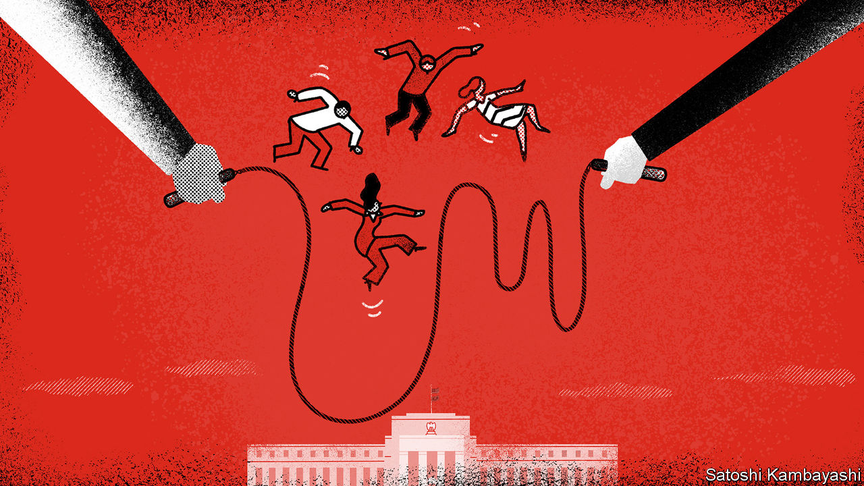

IT SEEMS AS if there is nobody to whom the Federal Reserve will not lend. Since the covid-19 pandemic wrought havoc on financial markets in March, America’s central bank has promised to buy up to $750bn in corporate bonds and $500bn in state- and local-government debt. It has stood behind the market for commercial paper, behind money-market funds and behind foreign central banks in need of dollars (see [article](https://www.economist.com/node/21788211)). On June 15th lenders were invited to register for its “Main Street Lending Programme”, which will purchase loans to small- and medium-sized businesses. The same day it announced that it would buy corporate bonds not only through exchange-traded funds, but directly, too. Such uninhibited use of its balance-sheet brings to mind the words of Walter Bagehot, the primogenitor of modern central banking, whose advice for times of stress was to lend “to merchants, to minor bankers, to ‘this man and that man,’ whenever the security is good”.

The security in this case is mostly a guarantee by America’s Treasury to absorb some of the Fed’s losses. And yet the biggest beneficiary of the monetary fire hose remains the government itself. Since early February the central bank has bought $1.7trn of federal debt, equivalent to 163% of the government’s entire net issuance in 2019. On June 10th it promised to keep buying at least $80bn in Treasuries per month. Many analysts expect that in September it will promise to buy as much as needed to keep shorter-term bond yields near zero—a policy known as “yield-curve control”.

In March the Fed’s bond-buying was intended to calm markets and arrest an alarming rise in Treasury yields. It still sees its purchases as preserving “smooth market functioning”. But as the memory of market stress recedes, its focus will shift to stimulating the real economy, about which the Fed is gloomy. Its median rate-setter expects the unemployment rate to be no lower than 6.5% at the end of 2021. On June 16th Jerome Powell, the Fed’s chairman, warned Congress about the potential scars that a long downturn might inflict.

The Fed made a similar transition from supporting markets to stimulating growth after the global financial crisis of 2007-09. It has not attempted yield-curve control, though, since 1951. The possible return to it marks a shift in the debate over market intervention—whether it is more effective to set the quantity you buy, or the price you pay. Choosing one means leaving the other to the whim of your counterparties. In the 2010s the Fed stuck to buying fixed quantities, fearing the unlimited commitment to buy that comes with pegging bond yields. In any case, economists wielded studies that found that bond purchases had a predictable impact on yields.

Yet the attitude of central bankers is evolving. That is partly because of recent experiments with yield-curve control. In 2016 Japan began fixing its ten-year bond yield around zero; in March this year the Reserve Bank of Australia (RBA) started pegging three-year yields around 0.25%. The evolution also reflects doubts about how quantitative easing (QE) works. Some economists, such as Gertjan Vlieghe, a rate-setter at the Bank of England, and Michael Woodford of Columbia University, argue that, when markets function normally, QE only brings down long-term yields on a sustained basis if it signals to traders that the short-term interest rate—the more humdrum instrument of monetary policy—will not rise for a long time.

Yield-curve control, then, might be a more transparent way of signalling the future path of the short-term rate. The RBA, for instance, pegged the three-year yield at 0.25% in order to underscore its expectation that the short-term rate will stay at that level for several years.

Moreover, yield-curve control can send the signal while reducing the need to purchase vast quantities of debt. As long as investors believe the central bank’s promise to target a certain variable, be it a bond yield, an exchange rate or inflation, they tend to bring about the outcome on their own. The Fed’s pledge to buy corporate bonds calmed the market in March, for instance, even though it did not start buying until May. So too with yield-curve control. In order to back its peg the RBA has bought only A$50bn ($34bn), less than 8% of Australia’s public-debt stock. Although some analysts regard the Bank of Japan’s yield-curve cap as an innovative form of stimulus, close observers see it as an excuse for the central bank to buy less. When it was introduced the Bank of Japan kept its existing target of buying ¥80trn ($748bn) of government debt a year—but then ignored it. Before the pandemic, it was buying bonds at less than a fifth of that pace.

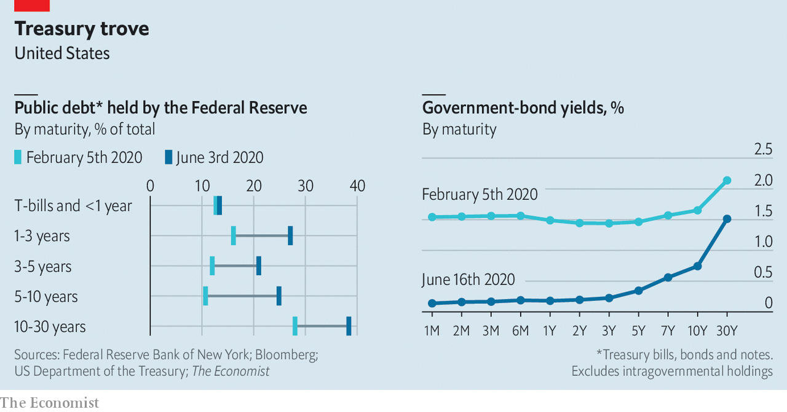

Swapping purchases for pegs might eventually seem attractive to the Fed. It already owns over a fifth of all net government debt, and nearly twice that share of longer-dated bonds (see chart). It might also prevent seeming clashes between monetary and fiscal policy. So far the Treasury has financed America’s enormous fiscal stimulus almost entirely through short-term bills. It will probably refinance that borrowing at longer maturities. But doing so puts back into the market the longer-dated assets the Fed is buying up in order to keep yields low. In the 2010s refinancing led to allegations that the Treasury and Fed were “rowing in opposite directions”. Were the Fed pegging rates, it would offset the effect of any Treasury debt-maturity operations passively, and avert controversy.

Working out how best to manage bond purchases to boost growth is only a part of the daunting task that confronts the Fed. It will have to consider, as the economy emerges from lockdown, how to withdraw the vast support it has put in place for the private sector, and face losses on some of its loans. But getting monetary policy right is its most important responsibility—not just to lend to “this man and that man”, but to ensure that the economy is strong enough for each to prosper. ■

This article was downloaded by calibre from <https://www.economist.com/finance-and-economics/2020/06/20/the-fed-has-been-supporting-markets-now-it-must-find-ways-to-boost-growth>

|  |  |  |  |
| --- | --- | --- | --- |
|  | Articles | Sections | Next |

|  |  |  |  |
| --- | --- | --- | --- |
| Previous | Articles | Sections | Next |

#### Swapping panic for calm

# The successes of the Fed’s dollar-swap lines

America’s central bank shines in a global role it resents

Jun 20th 2020 | HONG KONG

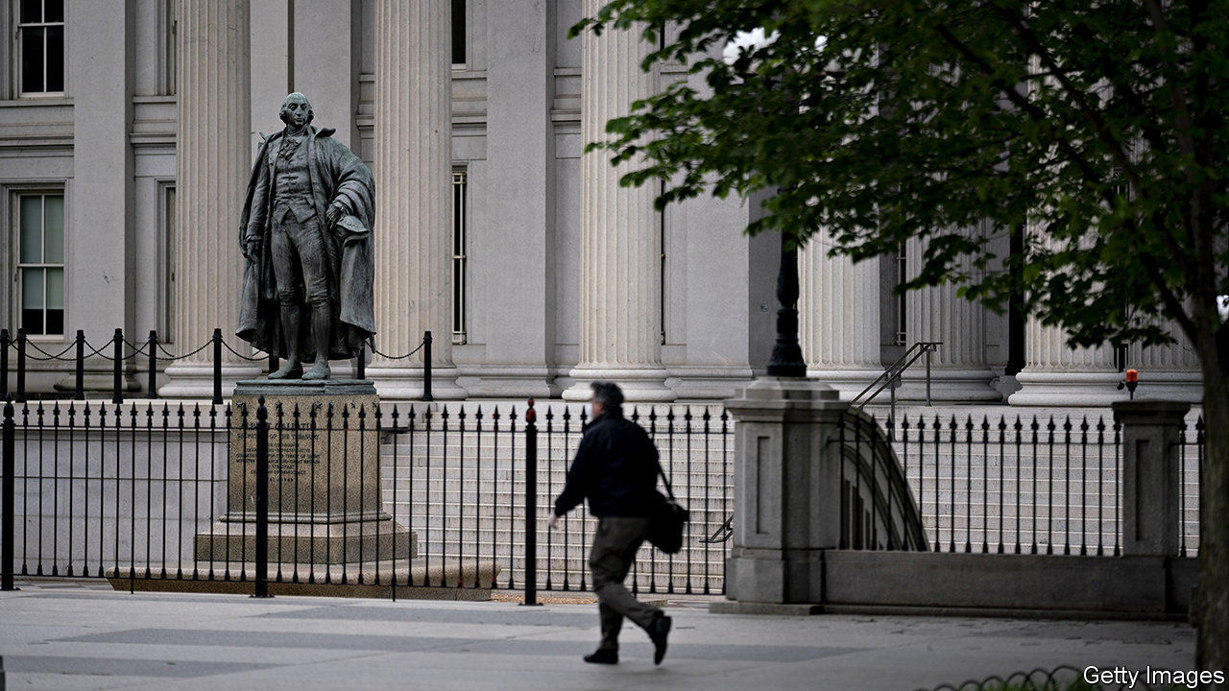

THE FEDERAL RESERVE steadfastly refuses to view itself as the world’s central bank, which is a pity, because it is becoming quite good at the job. One sign of its success is the stabilisation of the world’s reserve currency. The dollar spiked by over 8% against a basket of six other widely traded currencies between March 9th and 20th, as covid-19 panicked investors. But now the greenback is roughly back to where it was at the beginning of the year.

Central banks usually concern themselves with their own country’s money supply, which is chiefly composed of depositors’ claims on the country’s banks. But the supply of dollars extends far beyond national boundaries. Last year, banks outside America’s jurisdiction had dollar liabilities worth over $10trn, reckon Iñaki Aldasoro and Torsten Ehlers of the Bank for International Settlements (BIS).

To fund themselves, these banks rely heavily on selling short-term dollar liabilities, including certificates of deposit and commercial paper, to investors. The traditional buyers of this paper are “prime” money-market funds (which are a little more adventurous than funds that stick to government bonds and the like). After the pandemic shattered global market confidence, investors began pulling their money out of these funds, and the funds, in turn, stopped buying the banks’ paper. That forced the banks to scramble for other sources of funding. Borrowing from each other became dearer (at the height of the panic, banks had to pay a risk premium of about 1.4 percentage points). And it became costlier to obtain dollars through foreign-exchange “swaps”, in which one party borrows dollars from another, while simultaneously lending them euros, say, or yen.

As the offshore market is not fenced off from America’s own markets, these stresses washed onshore. That gave the Fed an excuse to act. On March 15th it eased the terms of its swap lines with central banks in Britain, Canada, the euro area, Japan and Switzerland. Four days later it extended additional lines to nine others, including the central banks of four so-called “emerging markets” (Brazil, Mexico, Singapore and South Korea).

The Fed has always been uncomfortable making quasi-diplomatic decisions about swap lines. It knows that by picking some countries, it risks sowing doubt about others. Turkey, for example, has long coveted a swap line. India also sought one, according to the Indian Express, a newspaper. The swap-envy is telling. It shows that a Fed swap line is not a source of stigma in the way an IMF loan can be. (Indeed, the fund has tried to brand its new, condition-light loans for stronger countries as “swap-like”, in the hope of making them more popular.) Brazil, with its comfortable stock of reserves, has not even used its swap line. It values it more for the insurance it provides and the signal it sends, says Alberto Ramos of Goldman Sachs, a bank.

By the end of April ten central banks had drawn over $440bn between them. The biggest take-up was by the Bank of Japan. Its country’s banks need dollar funding for their heavy overseas lending. And Japan’s pension funds and life insurers also need to hedge their large holdings of dollar assets by, in effect, borrowing dollars, points out Brad Setser of the Council on Foreign Relations, a think-tank.

Favourable dollar funding meant financial institutions did not need to resort to a fire-sale of dollar assets, say Egemen Eren, Andreas Schrimpf and Vladyslav Sushko of the BIS in a recent paper. In the five countries first given swap lines, the cost of borrowing dollars fell sharply. Indeed, some banks in these countries were able to borrow more cheaply (via commercial paper or certificates of deposit) than their American peers, according to the authors. Moreover, banks in these countries sometimes lent their dollars to other banks elsewhere, helping to alleviate the dollar shortage globally. Perhaps, then, the Fed’s agonising over whom to favour with a swap line did not matter all that much. As long as it provided enough dollars to central banks somewhere, their banks could funnel any surplus dollars elsewhere.

One of the Fed’s innovations was to offer longer-term swaps lasting 84 days. The first of these matured on June 11th, reducing the amount of dollars outstanding by almost $92bn. If the foreign banks that had borrowed these dollars (through the Bank of England’s and the European Central Bank’s swap lines with the Fed) still needed them, they would have rolled them over. But they did not—suggesting that the swaps had eased much of the stress that motivated them. ■

This article was downloaded by calibre from <https://www.economist.com/finance-and-economics/2020/06/20/the-successes-of-the-feds-dollar-swap-lines>

|  |  |  |  |
| --- | --- | --- | --- |
| Previous | Articles | Sections | Next |

|  |  |  |  |
| --- | --- | --- | --- |
| Previous | Articles | Sections | Next |

#### Clarifying the battle lines

# China’s poverty line is not as stingy as commentators think

Nor is China as poor as Li Keqiang implies

Jun 20th 2020 | HONG KONG

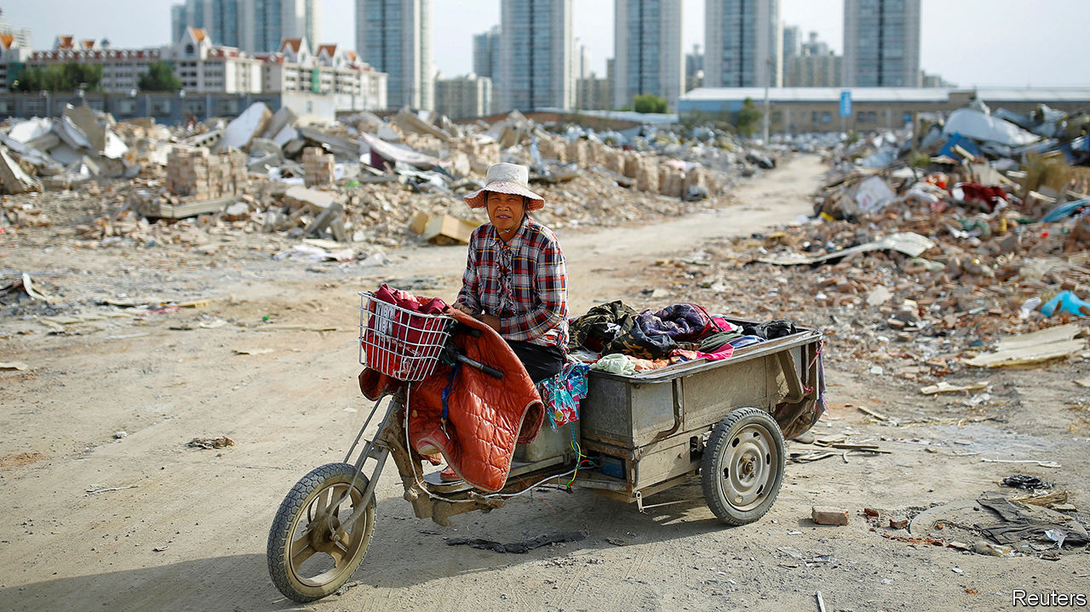

SINCE 2017 China’s government has described fighting poverty as one of three “tough” or “critical” battles (alongside quelling pollution and financial risk). Despite the covid-19 pandemic, it still seems confident of victory this year. In March Xi Jinping, the president, pointed out that the number of rural poor fell to 5.51m in 2019. That is only 0.4% of China’s vast population. Regional overall poverty, he said, had been basically eradicated.

The claim seemed wildly at odds with another statistic, cited last month by Li Keqiang, the prime minister. “There are still some 600m people [whose] monthly income is barely 1,000 yuan,” he said at the close of the annual meeting of China’s parliament. Since 1,000 yuan is worth only about $140, the figure seemed both surprising and depressing. Many commentators concluded that China’s victory against poverty was hollow, achieved not by lifting people up but by watering the definition of poverty down.

This scepticism, though, is dogged by two misunderstandings. The first is the conviction that China’s rural-poverty line must be ridiculously stingy, lower than the global standard of $1.90 a day. The second is the belief, inspired by Mr Li’s imprecise remarks, that 600m Chinese live on 1,000 yuan a month or less. Neither claim is true.

About a decade ago China drew its rural poverty line at 2,300 yuan a year, or 6.3 yuan a day. The World Bank’s most commonly used global poverty line is $1.90 a day. Since 6.3 yuan is worth only about $0.90 at today’s exchange rate, it seems natural to think that China’s poverty line is much lower than the World Bank’s.

Natural, but wrong. A fair comparison must first note that China and the World Bank drew their poverty lines with different years in mind. China’s line is based on the prices prevailing in 2010; the World Bank’s, on prices in 2011. China updates its line every year to reflect the inflation faced by the rural poor. In 2011 the threshold was 2,536 yuan, or 6.95 yuan a day.

That is still a meagre amount. But because prices tend to be lower in rural China than in America, 6.95 yuan stretches further than the equivalent amount of dollars would in America. So the yuan should be converted into dollars not at the market exchange rate, but at the purchasing-power-parity rate. That was 3.04 yuan per dollar in 2011, according to Martin Ravallion of Georgetown University, who helped set the World Bank’s line. Thus China’s rural-poverty line is equivalent to about $2.30 a day in 2011 purchasing-power-parity dollars, comfortably above the $1.90 global line. Indeed, the bank’s poverty count for China is lower than the government’s.

What about the second misunderstanding? After the furore caused by Mr Li’s comments, China’s National Bureau of Statistics tried to sort out the confusion this week. It pointed out that the 610m people living in the bottom 40% of China’s households had a monthly income per person of almost 1,000 yuan. In other words, if their combined income were divided equally between them, they would each receive roughly 1,000 yuan (ie, 3,000 yuan for a typical household of three). That is the basis for Mr Li’s statement. But it is different from saying that all of these 610m live on 1,000 yuan or less. Imagine a country of ten people, where the bottom four earn $1, $2, $3 and $4 a day, respectively. Their income per person is $2.50. But only two of them live on less than this amount. China’s leaders often quote official statistics that flatter the economy. But on this occasion, Mr Li’s comments unflattered to deceive. ■

This article was downloaded by calibre from <https://www.economist.com/finance-and-economics/2020/06/20/chinas-poverty-line-is-not-as-stingy-as-commentators-think>

|  |  |  |  |
| --- | --- | --- | --- |
| Previous | Articles | Sections | Next |

|  |  |  |  |
| --- | --- | --- | --- |
| Previous | Articles | Sections | Next |

#### Better tailored

# The euro area’s stimulus is less stingy than in past crises

Even so, more stimulus will be needed this year

Jun 20th 2020 |

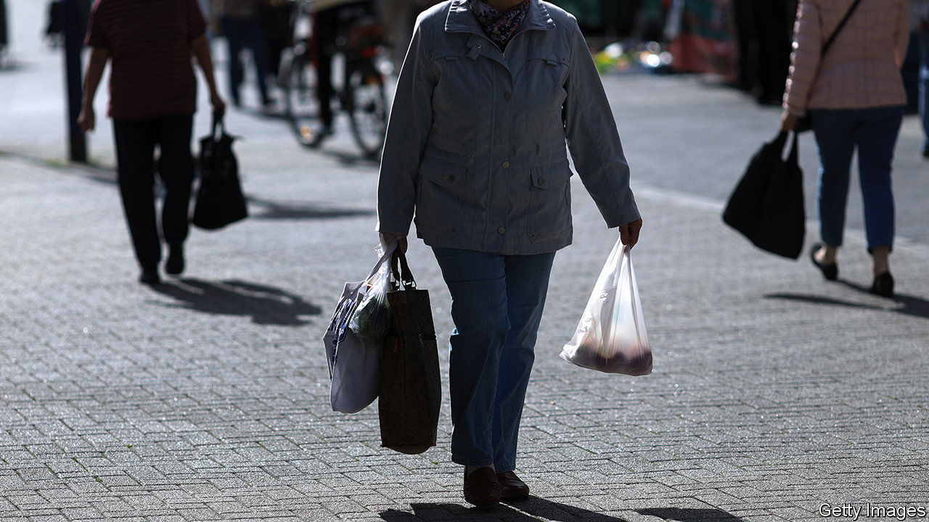

THOSE STRUGGLING to break bad habits should take inspiration from the euro zone. During the global financial and sovereign-debt crises it did too little to shore up growth; at times monetary and fiscal policy were tightened precisely when they should have been loosened. By contrast, its response to the covid-19 pandemic has been less flat-footed. Consider the events of the first three weeks of June alone. Germany’s government, usually tight-fisted, announced a stimulus package of at least €130bn ($146bn). The European Central Bank (ECB) said it would buy another €600bn in bonds. And as The Economist went to press, national leaders were due to discuss setting up an EU-wide “recovery fund” of €750bn, an idea first floated in April.

The question is whether policy can remedy a grave weakness: that countries facing the greatest economic damage are also those with the least fiscal space. Germany’s outbreak was relatively less severe, and its lockdowns less stringent. Its new programme takes its total fiscal stimulus this year to 9% of GDP, according to economists at UBS, a bank (see chart). That is bigger than America’s. But France, Italy and Spain, which have had worse outbreaks and stricter lockdowns, and risk losing valuable tourism revenues over the summer, also have higher government-debt ratios. Fiscal support has been stingier there.

The good news is that EU policymakers are trying to redress the imbalance. Thanks in part to Germany’s newfound generosity, the recovery fund could direct cash to countries according to need rather than what they contribute. A proposal by the European Commission suggests that Italy could receive grants equivalent to about 5% of its GDP, and loans worth another 5%, says Jacob Nell of Morgan Stanley, a bank. Germany and the Netherlands might receive funds worth only 1% of GDP. The bad news is that although many economists expect an agreement to be struck, a few countries—such as the Netherlands and Sweden—are yet to sign up. As a result the fund could well become stingier. Moreover, the cash will only begin to be doled out in 2021, and will be spread over a number of years.

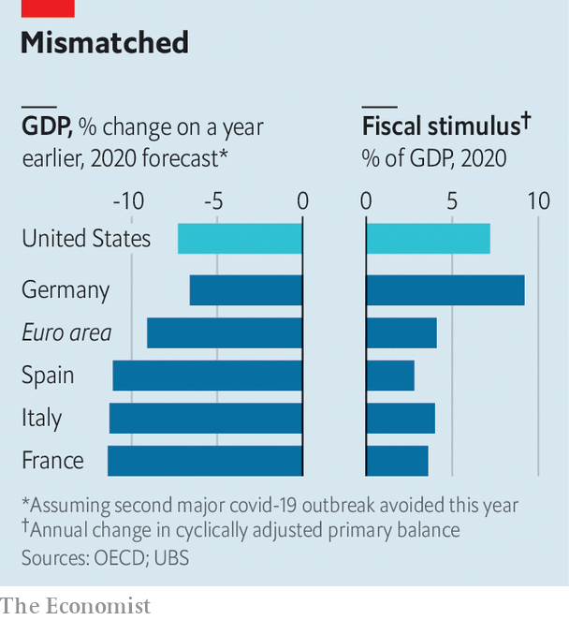

That means that the ECB must do the heavy lifting this year. All told, it is due to buy €1.6trn in public and private-sector debt in 2020, equivalent to 14% of last year’s GDP. Like the commission the bank has shifted away from its usual “one-size-fits-all” approach. Instead of buying assets in line with its “capital key” (ie, a country’s contribution to the bank’s capital, which is in turn proportional to its economic size), it seeks to contain the spread between the bond yields of riskier countries and those on German bunds. Around 22% of the purchases through its pandemic programme and its older quantitative-easing scheme in April and May were of Italian paper, whereas Italy’s share of the capital key is 17%, says Sven Jari Stehn of Goldman Sachs, another bank. That means the ECB could indirectly fund all of Italy’s deficit this year.

Despite all this, the euro area is probably still short of stimulus in 2020. Though it seems likely to suffer a bigger economic hit than America, its overall fiscal support is smaller. The pace of ECB purchases is more sedate than that of America’s Federal Reserve. Few economists think existing stimulus will rouse inflation, which was stubbornly below the ECB’s target even before covid-19. Still more bond-buying is therefore probably on the cards. The recovery fund could set a precedent, hopes Mr Nell, allowing for a common fiscal tool to be used in other times of need. Good habits, once formed, tend to stick. ■

This article was downloaded by calibre from <https://www.economist.com/finance-and-economics/2020/06/20/the-euro-areas-stimulus-is-less-stingy-than-in-past-crises>

|  |  |  |  |
| --- | --- | --- | --- |
| Previous | Articles | Sections | Next |

|  |  |  |  |
| --- | --- | --- | --- |
| Previous | Articles | Sections | Next |

#### Forty acres and a mule

# The economics of reparations

The difficulties of working out how to compensate the descendants of slaves

Jun 20th 2020 |

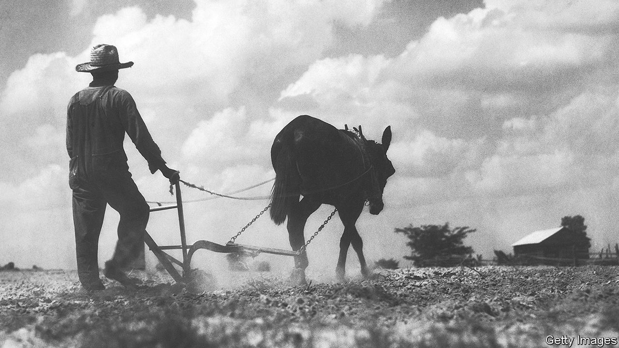

IN A SURVEY last year 29% of Americans supported the idea that the government should make cash payments to black Americans who were descendants of slaves—twice the share that agreed in the early 2000s. As protests have rocked America in recent weeks, the idea of reparations to atone for the atrocity of slavery, as well as to reduce the persistent gaps in income and wealth between people of different skin colours, has gained further prominence. Joe Biden, the presumptive Democratic nominee for president, has said he wants to explore it. On June 11th California’s state lawmakers passed a bill that establishes a task-force to study and propose recommendations for reparations. The chances of the federal government implementing such a policy seem remote. But how would such a scheme work?

As “From Here to Equality”, a new book written by William Darity, a scholar on reparations at Duke University, and A. Kirsten Mullen, shows, the practicalities tend to take a back seat to philosophical arguments over whether reparations are needed in the first place. Genealogists would face the tricky task of determining who would be eligible for them. Economists, meanwhile, would have to consider two questions: how much to pay, and how best to spend the money?

History offers a guide to the first question. Past claims for reparations have relied on the notion that people were wrongly deprived of income or property, or were unfairly forced to incur costs. For instance, Israel calculated its claims for reparations from Germany after the second world war in part by estimating the expenditure it incurred in order to resettle Jewish victims of Nazi persecution. An official report into America’s forced relocation and incarceration of Japanese-Americans during the war reached the conclusion that they had been unfairly deprived of income and property worth $3bn (in today’s prices). In 1988 the American government issued a formal apology and eventually compensated 80,000 victims.

Many scholars have tried to work out what would count as sufficient compensation for the descendants of slaves, but there is little agreement between them. One approach is to focus on compensation promised by the Union Army to freed slaves in 1865—the value of 40 acres of land and a mule—which was never realised. The amount of cropland required to meet that commitment today has a value of about $160bn (0.7% of American GDP in 2019).

Other approaches lead to much bigger sums. One calculates the difference between what slaves were given by way of maintenance, and what free workers were paid. An estimate puts that at roughly $4trn in today’s money (19% of GDP), once you account for the financial returns that could have been made if the money had been paid on time. But some argue that slaves held down the wages of free workers, meaning that the true value of slaves’ lost wages is higher. Mr Darity and Ms Mullen say that the difference in mean net wealth between white and black households ($795,000 in 2016) is the “most robust indicator of the cumulative economic effects of white supremacy”. That points to reparations of nearly $8trn, or 37% of GDP. (The authors suggest that this should be partly financed by printing money, something that will make most wonks queasy.)

Another area of disagreement concerns the form that reparations should take. Mr Darity and Ms Mullen argue that for “both symbolic and substantive reasons, an effective programme of restitution must include direct payments”. But cash transfers may do less to reduce inequality than their supporters hope. Research on inheritances, for instance, suggests that most heirs consume their windfall within a few years (purchases of cars are especially popular). A sizeable part of the income gap between black and white Americans reflects differences in education levels; big one-off payments alone cannot alter that. And research by Mr Darity and Dania Francis of the University of Massachusetts Boston finds that reparation payments could increase non-black incomes relative to black ones, if the spending thus facilitated flowed largely to non-black-owned firms. “Our paper points to the need to improve the infrastructure of black-owned businesses and banking so that dollars from reparations can flow into black communities,” says Ms Francis.

To this end, some economists argue that reparations should fund training and education programmes, or subsidise business lending. Others point to “baby bonds”, which would be targeted at poor children and help them pay for university or to start up a business. Naomi Zewde of the City University of New York finds that baby bonds could substantially reduce racial wealth gaps among young people.

Reparation payments could be spent in other ways. Money paid out to Japanese ex-internees has been used to fund academic chairs and historical archives. Reparations from Germany pay for food and medicine for Holocaust survivors. But before America can widen support for reparations, it will have to debate what works. ■

This article was downloaded by calibre from <https://www.economist.com/finance-and-economics/2020/06/20/the-economics-of-reparations>

|  |  |  |  |
| --- | --- | --- | --- |
| Previous | Articles | Sections | Next |

|  |  |  |  |
| --- | --- | --- | --- |
| Previous | Articles | Sections | Next |

#### Buttonwood

# To understand the new wave of small investors, look to China

Speculation is as old as the hills, but you can count on some variations

Jun 20th 2020 |

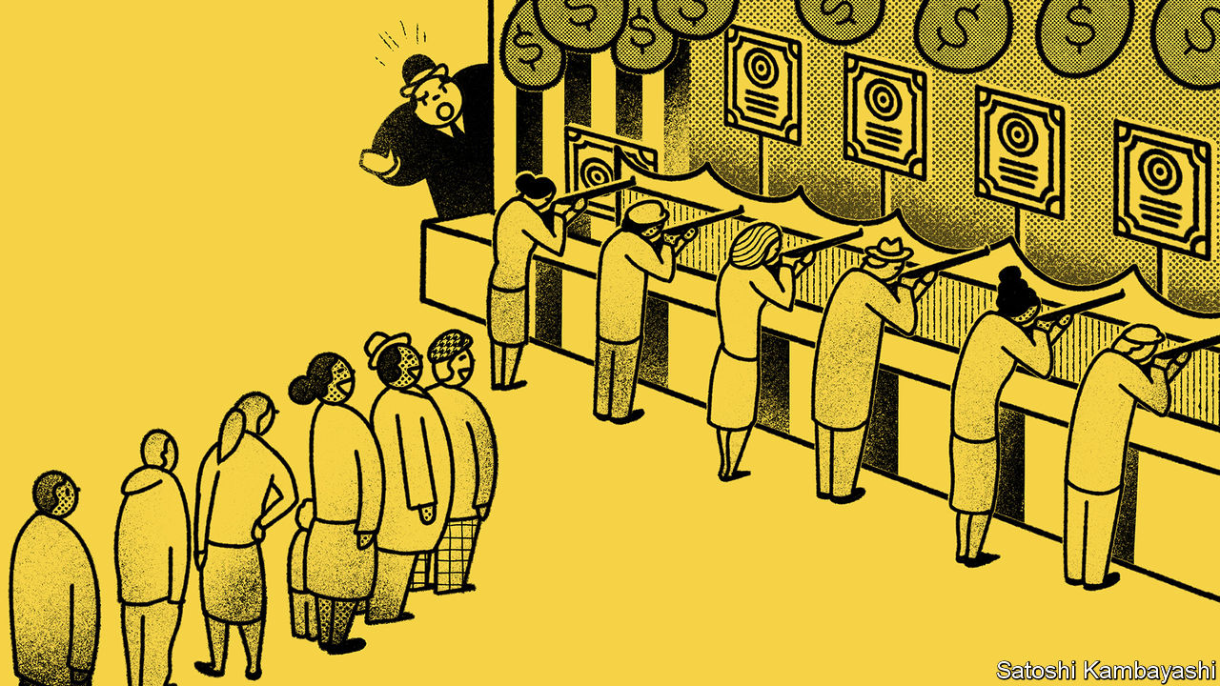

THERE IS NOTHING new on Wall Street. Speculation is as old as the hills. So says the protagonist of “Reminiscences of a Stock Operator”, published in 1923. Quite so—but you can count on some new variations. Take the case of Nikola Corporation, which makes trucks powered by green energy. On June 8th its stock price doubled. It was then worth more than Ford. Yet it has sold no vehicles. “Sympathetic magic”, explains a seasoned investor. Nikola is named after Nikola Tesla; as is Tesla, the leading electric-vehicles firm. That is enough of a buy signal.

Enough, that is, for a new army of retail speculators, which is blamed for a lot of strange moves in stock prices. Since March, no-cost brokerages that cater to small investors report a dramatic surge in new accounts and trading volumes. A noisy gaggle of social-media and chat-room pundits has emerged. David Portnoy, a sports-betting media-mogul reinvented as “Davey Day Trader” is perhaps the most prominent. The retail army has marched into America’s evergreen tech stocks. Less predictably they are also keen buyers of grounded airlines, of beached cruise liners and, strangest of all, of Hertz, a car-rental firm that has filed for bankruptcy.

Some of this recalls the era of Jesse Livermore, whose exploits are fictionalised in “Reminiscences”, with its bucket shops, tipsters and crazy buying of A.O.T. (Any Old Thing). There are strong parallels with the day traders and chat-room herds of America’s dotcom mania in the late 1990s. But you don’t have to go back even that far. A lot of the archetypes are found more recently in China.

There are striking resemblances between America in 2020 and China’s stockmarket fever of 2015. The economy was in a tough spot. The real returns on bank deposits were negative. There were plenty of liquid funds to lubricate trading. Brokers and shadow banks were lending freely to retail speculators. The retail wave in America differs in the sources of economic trouble and liquidity. Much of the money going into new trading accounts is from government transfers to workers idled by covid-19. With free time, free money and free trading—plus no sports—why not take a punt on the markets?

Rumour, connections (real or imagined) and tips have always played a big role in determining what stocks retail speculators buy. In Livermore’s day, every bucket-shop punter kept his ear open for a tip to get aboard Burlington or Northern Pacific. What has changed is the speed at which tips spread and so how synchronised retail buying has become. The result is a rapid succession of fads: first tech darlings; then bombed-out stocks; then something else. This rotation of investment themes is a recurring pattern in China’s market, says Adam Levinson of Graticule, a Singapore-based asset-manager.

As noisy as Mr Portnoy and his ilk are, they have been almost drowned out by the tut-tutting of jowly investors. The pros are shocked—shocked, they tell you—to find that there is gambling going on. Much of their ire is directed at the million-plus users of r/wallstreetbets, a Reddit forum where frat-boy argot is mixed with trading jargon. Its devotees are not the type to buy a stock based on a model of discounted cash flows. Instead they favour buying call options. A certain kind of call option—deeply out-of-the-money and close to expiry—is much like buying a lottery ticket or making a long-odds sports bet. They can pay off spectacularly for a relatively small outlay if the stock price suddenly surges. And, like bucket-shop bets, they are self-expiring.

Put aside the harrumphing for a moment. There is something to cheer in all this. Academics have puzzled over why more people do not participate in the stockmarket. The literature suggests peers have an influence. A paper in 2002 by Esther Duflo and Emmanuel Saez, for instance, finds that the pension choices of university librarians were swayed by their colleagues. That does not mean there is nothing to worry about. Outside of their pension plans, even experienced retail investors have a habit of over-trading—to the detriment of returns. The tendency to churn portfolios is higher in men than women. It is linked to over-confidence and thrill-seeking.

The Stock Operator knew the type. There is a higher grade of speculator, he said, who knows enough to avoid the trading mistakes beginners make. This kind loves to buy on stock declines and to quote wise-sounding aphorisms. The bucket shops and brokerages love him. For it is this sort of speculator, the “semi-sucker”, that keeps them in business.

This article was downloaded by calibre from <https://www.economist.com/finance-and-economics/2020/06/20/to-understand-the-new-wave-of-small-investors-look-to-china>

|  |  |  |  |
| --- | --- | --- | --- |
| Previous | Articles | Sections | Next |

|  |  |  |  |
| --- | --- | --- | --- |
| Previous | Articles | Sections | Next |

#### Ninety percent of everything

# As the virus rages on shore, merchant seamen are stranded on board

The merchant seamen who keep the world warmed and fed are trapped in floating prisons

Jun 18th 2020 |

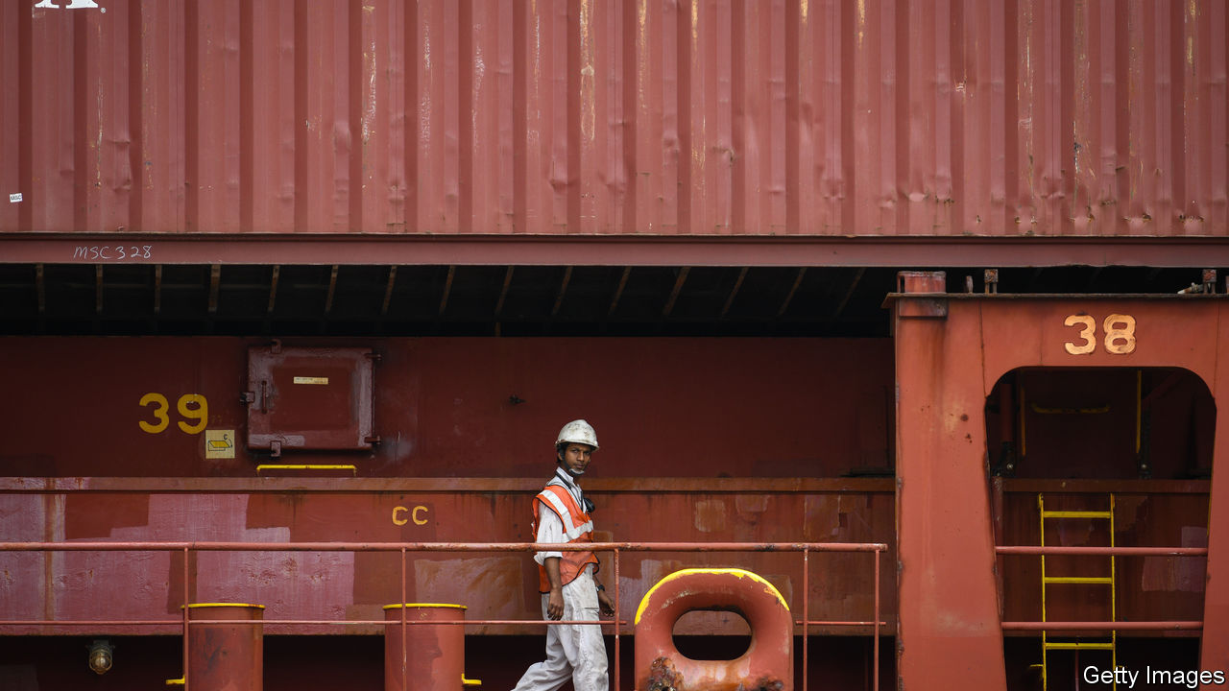

“I’M NOT COMFORTABLE in my chair with such a crew,” says the captain of a cargo vessel in the South Atlantic en route from Bermuda to Singapore. He is eight months into a four-month contract, and almost everyone on board has also already worked at least double his contracted time. He hopes Singapore will accept that sailors who have seen almost no one but each other for months pose no infection risk and permit a crew change. If not, some may refuse to keep working. On June 16th an industry-wide agreement to allow emergency contract extensions expired, but that is no guarantee that ports will open up. “Believe me,” he says, “the situation is critical.”

When Rose George, a journalist, wrote about the shipping industry in 2013, she called her book “Ninety Percent of Everything” to convey its importance to global trade. But during the covid-19 crisis almost none of the mariners who keep the world fed, warmed and entertained have been allowed on shore. At any moment 1.2m are in cargo vessels on the high seas. (Half as many again work on cruise ships or vessels transporting goods within a single country’s territory.) At least 250,000 have finished their contracts and have no idea when they will be relieved. Similar numbers are stuck at home with no idea when they will next get work. Both totals are rising by tens of thousands each week.

In normal times, crewing the world’s merchant fleet is a logistical miracle. Ship-management firms handle the rosters, signing crew on, flying them from their home countries to a convenient port, and getting them off their ships again and on a plane home. Many mariners are from developing countries, in particular India, Indonesia and the Philippines. They often start and end their contracts in hubs such as Dubai, Hong Kong and Singapore. Contracts are typically of three to nine months, with one month’s variation in either direction to make planning easier.

The virus has thrown an almighty spanner in the works. Countries that classified lorry drivers, pilots and cabin crew as essential workers overlooked merchant seamen, even though their work underpins the global economy. Some will accept their citizens, but ships may not be calling at a suitable port, and management companies may not be able to line up relief. With few scheduled flights, the sailors who manage to disembark may not be able to get home.

At first they were proud to be able to help in the global emergency, says Lars Robert Pedersen of BIMCO, which represents the owners of about 60% of the world’s merchant fleet. They are used to hard work and long contracts. But when official neglect continued, sailors’ morale became a problem. “They are fed every day, and they are getting paid, but that’s not the point,” he says. “They are effectively imprisoned on board their ships.”

Owners and managers are trying to make confinement more bearable with free internet and wage top-ups, says Andreas Hadjipetrou, the managing director of Columbia Shipmanagement. “One captain asked for gym equipment and karaoke,” he says. “The crew created a band and sent us a video clip.” More importantly, they are doing everything they can to facilitate crew changes—which take not just planning, but a hefty dose of luck.

Among the merchant seamen relieved during the lockdown is Hrisheet Barve, a ship’s captain and an Indian from the state of Goa. By the end of May he and 16 crew members, also Indian, were months over contract. Since they were sailing along India’s coast, he proposed to the ship’s management company, Anglo-Eastern, that it divert to the port of Cochin in the state of Kerala for a crew change. The company agreed, despite the cost and delay. Even though the men were all nationals, disembarking required lengthy negotiations with the shipping ministry and port and state officials. They had seen no one else for months, but still had to spend two weeks in quarantine.

By the end, says Captain Barve, he was very worried about his men’s mental state. “When you’re all in the same boat—pun not intended—you can pull each other down.” And tired, miserable sailors are unsafe, he adds. “It just takes one captain to make a mistake and run a tanker aground and cause an oil spill. They will say it was a navigational error but the real culprit will be that he was working way longer than he should have been.”

The International Maritime Organisation, the arm of the UN that deals with shipping, has drawn up a protocol for crew changes during the pandemic. It requires governments to classify merchant seamen as essential workers, thus enabling them to travel and cross borders. Ports and airports need facilities for testing and quarantine, and safe connections. “We have the standard operating procedure ready to act on,” says Bjorn Hojgaard of Anglo-Eastern. “We just need help from regulators.”

The industry hopes that governments will be prodded into action by the sudden expiry of so many seamen’s contracts. The International Transport Workers’ Federation (ITF) says it will support any seamen who refuse to work. If that leaves too few people to operate a ship safely, its insurance policy could lapse, and full liability fall on the captain and owner, who might then decide it was too risky to keep going. The trade that has flowed so smoothly throughout the pandemic might finally gum up. “Everyone is happy to reap the benefits of global trade,” says Stephen Cotton, the ITF’s general secretary. “But no one seems willing to step up when it comes to safeguarding those who deliver the things they need every day.” ■

This article was downloaded by calibre from <https://www.economist.com/finance-and-economics/2020/06/18/as-the-virus-rages-on-shore-merchant-seamen-are-stranded-on-board>

|  |  |  |  |
| --- | --- | --- | --- |
| Previous | Articles | Sections | Next |

|  |  |  |  |
| --- | --- | --- | --- |
| Previous | Articles | Sections | Next |

#### Free exchange

# New research casts light on the pandemic’s effects on resource allocation

Capital markets are signalling that lasting change is in the works

Jun 20th 2020 |

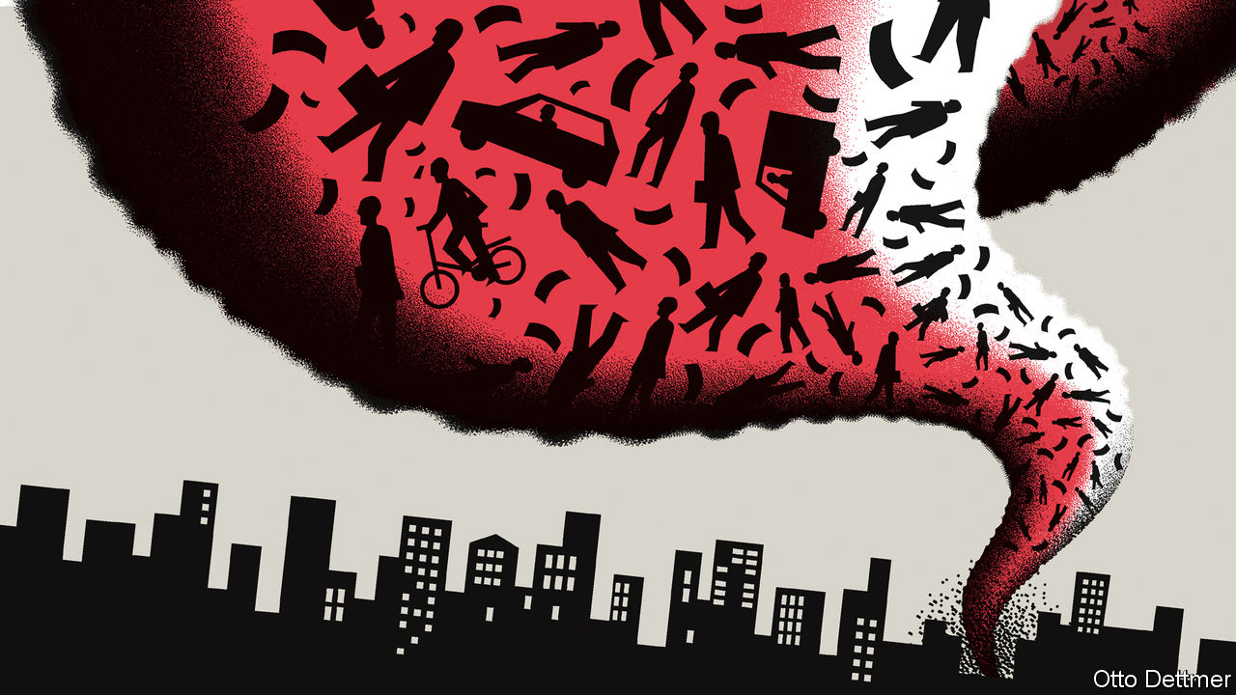

AS COVID-19 SPREAD around the world, many governments prescribed the economic equivalent of a medically induced coma. Halting the transmission of the disease meant shutting down economic activity. But to restore economies to health quickly, connections between workers and firms needed to be maintained, so that activity could pick up from where it had left off. It seems increasingly clear, though, that not everything will return to normal once covid-19 is eventually beaten. As economies adjust, there is likely to be a substantial reallocation of people and resources.

Flexible economies that can nimbly reallocate resources ought to have an easier time weathering shocks and unlocking the productivity-boosting benefits of new technologies and business models. As the pandemic spread it induced a sudden, violent shock across the economy. While millions of workers and machines were idled, demand for some skills and products soared. Much of this is almost certain to prove temporary. The production of ventilators rose sharply in the first half of 2020, but might eventually fall back to, or below, pre-pandemic levels, as hospitals find they have more than they need in normal times. Other shifts are likely to persist. In March and April Amazon hired 175,000 workers to manage a surge in online shopping. Firms offering products to facilitate telemedicine and online learning also took on scores of new employees. Many of these will stay, just as many pandemic-linked lay-offs will become permanent.

In a paper published in May Jose Maria Barrero of the Instituto Tecnológico Autónomo de México, Nicholas Bloom of Stanford University and Steven Davis of the University of Chicago analysed a monthly survey of business uncertainty, which assesses firms’ expectations for sales, hiring and investment over the next year. The authors found a surge in expected job reallocation from January to April, and conclude that 42% of lay-offs linked to the pandemic are likely to prove permanent. Similarly, recent analysis produced by Adam Ozimek, the chief economist at Upwork, an online labour exchange, suggests that the shift to remote work prompted by covid-19 will leave a lasting impression. Of the hiring managers surveyed by Upwork, 62% say their workforce will be more remote than before the pandemic.

Capital markets, too, are signalling that lasting change is in the works. Messrs Barrero, Bloom and Davis analyse the dispersion of equity returns, surges in which are often treated as an indicator of a reallocation shock. The authors note that dispersion soared in March to levels last seen during the dotcom bust and the global financial crisis. In a recent paper Marco Pagano of the University of Naples Federico II and Christian Wagner and Josef Zechner of the Vienna University of Economics and Business compare the stock performance of businesses that are “pandemic-resilient” (eg, makers of computer-related products and pizza-delivery firms) with those of highly vulnerable ones (eg, mining firms). The former group outperformed the latter by 10% in February-March. Adjusting for risk and other factors only reinforces the point. The cumulative risk-adjusted returns of a high-resilience portfolio were roughly 25% higher than a low-resilience one in the same period. Differential movements in share prices provide a gauge of market sentiment about firms’ prospects. As a higher stock price makes it easier for companies to raise funds in order to expand, they also represent a mechanism by which capital flows from endangered firms to flourishing ones.

The authors extend their analysis back in time and come to the rather striking conclusion that the outperformance of less vulnerable firms predates the pandemic. They detect that returns began steadily diverging in 2014, before widening further in the second half of 2019, and then exploding early this year. This does not imply that markets foresaw the pandemic. It is owed, in part, to a boom in the price of technology stocks. Yet it helps illustrate why much of the reallocation now under way is very likely to stick—because it represents a continuation of trends that were long blessed by capital markets. Investors seem to have become steadily more cognisant of the risk of disasters. Options prices imply that over the next two years investors require a far higher expected return in order to accept exposure to vulnerable firms than to more disaster-resilient ones. The premium was rising before covid-19 but it has since rocketed, as the shock of the pandemic reinforced the tendency. In a similar way, the reallocation of resources now taking place in retail, health and education may in fact represent an acceleration of trends already established before the outbreak of the coronavirus.

## There’s no turning back

If in fact covid-19 is engineering structural economic change, this complicates the already difficult decision of whether or not to keep struggling companies and jobs afloat. Compared with the rest of the rich world, America appears to have done less to freeze its economy in place. The number of corporate filings for bankruptcy in March and April was 22% above that in the same period in 2019; by contrast, bankruptcy filings in Germany were no higher. Unlike other rich countries, America has prioritised temporarily increasing the generosity of unemployment benefits (until the end of July) over using government support to help prevent job losses in the first place. Unemployment has consequently risen much more than it has in Europe.

The choice ahead is tricky. Messrs Barrero, Bloom and Davis warn that generous support could prove counterproductive, since it might discourage workers from seeking new jobs in expanding sectors. But withdraw stimulus too soon and the economy could remain mired in a slump, retarding the growth of frontier industries. Keep it going for just long enough, though, and the decision to allow the pandemic to destroy some jobs and companies, the better to let more robust and productive ones rise in their place, might one day be seen as remarkably fortuitous. ■

This article was downloaded by calibre from <https://www.economist.com/finance-and-economics/2020/06/20/new-research-casts-light-on-the-pandemics-effects-on-resource-allocation>

|  |  |  |  |
| --- | --- | --- | --- |
| Previous | Articles | Sections | Next |

|  |  |  |
| --- | --- | --- |
| Finance & economics | Sections | Books & arts |

Science & technology

Arctic exploration: Pole position

.

|  |  |  |
| --- | --- | --- |
| Finance & economics | Sections | Books & arts |

|  |  |  |  |
| --- | --- | --- | --- |
|  | Articles | Sections | Next |

#### A floating Arctic laboratory

# An icebreaker called Polarstern is revealing the Arctic’s secrets

Everything depends on how the ice behaves

Jun 20th 2020 |



THERE IS “LOCKDOWN”. And then there is lockdown. Those who have spent the past weeks allowed out only to exercise and visit the shops might spare a thought for the passengers and crew of Polarstern (Pole Star), pictured above. Polarstern is an icebreaker belonging to the Alfred Wegener Institute for Polar and Marine Research, in Germany, and her ship’s company are in a different class of lockdown entirely. Their vessel is afloat in the pack ice of the Arctic Ocean, and communications are so minimal as to preclude phone calls, let alone Zoom. Only pictureless messages and emails are possible.

Polarstern is the location of MOSAiC, the Multidisciplinary drifting Observatory for the Study of Arctic Climate. She sailed from Tromso, in Norway, on September 20th 2019 and travelled to a point at latitude 85°N (see map). Here, mimicking the first high-Arctic voyage, made in 1893 by Fridtjof Nansen, a Norwegian explorer, her captain fixed her into an ice floe that carried her along at about 7km/h, courtesy of an ocean current called the transpolar drift stream. Her closest approach to the pole itself, 156km, was on February 24th.

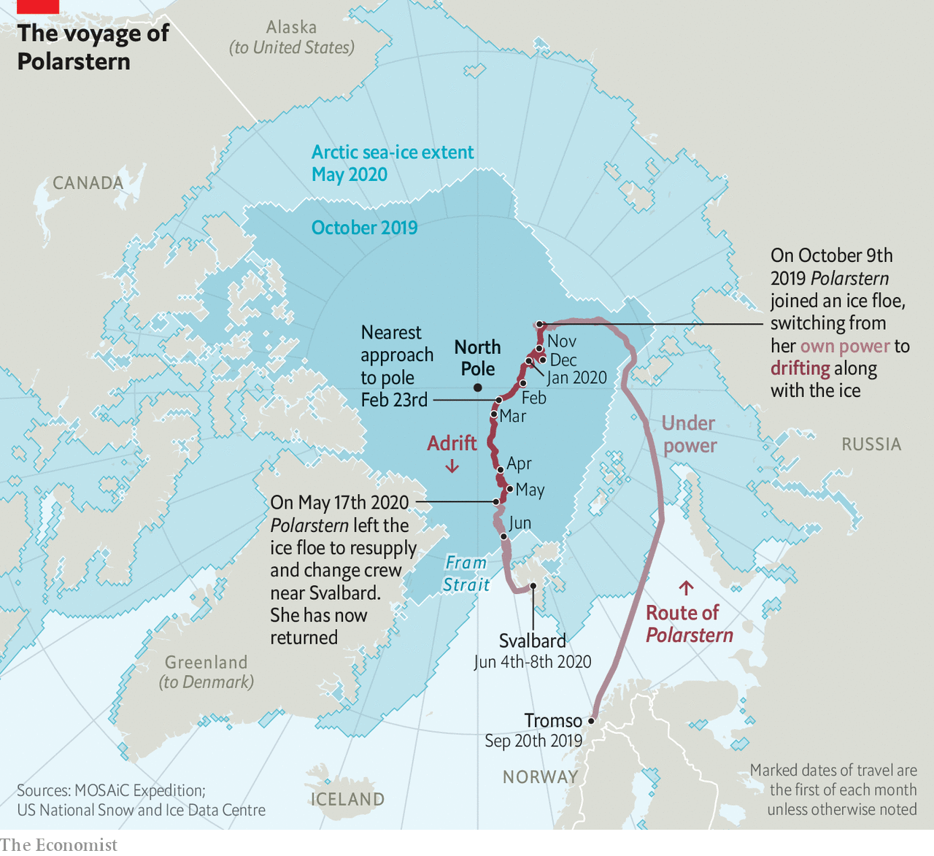

Things have not, however, gone according to plan. The idea was for a revolving cast of 300 scientists each to spend two months on board. This would have permitted specialists in the study of different seasons and conditions—winter or summer ice, say—to be there at the appropriate moment, and would also have had the benefit of protecting everyone from cabin fever.

## Unplugging the freezer

A planned rotation in April had, though, to be cancelled. Norway, the new shipmates’ intended departure point, had closed its borders in response to covid-19. That left the original company with no liberation date. Eventually, two transfer ships with the newbies on board sailed from Bremerhaven, in Germany. And on May 17th Polarstern broke free from her icy prison and headed south to meet them off the coast of Svalbard. On June 8th she began the return trip, and arrived back at her original piece of ice (which had moved) on June 17th, to resume drifting with it until she breaks free in September, in the Fram Strait between Greenland and Svalbard.

The coronavirus has not changed MOSAiC’s objectives, however. These are to study the structure of Arctic ice and how this changes with the seasons, and to look at the air above that ice, the water below and the creatures living in that water—and, indeed, in the ice itself. All of these are interlinked. They also link the place with the wider world, for the Arctic is both a recorder and a driver of climate change.

It is a recorder because the visible difference between ice and water, and the obvious relationship between global temperatures and the amount of ice around, mean together that the ice’s waxing and waning shows in an easily graspable way how things are changing. And changing they are, for the extent of the Arctic sea ice in summer has declined by 30% in the past 30 years, and that loss is accelerating (see chart).

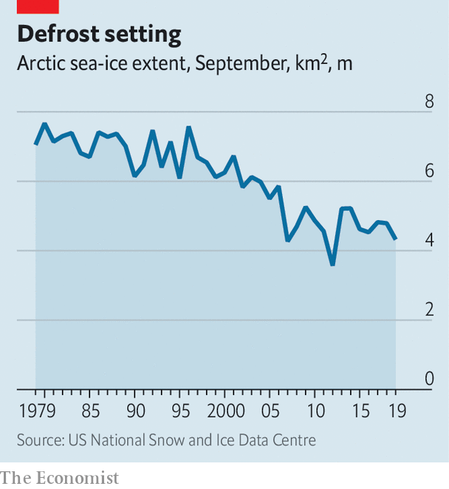

The Arctic is also a driver of climate change, though, because the whiteness of ice means it reflects sunlight back into space, thus cooling Earth, whereas the darkness of open water means it absorbs that light. The less of the former that is happening, and the more of the latter, the faster global temperatures will rise.

Start, then, with the ice. At the moment this is monitored mainly by satellite. Measuring the extent of the Arctic’s ice from space is easy. Measuring its thickness is trickier. From orbit, this is done by a mixture of radar and laser beam. Icesat 2, an American craft, provides laser-altimeter data that record the height above sea level of the top of the snow that overlies the ice. Cryosat 2, a European one, uses radar to penetrate the snow and measure the height of the top of the ice itself. The thickness of the ice in a particular place can then be calculated by applying Archimedes’ principle of floating bodies to the mixture of ice and snow, and subtracting the thickness of the snow. However, Julienne Stroeve of University College London, now safely returned from her leg of the mission, believes that the data collected by these two satellites may be inaccurate, leading to an overestimation of the ice’s thickness.

When all is working perfectly, the return signal for Cryosat 2 comes exactly from the boundary between the ice and any overlying snow. Dr Stroeve thinks, though, that this is not always what happens. Variables such as layering within the snow, along with its temperature and salinity, might affect the returning radar signal by changing the snow’s structure and density. This could cause the signal to be reflected from inside the snow layer, rather than from the boundary where it meets the ice. If that were happening, it would create the illusion that the ice beneath the snow is thicker than is actually the case.

To investigate this possibility Dr Stroeve took a purpose-built radar on board Polarstern. Each week, she and a colleague mounted this 170kg instrument on a sled and dragged it to a new site, to sample different snow conditions. As they towed it, they sent radar pulses on the frequency bands used by the satellites downwards into the snow and measured the amount of backscatter. The deflection of the signals in this backscatter gives a picture of how particular snow conditions might be changing the way the satellite’s radar is returned.

Dr Stroeve’s radar died on January 31st—one of many of the expedition’s machines that fell victim to the Arctic winter. But by the time that had happened she had managed to gather a fairly good set of data. Her conclusion is that the reflection does indeed sometimes come from the interface between snow and ice, as it is supposed to. But not always. The discrepancy is important. Her measurements already show that the ice is “definitely thinner than the satellites suggested”. She has yet to analyse the data fully, but preliminary investigation indicates that both snow depth and temperature influence backscatter. It therefore looks likely that the amount of Arctic sea ice around has been overestimated. That brings closer the moment when, if temperatures continue to rise, the ice will vanish altogether in the summer.

The thickness of the pack ice is not the only thing that matters, though. Its topography is also important. This is the province of Jennifer Hutchings of Oregon State University. She is using GPS buoys to track the motion of the ice around the ship. Though sea ice is solid, it is not rigid. It forms but a thin skin on the ocean—varying in depth from around 30cm in summer to a couple of metres in winter—so is readily moved by wind and current.

As the ice moves it stretches and cracks in some places. Large cracks formed in this way are called leads, because they are wide enough to “lead” a ship. In other places, by contrast, movement makes the ice thicker. As individual panes of ice butt up against each other, they create ridges that can be metres high. Dr Hutchings has not yet had a chance to process her data. But even from the ship’s deck she has been able to watch leads opening and ridges forming around the vessel. Her eyes and ears, as well as her instruments, tell her that this winter the ice has been particularly mobile—and has thus become particularly rough, with a surprising number of ridges.

These ridges may affect the rate at which the ice melts—but to complicate matters, this could happen in two opposing ways. Ridges make ice thicker, and thicker ice melts more slowly. On the other hand, a ridge projects down into the sea as well as up into the air (Archimedes, again), so it may stir up water from below the surface. Deep water is warmer than the surface layer, so this stirring would serve to increase melt rates. Moreover, to add to the confusion, ridges are prone to having pieces of ice fall off them into the sea, to form small blocks known as brash. This brash, having more surface area per unit volume than unbroken ice, melts faster.

Dr Hutchings’s main observation, though, is a change in the ice’s structure. Historically, this far north, where ice is always present in some form, winter is the time when it builds up as new layers are adding to existing floes, thickening them. In summer the ice then melts back a little. But a core of the stuff remains from year to year and, over successive winters, more layers are added. That forges what is known as multi-year perennial ice.

Dr Hutchings and her colleagues have, however, found something rather different is now going on. Instead of being composed of ice accumulated over many years, much of the perennial ice pack is no longer truly perennial—it is “juvenile”, having built up over only the past two years.

To Dr Hutchings, this is further evidence confirming what satellite images of the ebbing and flowing of the pack ice suggest—that the end of year-round ice cover at the North Pole may be near, with a summer melt-back so substantial that the pole itself sees clear, blue water.

Jeff Bowman of the Scripps Institution of Oceanography, in San Diego, is also interested in the behaviour of the ice. In his case, that interest is directed towards its effects on Arctic life. The main question he has been asking is whether the Arctic ecosystem as a whole is a net producer or absorber of carbon dioxide. The answer to this question has implications for the amount that the Arctic contributes to global warming. It depends on how much photosynthesis is taking place in the region. And that, in turn, depends on the extent and topography of the ice cover.

The Arctic Ocean has few multicellular plants. But it does have single-celled algae and photosynthesising bacteria. These live both in the water and in the ice itself. And, though tiny, they are abundant. It is they that Dr Bowman, who is a marine microbiologist, is studying, to discover how they affect the Arctic’s carbon balance.

To measure the activity of these micro-organisms he has been analysing the amount of oxygen in the water. This is an indicator of how much photosynthesis is taking place. In doing so, he has discovered that the physical condition of the ice—particularly the ridges being studied by Dr Hutchings—has an important effect on these creatures and their productivity.

Oceans, the Arctic included, fall naturally into layers, with the stillest water at the bottom, where there is also little light. Ascend the water column and both motion and light increase. Near the top is what is known as the surface mixed layer, which turns over continuously in response to the wind. Sea ice generally reduces this wind-induced mixing. But ice ridges act like tiny sails, catching the wind, moving in response and thus stirring the water beneath. The consequence, Dr Bowman has found, is a surprisingly deep mixed layer.

That is bad news for photosynthesising planktonic microbes. The already low level of light below the ice means they can grow only when they are close to the surface. If they get “mixed down” away from the light they cannot photosynthesise.

This is not, however, a problem for those organisms actually embedded in the ice. For them, thinner ice means they get more light, rather than less. That raises their productivity. The result, as observed by Dr Bowman, was an unusually early spring-ice algal bloom this year.

It remains to be seen what the effects of the early bloom are. But shifts in the timing of events of this sort can have consequences. For example, if the algae bloom early, the tiny animals that eat them may hatch too late to catch their main food source. Fewer of these zooplankton means, in turn, less to eat for things further up the food chain—like fish, seals and polar bears.

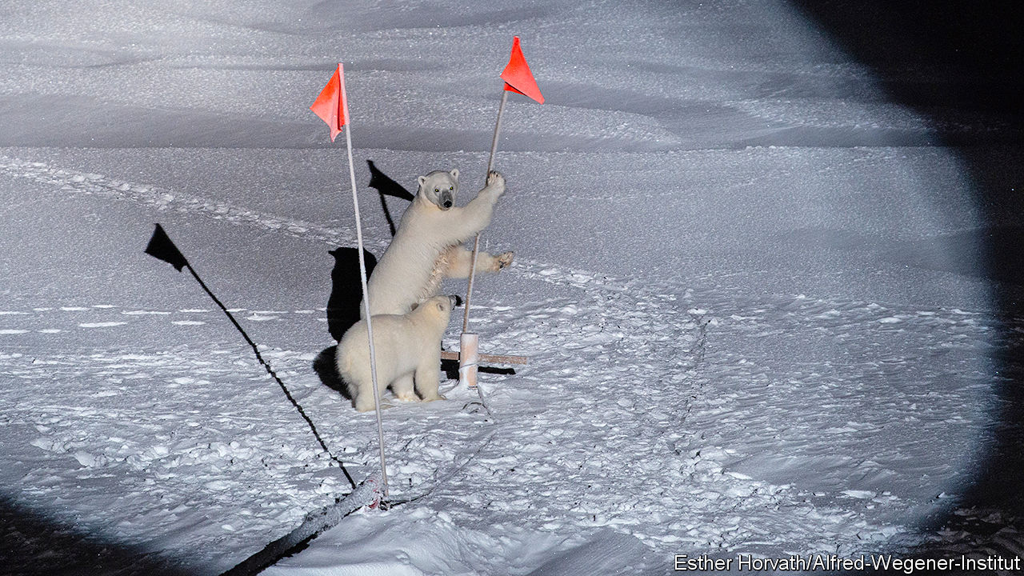

We were here first!

But what is true of winter is not necessarily true of summer. The return of the sun means the winter’s subtleties are now being replaced by a stronger, more obvious consequence of the reduced sea ice. This is that more light can blast through the water into the ecosystem. That, too, will affect the timing and intensity of phytoplankton and ice-algal blooms.

The effects on the carbon balance of the early algal bloom in the spring will play out in the coming months. The uneaten algae may act as a carbon sink, mopping up carbon dioxide. Alternatively, they may increase levels of carbon dioxide if their mistiming serves to put out of kilter an ecosystem that would otherwise have absorbed it. The new set of researchers on MOSAiC will follow this up.

The changes in the ice that Dr Hutchings has been observing also seem to influence the atmosphere, according to one of the other researchers on board Polarstern—Lauriane Quéléver of the University of Helsinki. Ms Quéléver is interested in the chemical composition of Arctic air, and in particular how certain scarce molecules in it act as precursors for the formation of clouds. This, she has discovered, seems to be controlled by the behaviour of the ice.

On most parts of Earth clouds form as droplets of water condense around “seeds” of dust or organic molecules. In the Arctic there is little dust. Biological activity, too, is in short supply compared with elsewhere—and is, moreover, conducted mainly below the barrier of the sea ice. It might therefore be expected that there would be few seeds present for clouds to form around. And yet, clouds are present.

## Clouds on the horizon

Ms Quéléver’s starting point for investigating this matter was previous research carried out on islands at lower latitudes in the Arctic—specifically, Greenland and Svalbard. Cloud seeds there tended to be compounds containing sulphur, nitrogen, chlorine, bromine or iodine. Using a score of instruments held in a container at the ship’s bow, she looked for these molecules. And she found them.

That was not a complete surprise. What did surprise her, though, were the quantities she found them in. She expected their concentrations in winter, the least biologically active time of year, to be low to non-existent. In fact, they were similar to those found in Greenland.

The only plausible source of these molecules is the micro-organisms Dr Bowman is studying. And, as if to support that idea, she also saw that spikes in the concentrations of molecules of interest correlated with “ice events” around the ship, such as the opening of big leads which brought the air into contact with the seawater below.

The link between the sea ice cracking and the release of potential cloud seeds suggests that more cracks in the ice sheet could lead to more clouds in the Arctic. What overall effect that might have on the climate is unclear. Summer clouds would reflect sunlight back into space, cooling the planet. Those formed in winter, when the sun is below the horizon, would serve as insulation, warming it. As with the way Dr Hutching’s ridges affect the melting of ice, two opposite outcomes are possible—or perhaps the net effect will be that they cancel each other out.

As this example shows, properly disentangling the interactions between Arctic ice, atmosphere and ocean life will require data collected across a full year—for the contrast between winter and summer at the poles is greater than anywhere else on the planet. Polarstern’s unexpected detour has come at the cost of some of these data, but in partial compensation the expedition left several autonomous machines on the ice, to continue harvesting as much information as possible during the ship’s absence. With luck, then, the expedition has been saved to finish what will be the most comprehensive study so far made of the Arctic and its influence on the climate. If that happens, the researchers on board will have had the most productive lockdown imaginable—with no Zoom involved.■

This article was downloaded by calibre from <https://www.economist.com/science-and-technology/2020/06/20/an-icebreaker-called-polarstern-is-revealing-the-arctics-secrets>

|  |  |  |  |
| --- | --- | --- | --- |
|  | Articles | Sections | Next |

|  |  |  |
| --- | --- | --- |
| Science & ... | Sections | Economic & ... |

Books & arts

The fate of nations: Too many setbacks

.

Goths v Romans: Loser’s justice

.

Alfredo Jaar: Opening the black box

.

Rewatching “The Prisoner”: He was not a number

.

Illness in literature: Climb every mountain

.

|  |  |  |
| --- | --- | --- |
| Science & ... | Sections | Economic & ... |

|  |  |  |  |
| --- | --- | --- | --- |
|  | Articles | Sections | Next |

#### Too many setbacks

# A historian sets out to explain Spain’s tumultuous past

The country’s modern history has been tragic. But today its predicament is less exceptional

Jun 20th 2020 | MADRID

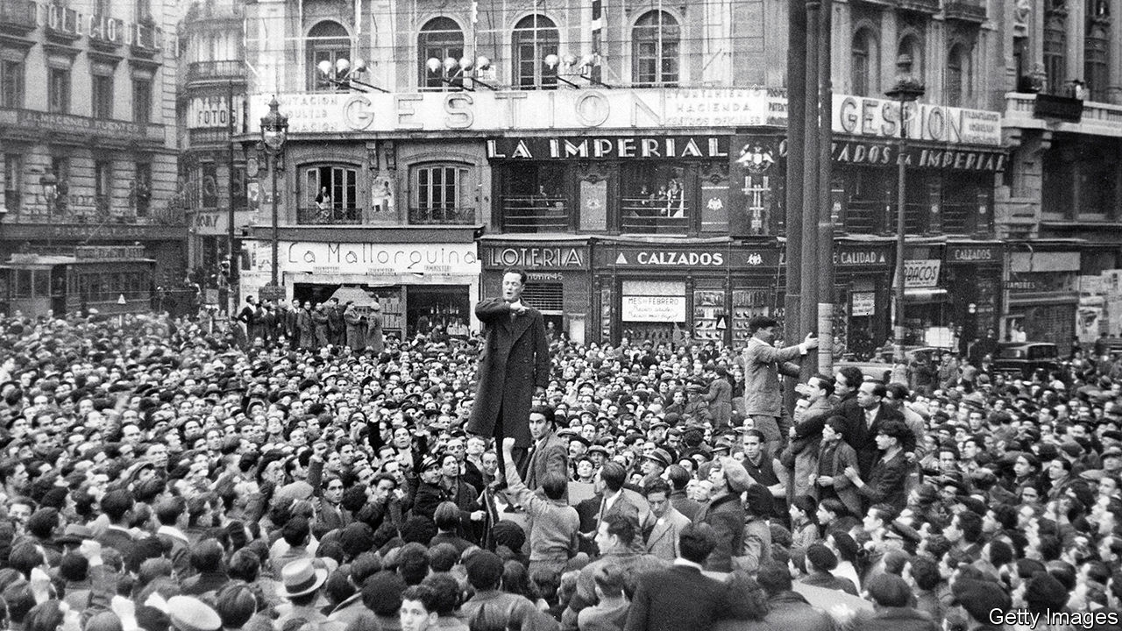

A People Betrayed. By Paul Preston.Liveright; 768 pages; $35. William Collins; £30.

IN 2018 A court in Madrid sentenced several former officials of the ruling conservative People’s Party (PP) to long prison terms for taking kickbacks on public contracts. It cast doubt on the credibility of evidence given by Mariano Rajoy, the prime minister, who had appeared as a witness. Within a fortnight Mr Rajoy was out, his government the first to be ousted by a censure motion since Spain returned to democracy and constitutional monarchy in the late 1970s, after the long dictatorship of Francisco Franco. Pedro Sánchez, the Socialist leader, breezed into power pledging to restore the dignity of Spanish politics.

Two years and two general elections later, he heads a weak minority coalition with Podemos, a far-left party. Instead of dignity, there is crispación, Spain’s word for no-compromise adversarial politics. Even before the pandemic receded, the vitriol was back. The PP and Vox, a newish party of the hard right, accuse Mr Sánchez of mismanaging the disease (though the PP regional government in Madrid did no better). Podemos, preposterously, accuses the opposition of seeking a coup. Meanwhile, Catalan separatism smoulders; some of its leaders are in jail after their illegal declaration of independence in 2017. Juan Carlos, the king who helped nurse democracy to life, abdicated in 2014. He is now being investigated over a contract in Saudi Arabia.

No wonder many moderate Spaniards fear that a golden age of democratic progress has come to an end, and that the country is reverting to older, more destructive habits. So the latest book by Paul Preston, a British historian of modern Spain, is timely. A political history of the past 150 years, “A People Betrayed” has a thesis: that the country has been held back by corruption and political incompetence, which have in turn led to breakdowns of social cohesion that have often been met with state violence. This especially applies, the author argues, to relations between the central government and Catalonia.

Mr Preston begins with an earlier restoration of the monarchy, in 1876, and the creation by Antonio Cánovas del Castillo, a conservative statesman, of a civilian democracy based on electoral manipulation by corrupt caciques (political bosses). “Excluded from organised politics, the hungry masses could choose only between apathy and violence,” Mr Preston writes. Many chose the latter, in the form of anarchist terrorism. Attempts at reform, from above or below, failed. With the encouragement of Alfonso XIII, a meddling and frivolous king, General Miguel Primo de Rivera took power in 1923. His fall brought down the monarchy (again).

The republic that followed offered a new start. But its attempts to curb the power of the army and the church, grant home rule to Catalans and Basques and implement land reform, all amid the Depression of the 1930s, may have been too ambitious. Resistance to this programme was accompanied by a drift to extremes of both right and left. This culminated in the military rebellion of July 1936 and the Spanish civil war. Having ground out a bloody victory with the crucial initial help of Hitler and Mussolini, Franco erected a brutal, introverted dictatorship.

It was also a corrupt one, as Mr Preston shows. Franco bought off potential rivals with opportunities for enrichment. His own family, and their entourage, were grasping. Franco took a secret stipend from the telephone company and sold donated coffee from Brazil on the black market. His wife, Carmen, was the terror of Madrid jewellers, who dared not present their bills.

After two decades of failed economic autarky, in 1957 Franco brought in technocrats who opened up the economy, triggering growth that created a middle-class urban society. Political modernisation would come only with Franco’s death, when moderates in the regime came to terms with an opposition that had learned the bitter lessons of past extremism. Despite threats from military diehards and the Basque terrorism of ETA, democracy thrived as the Socialists and PP alternated in power. But in the 21st century blemishes appeared. An unchecked property boom led to a bust and a slump. Officials abused savings banks and took bribes for re-zoning land.

## Tragic, but how exceptional?

Mr Preston knits all this together into a compellingly readable narrative (even if parts are familiar from his earlier books). He picks his arch-villains well. They include General Severiano Martínez Anido, a sadistic satyr who tried to crush the Catalan anarchists through murder, torture and agents provocateurs; Juan March, a profiteer and tobacco-smuggler who financed Franco’s coup; Alejandro Lerroux, an “outrageous rogue and virtuoso carpetbagger” who opportunistically moved from left to right; and Francisco Largo Caballero, a naive and vain Socialist leader whose mouthing of revolution and sabotage of effective government helped doom the republic.

Despite everything, though, Spain became a developed and socially tolerant democracy—and at times Mr Preston’s relentless indictment feels overstated. For example, recent Spanish historiography is less coruscating in its judgment of the restoration political system. The author is too ready to blame Basque terror and Catalan separatism on the clumsiness of Madrid, rather than on their practitioners. With some exceptions, the recent corruption was naively provincial rather than the grand larceny of a March or Franco. Albeit tardily, it has been punished. Spain ranks 30th out of 198 countries in Transparency International’s index of perceptions of corruption, ahead of Israel, Poland and Italy.

Why has Spain’s history been so tragic? Spaniards are rightly fed up with being cast by foreigners as violent fanatics, and a backward exception in Europe. Mr Preston, too, rejects that. Most historians highlight a weak state, difficult geography with industrialisation mainly in peripheral regions, an army that refused to accept the loss of empire, and missed political opportunities. “Too many setbacks”, as Santos Juliá, a Spanish historian who died last year, entitled his final book.

While disgust at corruption has played a role, the political strains of today owe more to the slump and the emergence of rival populisms in the form of Catalan nationalism, Podemos (with its mixture of Leninism and Peronism) and Vox. In this respect, contemporary Spain looks like the rest of Europe as much as like its own past. ■

This article was downloaded by calibre from <https://www.economist.com/books-and-arts/2020/06/20/a-historian-sets-out-to-explain-spains-tumultuous-past>

|  |  |  |  |
| --- | --- | --- | --- |
|  | Articles | Sections | Next |

|  |  |  |  |
| --- | --- | --- | --- |
| Previous | Articles | Sections | Next |

#### Goths v Romans

# A brilliant Goth’s-eye view of the sack of Rome

History is written by the winners—unless the losers are more literate

Jun 20th 2020 |

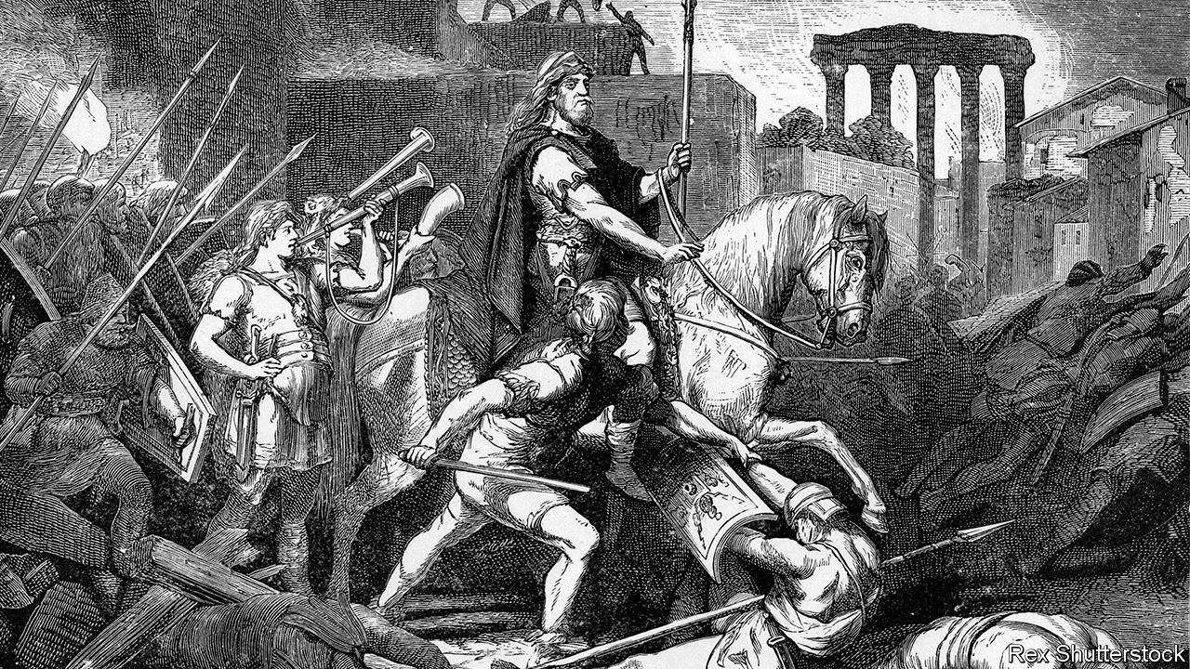

Alaric the Goth. By Douglas Boin.W.W. Norton; 272 pages; $26.95 and £19.99.

THE SMOKE began to rise above the orange-tiled roofs of the eternal city on August 24th 410AD. The watchmen had not seen the gate being opened; they had not seen Alaric the Goth creep in. But as night turned to day, they saw his works. Rome had been besieged and starved on and off for two years; it was said to be so hungry that mothers fed on their babies rather than vice versa. Now it burned and bled. Ancient basilicas went up in flames. Women were raped in the streets; an elderly one was cudgelled as she begged for mercy.

Amid this panorama of carnage there was one more piece of destruction that is often overlooked: the annihilation of the Gothic reputation. Today, as Douglas Boin of Saint Louis University points out in his superb book, the word “Gothic” has become synonymous with all that is “dark, gloomy and macabre”. History, it is often said, is written by the winners—but that is only if they can write. If they can’t, then history is written by the losers, crossly.

Almost as soon as Alaric, ostensibly the victor, decamped to move across Italy, the pens of Rome’s greatest authors were moving across the page. Goths could write a bit but they couldn’t match this. “My voice sticks in my throat,” lamented St Jerome, “sobs choke my utterance.” The monk Pelagius recorded the universal “terror of death and slaughter”; St Augustine started to churn out “The City of God”. Each affirmed not only the Gothic attack but an iron rule of history: never murder a people more literate than you. Alaric—like Attila, the Vandals and the Vikings—has paid the price.

Unfairly, Mr Boin argues, as he writes the history that the Goths never managed to. No one has undertaken a chronicle from Alaric’s point of view, a lacuna that makes this book worthwhile—and hard to pull off. Sources are scant and, as Mr Boin admits, his narrative is a patchwork: a snippet of archaeology here, a strand of military handbook there, all tied together with excerpts from general histories of the period. There is, in truth, not much Alaric the Goth in “Alaric the Goth”.

Instead, readers get the outline of his life—born in the 370s in the Danube delta, part of what was then called Gothia, a long stint in the Roman army, then disillusionment—and a lot of brilliant detail. This is less a biography than the anatomy of an empire. Mr Boin opens up the Rome of the fourth and fifth centuries and examines it with scientific precision and a wonderful turn of phrase, guiding readers with erudition and verve into battles in which men’s eyes are stabbed by arrows “the way a silver toothpick stabbed an olive”.

He paints a picture of an unbearably divided world. While soldiers campaign, wealthy Romans turn living into “performance art”. In an ancient version of the Instagram dinner, hosts obsessively record the weight of food they serve, as they serve it, so that “guests salivated while their hosts scribbled”. In yacht-club chatter, idle young men talk in learned and aggrandising analogies. Sailing around the bay becomes “going after the Golden Fleece”.

Mr Boin peers closest of all at the indignities of Gothic life. The migration of Goths across Europe is often characterised as a barbarian invasion, but the story told here is of families struggling to survive rather than thugs fighting for the hell of it. Rome itself was overrun with Goths long before Alaric arrived. By the late fourth century 30,000 lived in the capital, often as slaves. Snatched by traders, Gothic children spent their childhoods sweeping the floors of farmhouses. Roman border patrols had orders to separate migrating parents from their sons, whom many Gothic mothers never saw again. Mr Boin offers this detail with a nudge, then moves on. Thankfully, this is not Trump in a toga.

Alaric not only survived this difficult world; he thrived in it. He was, sources say, “more like a Roman” than a Goth. By the end of the fourth century, Alaric had fought long enough and hard enough that he might have expected a reward (respect, stability, citizenship). He didn’t get it. A coveted generalship was summarily terminated. He protested, but was ignored. Finally, humiliated and belittled, on August 24th Alaric the Goth—or rather, Alaric “more like a Roman”—slipped inside the city walls. ■

This article was downloaded by calibre from <https://www.economist.com/books-and-arts/2020/06/20/a-brilliant-goths-eye-view-of-the-sack-of-rome>

|  |  |  |  |
| --- | --- | --- | --- |
| Previous | Articles | Sections | Next |

|  |  |  |  |
| --- | --- | --- | --- |
| Previous | Articles | Sections | Next |

#### Opening the black box

# Alfredo Jaar makes art from the news

His latest video adapts footage of coronavirus burials on Hart Island off the Bronx

Jun 20th 2020 |



LIKE MUCH of his art, “Between the Heavens and Me”, Alfredo Jaar’s most recent video, was drawn not from his imagination but from the news. In this case it began with a report on the BBC about Hart Island off the Bronx. The prison detail at the island’s cemetery—where, for decades, indigent New Yorkers were interred in mass graves—was working round the clock to bury the unclaimed bodies of those who had died, alone and unloved, with covid-19. “My brain could not comprehend what my eyes were seeing,” Mr Jaar says.

He slowed down the footage, replacing the commentary with a haunting tune by Anouar Brahem, a celebrated Tunisian oud player. Over and over the scene repeats itself: uniformed gravediggers stack coffins in a freshly dug trench with solemn deliberation, as if they are making an offering to Mother Earth. “Here we have the poorest people in New York,” Mr Jaar explains, “the anonymous, the invisible, the no-name people being buried by prison inmates, many of whom are poor and black like them. I wanted the film to be a lament.”

In an artistic tradition made famous by Andy Warhol and Robert Rauschenberg, his videos force viewers to consider the effects of their incessant exposure to horrific images. They also highlight the tendency of the news to focus on a tragedy, then move on. “News events cover reality in both senses of the word: reporting it even as they conceal it,” remarked Hartwig Fischer (now director of the British Museum) when he included Mr Jaar’s work in a show at the Kunstmuseum Basel in 2005.

Now 64, Mr Jaar was a teenager in Chile when Salvador Allende was ousted in a military coup, but has lived in New York since his mid-20s. He is not a conventional studio artist, reckoning he has travelled 7m miles (11.3m kilometres) to create art that is meant to provoke. He has staged over 100 “public interventions”, art-world-speak for performances in which audiences gather to watch or even take part. In 2019 he walked the streets of Edinburgh wearing a sandwich board reading “I Can’t Go On, I’ll Go On”, a quotation from Samuel Beckett. Next year, when a retrospective of his work opens at the Hiroshima City Museum of Contemporary Art, his board will read, “Teach Us To Outgrow Our Madness”. That is a reference to the Japanese Nobel laureate Oe Kenzaburo, but it is also what Mr Jaar feels like saying “when I see the madness that is taking over this planet”.

“People see new meaning in his work every time they confront it,” says Pablo León de la Barra, a curator at the Guggenheim Museum, which owns one of his best-known pieces, a series of electronic billboards called “A Logo for America”. One panel superimposes an image of the two American continents onto the word “AMERICA”, quietly insisting that there is more than one kind of American. Another enigmatically combines the words “This is not America” with a map of the United States. When it was shown in Times Square in 1987, during Ronald Reagan’s presidency, viewers interpreted the sequence as a critique of his administration’s interference in Nicaragua and Grenada. Displayed on the square again in 2014, it seemed a comment on the treatment of migrants. Now, Mr León de la Barra says, it might be regarded as a statement about racism.

Mr Jaar’s travels have ground to a halt this year. Confined to his apartment in SoHo, with books stacked to the ceiling and several thousand CDs, he has slept in the same bed for weeks on end for the first time in decades. He has been reading poetry, listening to the melancholic music of love and longing known as saudade, which is made most commonly by the Portuguese diaspora—and working. “It’s for my mental health, as much as anything else,” he says. He will have much to do when the lockdown lifts; four big exhibition projects have been postponed because of the pandemic, and more are in the offing.

In August Clara Kim, senior curator at Tate Modern in London, hopes to reopen “A Year in Art: 1973”, a show that includes “Studies on Happiness”, a video installation by Mr Jaar that portrays emotional reactions to the coup in Chile. “Violence might be invisible to us,” he says. “But it exists out there, and we will see the consequences of it sooner or later.” The power of his work, says Ms Kim, stems from his dual role as artist and witness—not just through the contemporaneous recording of violence, but in teasing out responses that stretch over decades.

In the mid-1990s Mr Jaar began to focus on the Rwanda genocide. Reports about the massacres compelled him to go to the country, he recalls; over several trips, he took thousands of pictures from which he has created installations around the world (see picture). Returning to New York he found some of his own images so shocking that in one work, “Real Pictures 1995”, he entombed the photographs in a series of black boxes, never to be opened.

Later this year Mr Jaar’s Rwandan work will appear at the Zeitz Museum of Contemporary African Art in Cape Town, the first time it has been exhibited in Africa. Audiences will once again be forced to think about, and beneath, scenes they have encountered on television or social media. “I want people to see these images,” Mr Jaar says, “to actually see them, in order to bring them inside in their brain, in their heart, in their soul, to try to understand what’s happening to us.” As Ezra Pound said of literature, Mr Jaar’s art is news that stays news. ■

This article was downloaded by calibre from <https://www.economist.com/books-and-arts/2020/06/20/alfredo-jaar-makes-art-from-the-news>

|  |  |  |  |
| --- | --- | --- | --- |
| Previous | Articles | Sections | Next |

|  |  |  |  |
| --- | --- | --- | --- |
| Previous | Articles | Sections | Next |

#### Home Entertainment

# “The Prisoner”, a classic TV series, is apt lockdown viewing

Confinement is not all that makes the show timely

Jun 20th 2020 |

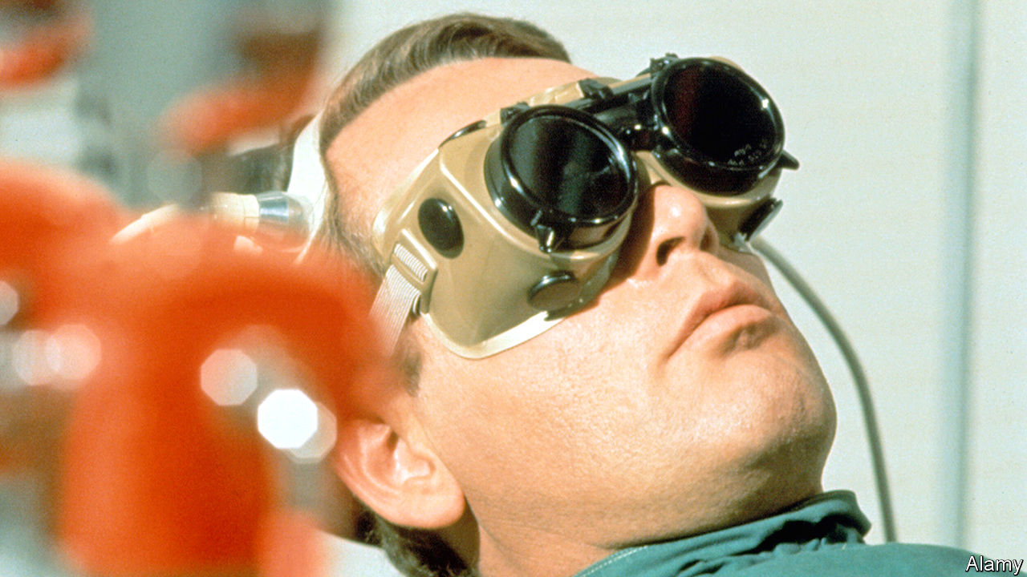

A MAN ANGRILY quits his job in London and drives his sports car home. He awakes the next morning, draws the curtains—and finds himself in a fantastical Italianate village. Confused, then indignant, he tries to leave. But the taxis and telephones provide “local service only”. The village and its inhabitants are nameless. Number 2 is in charge, though he answers to an unseen superior. The man is told: “You are Number 6.”

A British television drama first screened in 1967, “The Prisoner” is either perfect lockdown viewing or the opposite, depending on your disposition. Over 17 episodes, Number 6 rages against his confinement and the village’s stifling, sinister bureaucracy. “We have a saying here,” says a villager. “A still tongue makes a happy life.” The hero demurs. He gets out by helicopter, and later in a boat fashioned from his winning entry to the village art show, in which all the exhibits exalt Number 2. But he is foiled. His handlers were in control all along.

You never learn exactly what his job was, but it was plainly secret, official and important. Why did he resign? The task of successive Number 2s is to trick, cajole, bully or torture him into telling. One tries to manipulate his dreams. Another confronts him with his double. Still others dangle damsels in distress. None of your damn business, he tells them.

It is easy to over-analyse “The Prisoner”, and many fans have. A banner at a recent anti-lockdown march in London proclaimed (but garbled) Number 6’s cry of defiance: “I am not a number: I am a free man!” According to Andrew Pixley’s guide to the series, over-interpretation of the story irked its two creators, Patrick McGoohan, the star and executive producer, and George Markstein, the script editor.

Nevertheless, they plainly wanted to make their viewers think. “The Prisoner” invites you to ponder the relationship between the individual and authority—though you needn’t conclude that a coronavirus lockdown amounts to a conspiracy against the people. The potential abuse of technology and surveillance is a recurring theme. The inhabitants of the village can be observed night and day; in one episode they absorb a history course, beamed from their televisions directly into their brains, within seconds.

At bottom, “The Prisoner” remains a bizarre yet brilliant TV classic, about a spy whose masters won’t let him go. Though expensively made for its time—it was shot in colour and on location—it still has plenty of flaws. The plot can be downright confusing, not least in the final unmasking of Number 1. But it has an abundance of charms, including its picturesque setting in Portmeirion, north Wales. Above all it has McGoohan’s steel-gazed, black-blazered hero, railing indomitably against his captors. Does he finally escape? Watch it, and see for yourself. ■

This article was downloaded by calibre from <https://www.economist.com/books-and-arts/2020/06/20/the-prisoner-a-classic-tv-series-is-apt-lockdown-viewing>

|  |  |  |  |
| --- | --- | --- | --- |
| Previous | Articles | Sections | Next |

|  |  |  |  |
| --- | --- | --- | --- |
| Previous | Articles | Sections | Next |

#### Home Entertainment

# Time to climb “The Magic Mountain”

Thomas Mann’s saga of high-altitude sickness is oddly uplifting

Jun 20th 2020 |

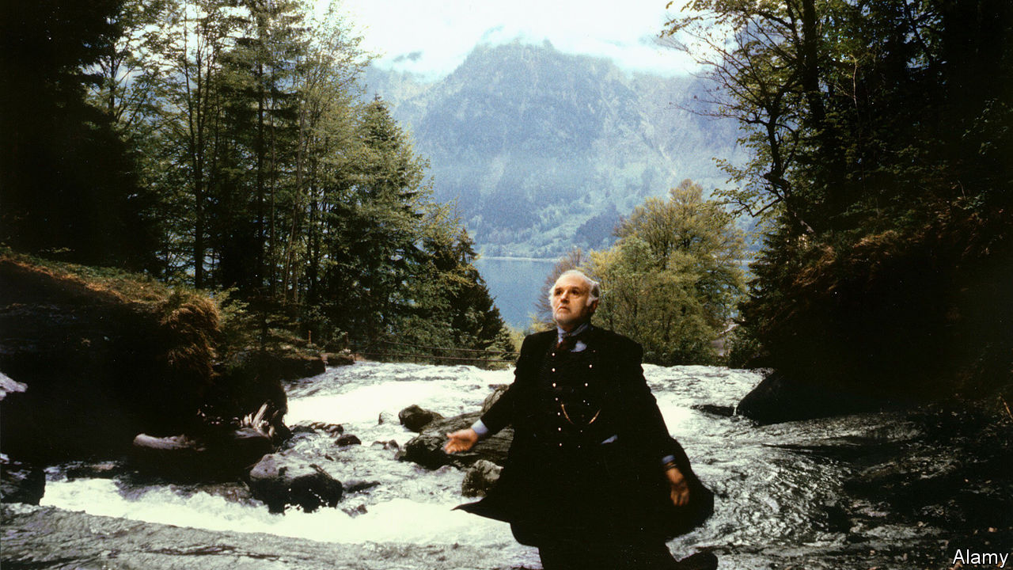

WHEN HANS CASTORP makes a midsummer visit to Davos, where his tubercular cousin, Joachim, is being treated, he expects to be there for three weeks. A job at a shipbuilding firm awaits Hans, the unassuming son of a merchant family from Hamburg. But he develops a fever, and ends up staying in the Swiss Alps for seven years. In the mountains, time moves elastically—days lengthen and years hurry past—as it can in a lockdown.

The action of “The Magic Mountain”, wrote Thomas Mann in a foreword, takes place “a very long time ago”—and even though his novel, published in 1924, is set in the preceding decade, it evoked a vanished world. It refers to a Germany not yet crushed by the first world war and the subsequent reparations, a country that still has an empire, as well as strict hierarchies and conventions. These are scrupulously observed by the pan-European characters in the story, a Bildungsroman and dark comedy of manners in which even the dining tables are classified by social status.

Mann’s fictional sanatorium, the Berghof, is probably modelled on the Schatzalp, a mansion reachable only by foot or funicular, which today is a hotel. Practically the whole cast of his novel have tuberculosis, which at the turn of the 20th century killed one in seven people in Europe and America. He presents the symptoms unflinchingly, including “a coughing that had no conviction and gave no relief, that did not even come out in paroxysms, but was just a feeble, dreadful welling-up of the juices of organic dissolution”.

Yet though the disease is everywhere, it is discussed euphemistically. Newcomers are diagnosed as anaemic. As is still the case in the rich world, death is hidden. “You hear nothing of them, or only by chance afterwards,” Joachim says of patients who succumb. “Everything is kept strictly private.” Hans learns that corpses are brought down the mountain by bobsleigh.

Surprisingly for a tale of fatal lung disease, however, the tone is gently ironic, a levity that offsets the symbolism and philosophy. Officially, Hans is a visitor, but he lives the life of a patient, which revolves around gossip, walks, infatuations, intellectual discussions, five hearty meals a day and a strict regimen of bed rest, temperature-taking and alcohol rubs. Hans takes to this high-altitude life better than Joachim, an officer who longs to return to the army. He does—and comes back to the mountain even sicker. Hans, by contrast, seems cured, and at the close leaves for the even deadlier battlefield.

As with his elongated stay at the sanatorium, so with the novel itself. Based on Mann’s own impressions of Davos, where his wife was treated, it was conceived as a short story, a humorous companion piece to “Death in Venice” (itself set during an outbreak of cholera). The author expected “The Magic Mountain” to find only a small audience. But in one of the strange transformations that illness can effect, it grew into an elegant, 900-page reflection on mortality, read and revered by millions. ■

This article was downloaded by calibre from <https://www.economist.com/books-and-arts/2020/06/20/time-to-climb-the-magic-mountain>

|  |  |  |  |
| --- | --- | --- | --- |
| Previous | Articles | Sections | Next |

|  |  |  |
| --- | --- | --- |
| Books & arts | Sections | Graphic detail |

Economic & financial indicators

Economic data, commodities and markets

.

|  |  |  |
| --- | --- | --- |
| Books & arts | Sections | Graphic detail |

|  |  |  |  |
| --- | --- | --- | --- |
|  | Articles | Sections | Next |

# Economic data, commodities and markets

Jun 18th 2020 |

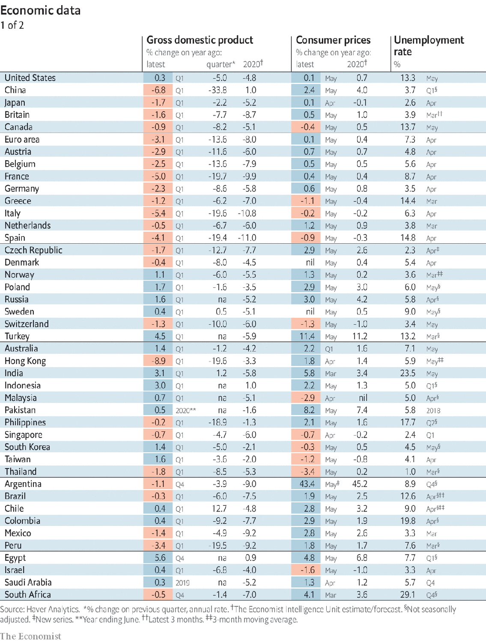

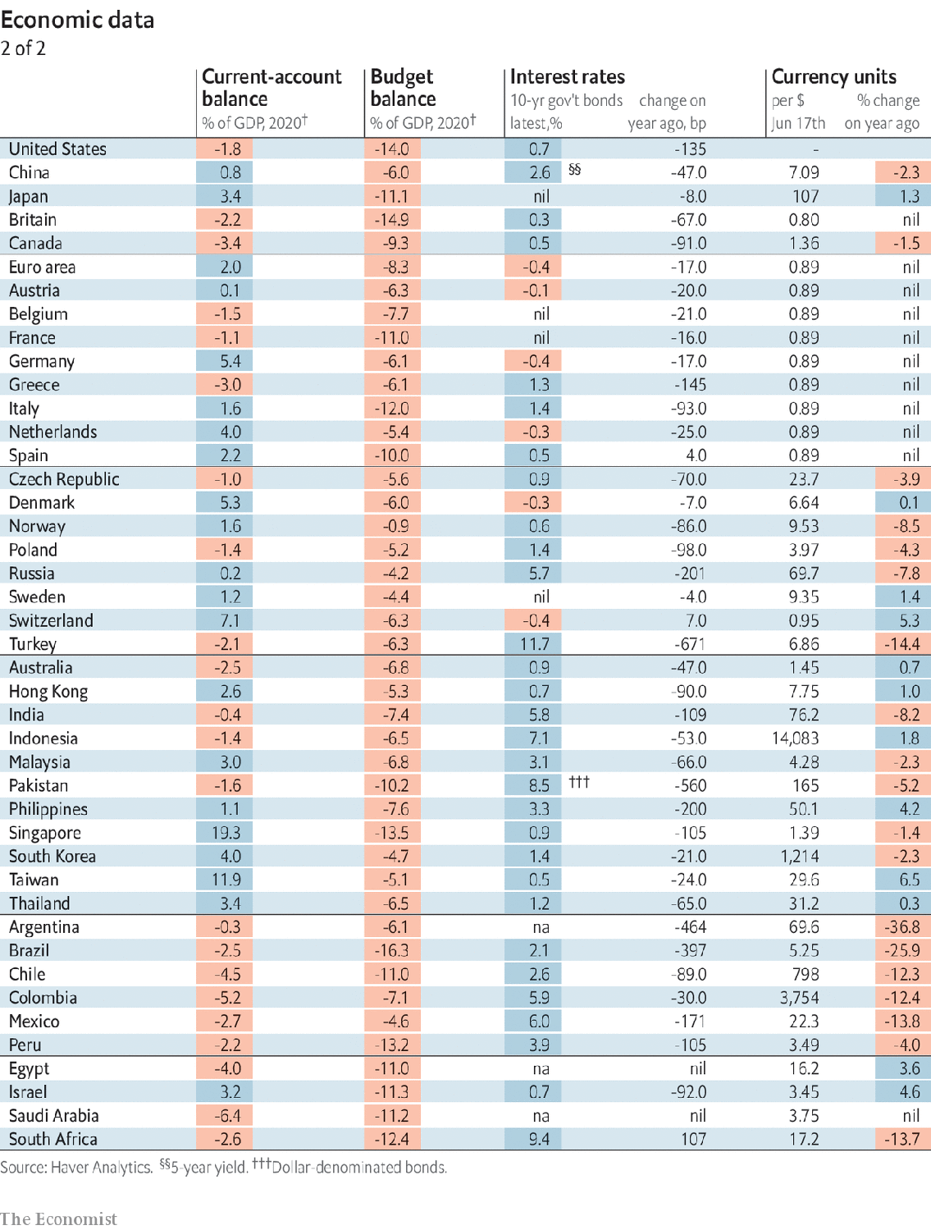

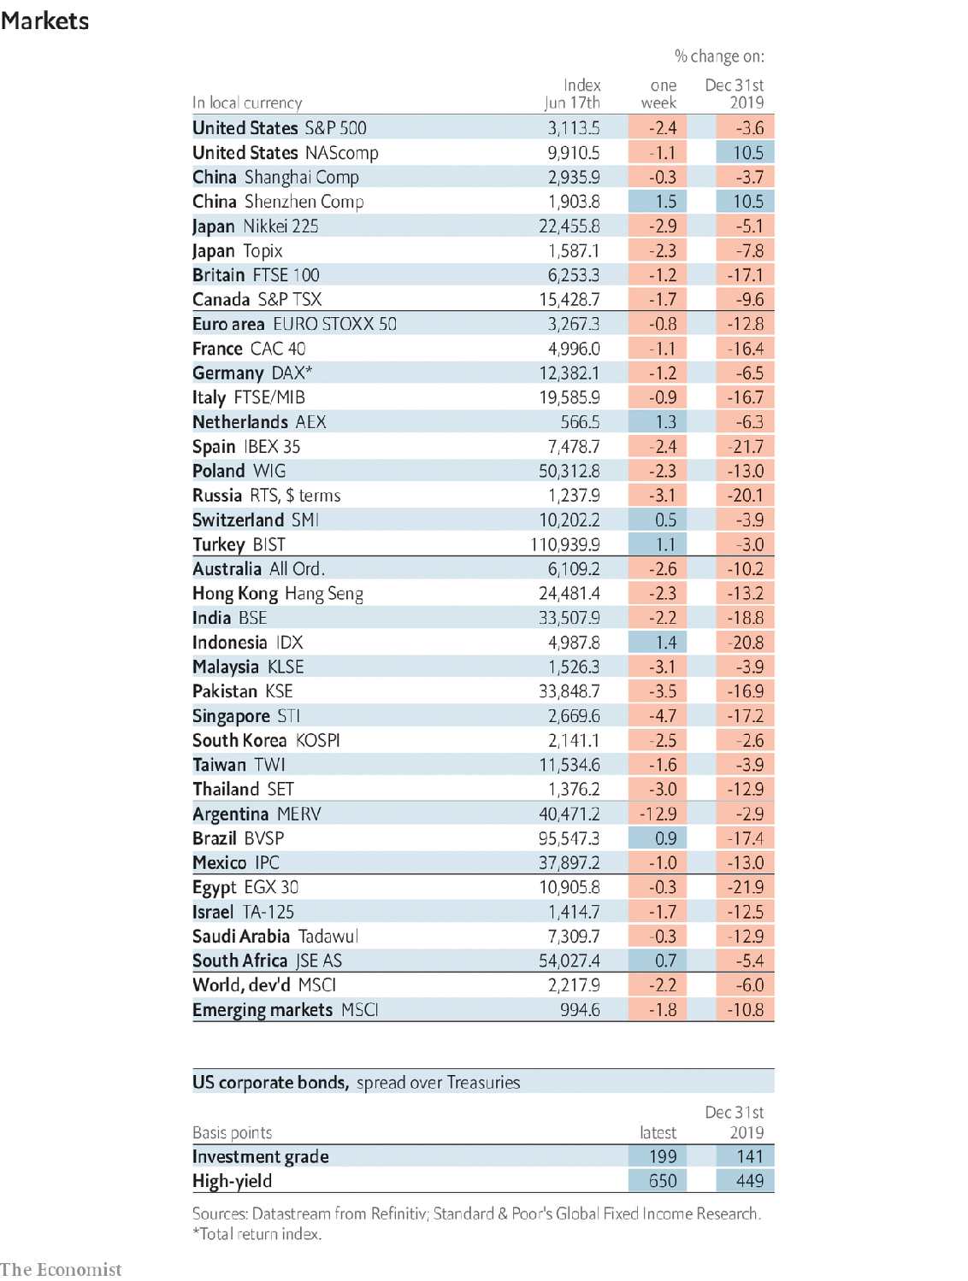

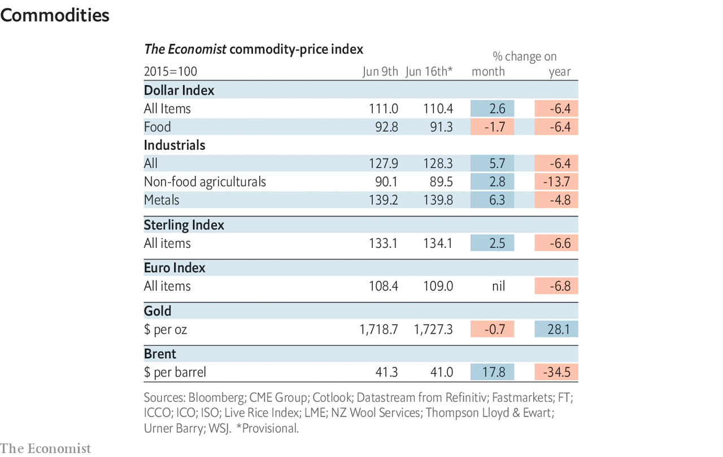

This article was downloaded by calibre from <https://www.economist.com/economic-and-financial-indicators/2020/06/18/economic-data-commodities-and-markets>

|  |  |  |  |
| --- | --- | --- | --- |
|  | Articles | Sections | Next |

|  |  |  |
| --- | --- | --- |
| Economic & ... | Sections | Obituary |

Graphic detail

The Sahel: The next Afghanistan?

.

|  |  |  |
| --- | --- | --- |
| Economic & ... | Sections | Obituary |

|  |  |  |  |
| --- | --- | --- | --- |
|  | Articles | Sections | Next |

#### Mapping conflict in west Africa

# Fighting in the Sahel has forced 1.7m people from their homes

Jihadists are only partly to blame

Jun 20th 2020 |

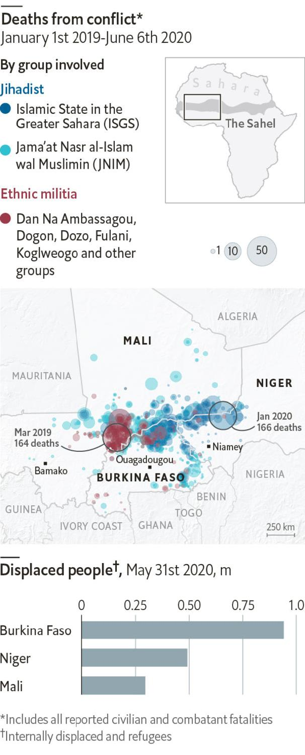

WESTERN GOVERNMENTS have long debated whether the costs of intervening in dangerous parts of the world exceed the risks. In February the United States signed a peace deal with the Taliban in Afghanistan. But just as America extricates itself from one conflict, a power vacuum in Africa’s Sahel may drag it into another.

The Sahel, a semi-arid strip south of the Sahara desert spanning 4,000 miles (6,400km), is unusually troubled. Its hinterlands are far from any city and mainly populated by nomads. The state’s writ does not hold; public services barely exist. The Sahel’s borderlands have long been dangerous: just 3.5% of the population of north and west Africa lives within 10km of an international frontier, but 10% of deaths from armed violence occurred in these areas between 1997 and 2019.

Jihadists are now entrenching themselves in ungoverned spaces. After Islamic State was ousted from the Middle East, it began to regroup in the Sahel. At times it has co-operated with al-Qaeda; at others, the two groups have clashed. To sow terror and conquer territory, the jihadists have committed atrocities, such as murdering a mentally disabled man, hiding a bomb on his corpse and blowing up 17 mourners at his funeral. Some 4,800 people died in battles or acts of terror in 2019, a six-fold increase on 2016. Another 3,900 have died so far this year.

The recent surge in conflict cannot be attributed to Islamists alone. Ethnic militias, such as Dan Na Ambassagou (“hunters who trust in God”) and Koglweogo (“guardians of the bush”), have been involved in 17% of deaths since January 2019. The governments of Mali and Burkina Faso have allegedly helped arm the groups so that they can protect civilians. In practice, the groups are mostly killing Fulanis, a largely Muslim minority. That has led some Fulanis to join the jihadists or to form their own militias. The killing has displaced 1.7m people across the central Sahel. In 2020 an average of 3,000 people a day have fled.

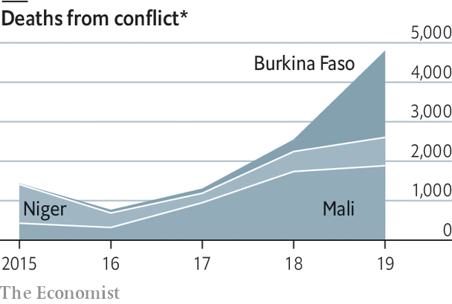

Armies of all stripes are trying to regain control, sometimes brutally. Soldiers from Burkina Faso, Mali and Niger have murdered hundreds of civilians this year. Meanwhile, the UN has 15,000 peacekeepers in Mali. France has 5,100 troops in the Sahel to fight jihadists. America has 1,200, mainly for intelligence and logistics—though Donald Trump is considering withdrawing some of them. That would be a boon for jihadists, who on June 3rd lost Abdelmalek Droukdel, the head of al-Qaeda’s network in the region, to a French raid helped by American intelligence.

These various troop deployments are not large enough to police the area, which is as large as India. To dislodge the jihadists, governments will have to govern. Besides security, locals crave jobs and health care. However, given the West’s fatigue after its failures in Afghanistan and elsewhere, countries in the Sahel can expect only modest help from abroad for their own nation-building efforts. ■

Sources: Armed Conflict Location and Event Data Project; UNHCR

This article was downloaded by calibre from <https://www.economist.com/graphic-detail/2020/06/20/fighting-in-the-sahel-has-forced-17m-people-from-their-homes>

|  |  |  |  |
| --- | --- | --- | --- |
|  | Articles | Sections | Next |

|  |  |  |
| --- | --- | --- |
| Graphic detail | Sections |  |

Obituary

Lily Lian: The lark of metro Barbès

.

|  |  |  |
| --- | --- | --- |
| Graphic detail | Sections |  |

|  |  |  |  |
| --- | --- | --- | --- |
|  | Articles | Sections | Next |

#### The lark of metro Barbès

# Lily Lian died on May 24th

The last singer of popular songs on the streets of Paris was 103

Jun 20th 2020 |



THE FIRST OF May had a special place on Lily Lian’s calendar. It was her birthday, to begin with. It was also May Day, the workers’ holiday, when she would sing revolutionary songs at the Communards’ Wall, the Mur des Fédérés, in Père Lachaise cemetery. Her father, a fighter in the Resistance, was buried close to it with other communist heroes. She felt proud to salute him, even if her view of him was scarred by bitter rows. And May Day was the fête du muguet, when strolling vendors sold lilies-of-the-valley to passers-by. These sprang up in the woods, and so had she, a love-child conceived in some mossy corner near Versailles. She and the flower-sellers often found themselves together by the Wall.

The Mur des Fédérés was a fine place to sing, though she had others. La Madeleine drew wedding crowds and glowing-after-mass congregations. Railway stations were good, especially if they had arcades for shelter when it rained, though a rainy day was a washout, generally. Her favourite pitch was the Barbès-Rochechouart metro station, by the grilles where passengers changed from the surface to the underground line. There she would stand with her group—two or three musicians, with a friend to hawk the scores—and sing through her tin megaphone the people’s favourites. These hardly varied over the years: “Le chant des Partisans”, “Le petit vin blanc”, “On boit l’café au lait au lit”, time and again to the crowd until they all joined in.

It was not a grand living, but it was decent. She was not begging, which was important, since begging was not allowed. The trade was strictly regulated by the préfecture de police, with a permit needed to sing, and by the groups themselves, who drew numbers out of a hat each week to allocate their pitches. When she first put a toe on the streets, in the mid-1930s, there were 30 others. It was a competitive business, but she could not cut her prices; at 20 francs a go, she needed to sell 100 scores at each performance just to pay the rent. Luckily she was healthy and her voice strong, since she stayed out for 12 hours a day and in most weathers—even in temperatures of ten degrees below, when people would run out of cafés with mulled wine to warm her up. War interrupted things, but after that great Liberation day in August 1944, when she belted out “La Marseillaise” as de Gaulle appeared on the Champs-Elysées and found the crowd joining her, she knew she had arrived.

Her timing seemed strange to some, just as her metier was fading. But singing made her feel free; and what she was doing was important. She was continuing a long tradition of popular songs in the street, one first organised in the revolution of 1789 to stir up citizen spirit and raise morale. She thought of herself as a teacher, promoting songs (a few new ones, like “La Mer”, mixed in with the old), getting the people to learn them, and selling them scores so that they could practise at home. It was a truly communal enterprise. Another favourite pitch was outside the giant Renault factory in the suburbs, where at midday when the siren sounded a wave of workers in blue overalls would stream out and, with luck, cluster round her, chewing their casse-croûte as they listened. She was closer to her audiences than any film star; she could feel them press round her, watch how they reacted, notice the women with their prams or the passing cyclists pausing to listen, see new lovers leaning on each other as they sang from a score. Spreading love in songs was another job she was doing.

Street singing combined the two essentials in her life. One was Paris, specifically on or near the place de la Nation and the rue de Buzenval, where she was born and where she lived for her last 70 years. Her popular name was “Lily Panam”, argot for “Paris Lily”. As a child she had been dragged to le Nord for a while, to a farmhouse half-drowned in mud; she pined for the sparkling city she had seen from her parents’ tiny mansard flat. She needed pavements. And she needed to sing, so ardently that nothing could stop her. As she ran errands or peeled vegetables, she sang. As her parents split up, with their new partners variously abusing her, she cried a bit, shouted back, but sang. At 18, having definitively run away with five francs in her pocket, she was posing for naked tableaux in Pigalle. During the German Occupation she hid in a cousin’s hotel to escape forced labour. Between times she did shop-work, and sang.

The street was her escape. Yet she could not help dreaming of stardom, too. It was possible. In 1935 she had encountered Edith Piaf, a little scrap of a woman in a shabby black dress, performing on the street illegally. She agreed to watch out for the police on Sundays, and for a spell Piaf coached her in how to sing as she did, from the heart and guts. But soon she was discovered, and their ways parted. When Piaf invited her to come and see her at Gerny’s, an ultra-chic cabaret, she felt too shy to go.

Street singing was dying fast, though. By the beginning of the 1950s those 30 groups were fast disappearing. Soon she was the last. And more glittering worlds beckoned: cabaret, variety, film, television. She had tried film once, for Marcel Carné in “Les Portes de la Nuit”, but had been fired for saying that she couldn’t imagine singing the film’s main number in the street. For three years, despite being married (marriage never got in her way), she kept company with Vincent Scotto, an old, grey, high-living songwriter, in hopes he might make a star of her. But he tried to take her over, changing her name, her hair and her clothes. Especially, he stopped her singing in the street; so she marched out.

There were recordings later, and regular appearances on a TV show compèred by Pascal Sevran, whom she had helped when he started out in 1963. No breakthrough came, though. Occasionally in the 1970s she would do a little turn on the Paris streets, ringing out the old songs while the station queues looked on, largely uncomprehending. The city had changed. Most people ran now; they had no time to stop and listen any more. Fraternité and gaiety had gone, with the songs. But every bit that was left seemed to gather round her at the local bistro near her flat in rue de Buzenval where she still lived in proud independence, raising a song and a glass to her on her 100th birthday in 2017, on the first of May. ■

This article was downloaded by calibre from <https://www.economist.com/obituary/2020/06/20/lily-lian-died-on-may-24th>

|  |  |  |  |
| --- | --- | --- | --- |
|  | Articles | Sections | Next |